Support an Athlete- Develop Football in Pakistan
Quarterly Report: February to April 2020

Liverpool Football Club Training:
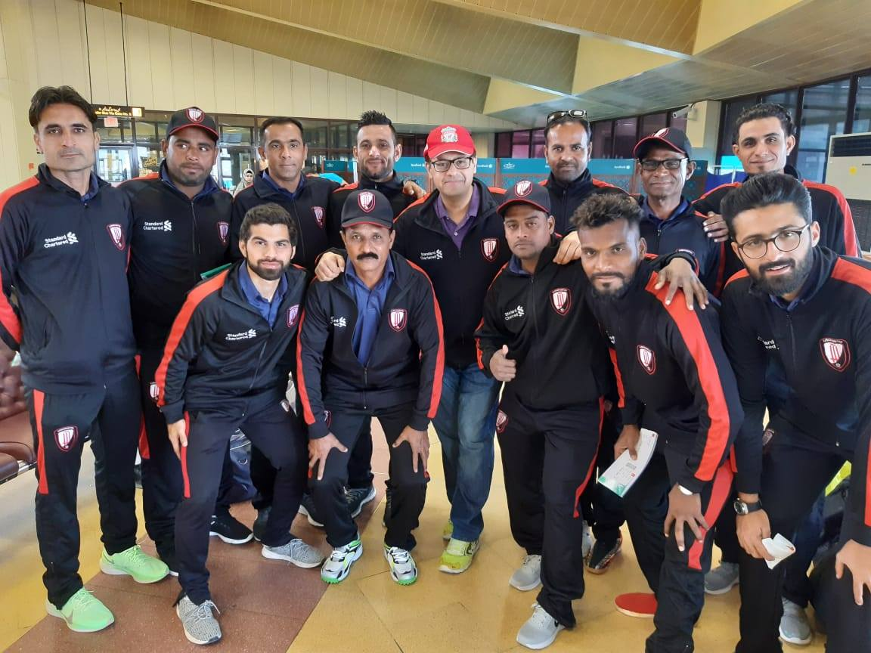
Standard Chartered Bank provided the opportunity to 12 Karachi United coaches to attend “Train the Trainer Workshop” held in Dubai from 20th to 24th February. 2 UEFA A Licensed Coaches from Liverpool FC International Academy conducted the program in which they shared different coaching techniques and methods. These 12 coaches work with the 1000+ children from underserved areas of Karachi who participate in different football tournaments and this training program has up-skilled them and they can now educate the children better about the football fundamentals.
Figure 1 Karachi United coaches posed for a group photo before departing for the workshop

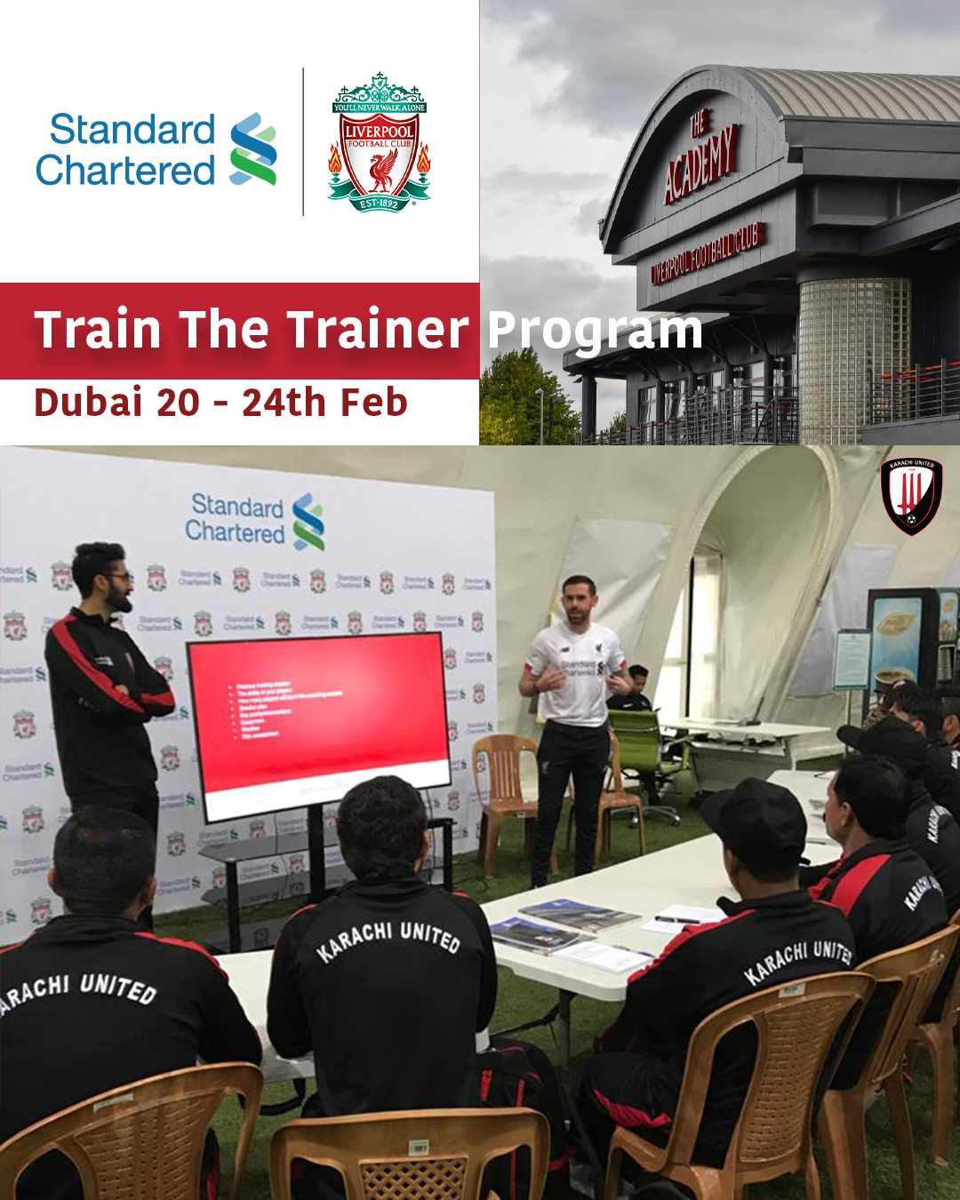

Figure 2 Karachi United coaches are attending the workshop in Dubai

Professional Team VS Sindh Government Press:
Pakistan Football Federation organized a football match between Karachi United professional Team and SGP – Sindh Government Press on the 14th of March. Both teams showed fabulous performance and tried their best to win the match. Amir scored a goal after 87th minutes to give Karachi United a 1-0 lead. However, SGP could not produce any counteroffensive against Karachi United. After competitive game, Karachi United won the match by 1-0 score.
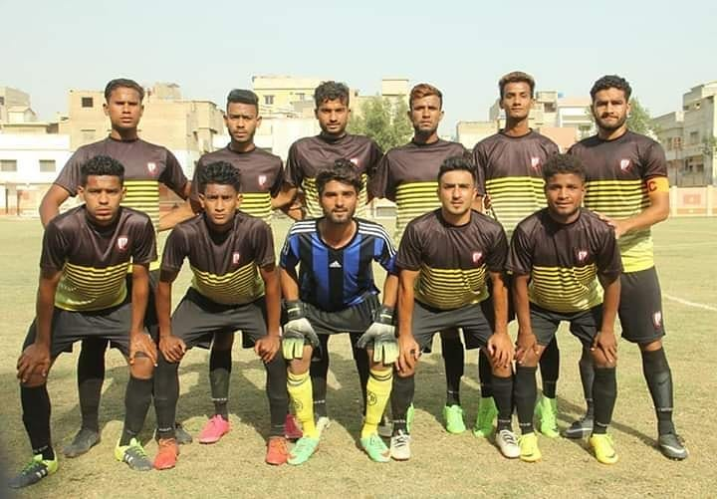
Figure 1 Karachi United Pro team posed for group photo before the match on 14/3/2020

Inclusive Football League:
Karachi United, kicked off 2nd inclusive football league during this period in which Karachi United Academy team also participated. The aim of this league is to promote sports among underprivileged children as well as young students of Madrasah (religious institutions). This league provides a platform for Young football teams from across the under-served areas of Pakistan (Karachi) to come together, break barriers and inculcate the spirit of competition.
Group matches of inclusive football league II take place on every Thursday and Friday at Karachi United Football turf. Karachi United is providing transportation facilities to all teams and also providing light refreshment at the end of each match. A total of 30 matches have been played but unfortunately, Karachi United had to suspend remaining league matches due to current COVID-19 pandemic. League will be resumed once the situation is under control.

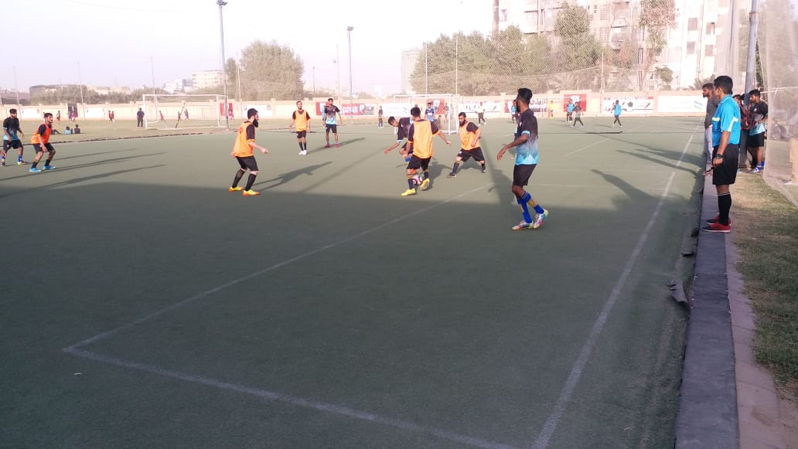

Figure 1 Teams are in action during the match

