**Support an Athlete- Develop Football in Pakistan**

**Quarterly Report**

**National Challenge Cup Tournament: -**

The Pro Team participated in the National Challenge Cup tournament that took place in Lahore. The tournament started on 28th November and ended on 20th December. Karachi United qualified for the Round of 16 after winning matches Huma FC and NBP in the group stages but then lost to WAPDA in the Round of 16 stage. The star players for KU were Anees Fakir and Shahnawaz. The scores for the group matches were the following:

|  |  |
| --- | --- |
| **Team** | **Result** |
| KU vs NBP | 1-0 |
| KU vs Huma FC | 2-0 |
| KU vs Falcon FC | 1-2 |
| KU vs WAPDA | 0-3 |

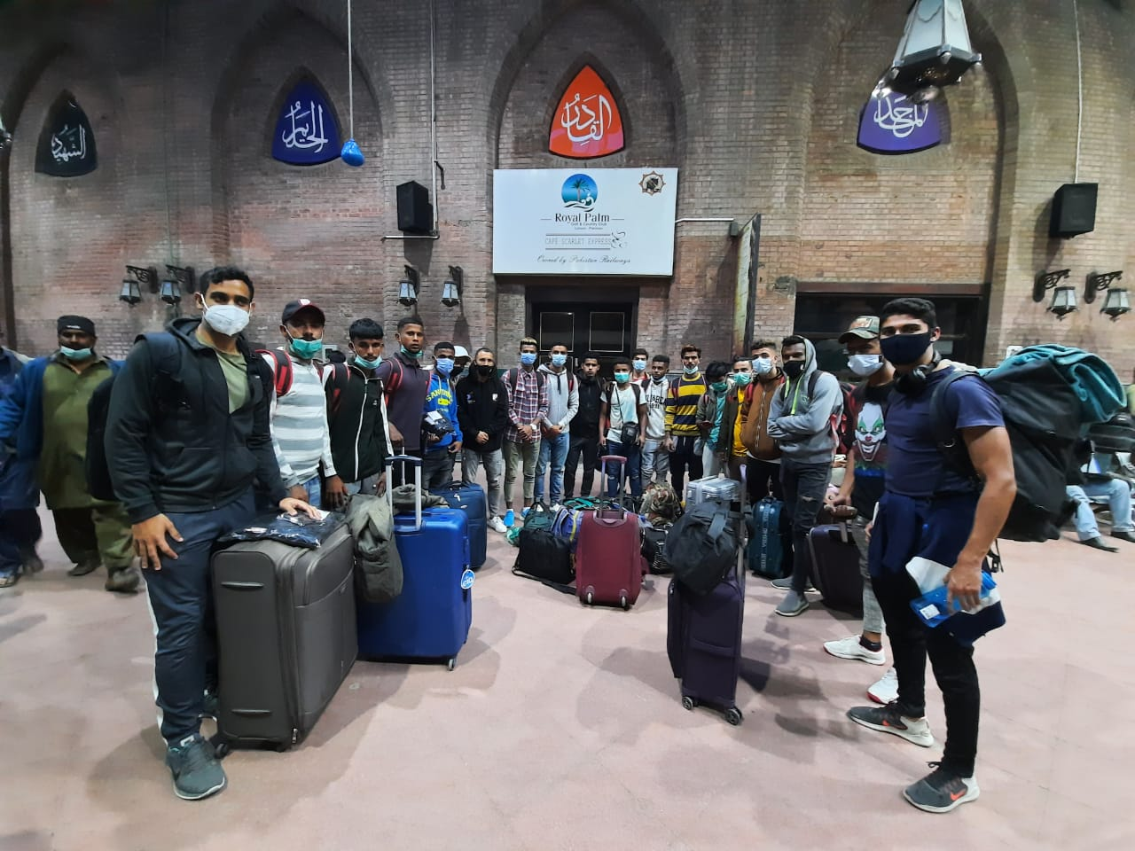

Figure 1 Karachi United team reached in Lahore

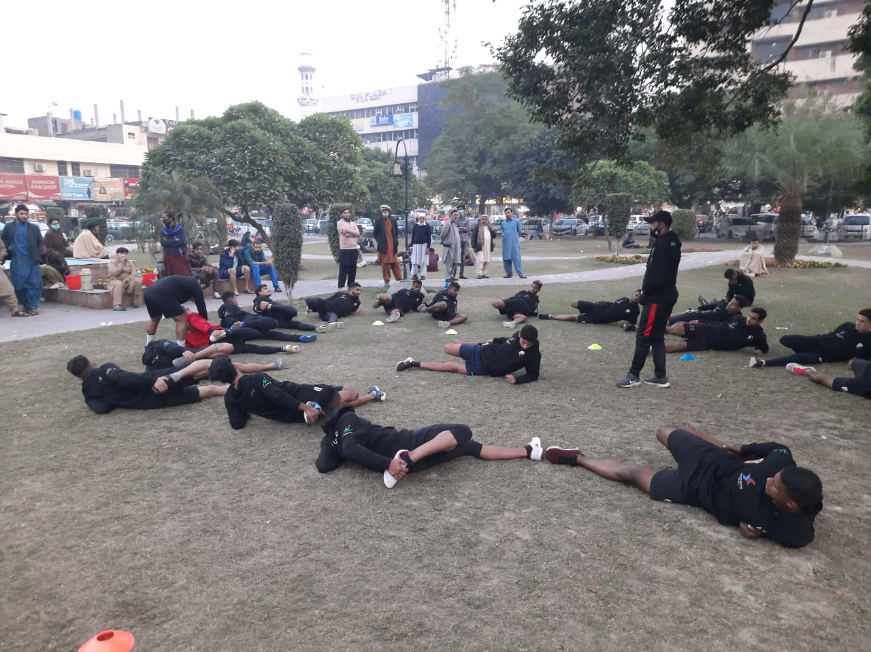

Figure Karachi United Team is having warm up session

**Coaches Development Program:**

Karachi United is offering Coaches Development Program free of cost. Karachi United professional coaches take online classes twice a week. The coaches who conduct football training session in less privileged areas of Karachi, participated in this course. These coaches also belong to underserved areas where they do not have access to professional football coaching so Karachi United provided them platform to attend free football coaching classes. A total of 12 coaches participated and cleared level 1 during this period.

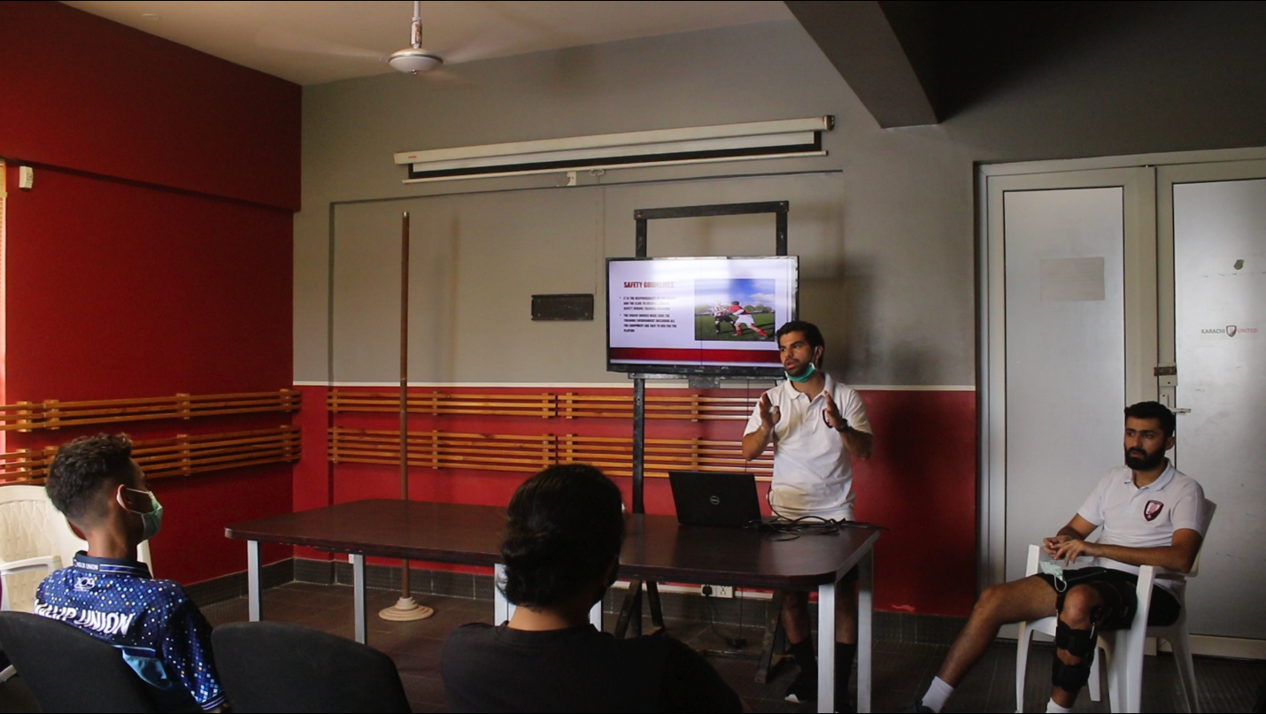

Figure 1 Mr. Kareem, Karachi United coach, is delivering the lecture