**Support an Athlete- Develop Football in Pakistan**

**Quarterly Report**

**Coaches Development Program: -**

In order to improve the quality of football coaching, Karachi United launched CDP (Coaches Development Program) for community centers coaches. A total of 40 participants have undergone the course provided during this period. The course involved 8 online classes and 3 practical. Certification issued to participants after completion of the course.  KU Youth coaches also received workshops 3 times a week from April to August to develop standard of coaching at Karachi United.

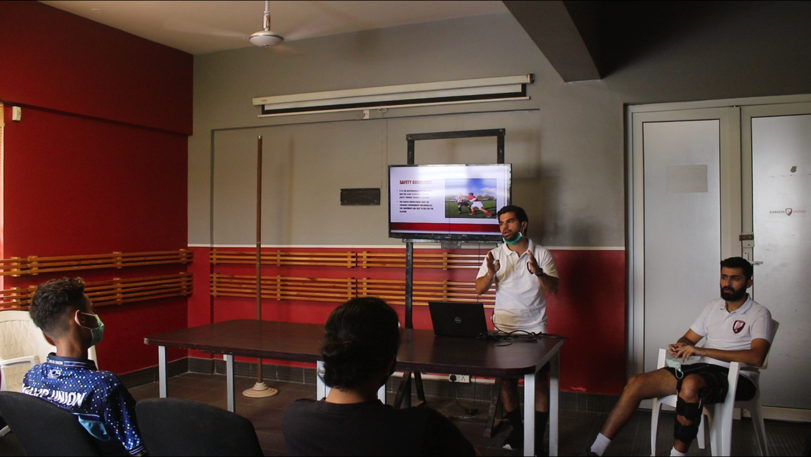

Figure 1 Mr. Kareem, Karachi United coach, is delivering the lecture

**Professional Team:**

B Division PFF League was to resume on 10th September while Pro Team Preparations and training resumed on 10th August. PFF Informed all teams that league will be delayed indefinitely due to Covid-19 but encouraged all teams to continue training.

**Karachi United Academy:**

Karachi United suspended all the activities due to Covid-19 since March. The activities will be resumed once the situation is under control.