Support an Athlete- Develop Football in Pakistan
Quarterly Report: November 2018 to January 2019
SCB-KU Youth League 2018:
The SCB KU Youth League, which was aimed at promoting sports amongst children, ended during the month of December. Baldia U-10, KU Academy U-12, Lyari Kakri U-14 and Agha Khan Girls School lifted the champion trophies of this league. The real motive of this league was to give these players who don’t get the chance to play high level competitions, a chance to experience a professionally organized international standard event. In order to increase the standard of the league, official referees and match commissioners were appointed for every match. A total number of 720 boys and 80 girls participated in this 3 months long football league that involved 44 teams – 36 boys and 8 girls’ teams. The boys were from the age category of U-10, U-12 and U-14, every category having had 12 teams each. Over a three months period these teams not only played 128 matches but were also involved in building the players’ character and improving their skills that helped them improve their quality of life in making their life better. The League gave an opportunity to coaches to select players for Karachi United’s Academy Program centered on elite player development. The following players were selected for the Academy Program: Hafizullah and Abu Bakar (Baldia Center), Naseer Jan (Malir Center), Abdullah and Mubeen (Lyari Kakri), Sameer, Ameer, Adbul Ghani and Ayan (Lyari Center).
The prize distribution ceremony was held on 17th December at Karachi United stadium. Mr. Imran Ali, CEO of Karachi United and Shazad Dada, CEO of Standard Chartered were also present on the occasion and distributed the prizes amongst the teams and players. The winners of the SCB KU Youth League 2018 are as follows:
Category | Boys Under-10 | Boys Under-12 | Boys Under-14 | Girls
Winner | Baldia Center | KU Academy | Lyari Kakri Center | Agha Khan School (Kharadar)
Runners up | Malir Center | Malir Center | KU Academy | Al Qadir School
Top Scorer | Ubaid Adeel from Lyari General | Sameer from KU Academy | Anzala from KU Academy | Maryum from Agha Khan School
Most Valuable Player | Hafizullah from Baldia Center | Murad from Malir | Ahmed from Baldia Center | Mishal from Al Qadir School
Golden Glove | From Orangi Town | Kashif & Uzair from KU Academy | Jasim from Lyari Kakri Center | Shumaila from Agha Khan School
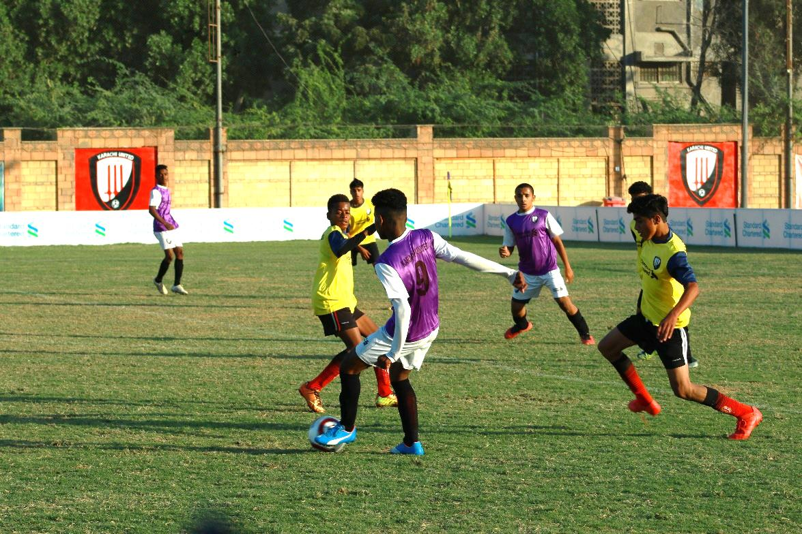

Figure 1 Lyari Kakri and Karachi United U-14 are in action during the final of SCB-KU Youth League 2018
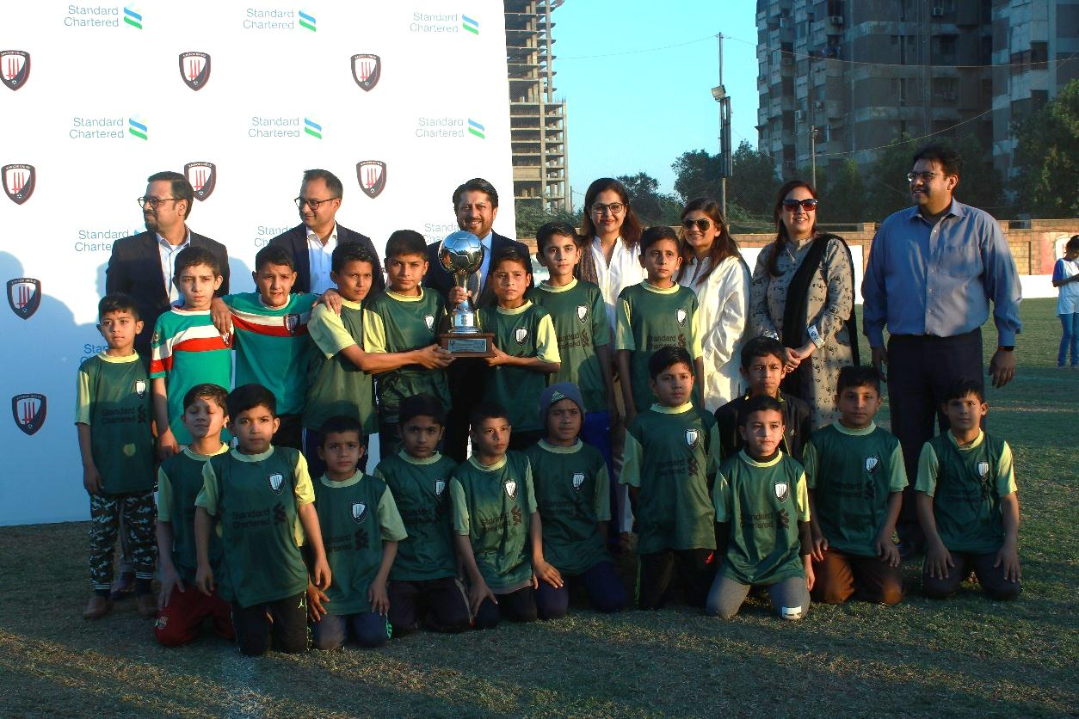

Figure 2 Players of Baldia Center U-10 pose with trophy after winning SCB -KU Youth League 2018
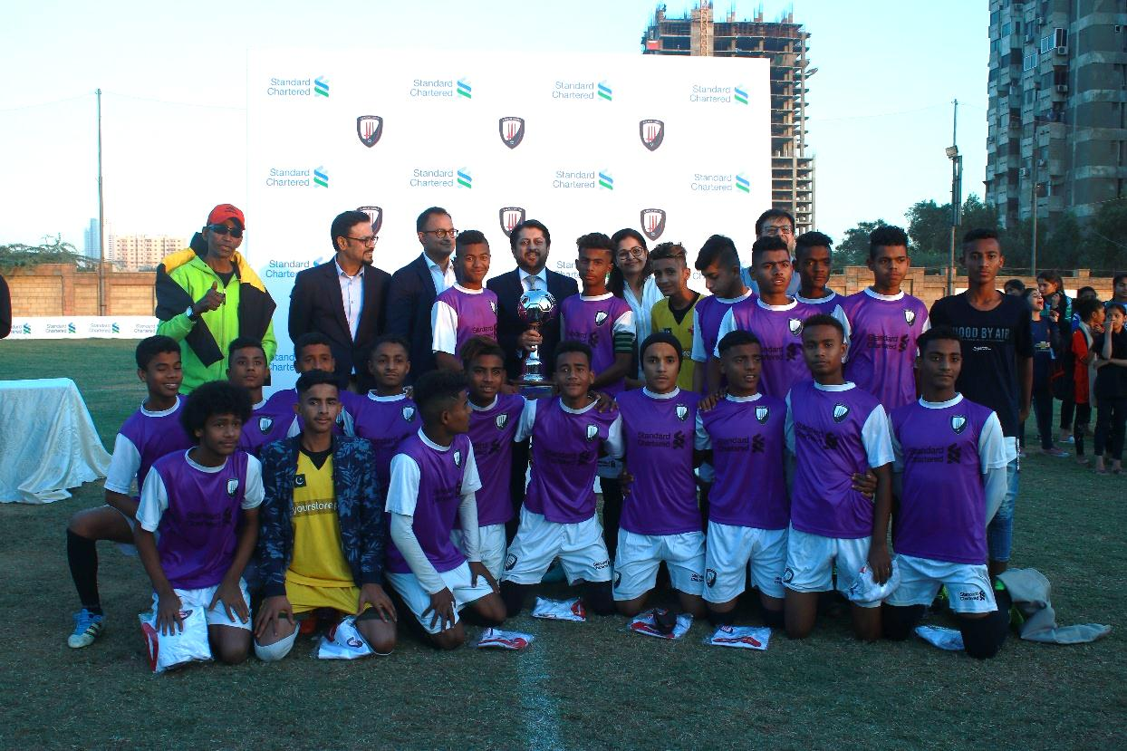

Figure 3 Mr. Shazad Dada, CEO of SCB, presents the winners’ trophy to the captain of Lyari Kakri
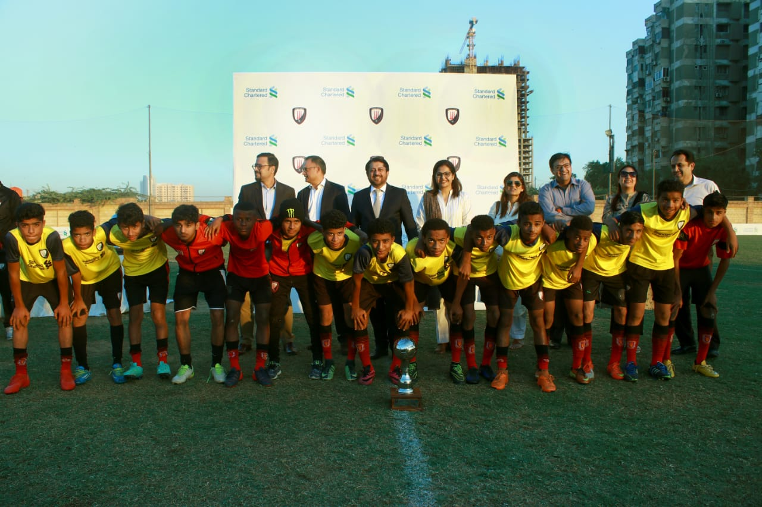
Figure 4 Players of Karachi United Academy U-12 pose with trophy after winning SCB -KU Youth League 2018

Life Skill Training Sessions:
Karachi United conducted a total of 12 life skills sessions during this period in which the certified life skill trainer imparted cognitive and social skills in the athletes such as: decision making, coping with pressure, resilience, problem solving and leadership skills. The benefits of football and training sessions evoke huge amounts of passion, bring unity among players, boost up self-confidence and teaches time management. During life skill sessions, inspirational success stories of Romelu Lukaku, Cristiano Ronaldo and Kylian Mbappe were shared via videos with the young boys. The trainer explained that these players faced an uphill struggle to achieve success but never gave up on their dreams. It was discussed that determination, hard work and passion make you stand out in the crowd. It was also highlighted that our attitude and perception play an integral role in achieving success. If you see the world through a negative lens, ultimately it will provoke prejudice and animosity against each other. In order to see peace, friendship and harmony, one has to replace the negative lens with a positive one. Also, at the end of each session, the boys were asked to share what they learnt from the session.

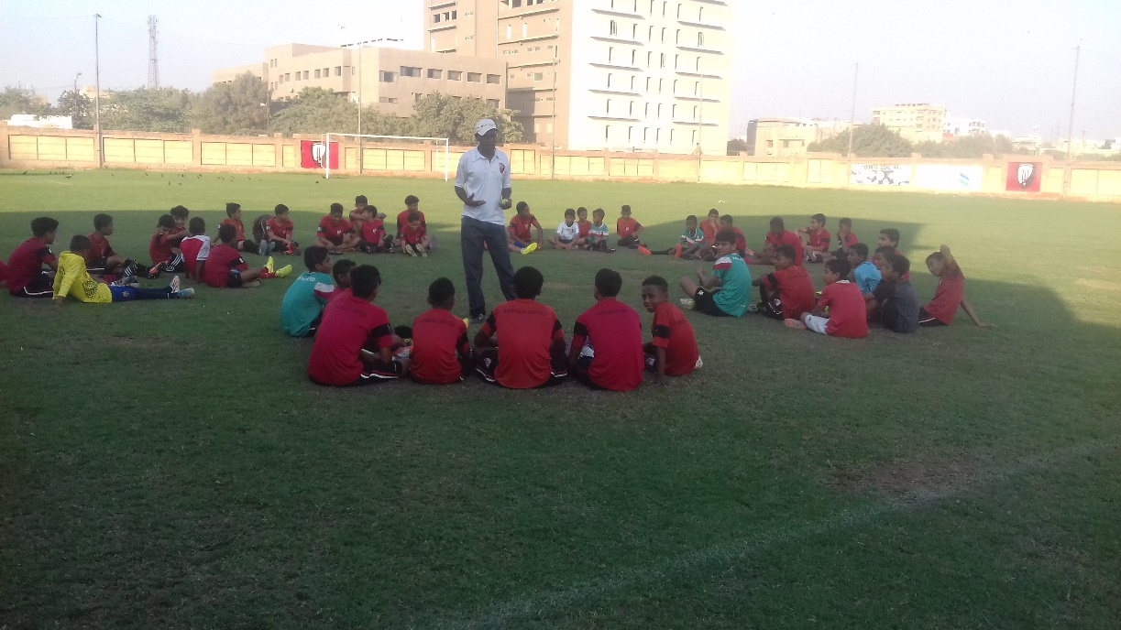

Figure 2 Trainer is conducting a group activity during life skill session

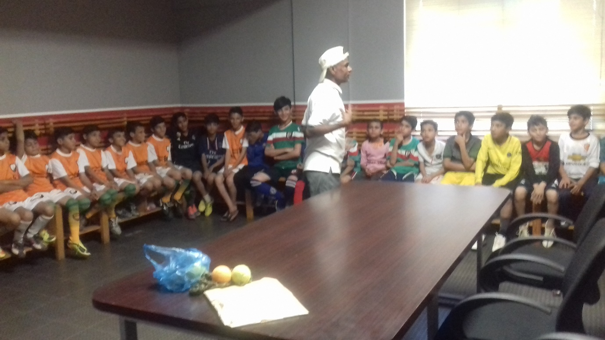

Figure 3 Boys are attending life skill session

