Support an Athlete- Develop Football in Pakistan
Quarterly Report: May to July 2019
Inclusive Football League:

Karachi United Academy participated in inclusive football league which was commenced in May. Karachi United has engaged 8 madrassas which play against our 8 community centers. Before commencing inclusive league, Karachi United conducted 16 life skill sessions. In order to eliminate communication gap, Karachi United clubbed one madrassa team with community center team. A total of 427 individuals were present including team members of Karachi United and madrassa ustad during life skill sessions. Group activities were also conducted during the sessions. The purpose of these group activities was to encourage madrassa students & community center players to educate about tolerance and give opportunity to practice real-time interactions embracing diversity.
Group matches of inclusive league take place on every Thursday and Friday at Baldia football ground and Baloch star football ground. Attendance is marked before the match. Madrassa, community centers and KU Academy are giving their best during 90-mintues game play. Group matches are also inculcating the spirit of competition amongst teams and has created the atmospheres of healthy competition. Karachi United is providing transportation facilities to all teams and also providing light refreshment at the end of each match. A total of 36 group matches have been played as of writing date of this report. The semi-final and final will take place in August.

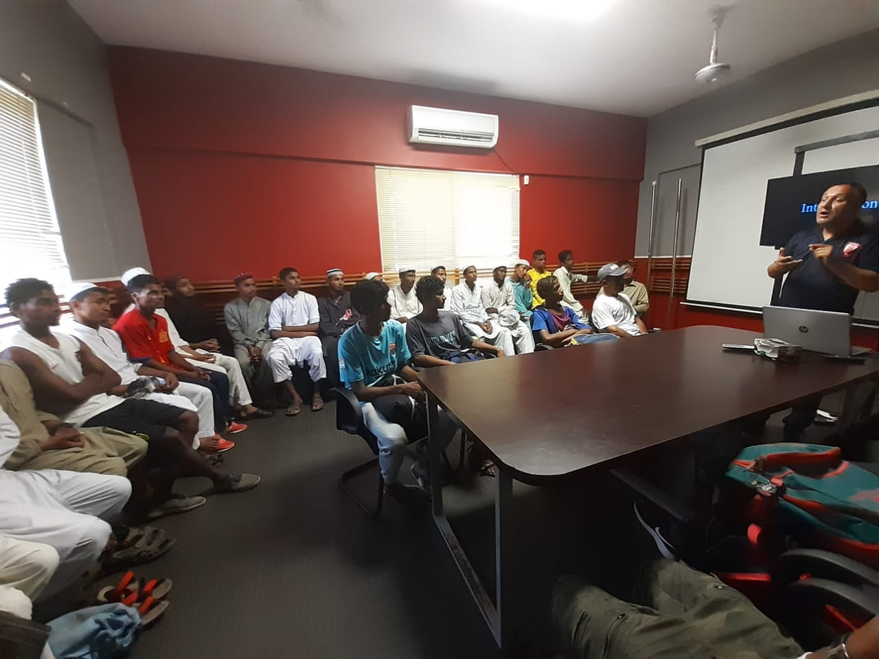
Figure 1 Mr. Talib is conduction life skill session at Karachi United stadium

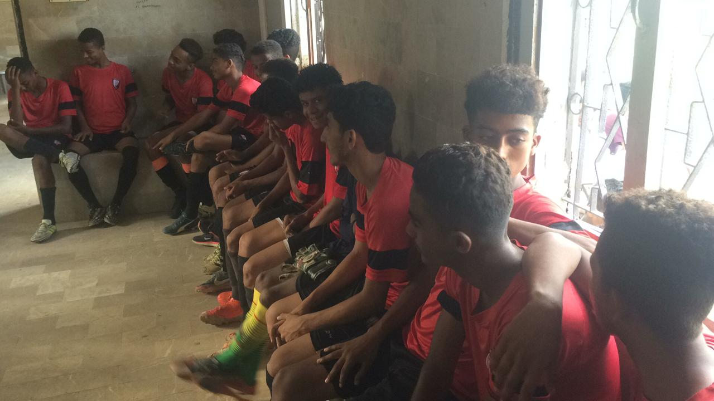
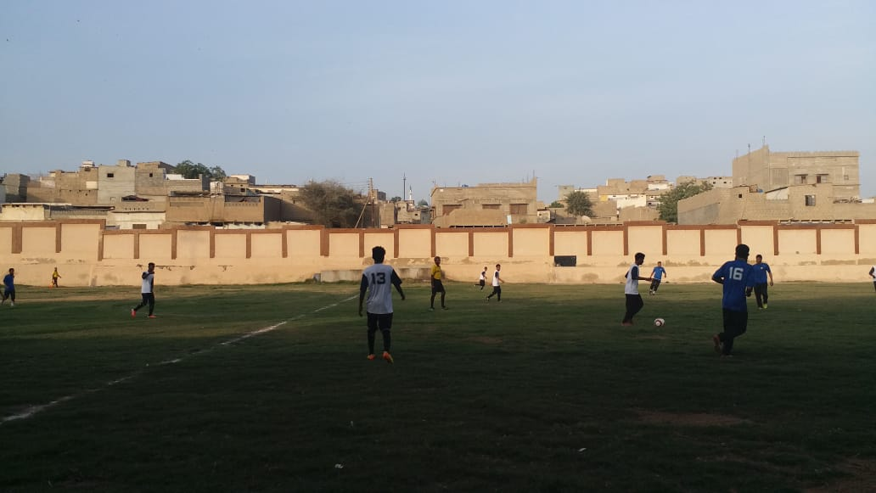
Figure 2 Teams are in action during group match at Baloch Majid Ground

Figure 3 Player of KUFF is attending session with Madrassa Aqsa

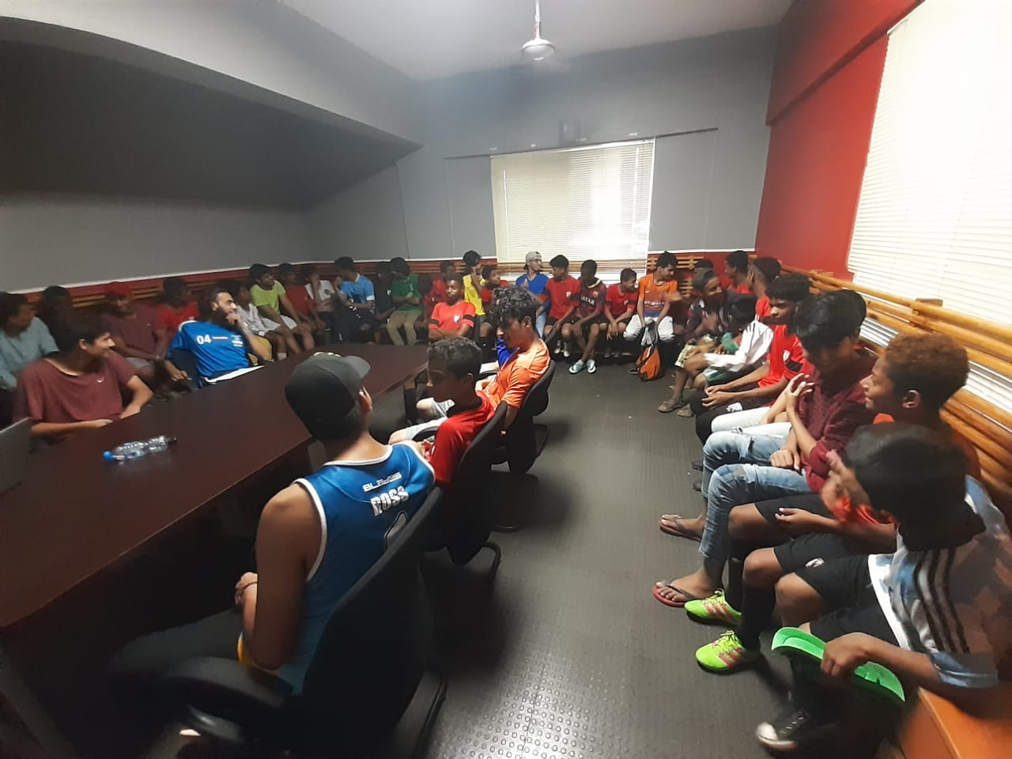

Figure 4 Madrasaa students are interacting with KU Academy players
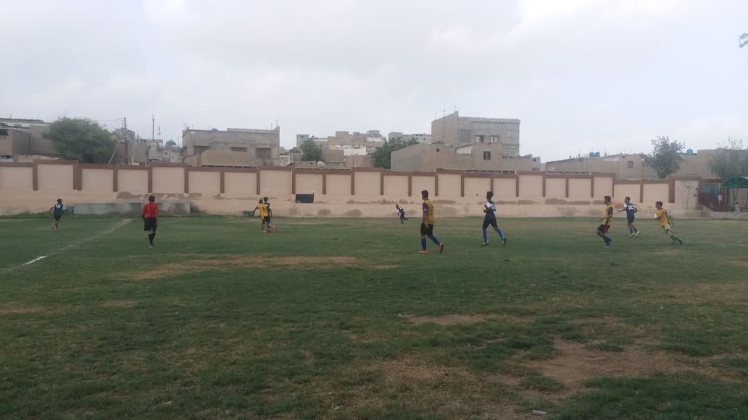

Figure 5 Teams are in action at Saeedabad football ground

Education Support Program:
Karachi United initiated education support program for Academy players during this quarter. The idea is to support players’ education so they can continue to develop holistically. Karachi United collaborated with Nixor College who runs “Taleem sub kay liye” (Education for all) program where students of this college voluntarily provide educational support (English and Math) to Academy players. Classes take place for one hour from Monday to Friday. Players are divided into different levels based on their educational level and one teacher is designated to teach English and Mathematics to 6 students. In order to enhance public and conversational skills, video sessions are also conducted weekly and to monitor the progress of the players, assessments and tests are also conducted bi-weekly.
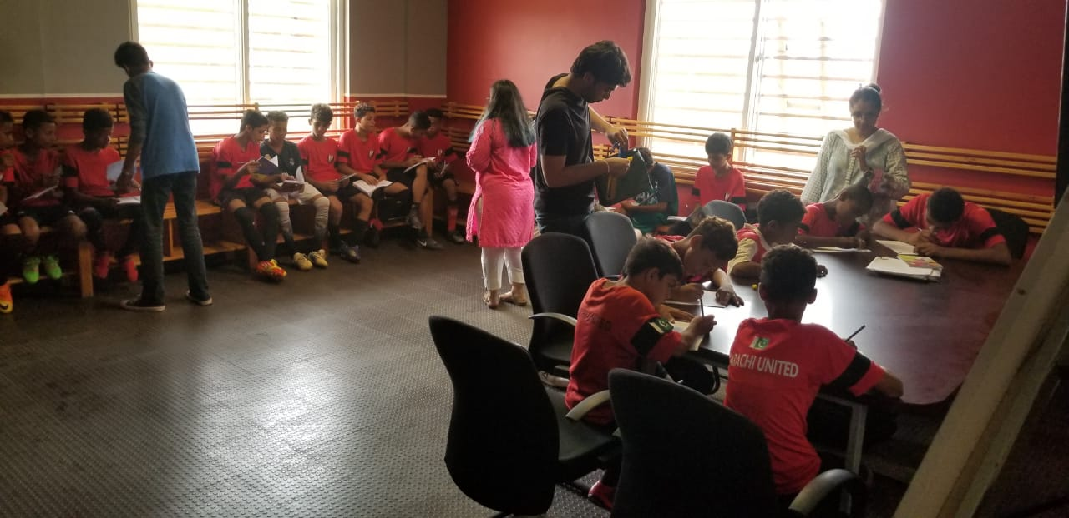
Figure 1 Nixor college students are conducting mathematics and English classes

Figure 2 Players are studying in groups
