Support an Athlete- Develop Football in Pakistan
Quarterly Report: February to April 2019
Qatar Tournament:

Karachi United Academy creates an environment in which children from lesser privileged backgrounds develop their football and life skills in order to enable them to utilize sport as a meaningful career choice to break out of their existing circumstances. Karachi United keeps providing them different platform such as KU- SCB Youth League, Azadi Cup and Quarterly Tournaments. Qatar tournament was also an opportunity for young footballers to showcase their potential on international level which Karachi United provided them a platform.

Aspire Academy (Qatar National Academy) Invited Karachi United for the Bilateral Series from 10th March to 14th March held in Doha. 27 squad members ( age group Under-10 & Under-12) hailing from Karachi United Community Center of Excellence showed splendid performance and the little footballers outplayed the opponents in the final to clinch the trophy of bilateral series. The KU players have shown great confidence and their football talent has been appreciated by the top international coaches present at the Aspire Academy. The performance of the players proved that Karachi United is capable of producing football talent in Pakistan.
The success of Karachi United was highlighted in electronic and print media of Pakistan and Qatar. The appreciation was also received from government as to honour this grand victory, Governor of Sindh also rewarded cash prize of Rs 10,000/= to each player and head coaches.
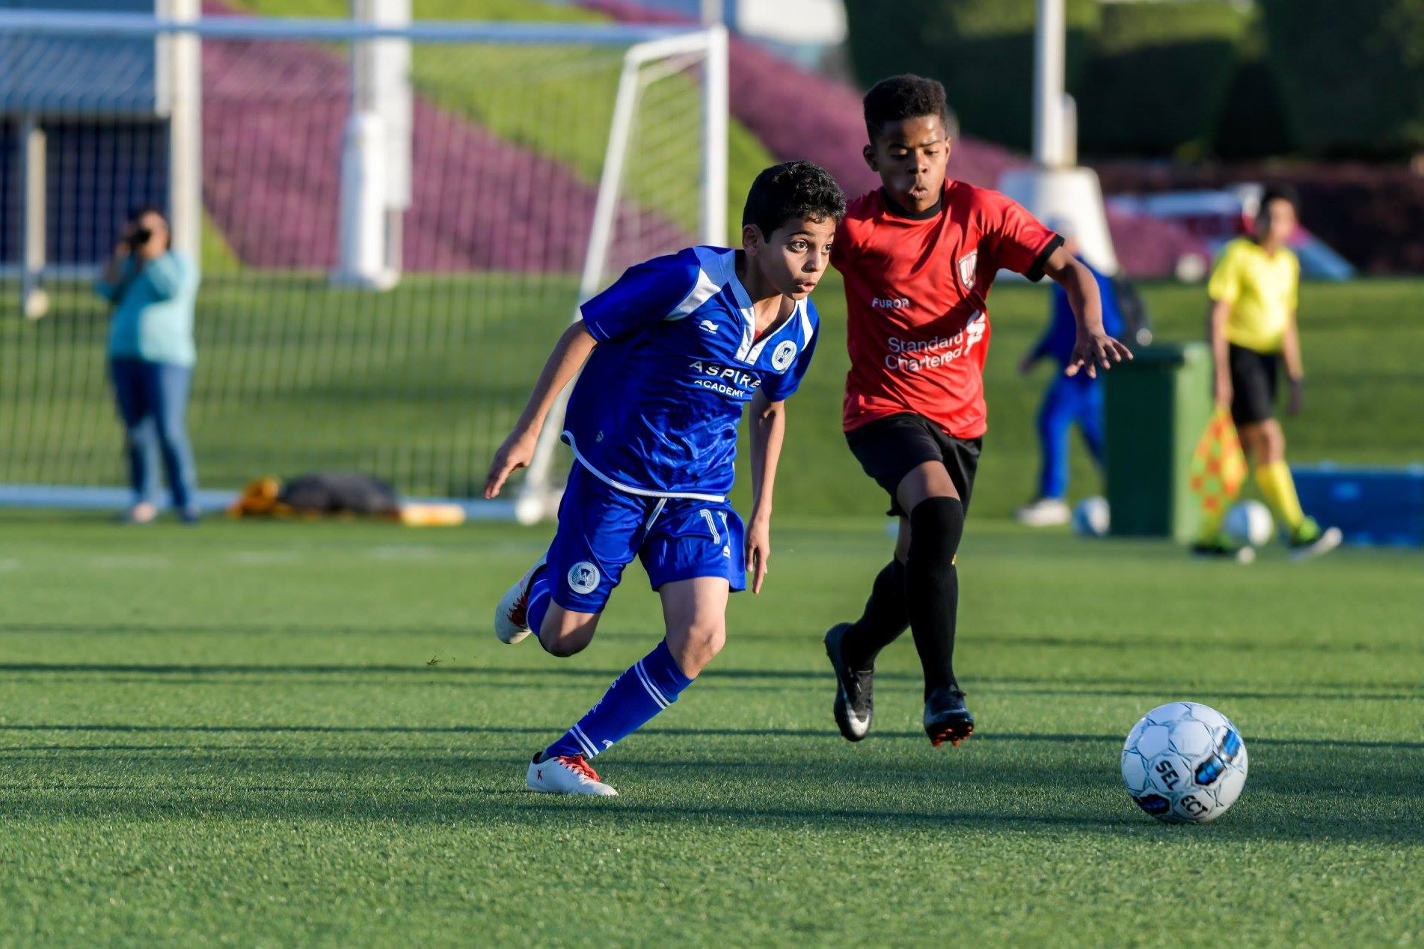
Figure 1 Aspire Academy and Karachi United Academy are in action during bilateral series
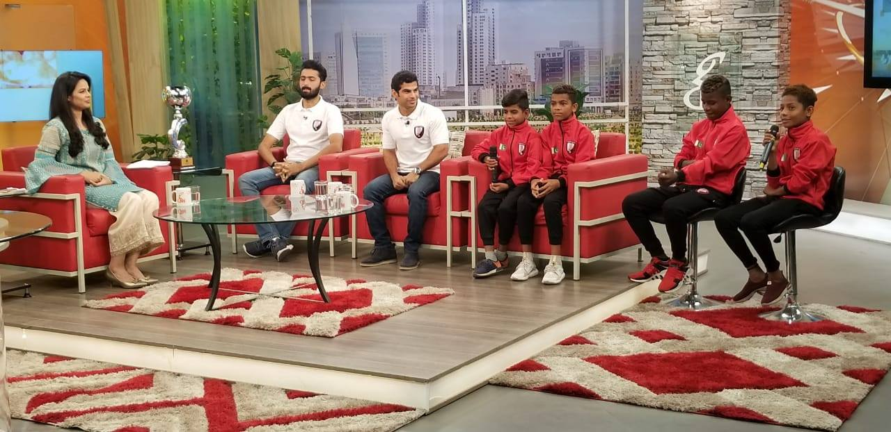
Figure 2 Adeel, Player of U-12, is sharing his experience about Qatar tour on GN TV show

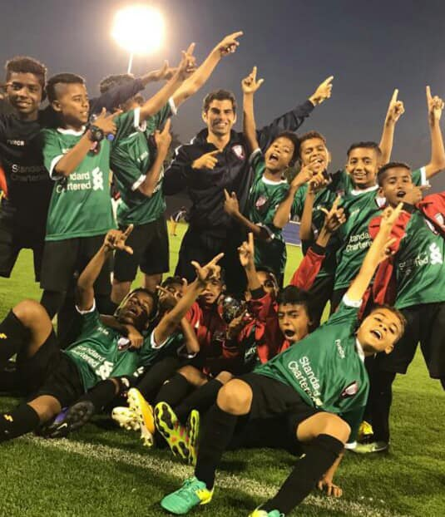

Figure 3 Karachi United Team is celebrating the victory along with coach

First Quarterly Tournament:
Karachi United Academy participated in first quarterly tournament in which a total of 8 teams participated who belong to different demographics. The main objective of this tournament was to bring the youth closer who lack interaction due to demographic distance between different areas. Youth today has very less opportunities where they can interact and get to know each other better. Karachi United provided them a platform where they showcased their football talent as well as they got chance to interact with the players outside their community which bridged the gap between different communities.
The tournament was a great opportunity for the players to enjoy friendly competition in a safe and professional environment as they usually don’t get the chance to play high level competitions. In order to increase the standard of the tournament, official referees and match commissioners were appointed for every match. Football standards were followed during the tournament e.g. scrutiny before match, match reports, yellow cards, red cards, first aid medical facilities and light refreshment at the end of each match. A total of 16 matches were played and each match was 60 minutes long.
The semi-final was held on 1st March at Karachi United football stadium in which KU Academy faced Saeedabad. It was a thrilling and exciting match that captured the interest till the last moment. Both teams could not score any goal within given time and result was decided through penalty shoot-out in which KU Academy scored 5 goals and Saeedbad scored 4 goals. Chakra Goth played 2nd semifinal against Chakiwara in which Chakiwara beat Chakra Goth by 1 goal. The final took place between KU Academy and Chakiwara on 2nd March 2019 at Karachi United Stadium. Both teams performed very well and went neck to neck to win the tournament. Both teams could not score any goal so to declare the winner of the tournament through penalty shoot-out, both teams were given the 5 chances to score the goal in which KU Academy could score only 3 goals while Chakiwara scored 4 goals and became the champion of the first quarterly tournament. The prize distribution ceremony was held at Karachi United Stadium. Mr. Asad Esa, Manager of Youth Program, and Mr. Sadiq, Football Coach at National Bank of Pakistan were invited as a chief guest who distributed trophies and medal amongst players.
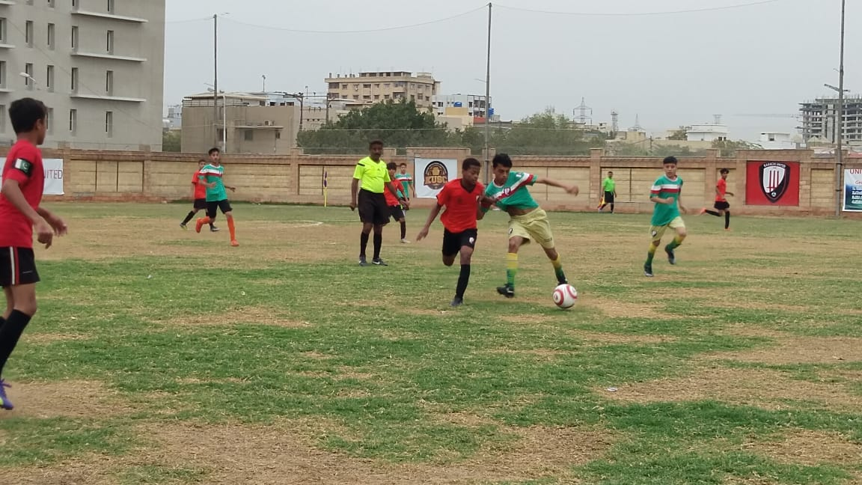

Figure 1 Semifinal between KU Academy and Saeedabad at Karachi United Stadium

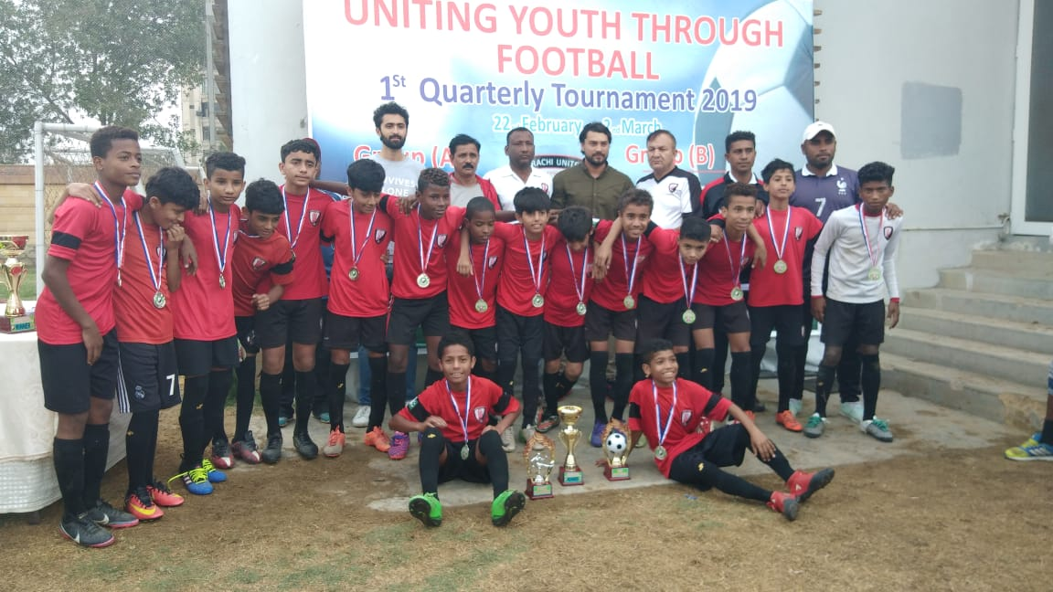
Figure 2 Players of Karachi United Academy pose with trophy

