Support an Athlete- Develop Football in Pakistan
Quarterly Report: August to October 2019

Coach Development Program:
Coach education is the most important thing that we can focus on in terms of developing our youth. To develop the players of tomorrow, we need to develop and improve our coaches from all levels in the developmental building blocks. Karachi United believes that we can't develop world class players without world class coaches because coach education assists greatly in the retention of players and coaches, as well as aiming to provide a continually improving holistic playing experience. In order to improve the quality of football coaching, Karachi United launched CDP (Coaches Development Program) during this quarter. This certification comprises of 6 levels and duration of each course is 2 months long (twice a week sessions for 2 hours each). Course for KU Youth Coaches and CoE Coaches is free of cost (Internal Candidates) and Validity of Certificate is 3 years. A total of 30 coaches have enrolled for this course who attend the classes twice a week at Karachi United football stadium.
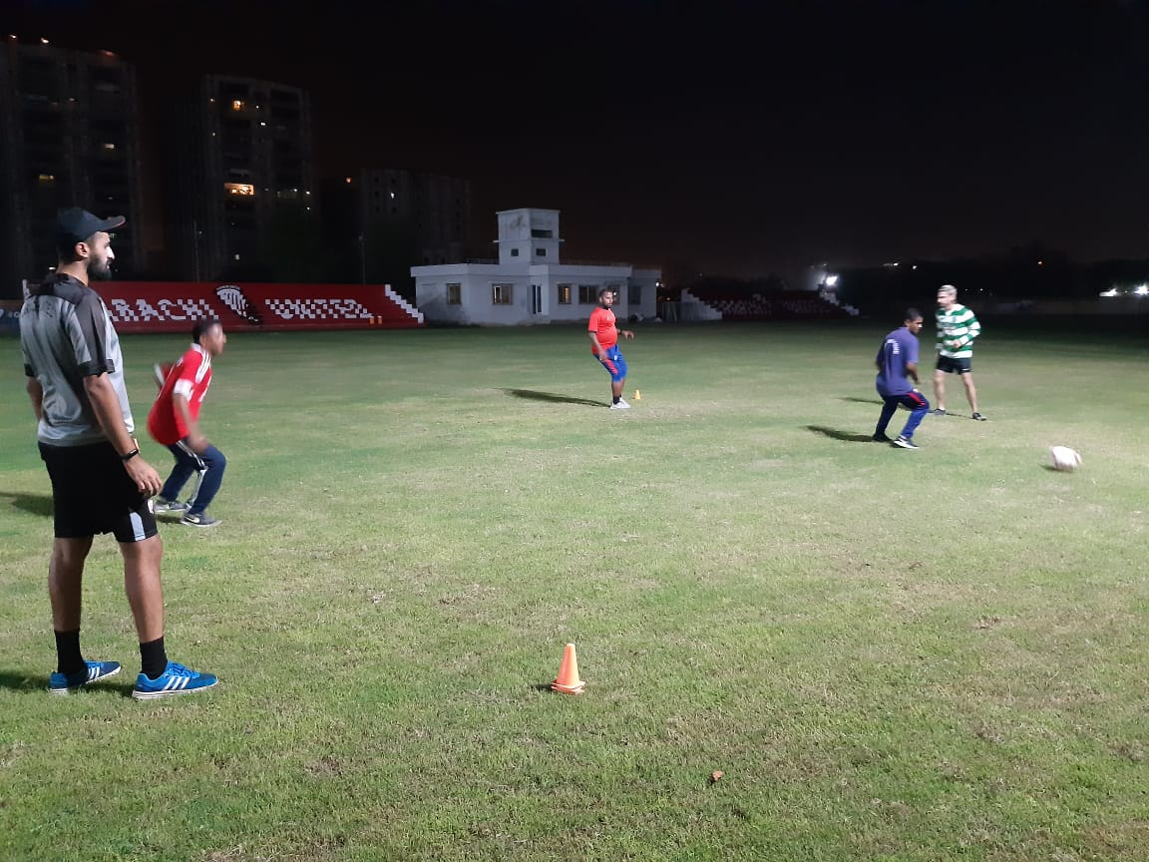

Figure 1 Coaches are practicing football techniques at Karachi United football ground

Standard Chartered – Karachi United Youth League 2019:
Karachi United in collaboration with Standard Chartered Bank launched Youth League in September 2019. With the remarkable success and very positive feedback from the last two years, Standard Chartered again in partnership with Karachi United, kicked off the 3rd “Standard Chartered Karachi United Youth League” to promote sports among children. This league provides a platform for Youth football teams from across the under-served areas of Karachi to come together, break barriers and inculcate the spirit of competition.
Youth League is successfully running right from September and the pace of it continued in October with full spirit. Youth League is mainly categorized in 3 groups i.e. U-10, U-12 & U-14. U-10 is divided into following groups:
GROUP A |  | GROUP B |  | GROUP C
Old Golimar | Baldia Town | Shireen Jinnah | Korangi Academy | Lyari General | Malir
Orangi Town | Lyari Kakri | KU Academy | KU Youth Clifton | Manghopir | Mauripur

The competition also includes a girls tournament to be played on a single league basis in a 7-a-side format with the top two teams competing in the final. This youth league offers an array of benefits but the benefits extends well beyond the field. They start learning to communicate with peers, can build strength and speed that will aid their overall physical development as they grow. It also encourages the young players to embrace the diversity. Karachi United has booked three football grounds for group matches and Karachi United is also providing the transportation facility to community center players. A total of 24 football matches have been played as of writing date of this report. This league has created the wave of euphoria amongst the players and they are enjoying the thrilling matches.

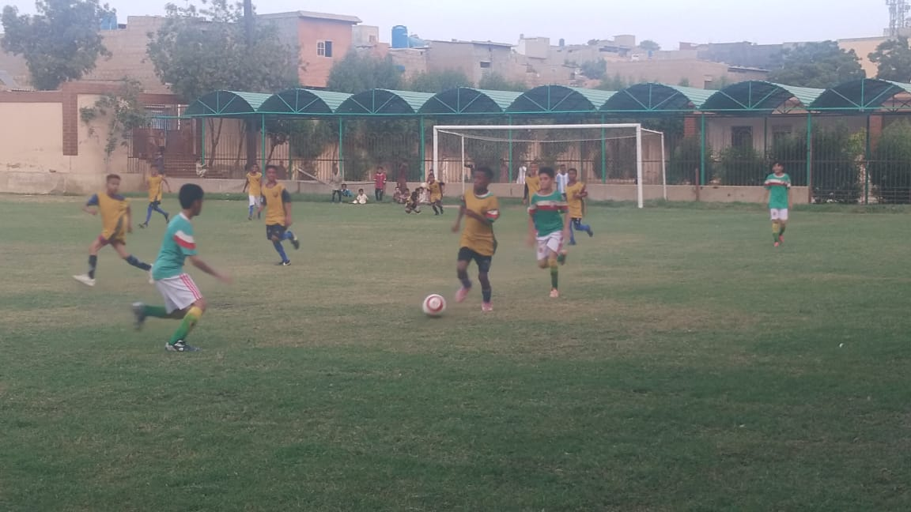
Figure 1 Teams are in action during the round match of SC-KU youth league 2019
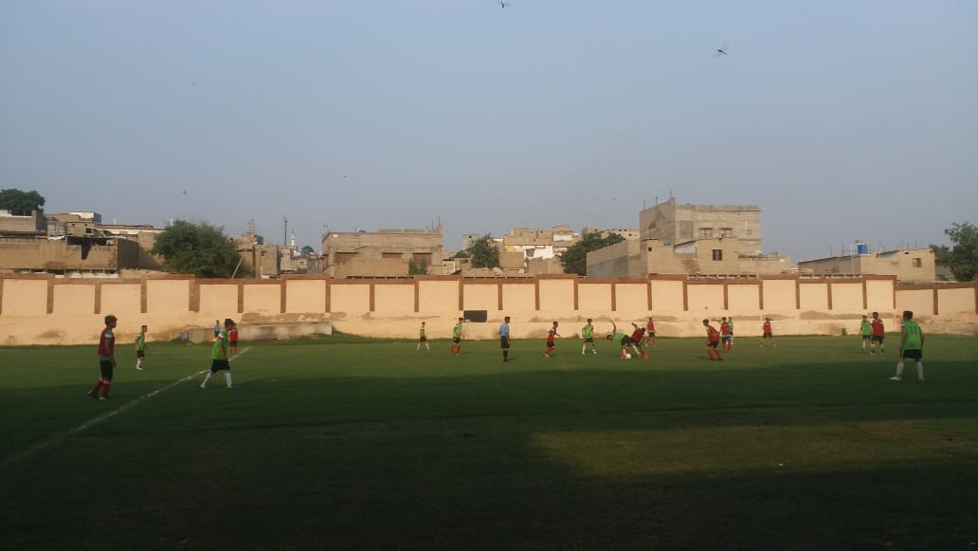

Figure 2 Orangi team faces Maripur team at Baldia football ground

