Quarterly Report

Report Duration | August-October
Donner | Global Giving
Grantee | Karachi United
Program | Athlete

SCB-KU Youth League:
In order to promote the sport activities among the youth, Standard Chartered and Karachi United organized the youth league in the month of September. The main purpose of the league is to provide the platform to young players to showcase their talent to the world. Youth league provide the opportunity to play outside the community which will boost up their confidence and improve their game as well.
This youth league offer an array of benefits but the benefits extends well beyond the field. They start learning to communicate with peers, can build strength and speed that will aid their overall physical development as they grow. It will also encourage the young players to embrace the diversity. Some of the matches of the league were quite interesting and thrilling. One of the match is reported below:
The match took place on 14th October, 2018 between KU under-12 and Orangi Town. It was the most interesting match of the league so far. Though one of KU under-12 player, Adbullah got injured on the match day and was unable to participate. KU under-12 dealt with this challenging situation confidently and all 10 players showed outstanding performance. They won the match by 5 goals. Such kind of matches enhance critical thinking of the players, make them stronger and optimistic during the unfavorable situations.
Football players need proper nutrition to stay energized and strong. In this league, KU provided ensure milk to players to keep youngster active. Milk is a source of protein and calcium, which digest slowly in the body for rebuilding muscle following any intense training session.
Friendly Matches:
During the month of August and September, friendly matches were held among the academies. The objective of these matches was to identify the strength and weakness of the teams. It also allows coaches to select the competitive and best players for upcoming tournaments. On the other hand, friendly matches also reflect the performance of the coaches and offer opportunity to the management to identify the weak areas of the training that needs to be improved.
First match was held on 23rd, August, 2018 between KU under-14 and Ibrahim Hyderi Academy. The last 15 minutes of the match ware very interesting as both team scored 2 goals. It seemed match would be draw but in the last moment, the KU under-14 scored the goal and won the match. Muhammad waqar was declared the best player of the match.
The second friendly match took place on 12th, September, 2018 between Young Baloch and KU under-10. It was a struggling match for Young Baloch as they could not score a single goal throughout the match but KU under-10 showed marvelous performance and won the match by 8-0 goals.

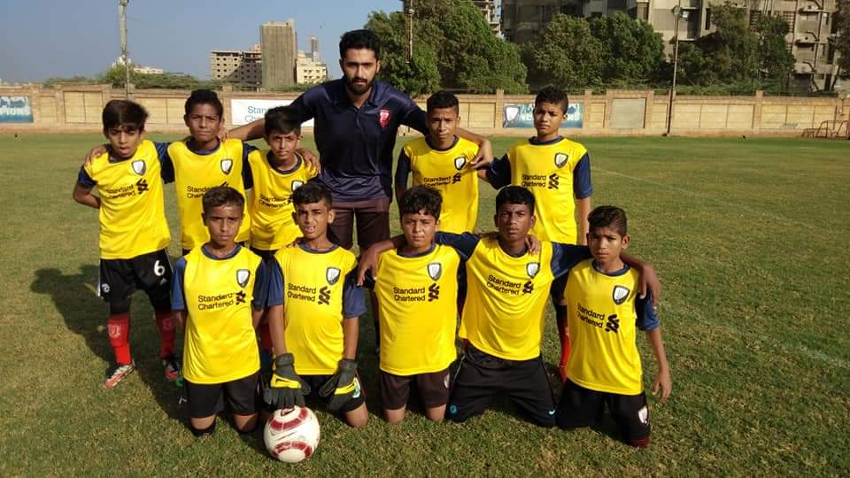
Figure 1 KU Under-12 is celebrating the victory along with the coach
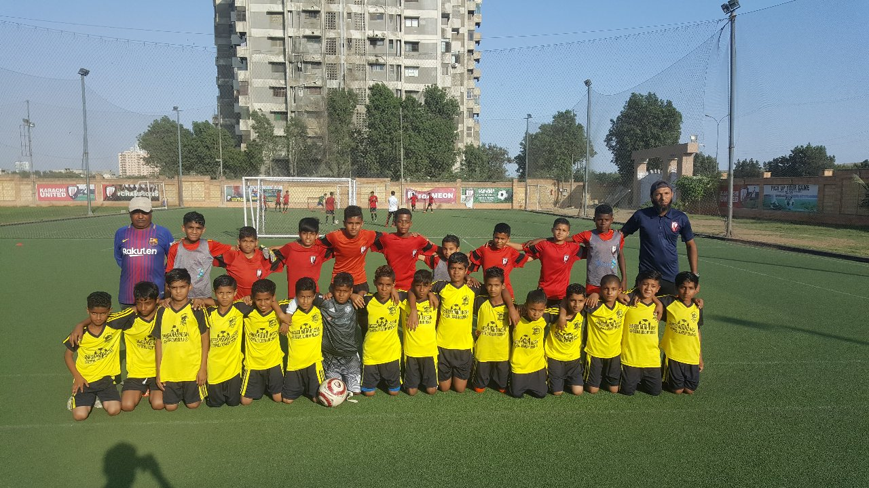
Figure 2 After the friendly match, Ibrahim Hyderi and KU Under-14 gathered for the group photo

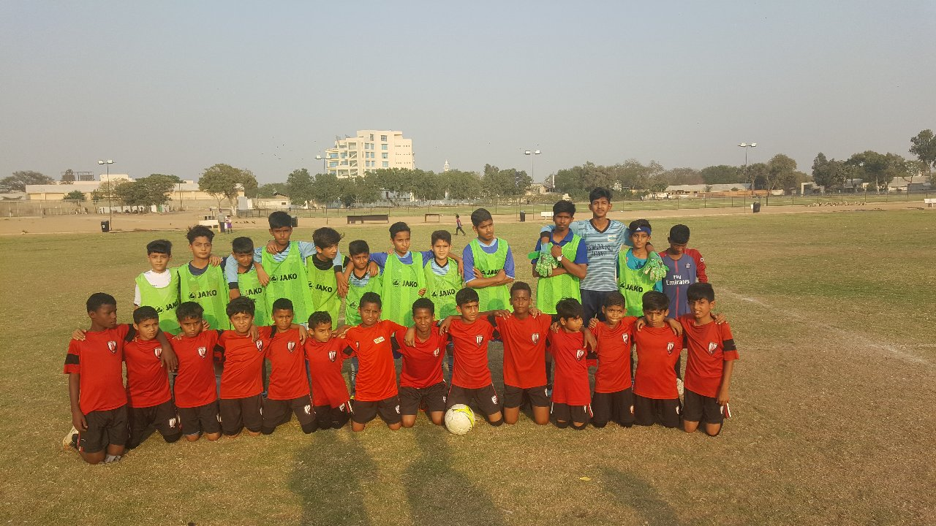
Figure 3 Young Baloch and KU under-10 are gathered after the friendly match

