Workshops Galore!

The past 3 months have been busy as we conducted seven workshops!
On the 9th of January, a workshop on Perception was conducted by Mrs. Vani Nagaraj, Special Educator and Director of Aarohan – Centre for Special Education. Mrs. Vani spoke about how children with special needs perceive their environment. Perception can be visual, auditory and tactile and individuals with autism perceive them differently to neurotypicals. Individuals with autism are more literal and care has to be taken to avoid confusion.

The second workshop was on Comprehension on 17th January by Mrs. Vani Nagaraj. She gave a detailed account on difficulties in comprehension and understanding faced by individuals with autism and how to make worksheets, activities and instructions easy to understand.
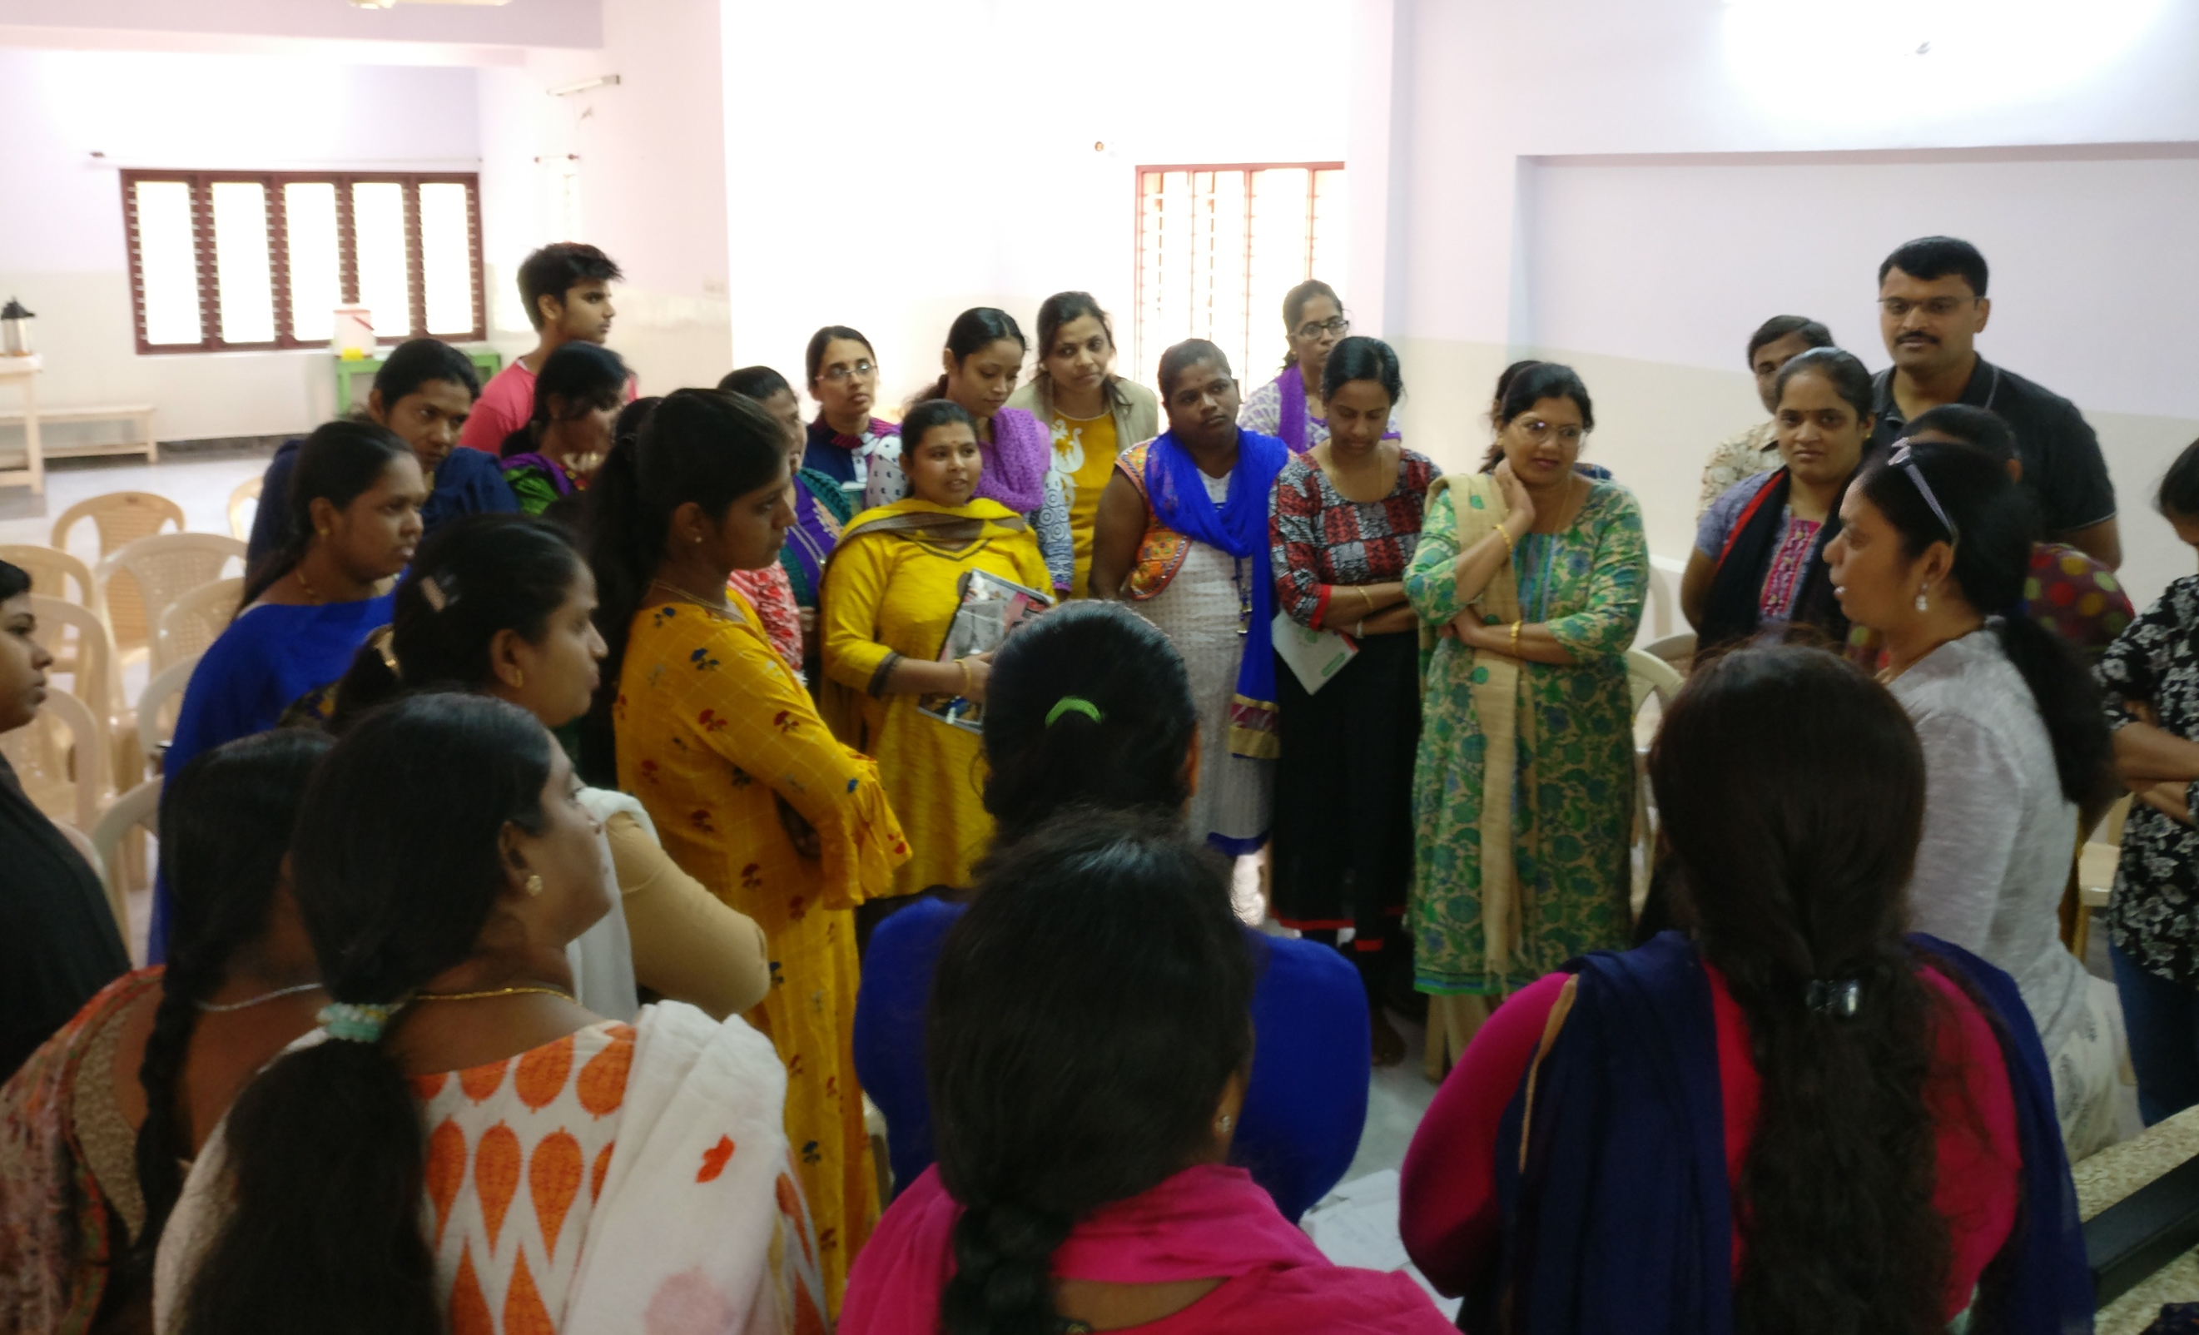

Ms. Nelie is from Netherlands and has been supporting ASHA since many years. She was a teacher and after retirement, visits ASHA to share her expertise in making teaching aids. On 22nd January, Nelie conducted a workshop for parents on Creating Teaching Aids using simple household materials using old boxes, food containers and items likes buttons. The parents found the workshop to be very helpful, especially the parents of our early intervention section who are always looking to create aids that are colourful and captivating.

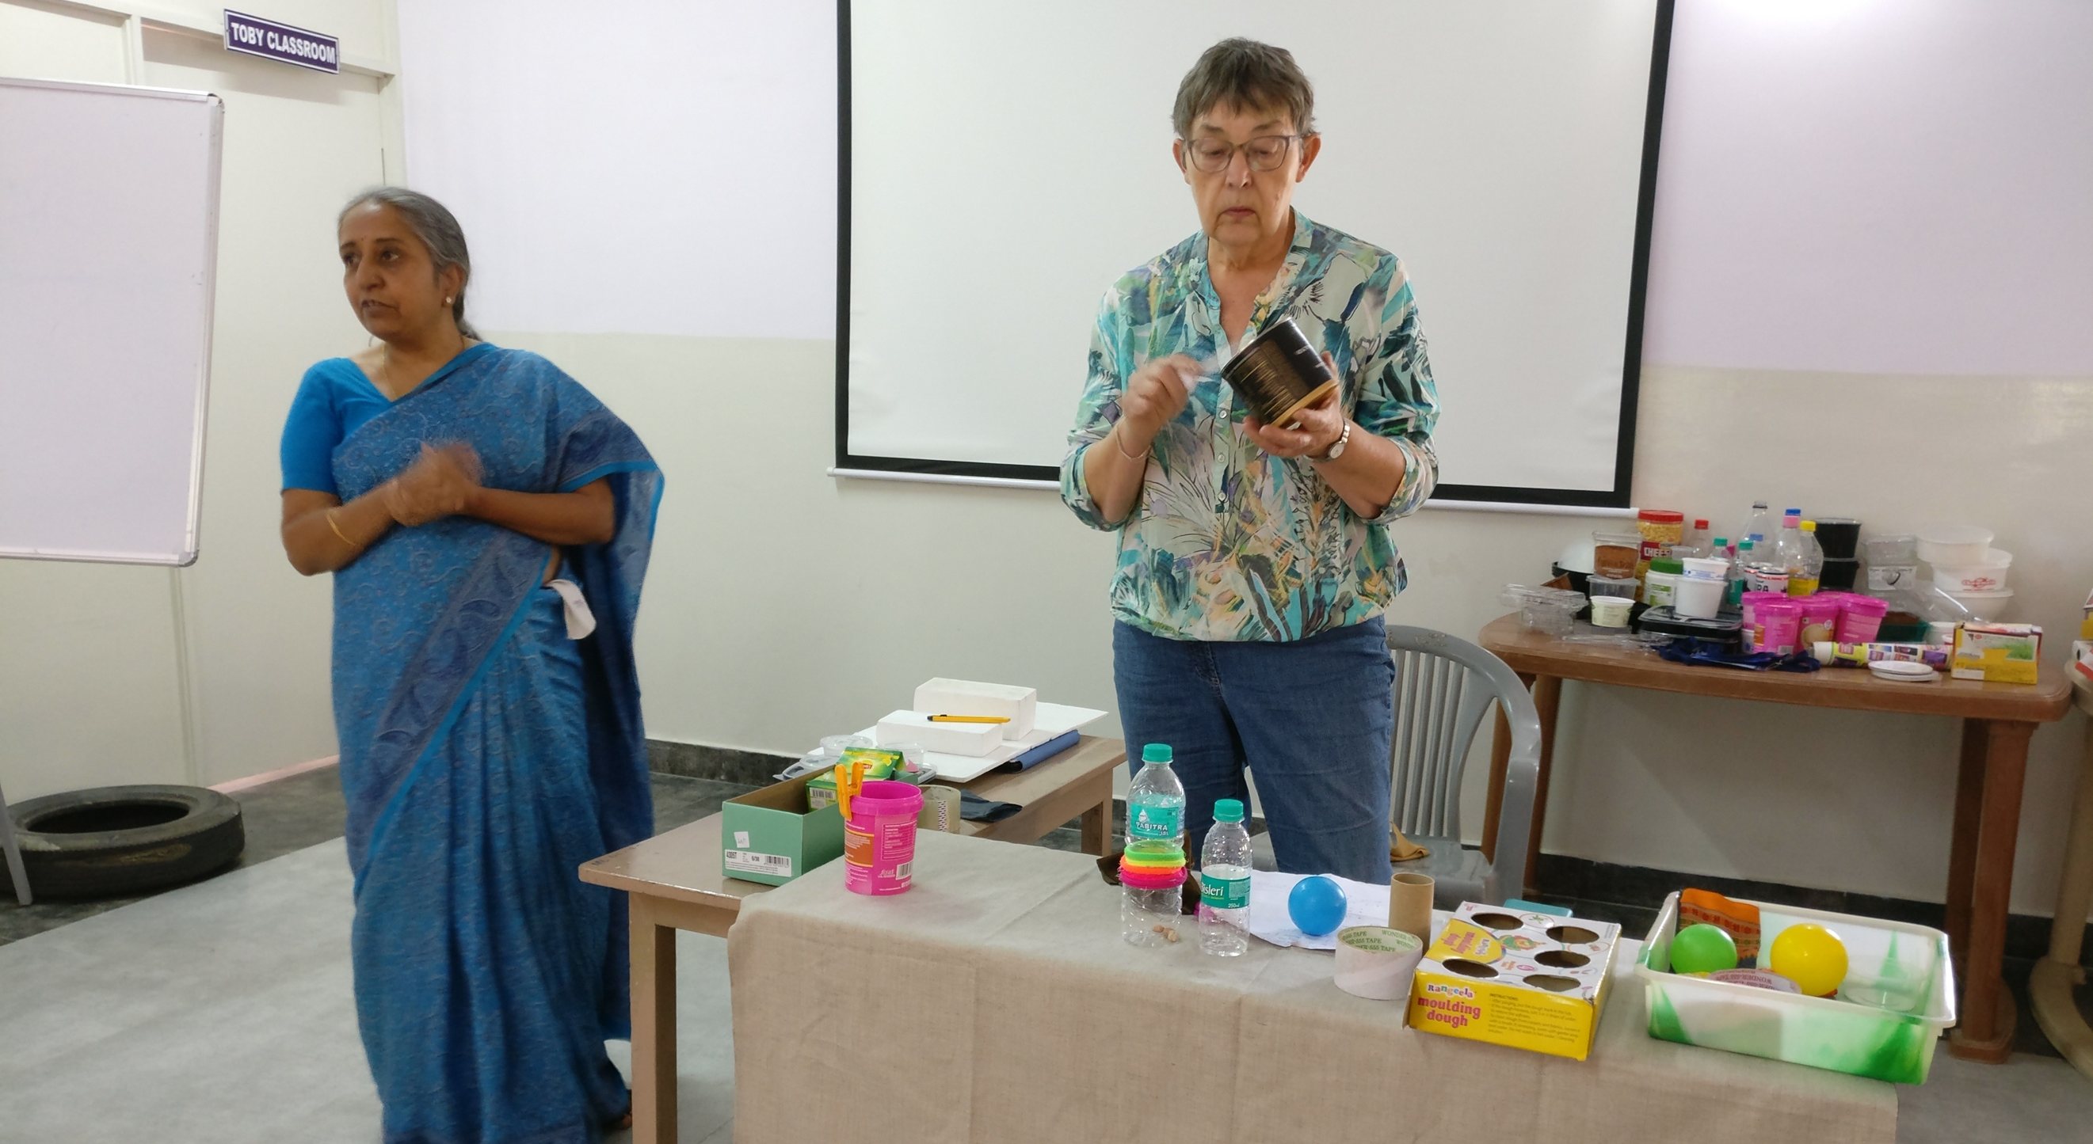

Alternate therapies have been successful as an intervention for autism. On 27th January, Dr. K. Basavaraj, MD, Head of Basava Healing Centre conducted a session for parents on Acupressure and Colour Therapy. Dr. Basavaraj explained how acupressure can bring positive results with absolutely no side effects.

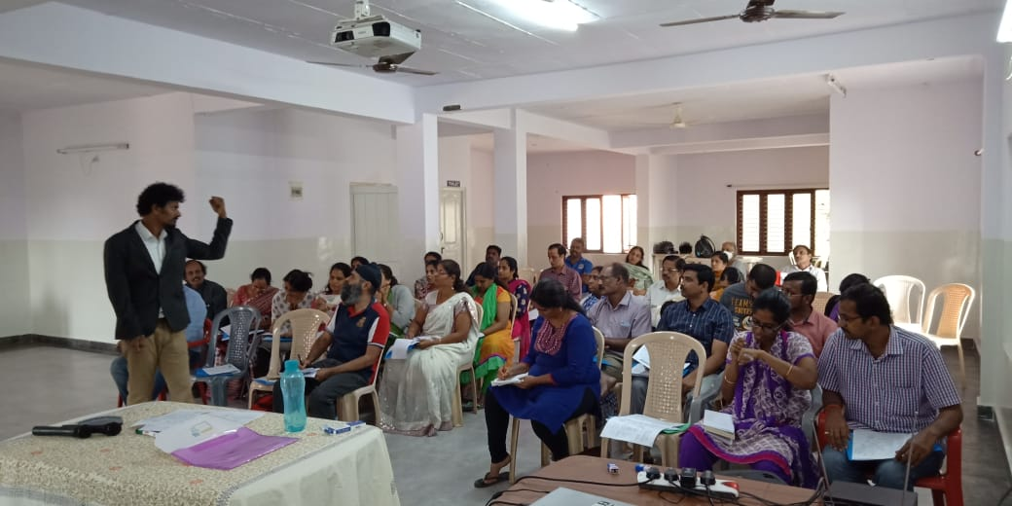

Mrs. Vani Nagaraj conducted a workshop on 30th January on Building Reading Skills in Children with Special Needs. Reading is an essential skill for anyone to function effectively in the environment. Mrs. Vani provided tips on how to encourage reading and build reading skills in the child through simple exercises.

On 7th February, Mrs. Vani conducted a session on Building Pre Academic Skills for Children with Special Needs. Pre academic skills are skills that are a pre requisite for learning academics. These include matching, sorting, identification etc. The parents found the session useful as Mrs. Vani displayed detailed teaching aids.
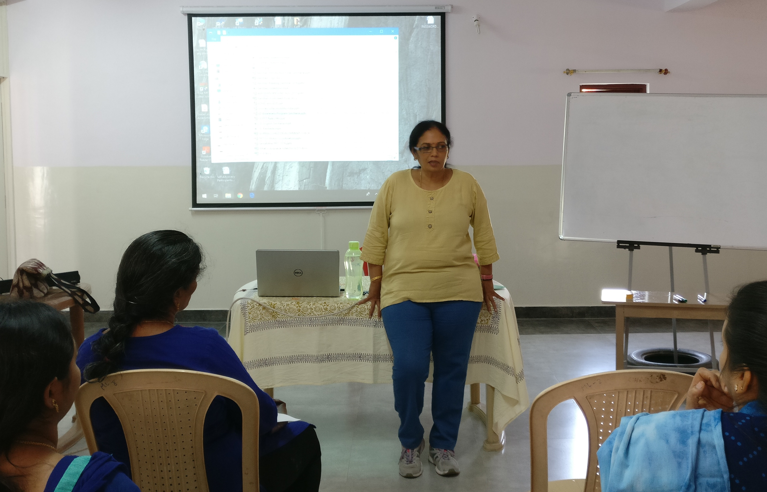

Managing finances and planning for a child with special needs is a pressing issue for parents of children with any special needs. To make this easier, Mr. Jitendra P.S. Solanki, a financial consultant, conducted an educational seminar on 17th February on Financial Planning for Families with Individuals with Special Needs. The parents also had one on sessions with Mr. Solanki and found the session very helpful.

