YCDA

New Journey
Youth Council for Development Alternatives (YCDA)Odisha, India Website: www.ycdaindia.org

of
Children

Prepared by :
YCDA - REPORT ON AFTERCARE CHILDREN OCTOBER TO SEPTEMBER 2018

Introduction
When a young adults leave child care institution, they shouldn’t have to do the work alone. We’re here to support them in that “next step” of life. Our aftercare programs are here to help them to lead a better life. Aftercare services available for who have completed the age of eighteen years but have not completed twenty-one years, also available for who are thinking of leaving out of home care who require assistance moving to independent living. During after care children are provided with life skill education, Vocational training, career counselling, placement opportunity, counselling for management emotions, financial support and other supports contribute for the social mainstreaming.

Some Key Component of Aftercare:

- Community group housing on a temporary basis for groups of 6-8 young person
- Encouragement to learn a vocation or gain employment and contribute towards the rent as well as the running of the home
- Encouragement to gradually sustain themselves without state support and move out of the group home to stay in a place of their own after saving sufficient amount through their earnings
- Provision for a peer counsellor to stay in regular contact with these groups to discuss their rehabilitation plans and provide creative outlets for channelizing their energy and to tide over the crisis periods in their lives
- Providing stipend during the course of vocational training until the youth gets employment
- Arranging loans for youths aspiring to set up for entrepreneurial activities

Group Living:
Children are staying in a group 4 to 8 in safe residential home. Here, children are encouraged to live together as a family unit. The room is run by Aftercare children. They learn and share responsibilities of running their own kitchen and home. In this home, the household duties are amicably shared by the children. Children are managing their day to day management. Children are much happier in preparing cooking. Children are now saving their money and use for their basic need.
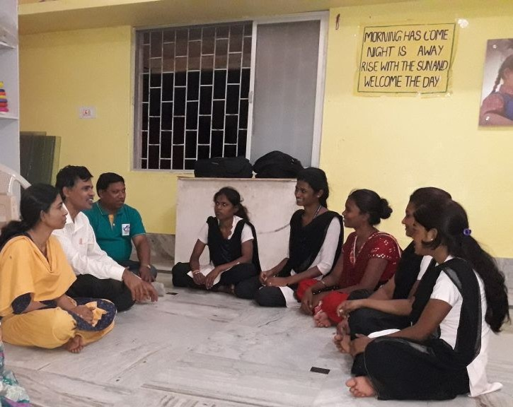
To handle this transition sifting process, many strategies are adopted like group living, independent living, hostels etc. to build their self confidence, life skills, attitude and management capacities.
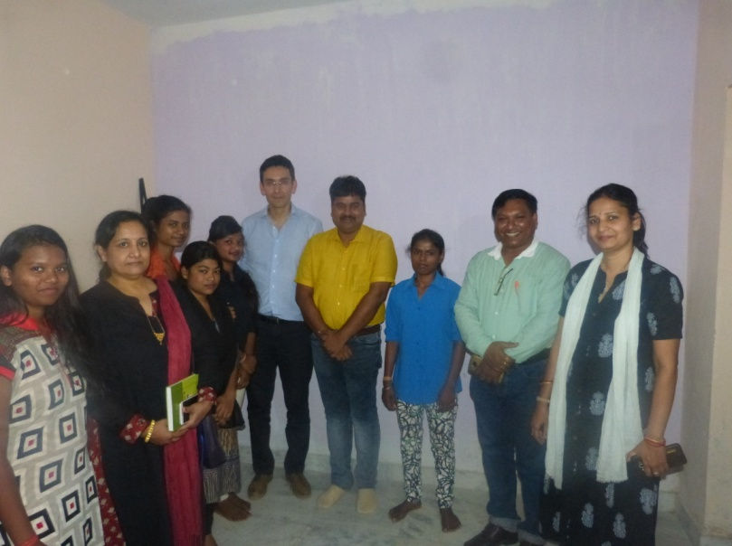

Children are trained on life skill education, career planning, financial management. Children have got their identity proof like Adharcard, Bank account, voter card,
.

Life skill education is given to children to enable individuals to deal effectively with the demands and challenges of everyday life. It addresses both the individual and interpersonal issues. It enhances their skill and personality and brings about a positive change in their behavior and attitude. The training focuses on self awareness, empathy, interpersonal relation to effective communication among the participants and developing leadership qualities. Life skill help people make responsible and informed and promote a healthy lifestyle as well career skill.





