Journey of
Care Leavers……

Report By
  - Youth Council for Development Alternatives (YCDA)
  - Odisha, India
Website: www.ycdaindia.org

A care leaver is a young adult who is leaving and spent their career in child care institution or any alternative care arrangement and has left the institute or care arrangement family after attain 18 years approved by the State through a court order or a child protection unit of the Government under the law is considered as the Care leavers.
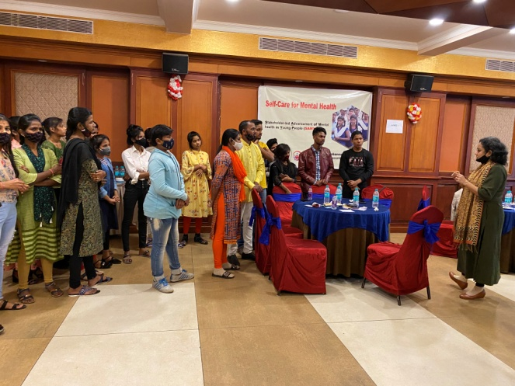
Leaving home care and setting out in a life lead is slightly terrified for any young person in India. Living independently is the most complex process in Indian society. Children after leaving the institutional care, is path to them in preparation for life in a normal society. Care leavers faced many challenges when they leave from Institution and they start living on their own for the first time without family. So this is very important for young adults to access their rights and entitlements and live their independent lives smoothly.
During this Covid pandemic Care Leavers have faced many challenges in social isolation and psychosocial stress. We have explored these after discussion with them. The fear and anxiety in this situation is being away from work, peers, adjusting to new ways of learning, fear of losing their job and income. The emotional and mental distress may increase the risk of psychiatric illness. Looking into the importance of the situation and the need to deal with the issues arising due to psycho social stress, YCDA conducted workshop on self care for Mental Health to reduce the stress and anxiety of care leavers and lead a healthy life.. In this workshop around 50 Care leavers were participated. The care leavers This workshop has motivated to care leavers to discuss about mental health and maintain healthy attitudes for communicating and help-seeking.
Life skill Education is giving frequently to the care leavers to enable individuals to deal effectively with the demands and challenges of everyday life. It helps to the care leavers in confidence to take decisions, communicate effectively with others and developing their skills and manage themselves to build a perfect life in the society.
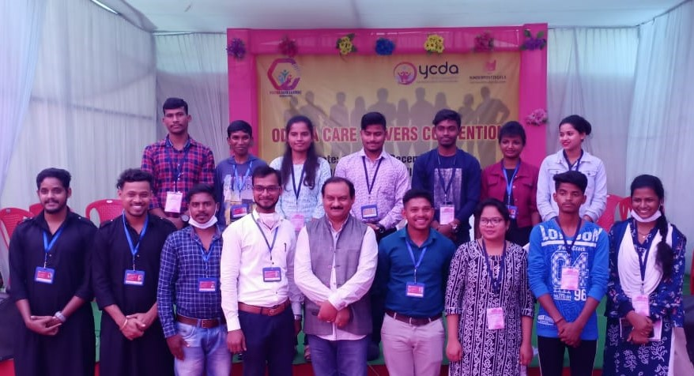
Care leavers faced many difficulties after the institution when they start living independently without support from family/care givers. So association is very important for young adults to access their rights and entitlements through lobby and advocacy and it also support the young adults who have grown up in aftercare programme, they can lead independent lives smoothly. Odisha Care Leavers Convention was held during this period. Around 150 numbers of young representatives from different parts of India participated and shared their journey, their learning and challenges they faced during covid19 pandemic. They also highlighted the issues and the support they required from the stakeholders.
New Life begin......
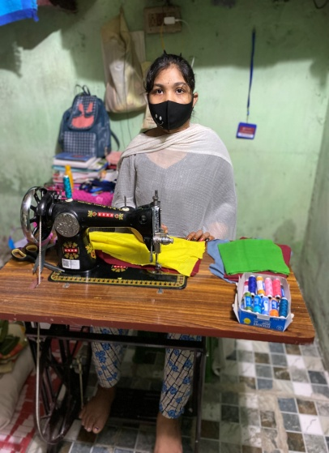
Mami (name changed) 20 years was staying in Child Care Institution when she was very small. He started a new life with loving care takers, where she continued her schooling there. She was very much kin interested to study in stiching. After completion of school education, she took admission in Govt. ITI Bhubaneswar to pursue higher education. She was bit worried about her study during covid 19 pandemic. It was hard time but she finished her course with a good result.
In this situation and her interest in stiching, YCDA came forward to extend cooperation. With the support of Inner wheel, YCDA supported her sewing machine for dress making which helped him to earn for her livelihood. Now she started earning for her new life. She personally thanks to the donors for making her dream possible. Her kin interest makes her dream fulfill.

