Life of Young Adults in Covid-19 Pandemic

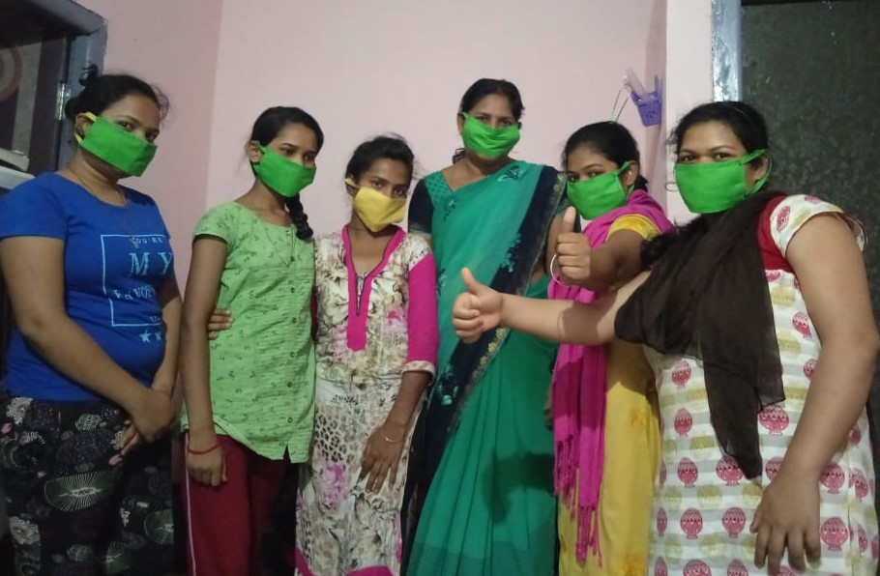

Prepared By: Youth Council For Development Alternatives (YCDA), Odisha
Website: www.ycdaindia.org

The Covid-19 pandemic is a global crisis. The lockdown in Covid-19 has forced milion of people to stay home has led to change the new way of life of every people. The pandemic has completely toppled lives across the nation, restricting movement, shutting the academic section and forcing millions to work from home. This pandemic crisis has brought the youth to a painful life. Day to day it’s very challenging time to cope in lockdown period. The lockdown could have an impact of without social contact, peer support, no personal contact, enforced isolation; wearing mask is leading to psychosocial stress.
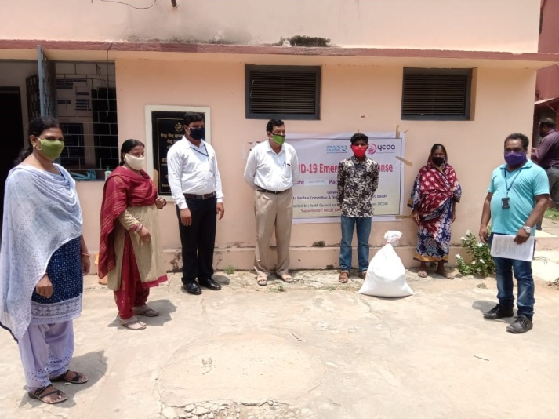
Lockdown has led to several changes in young adults and careleavers. In this crucial time, unlike others, these young adults don’t have an ideal family structure to stay back in family. Young adult’s education has been severely affected by this pandemic. The crisis has crippled all activities in career growth, fear of loss of job and unemployment. The life is very tough while managing their day to day life in food, purchasing essential items, monthly house rent payment, some have lost their job and source of income and also manage their mental health issues. Some have forced to leave their rent house because they don’t have resources to pay their rent and shared with other friend’s house. The emotional and mental distress may increase the risk of psychiatric illness.
Looking in to the situation lockdown, YCDA started remotely counseling support to the young adults to reduce their anxiety and stress and boosting the morale of young adults. It needs to have better conversation and make a positive environment in this pandemic situation.
YCDA helped them meet their daily nutrition needs, as well as sanitation needs like masks, soaps, sanitary napkins and sanitizers. We also have given advice of safety measures on the importance of hand-washing, and guidance on the use of masks besides other precautionary measures to protect and stay healthy
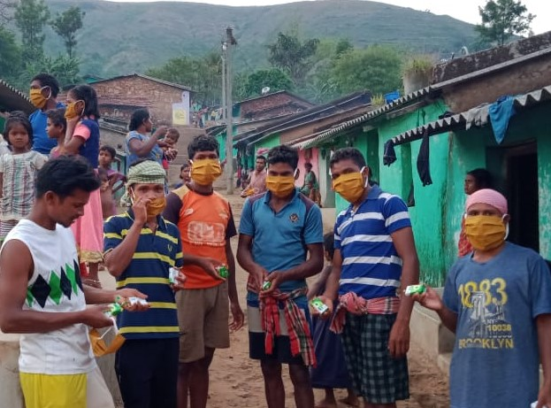
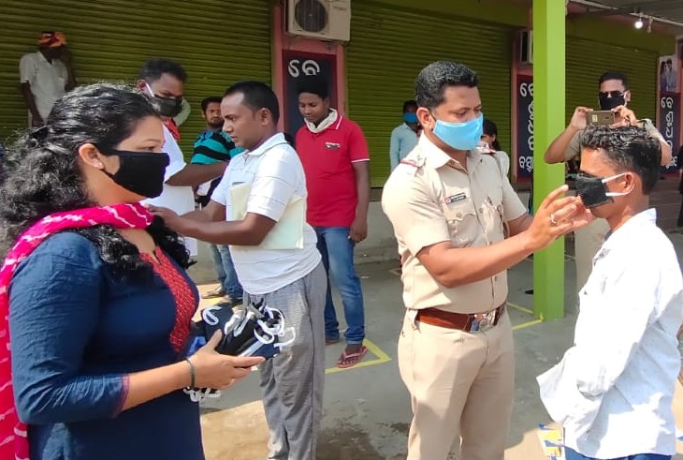

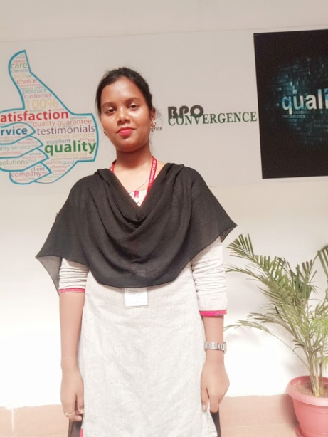
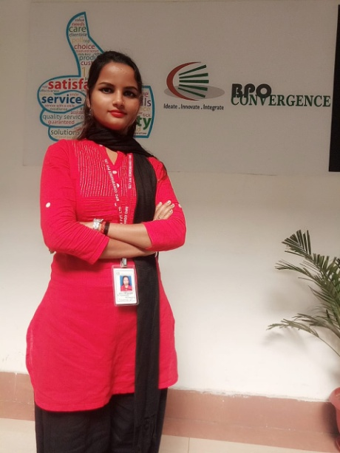
More happiness in giving than in receiving during Covid-19 Pandemic

Life became an idle on beginning day of the lockdown across the state as part of preventing the spread of COVID-19. No t ransport, no public movements, the city were a deserted look with only a few essential vehicles movement on roads in lockdown.
Mini and Itishree were brought up in child care institution for long period. They both continue their career there. Both the girls were kin interested to study more. During counseling they came into the YCDA’s Aftercare programme. YCDA shifted them to Aftercare group living home by order of Child Welfare Committee (CWC). They learnt many things to manage to them self and with their friends. They got training of life skills, Health Hygiene and Psychosocial support to manage effectively and the challenges of everyday life. Itishree did a course on web & graphic design from Escort Skill Development Centre, Bhubaneswar and Mini did vocational course in hospitality in ASD Education Pvt. Ltd
At this pandemic situation two young adults Mini Badra and Itishri Mohanty interested and step out to work for the people in this situation. They both got the chance to work in call center, OCAC, Government of Odisha State to keep a track of persons under home quarantine or in isolation way. There is a help line number 104 in call centre and that works for COVID-19 helpline to handle health queries, corona related enquiries and travel registration and also tracking people who are in quarantine. Each day around 200 call they were attended and enquire about their health status. This job is very tough in that situation but they both had patience to give service to the people. This is a great achievement for them and morale boost of their confidence level. Now they are performing well and become an independent young adult.
“I had a dream to work for the people in difficult circumstances, I am very happy to work for the people in my State in this Covid-19 pandemic”- Itishree

