Life After
Institution……

Report By
  - Youth Council for Development Alternatives (YCDA)
  - Odisha, India
Website: www.ycdaindia.org

At the age of 18, young adult aren’t fully equipped to handle their life by themselves. They need guidance and support to lead their life. This Aftercare programme connection the gap helps them to take the responsibility in young adult stage. This programme also empowers them to complete their education, stand on their feet and live independent and successful lives.
Programme Goal
The aim of the programme is to provide a secure stepping stone towards self reliance for the young adults who are in need of care and protection, by supporting them with life skills, higher education, career guidance as well as encourageing them to manage and independent kitchen to equip them for the furue.

According to the Juvenile Justice (Care and Protection of Children) Act, 2015 (JJ Act 2015), aftercare in India means ‘making provision of support, financial or otherwise, to persons, who have completed the age of eighteen years but have not completed twenty-one years, and have left any institutional care to join the mainstream of society’

LEGAL AND SCHEME PROVISION
Juvenile Justice Care and Protection Act 2015.
The following sections of Juvenile Justice care and protection Acts 2015, contain legal and
schematic provisions for providing aftercare services in India.
The following sections of Juvenile Justice care and protection Acts 2015, contain legal and schematic provisions for providing aftercare services in India.
- Aftercare is stated in Section 46 of the JJ Act, 2015. According to this Section, any child leaving a CCI on completion of 18 years age ‘may be provided with financial support in order to facilitate child’s reintegration into the mainstream of the society in the manner as may be prescribed’
- The focus of the 46 Section and Section 2(5) of the JJ Act, 2015, that defines aftercare, are the following:
a) Aftercare services are meant for persons who have completed 18 years age, but not above 21 years.
b) These services are both financial and non-financial in nature.
c) Aftercare services are meant for persons who have completed their stay in
CCI on attain 18 years of age.
d) Successful mainstreaming of young adults with society lies at the core of aftercare

Process to Re-integration to community

- Round table meeting with CWC (Child Welfare Committee) and DCPU (District child Protection Unit)
YCDA Resource Centre to promote conducted round table meeting to promote Aftercare programme in Puri in Collaboration with DCPU and CWC Puri. The District Child Protection Unit (DCPU), CWC members, representatives from 21 CCIs, staff from YCDA participated in the discussion. Participants discussed on various issues exist at different level for effective implementation of aftercare support to the children in the district.

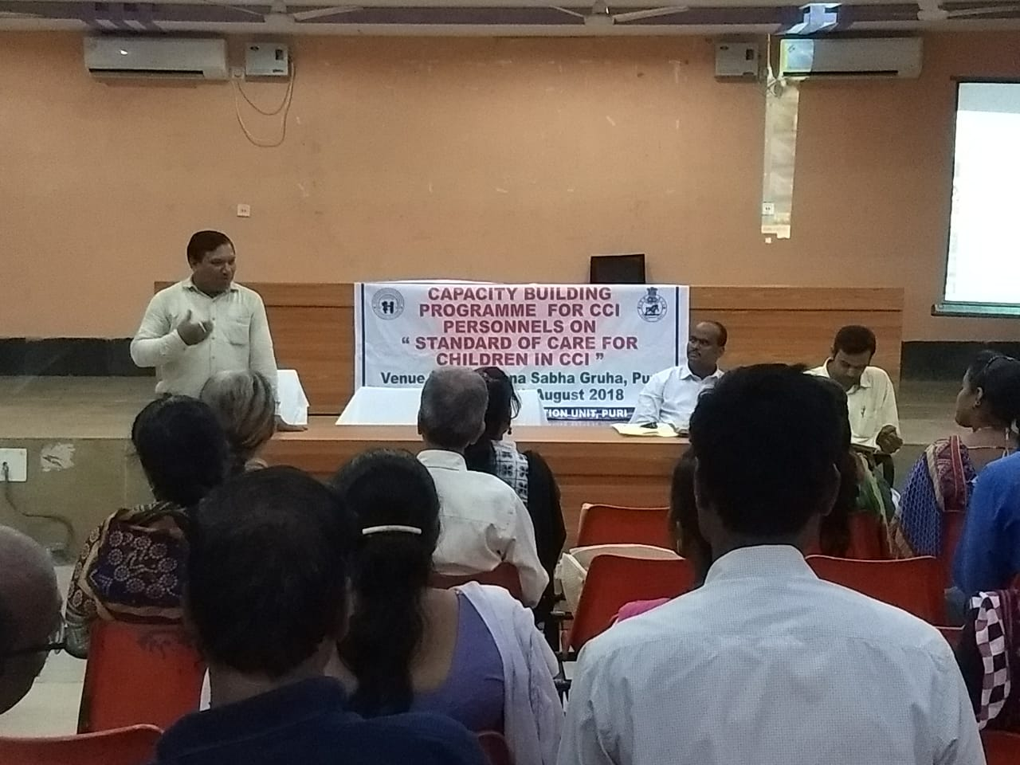
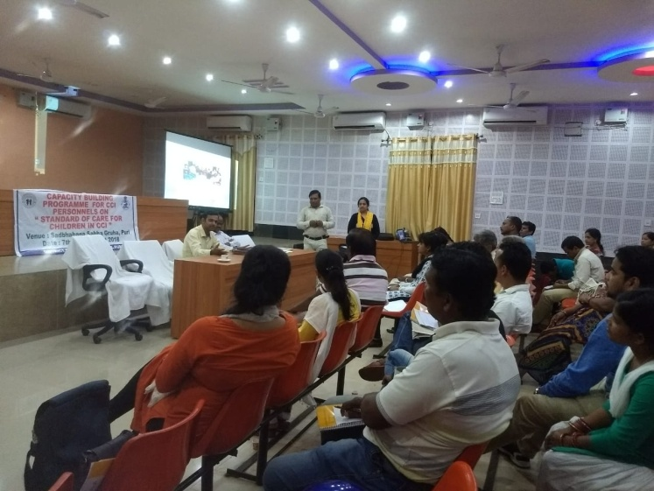
Key discussions are as follows:
- DCPU presented that in the district there are total 09 numbers of CCIs(Child Care Institution) having 75 numbers of children between the age group of 16 to 18 years . Among them 32 are girls and 43 are boys .
- In the meeting it was realized by all the stakeholders that in the district a more focused and systematic aftercare programme is required to support the children who are being institutionalized and reached 18 in various CCIs within the district
- To meet the need it was discussed to have a combined effort and to engage YCDA as a technical partner to support the DCPU and other stakeholders for implementing aftercare programme by reaching the targeted children and supporting in their smooth reintegration by empowering them socially and financially
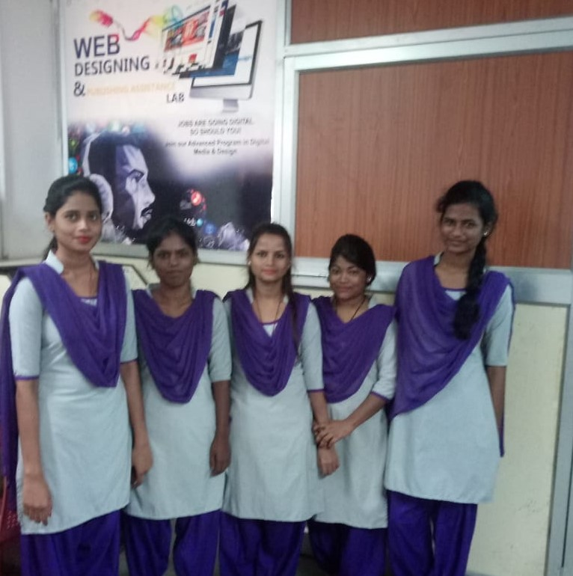

Children in Web Designing Course
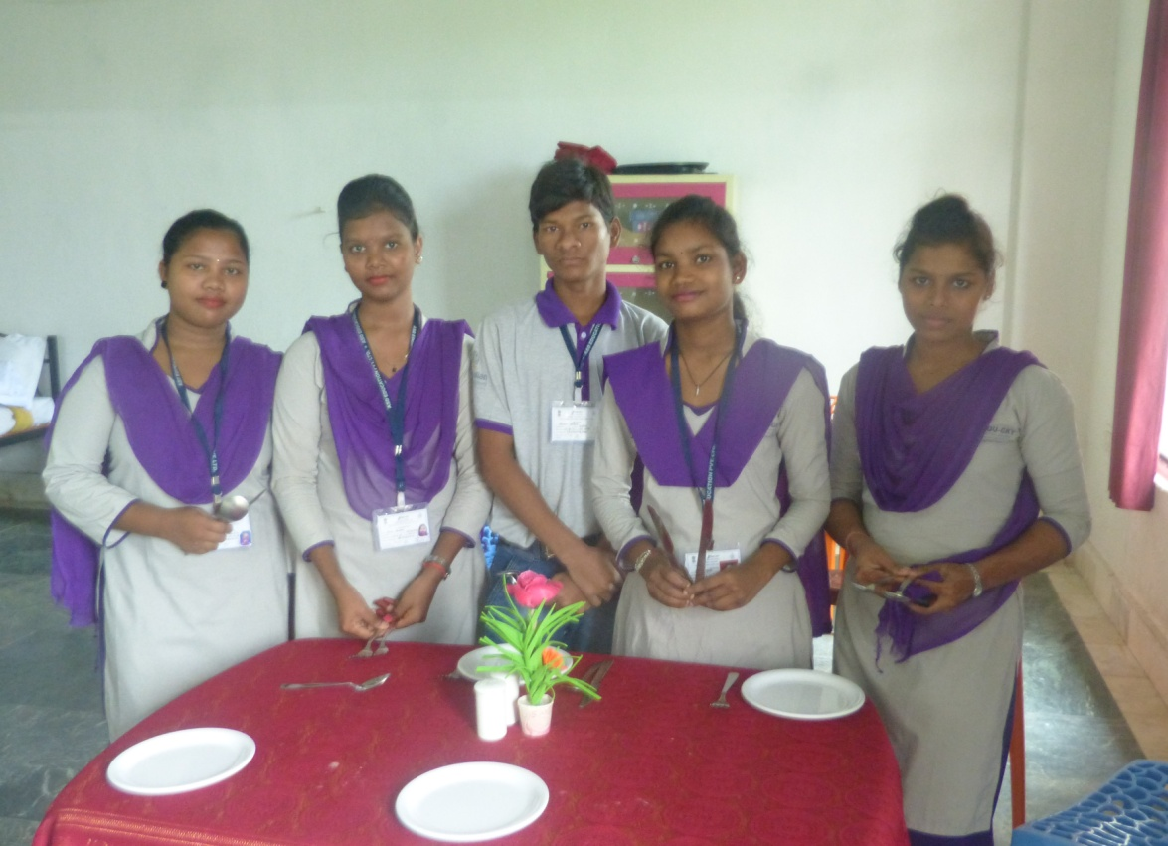

Children in Hotelmanagemet course

‘

‘Education is the powerful weapon
which one can use to change the life ’

