PROJECT PROPSAL
SUFFICIENT GRACE ORPHANAGE
PROJECT TITLE
Sufficient Grace Orphanage (SGO)
BENEFIERIES
So far we have one hundred orphans from nursery to primary seven that we provide for their basic needs.
CONTRACT PERSONS
- Pastor Ochoun Alfred
P.O BOX 205 NEBBI, UGANDA.
Telephone: +256776443511
E-mail: ochoun008@gmail.com 0r suffiecient2017@gmail.com
- Pastor Oyirwoth Silvious
Chairman Board of Governors
P.O BOX 205 NEBBI, UGANDA.
Telephone: +256778763334
E-mail: suffiecient2017@gmail.com
- Adubango Moureen
Secretary
P.O BOX 205 NEBBI,UGANDA.
Telephone: +256781264642
E-mail: suffiecient2017@gmail.com

LOCATION
Grace Orphanage is located in Nebbi district, Padyere County, Nyaravur sub county, Pamora Lower parish, Centre West village ,Uganda. 14 kilometers from district headquarters.

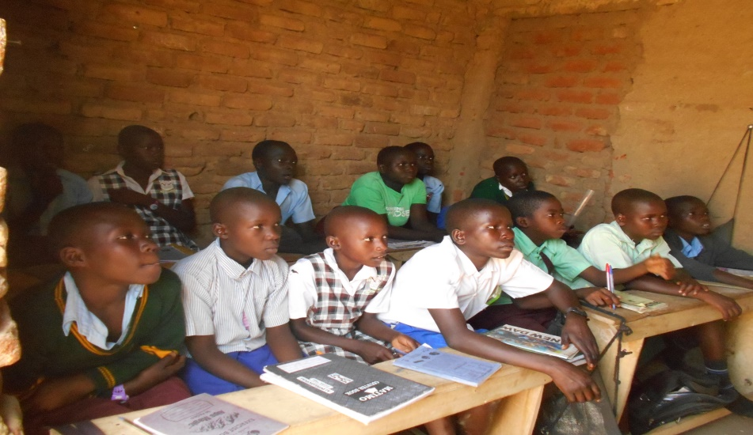

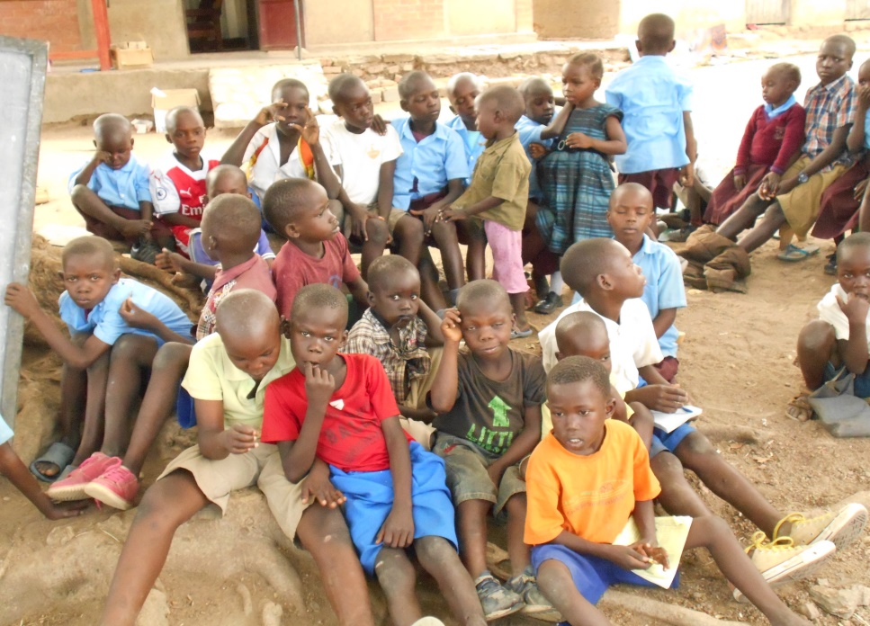

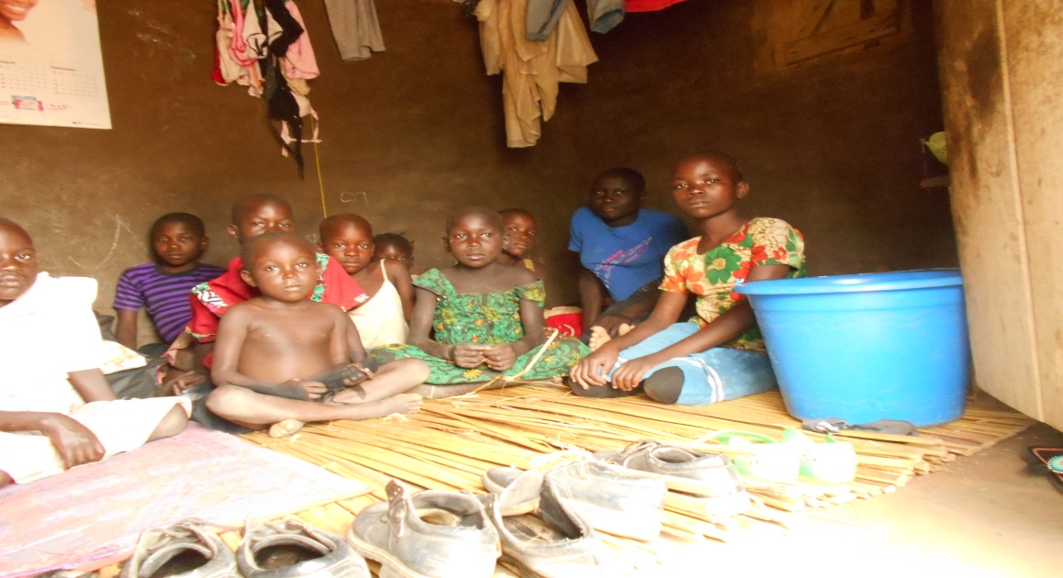

We have orphans from around the community and all over the country that we provide for education, accommodation and other basic needs.
It is a Christian non-profit organization with an international image.
The overseeing director pastor Ochoun Alfred is a born again and is a pastor of Greater Grace Church who believes that God is the father and mother of the fatherless and motherless. The orphanage was established in 2017 and has a current population of 100 orphans. The number of needy orphans who require sponsorship has escalated but due to the limited resources the orphanage is experiencing, we cannot help all the applicants and some keep on dropping off due to lack of sufficient accommodation facilities.
VISION
To train them up in a Godly way that they may grow up morally up right thus able to fight corruption in the community, support an informed and empowered student community whose education responds with their immediate needs for improved standard of living.
MISSION.
To provide education, accommodation, modern innovation, quality services, capacity building for competitiveness, hospitality and an opportunity for orphaned children within and out of the community.

GOAL
- To provide a home and an opportunity for the orphans to survive and live a better life out of trauma
- To own land that will cater for their accommodation and production of food through agriculture.
- To enhance the orphans with skills that can enable them earn a living through education.

2.0 PROBLEM STATEMENT.
The immediate need we have is the construction of accommodation blocks which will cost us USD $17042 as which is worth to build classrooms.
2.1 POSSIBLE INTERVENTIONS.
Any possible funding whether wholly or sectorial by item to help Sufficient Grace Orphanage realize its goals and objectives. The interventions suggested here are as a result of needs analysis conducted in the orphanage in the year 2017.
They are as follows:
2.1.1 ACCOMODATION SECTOR.
- Construction of a proper building.
- Installation of water to the orphanage premises which is 400 meters from the orphanage.
- To connect electricity which is 100 meters from the orphanage premises.
2.1.2 HEALTH SECTOR.
Participation in health sensitization programs through community based health care provisions in order to bring services closer to the adolescents in the implementation of PIASCY and PEARL government programs.
Support preventive measures for common curable diseases through clinical services from the orphanage nurse and invitation of other professional health workers to ensure the orphans are living in good health.
2.1.3 SOCIO- ECONOMIC SECTOR
Establishment of poultry and zero grazing sub project for the orphanage as a supplement for food nutrition.

2.1.4 MANAGEMENT /ADMINISTRATION SECTOR
Facilitation of project administration with office utilities.
Provision of orphanage van
3.0 TIME FRAME
This is a long term project that is already in operation but is seeking support from donor communities, foundations, charitable organizations, civil society organizations, NGO’s , FBO’s and other partners in development to join up hands to rescue the orphans as planned for in the WORK PLAN scheduled for January 2017- January 2019.

4.0 EXPENSES

A Child’s Monthly Needs List:
 | ITEM | US $  Monthly
1. | Food-Rice,beans,fish,vegetables,fruits,beef,milk,potatoes,posho,eggs,peas,pumpkin,porridge, Bread butter, sugar, Cooking oil, Salt, spices | $ 100
2. | Medical-Including periodical medical check-ups | $ 40
3. | Education-Tuition, school uniform, sportswear, pens, books, crayons /pencils. | $ 200
4. | Hygiene Supplies-Laundry soap, washing powder, bathing soap, Body cosmetics/lotion, sanitary pads, hair shaver, Jik, Vaseline, Tissue, Shoe polish, Toothpaste, Toothbrush, basin, Jerri can, | $ 85
5. | Total | $ 475
 | Annual Needs
6. | Beddings- Bed, Mattress, bed sheets, blanket, mosquito net, | $ 120
 | Grand Total | $ 595

Long term target:
We are looking at improving on the welfare of our children not only in their emotional, spiritual health or academic needs but also on their accommodation. We have a proposed budget for the construction of their new orphanage house. We believe once we have purchased the land, which we have already identified in the same community where the current grass-thatched orphanage is located, we will be able to achieve this objective of providing a furnished home for these orphans.

Proposed Construction Budget for Sufficient Grace Orphanage Home
PHASE 1.
ITEM |  | QUANTITY | UNITCOST UG | TOTALCOST UG | US D  $
Land | 3Acres |  |  | 6,000,000 | $ 1714
Bricks | 20 trucks |  | 120 | 3,600,000 | $1028
River Sand | 10 trucks |  | 30,000 | 300,000 | $85
Pit Sand | 6 trucks |  | 60,000 | 360,000 | $102
Cement | 200bags |  | 35,000 | 7,000,000 | $2000
Stones for foundation | 18 trucks |  | 45,000 | 810,000 | $231
Stones(gravel) | 15 trucks |  | 120,000 | 1, 800,000 | $514
Iron bars –y12 | 25 pcs |  | 28000 | 700,000 | $200
Hoop iron(hook wire) | 15 rolls |  | 35000 | 525,000 | $150
Binding wire | 25kg |  | 6000 | 150,000 | $42
Stirrup wire | 30pcs |  | 3500 | 105,000 | $30
Scuffles poles,3bunches of bamboo | 50 poles |  | 5000 | 250,000 | $71
Ordinary nails( 1.5,2,3,4,5 inches | 100kgs |  |  | 600,000 | $171
Construction tools (2wheelbarrows, 4spades, hoes, panga, pickaxe,2rolls of string, |  |  |  | 400,000 | $114
DPC | 10 rolls |  | 25000 | 250,000 | $71
Transportation |  |  |  | 5,340,000 | $1525
Labor cost |  |  |  | 4,536,000 | $1296
Miscellaneous |  |  |  | 2,000,000 | $571
TOTAL
PHASE 2. ROOFING
Roofing timber/wood | 450pcs |  | 15000 | 6,750,000 | $1928
Nails | 30kgs |  | 6000 | 180,000 | $51
Iron sheets | 120pcs |  | 45000 | 5,400,000 | $1543
Ceiling, ceiling /wire mesh | 10 rolls |  | 30,000 | 300,000 | $85
Electrical Installation |  |  |  | 500,000 | $142
Shuttering(fixing doors/windows |  |  |  | 550,000 | $158
Plaster in/out |  |  |  | 6,804,000 | $1944
Paint in /out |  |  |  | 4,439,000 | $1268
GRAND TOTAL |  |  |  | UG Shs. 59,649000 | $17042
House: 100 Orphans

4.1 ANTICIPATED OUTCOME.
N.B: This budget does not include their expenses that the project ably meets such as printing and stationary, general repairs, promotion, entertainment, telephone and postage, licensing and registration, consultancy, security, cleaning and sanitation and others. It has only handled prioritized and very needy areas which if supported will contribute to improve services leading to self sustainability after three years.
5.0 MONITORING AND EVALUATION.
Sufficient Grace Orphanage has a communication committee which meets on a basis to review and make reports on the progress of activities in each sector of the orphanage. Monitoring and evaluation that is usually carried out by the board of governors and other volunteers use the following criteria in assessment.
    - Number of utilities available in use/ not in use.
    - Number of teachers /support staff
    - Number of students using a particular utility
    - Number of day / boarding scholars in each class and the entire school
    - Number of orphans and unprivileged children from where and how supported.

5.1 STRUCTURE / PERSONNEL
SECRETARY
COORDINATORS
BOARD OF GOVERNORS

DIRECTOR

ORPHANS

6.0 CONCLUSION
We urge all individuals of good will and the international community who deplore suffering of mankind caused by poverty, man-made illnesses or natural disasters to join hands with Sufficient Grace Orphanage to support the orphans through education and accommodation to empower self sustainability and dignity.
7.0 FUTURE / OTHER AREAS OF FOCUS.
We have a prospective of starting up a vocational and computer training center for the orphans.
7.1 VOCATIONAL/ COMPUTER TRAINING CENTER.
This can help our orphans who have finalized senior four and senior six to acquire special skills which can enable them become self-employed and earn a living instead of being counted as drop-outs in-case they fail to join universities.

8.0 APPENDIX
8.1 ACRONYMS
OVC Orphans and Vulnerable Children
PWDs People With Disabilities
PIASCY Presidential Initiative on AIDs Strategy for Communication to Youth
PEARL Program for Enhancing Adolescence Reproductive Livelihood
CSOs Civil Society Organizations
NGOs Non-Governmental Organizations
FBOs Faith Based Organizations

