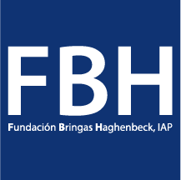


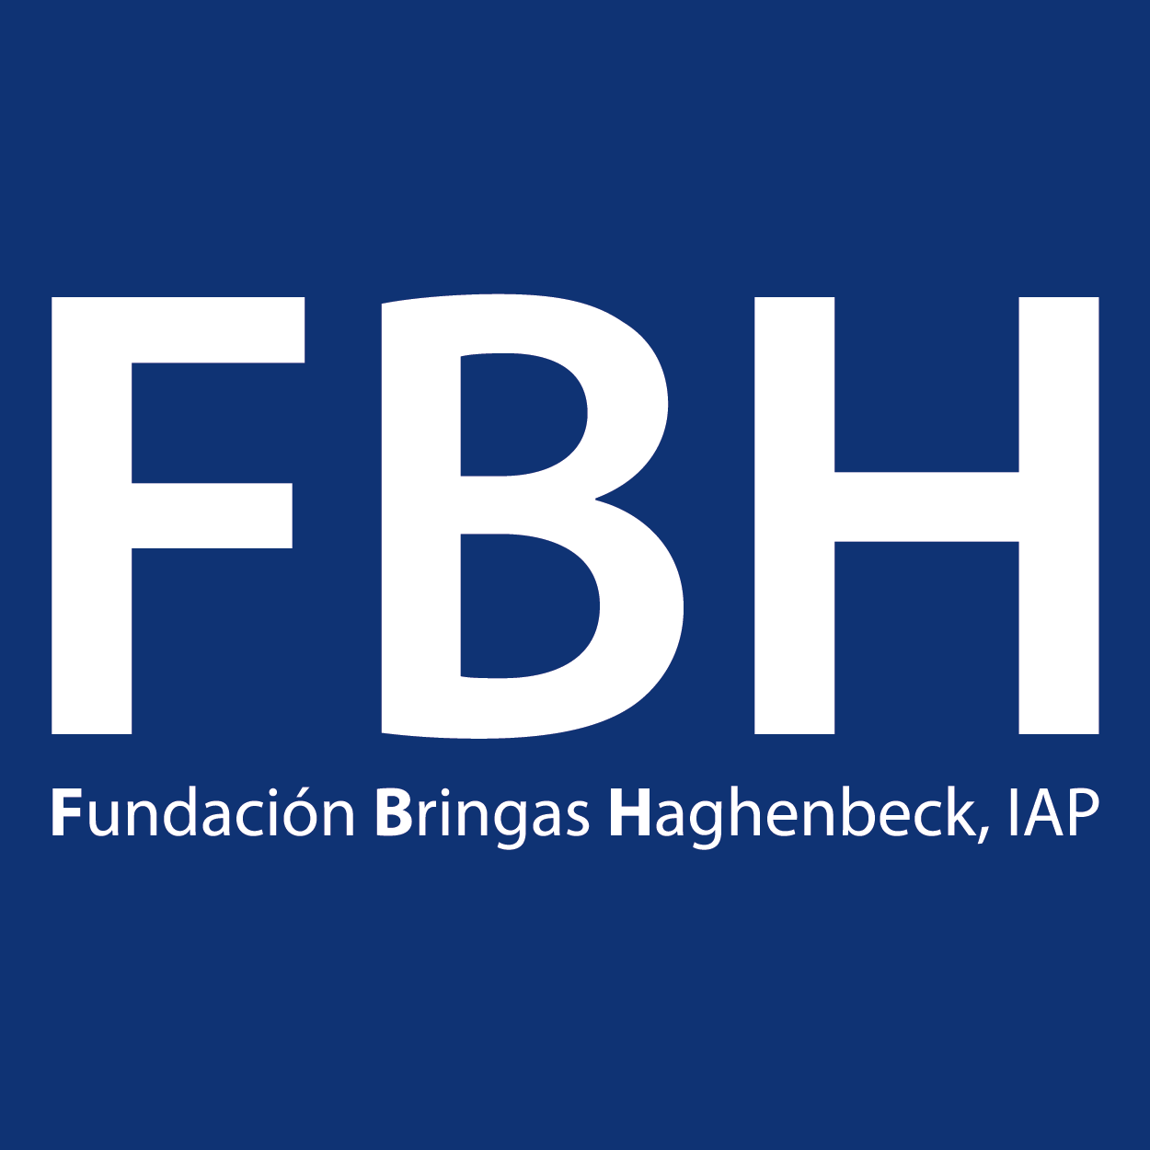
Dear Donor, we keep working!

Thanks to the team work oriented and based on our Intervention Model, the Foundation reduces the conditions of physical, mental, emotional and social vulnerability of the elderly residents, managing to improve their quality of life and that of their families through their residential service and with the execution of its programs of nutrition, medical and nursing care, occupational therapy, physical therapy and rehabilitation, emotional health and social integration. All this under a gerontological approach that allows systematic interventions, based on the contributions of the different scientific disciplines that provide knowledge to ensure the overall well-being of the elderly residents. The knowledge on Thanatology is present in the understanding of the situation of the residents, and in all their attention process, understanding that they are in a process of continuous losses and allows all the collaborators to be empathetic with the needs and behaviors of the residents. Methodologically, the interventions are planned, executed and evaluated to integrate all the points of view and knowledge of the different professional areas of the Residences.
One way to promote the health of elderly people, is to provide them with a dignified, active life and a role in the family and society.
In this sense, the quality of life is a permanent aspiration that supports the institutional care in the FBH Residences, without particularizing in each case or reason for which an older adult is institutionalized; The main objective of those who work there, is that elderly people, when served through the seven intervention programs or components can consider and feel that they live in favorable living conditions, equaling and if possible overcoming the previous conditions in the that they lived to influence that their last years are more and better lived.

We are grateful to support us and donate for our cause!

Thank you!

