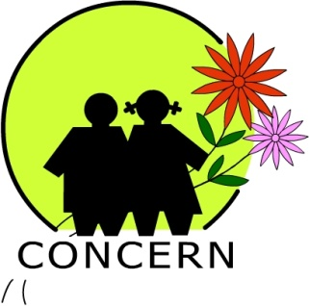
A Brief Profile:

Name of Organization : Concern for Children and Environment Nepal
(CONCERN Nepal)
Year of establishment: 1994
Mailing Address : House No 38, Dallu Aabash, Sidhartha Marg, KMC Ward No 15, G.P.O. Box: 4543, Kathmandu, Nepal.
Registration No : 403/050-51 date: 051.2.17
SWC Affiliation No. : 1718/051.3.6
Organization Registration Date: 2051.2.17
Organization Registration Date: No: 403/050-51
PAN No: 300724844 Date: 2003
Tax Exemption Certificate: Date: 2065.09.21 Numbers : 14492
Name of contact person: Dr. Bijaya Sainju, Executive Director
Contact number: Tel: 4289432, 4288253 Mobil: 9851030656
Email : concern@mos.com.np bijaya.sainju@gmail.com
Phone No. : 009771- 4289432/4288253
Fax no. : 009771- 4277033
No. of staff : 39

Total no of District covered by the program: 6 Districts, Kathmandu, Bhaktapur, Lalitpur, Kabhre, Dhading, Mahottary
Total VDCs/ Municipalities covered by organization: 25 VDCs, and 3 municipalities.
SC program VDC/ Municipality No 20 VDCs in Bhaktapur, Kathmandu and Lalitpur.

- CONCERN Introduction: Concern for Children and Environment Nepal (CONCERN-Nepal) is a nongovernmental and non profit organization established in 1993. The major objective of the organization is promotion & protection of child Rights in Nepal. Its principal purpose is to be an advocator for underprivileged children and at the same time to improve the living conditions of children working in hazardous situations in Nepal. The concept of CONCERN was developed in 1993 by a group of child rights activists and environmentalists dedicated to lessening the plight of children living extremely difficult conditions. CONCERN was officially registered at the Chief District Office of Government of Nepal in 1994 and in the same year was affiliated with the Social Welfare Council under the Women, Children and Social Welfare Ministry. CONCERN has been conducting various programs in partnership with INGOs targeting child labours living and working in hazardous and exploitative condition focusing in different clusters of Kathmandu valley. CONCERN initiated in formation & mobilization of Community based and school based child protection committees, facilitation for formation & implementation of code of conducts, child club formation & capacity building, access to education of child labours are major activities of the program.

- Vision
CONCERN believes that all forms of child exploitation can be completely abolished and that the empowerment of underprivileged children and working children in particular is a dire necessity.

Through community awareness and different child-related development activities, these affected children can become self-reliant and independent.

Overall development of these children can be achieved through the preservation and protection of their social and natural environment.

- Mission
The mission of CONCERN is to facilitate a process that helps to protect the Rights of the Child in general, and in particular it acts to abolish all sorts of exploitation of children by supporting underprivileged children and their families. It also works to achieve a better social and natural environment in which they live.

Objectives
- To advocate child rights within the community.
- To alleviate child exploitation by reducing and removing child labour.
- To promote and preserve a healthy social and natural environment.
- To empower children living in high-risk conditions.
- To assist in the economic development of underprivileged children and their families.
- To provide current child related information to relevant organizations and individuals.

- Focused Area:
CONCERN has been focusing its program on hazardous sectors of child labors like child porters, restaurant children, stone quarry children, brick kiln children, children in mechanic works and highway hawkers. Many children working in these sectors are working in abusive, exploitative and hazardous conditions. CONCERN worked with Plan Nepal from 2003 to 2009 for support and rehabilitation of migrant and non-migrant working children living in difficult conditions in Kathmandu Valley. Now CONCERN has been working with Save the Children International to ensure the protection rights of working children in Kathmandu valley. CONCERN is playing coordinating role for PPCC a national network of Partnership for Protecting the Children in Conflict. PPCC has been implementing different programs for children in conflict funded by KIOS, UNICEF and Watch list since 2009. CONCERN signed partnership agreement for Protection of Children in Brick Kiln with Save the children focusing in Bhaktapur and Patan districts’ VDCs.

- CONCERN present and previous partners:

Conceived the idea of formation of CONCERN - 1993

Joint work with Child Workers in Asia – 1994

Partnership with UNICEF – 1995 (for 2 years only)

Partnership with SC-UK/Action Aid Nepal 1995-1998

Partnership with ILO/IPEC - 1997

Partnership with SC-Norway 1998

Partnership with World Education – 2001

Partnership with Unicef on Meena Communication-2002

Partnership with – Plan 2003-2008

Partnership with ACT – 2003 (paper recycle project)

Partnership with BTF – 2006

Partnership with SVN - 2007-2011

Partnership with PPCC - (Watchlist, Kios and Unicef) 2005
Partnership with Stitching Balak – 2011-2013
Partnership with District Development Committee – 2011-2013

Partnership with SC – International - 2011-2014
Partnership with Advocacy Project – 2015-2018
Partnership with Municipality - 2017

- Involvement in Network Building of NGOs:

CONCERN is keenly interested in capacity and network building of NGOs specially focusing on children's rights, their protection and child participation. CONCERN Nepal is chairing in PPCC and CONSORTIUM of organizations working for child participation in Nepal. It has 61 member organizations working in child rights and child participation. CONCERN Nepal is involved in following networks:

Within the country: a) National Alliance of Organization for Street Children (NAOSC) b) National Alliance of Child Rights Organisations (NACRO), c) NGO Federation Nepal, d) Nepal Rugmark Foundation, e) Consortium for Child Clubs of Nepal, f) Kathmandu District Child Welfare Board g) PPCC – Partnership for Protecting Children in Conflict, h) SZOP School as Zone of Peace, i) NCE- National Campaign for Education, j) Global Campaign for Education, k) Central Child Welfare Board, etc.

Outside the country: a) Asia Japan Partnership Network for Poverty Reduction (AJPN), b) Child Rights Information Network-UK, c) Child Workers in Asia – Support Group, d) South Asian Coalition on Child Servitude, d) China Association of NGOs (CANGO), China, e) Asian Regional Resource Centre for Human Rights Education (ARRC) Bangkok, e) International Society for Prevention of Child Abuse and Neglect, f) China Association of NGOS (CANGO), g) CONCERN-Geneva solidarity Group, h) Nepal Watch UK, i) CONCERN Alling/Munich Solidarity Group, CONCERN/Milano Solidarity Group, j) Advocacy Project, US, etc.

9. Approach of CONCERN
- Participatory planning and review with stakeholders including children
- Mobilization and activation of concern stakeholders on child rights, child education and child protection issues
- Empower and activate youth groups, Child Protection Committee, and other local groups as change agent
- Using community radio service as awareness tool by children in their community.
- Developing Protection Subcommittee within PTA for the primary response in a child rights violation cases
- Lobby, campaigning and advocacy with local to national stakeholders
- Net working and coordination with likeminded organizations and media
- Rights based programming.
- Local ownership and transparency
- Do No Harm and peace sensitivity
- Social Inclusion

14. Members of CONCERN Nepal:

- Dr. Bijaya sainju
- Sarbendra pachhai
- Dr. Bhushan shrestha
- Kasturi shrestha
- Rashmila Prajapati
- Challes pradhan
- Hari Om Joshi
- Chandan Shrestha
- Laxmi Prakash sainju
- Jiyam Shrestha
- Prakash basi
- Promod ghimire
- Nihita pachhai
- Roshan shrestha
- Ambika shrestha
- Junu Majhi
- Surendra Maharjan
- Devaki Thapa
- Bishnu Maya Bhattarai
- Sunder Kumal
- Pemba Lama
- Sharmila Tamang
- Anup Vaidya
- Vikash Dhungana
- Bidur Nepali
- Sindhu Chhetri
- Yema Narayan Shrestha
- Bimal Basi
- Ashok Thapa
- Jenny Shrestha
- Muna Maharjan
- Eak Man Shreatha
- Aashram Maharjan
- Rajeshoer Shrestha
- Bikesh Shestha
- Mili amatya
- Rita Shaky
- Rina Pariyar
- Juna Pote
- Bhim Pradhan
- Jyoti Prakash Sainju
- Anjana Gurubacharya
- Hashina Disti
- Sushma Amatya
- Sanu Putuwar
- Rajendra Manandhar
- Sher Bahadur Oli
- Jaya Ram Karmacharya

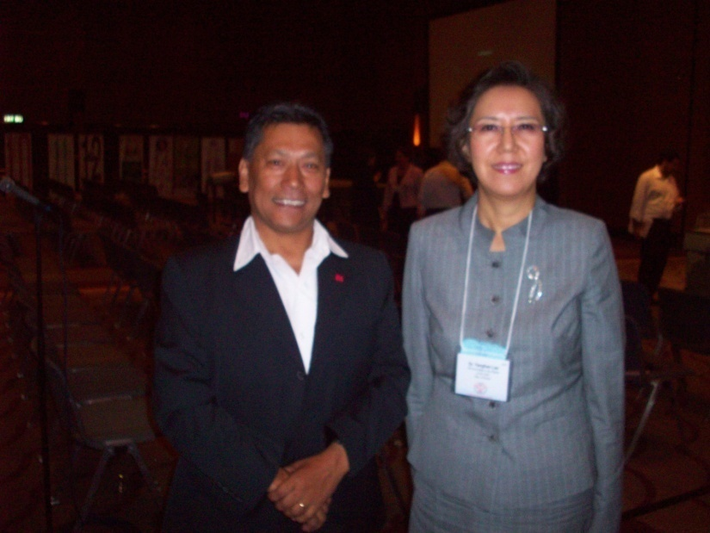
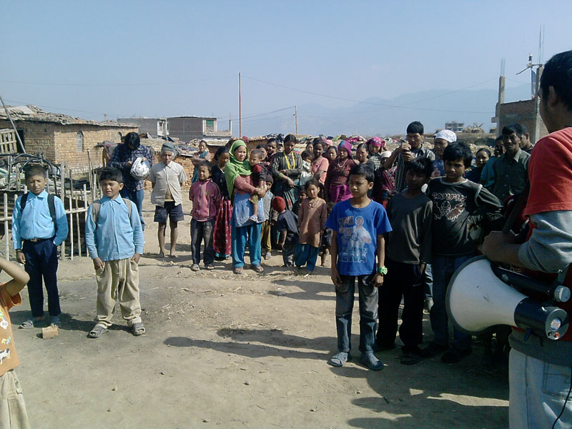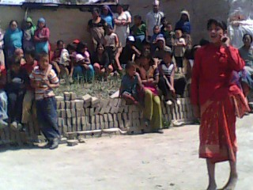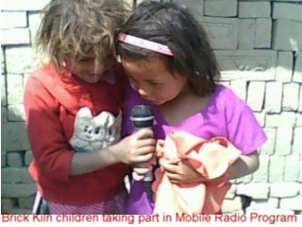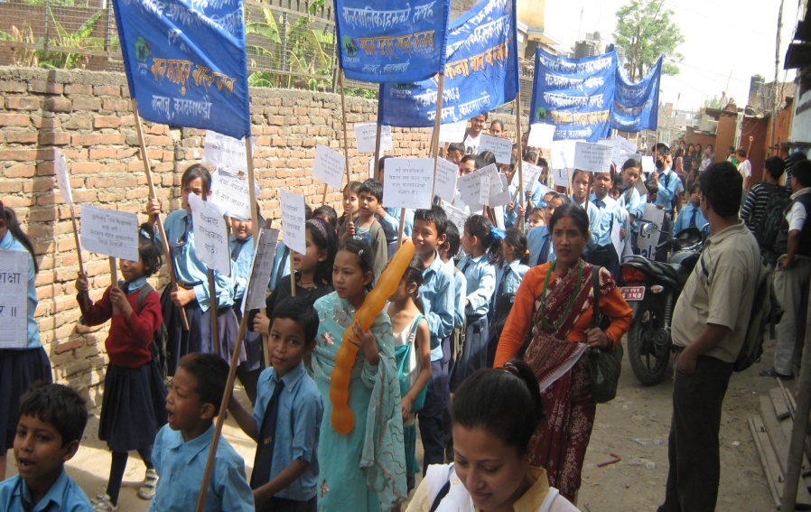
Child Led Initiative:
Street drama

