**Indian Handicrafts are magic and a source of income for village women**

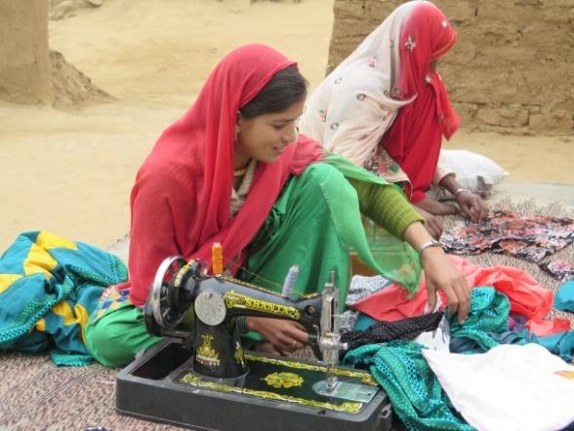 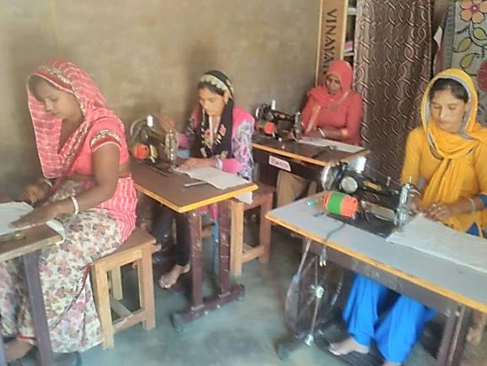

**From using manual sewing machines on the ground in 2015-16 to using table top machines in a well equipped craftwork centre in 2018**

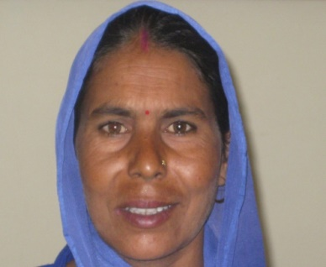 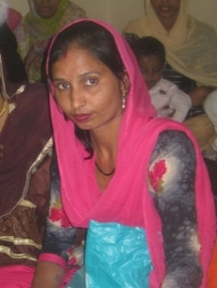

**Bimal – a handcrafts worker in Tijara Block……and Pepita who runs one of our Handicraft Centres**

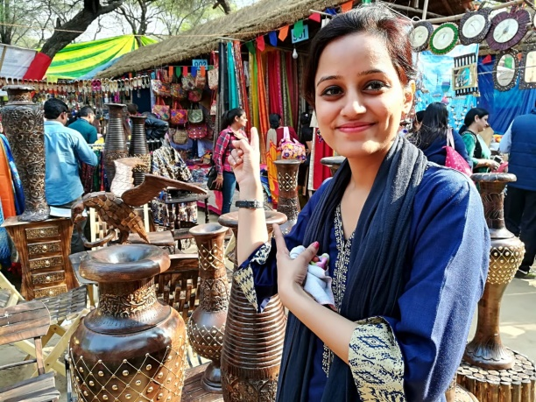 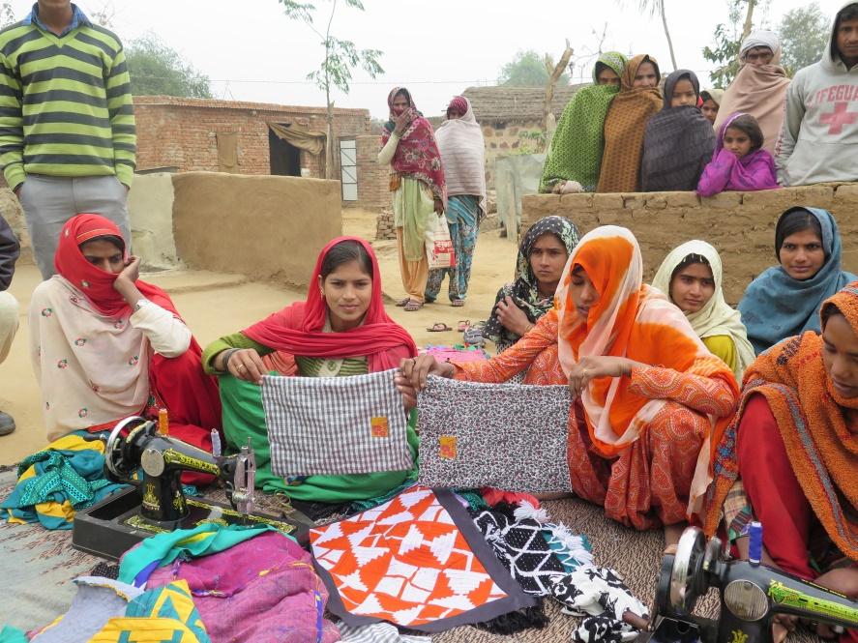

**Shweta, our new marketing manager, exploring sales outlets in a local market. She also aims to expand our success in getting bulk orders for easy to make items like shoe bags (above), and for sale of more elaborate items like those below.**

  