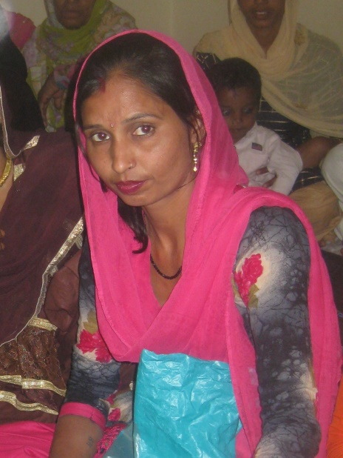
Pepita, one of the most successful beneficiaries of the GEN / End Poverty Handicrafts project
For her story see the September project report

