PROFILE
Initiative for Food, Environment and Health Society (IFEHS)
IFEHS - Influencing Policies, Touching Lives!

IFEHS is an organization charged with creating real and positive lasting change in the lives of the poorest Women, Children, Aged and Youth. IFEHS is registered as a Charity with Nigerian Corporate Affairs Commission (CAC/IT/NO 31730) on 17th March 2009 by a group of seasoned and passionate development practitioners. Our team holds a combined experience of over 45 years in local and international development initiatives such as Environment, Climate change, Education, Conflict management, Agriculture, Water, Entrepreneurship, and Health.

IFEHS Secretariat is located in Abuja with site offices in Enugu, Katsina, Anambra and Edo states.

VISION STATEMENT
An Equitable Society where poverty is reduced

MISSION STATEMENT
To enlighten and provide for our local communities to address the Economic, Education, Environmental, Agriculture and Health challenges that affect them while promoting cooperation, partnership and networking between government, civil society and the public for sustainable development.

OUR CORE VALUES
Integrity: to maintain highest standards of accountability and transparency in management of resources and processes.
Passion: to imbue our activities with zest and selflessness.
Empathy: to be sensitive to those we work with and work for.
Commitment to service: to remain resilient in carrying out our activities, against all odds.

OBJECTIVES
- To create real and lasting positive change in the lives of the poorest women, children, aged and youths in our communities
- To promote citizens right and ability to influence environmental, Economic, Agriculture, Health and Governance policies that sustain their communities
- To ensure sustainable development through enhanced education, economic independence, skills acquisition and human wellbeing for women, children, aged and youths;
- To support structures that promotes equity and justice.

CORE THEMATIC AREAS OF IFEHS; We work with Women, Children, Aged and Youth in Agriculture, Livelihood, Education, Environment and Health issues.

HEALTH

The overall aim of IFEHS in area of health care delivery is to promote equity and increase coverage of safe, affordable and effective health care interventions especially among the poor and the underserved communities through direct programme implementation, advocacy and community mobilization. The following are the niche areas of IFEHS in health care delivery:
- Maternal and Child health: IFEHS works with government agencies, development partners and communities to ensure increased coverage of Maternal and Child health related interventions such as immunization, Family Planning and nutrition especially among the poor and the underserved communities
- Priority Disease: IFEHS contributes significantly to global and national efforts towards reduction of health burden associated with Malaria, HIV/AIDS (OVC) and TB by collaborating with stakeholders to carry out advocacy and direct programme implementation at health facilities and community levels
- Primary Health Care Development: IFEHS recognizes importance of health system development especially at primary health care level to effective health care delivery; IFEHS therefore works with relevant government agencies to increase access to primary health care services and develop the capacity of health service providers. Technical assistance will be given to government agencies in areas of health policy formulation and health planning
IFEHS has competent and experienced public health experts who have expertise in the niche areas mentioned above. Besides, we also work with highly experienced international and local consultants to carry out programme design, programme implementation and Monitoring & Evaluation.

ENVIRONMENT

The overall aim of IFEHS in the area of Environment is to bridge the gap between human beings and the environment, by building synergy that reinforces interdependence and growth. This is carried out through the following means:
- Mobilization/sensitization of the public against environmental degradation through promotion of responsible activities such as waste to wealth programmes, erosion control group, management of drainage and vegetation management.
- Creating awareness about the menace of climate change, while promoting green house and vegetation practices.
- Raising public consciousness on the importance of a clean and hygienic environment as a panacea for checking epidemics using WASH.
- Promoting the adoption of practices and usages that ensure environmental protection sustainability.
- Encouraging dialogue and partnerships amongst stakeholders on practices that are ozone layer friendly.
- Inculcating in the youth and children at all levels the value of good environmental and watershed management skills.
- Promoting the teaching of environmental health, erosion management, and drainage related issues from primary to tertiary school levels.

AGRICULTURE/FOOD SECURITY
Under the Agriculture/Food Security areas, IFEHS is focused on building local capacity in managing food systems and culture on a sustainable basis. This is specifically carried out through the following means:
- To build the capacities of women, children and youth for food security
- To form women and youth co-operatives to access funds for food production
- To sensitize women and youth on the latest farming techniques and practices
- To mobilize communities to actively participate in government /donor funded agricultural projects
- To encourage functional literacy especially in the Northern Nigeria
- To bridge the gabs between the middle buyers and the farmers by creating awareness on the market opportunities
- To provide food to the aged, orphans and vulnerable children
OUR STRATEGY
The strategy has thus been summarized as follows;
- Gender mainstreaming
- Community Driven Demand approach (CDD)
- Sensitization/Awareness and campaign
- Grassroots project implementation
- Social Advocacy/lobbying
- Research and documentation
- Capacity building
- Networking, collaboration and coalition building

ACTIVITIES
For results and effective implementation of the organization thematic areas, the following activities have been outlined.
- Community Mapping, Needs /Impact Assessment
- Sensitization of all stakeholders on dangers of environmental pollution (solid and industrial waste)
- Capacity building in Health Management, Food Security and Sustainable Environment for the attainment of the MDGs
- Advocacy for the inclusion of Health, Economic and Environmental safe practices in line with international practice in our school curriculum.
- Sensitize the rural and urban dwellers to guard against natural resources depletion
- Promote the domestication of ratified international environmental policies
- To encourage tree planting in schools
- To promote recycling of waste to wealth

ORGAINIZATIONAL STRUCTURE
The organization consists of the Board of Trustees (BoT), Advisory Board and the Management. The BoT is the highest decision making body of the organization. They meet twice a year to assess management performance, to develop new project designs/implementation plans and to review the organization’s activities. The management is charged with day to day responsibilities of executing all policies and programmes of IFEHS as well as ratifying and implementing decisions; the management is headed by an Executive Director and Project Directors.
IFEHS Team Profile
We specialize in the following:
- Research and documentation
- Community mobilization
- Orphan and Vulnerable Children management
- Public Private partnership management
- Livelihood Need Assessment
- Communication Management
- Gender Mainstreaming
- Economic Empowerment through Skill acquisition
- Risk Management
- Counseling, mentoring and life-building skills development
- Workshop facilitation and Workshop/logistics
- Report writing
COMPLETED ACTIVITIES;
- Coordination of seven state NGOs that implements Social Mobilization and Accountability of Nigeria Erosion Watershed Management Project (NEWMAP) 2014 – ongoing
- Economic development for 2500 women and youths in FCT 2015-2018 sponsored by Japan Embassy
- Management of Communication component of Nigeria Energy and Gas Implementation Project (NEGIP) 2013-2015
- Sourcing and Management of $3,000,000= USADF grant for farmers cooperatives in Cross-River, Kaduna and Lagos states June 2012 -2014
- Corporate Planning for Kaduna State Ministry of Health Sept 2012-March 2013 -
- Ensuring adequate Gender Mainstreaming in IFAD-Community Based Agricultural Development Programme in seven states of Northern Nigeria; Borno, Kebbi, Katsina, Jigawa, Yobe, Sokoto and Zamfara State May 2009- November, 2012 -
- Training of over 200 women and Youths in different skills for economic empowerment; Irish Aid 2011/IFEHS Board -
- Enhancing the voice of women and youth in Orumba South LGA procurement issues; World Bank 2011 - .
- Empowering of 600 women in nine states of Niger Delta through different skills acquisition. IFAD –CBARNP April 2010 to November 2011
- Development of Sesame street programs for OVC/ USAID; 2009 -2013
- Mobilization of women and the vulnerable for adequate participation in IFAD-CBANDP in nine states of Niger Delta
- Empowering 87 youths through mechanical, electrical and furniture making skills; African in Diaspora, Sweden. April 2009 - date
- Evaluation of the impact of IFAD-CBARDP on Gender/Vulnerable group (IFAD-CBARDP) June, 2009 .
- Assessment of the social sector inclusion in Sustainable mining project (SMMRP/World Bank) July 2009
- Assessment of the Orphanage homes in FCT (Sesame street /USAID) & Stepping down of Sesame street workshops in Orphanages: May 2009 - .
- Management of Gender/ Communication component of Commercial Agriculture Development programme (CBARDP/ World Bank) November 2009-date -

OUR PARTNERS

Over the years, IFEHS has had engaging partnership with several corporate bodies and supportive individuals at local and international levels, notably the following:
- Ministry of Agriculture
- Ministry of Environment
- Ministry of Women Affairs
- World Bank/GPSA/GEF
- USADF
- Computer Aid International
- IMF
- IFAD
- MDF, Netherlands
- African Development Bank
- Irish Aid
- Africans in Diaspora, Sweden
- Save the Children’s’ Hearth Israel

IFEHS TEAM PROFILE:

The BOARD MEMBERS
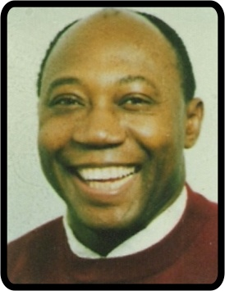 Prof Msgr Obiora F. Ike (Chairman)
Professor (Monsignor) Obiora F. Ike was born in Gusau, Northern Nigeria on 7th April 1956. He obtained his university studies of Philosophy, Theology, Political Science and Economics from 1975 to 1985 in Enugu - Nigeria, Insbruck; Bonn and London and obtained B.Phil; B. Theol; M.A Theology; M.Phil; Dr. Theology (Bonn). He also holds a Diploma in Journalism and Economics from the University of London. He was ordained a Catholic Priest in 1981 in Hohenems, Austria and served as Vicar General Enugu Diocese, Nigeria from 1998 - 2004.
Professor Obiora started his academic career as Lecturer in Professional Ethics (Berufsethik), Religion and Philosophy in Deutschoprdens Fachseminar fuer Altenpflege, Cologne, Germany (1980-86); thereafter moving to become Senior Lecturer in Political and Socio-Economic Sciences in the Spiritan International School of Theology, Attakwu, Nigeria (1987-1990). He is the Founder and Executive Director of the Catholic Institute for Development Justice and Peace, (CIDJAP), Enugu Nigeria since 1986 as well as Chair and Professor of Catholic Social Teaching, History and African Studies in linkage with the Enugu State University of Science and Technology. He has served as Visiting Professor to the Theologische Fakulteit, Tilburg, Netherlands (1993) and Guest Professor to the Johann Wolgang Goethe University, Frankfurt/M (1997).
Professor Obiora has served as President Club of Rome, Nigerian Chapter and Associate member of the Club of Rome; Chairman of many non-governmental organisations including the Growing Businesses Foundation; Enugu State Development Trust Fund; African Child Defence Initiative; Poverty in Africa Alternative; Umuchinemere Procredit Microfinance Bank Ltd; Nigerian Association of Catholic Social Scientists; Christian-Muslim Dialogue Enugu State; Africa Association for the Promotion of Catholic Social Teaching; Founder of the Africa Fund on Self Employment (AFOS Nigeria); SEPTA Enugu and Grassroots Women Empowerment and Development Education(GWEDE). Board Member and Director of over 15 International Organisations including Nigerianisch-Deutsche Kontakte Koeln; Alternative Dispute Resolution; Nigeria Caritas Council; New York Academy of Sciences; International Prisons Chaplains Association, Canada; Commonwealth Education Fund; Justice Development and Peace Commission.
He is the author of 67 published books, including "Wende dein Gesicht der Sonne zu" (2007); Globalisation and African Self Determination- What is our future? (2005); "Understanding Africa", (co-authored with Ndidi Nnoli Edozien as well as "Development is about People Business is about Ethics" (2004). He is a recipient of many Awards such as "Schalom Preis", Univeristy of Eichtaett, 1996; Paul Harris Fellow of Rotary International in Munich, 2004, "Omnis Religio", Frankfurt/M, 2005; Community Chieftaincy Title "Onwa N'Etlilora 1" of Umana Ndiagu, Nigeria; Papal Chamberlain, "Monsignore", Vatican City under His Holiness Pope John Paul II, 1999.
Professor is a polyglot, with fluency in German, French, English, Igbo and Hausa.

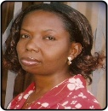 Engr.Virginia Uzoma Ifeadiro Founder/Executive Director)
Virgy holds a Bachelor degree in Agric Engineering and Msc in Social Work. She is an expert in Gender/vulnerable group, social development and humanitarian assistance and poverty alleviation. She has extensive public and private sector experience with over 17 years of practice in International and national organizations. She has developed, implemented and managed several programs aimed at empowering women, children and youths for poverty reduction.
Virgy has several fellowship awards including; Global Vital Voices Fellow, World Bank/IMF Civil Society fellow, Dutch Government fellow on Development, MDG Ambassador, Member Institute of Chartered Trustee Nigeria, Parishioner of honour 2008 by St Mary’s Catholic Church Karu, Abuja Nigeria, Daughter of Millennium 2000 by Nawfija Community. She also has written several published and unpublished books/articles.
Her mission is to empower women, children and youth for self-sustainability and influence policies that affect them in addition to promoting individual, secular philanthropy for development in Nigeria. She is passionate about Women, Children and Youth (The Vulnerable.)

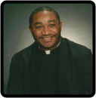 Rev Fr, Benedict Ogum Ezeoke

Fr Ogum is a priest of Catholic diocese of Nnewi in Eastern Nigeria. He worked as resident pastor in parishes before proceeding to United States of America to further his studies. His passion has been: progressive human development, poverty alleviation, human empowerment, self esteem development, and improvement of peoples’ live in general.

This passion influenced his choice of professional specialization to embrace the area that will assist empower the greater number of people to aspire and work toward a world free of greed, avarice and corruption. He studied Counseling at Loyola University Chicago, and currently studying Counseling Psychology in Argosy University also in Chicago-USA. He is a practicing therapist and Counselor.

He always believes that if we can shun selfishness for a moment, the dynamics of many poor lives could be turned around for good.

 Rev Fr Jude Obinna Ifeadiro

Fr Jude is a priest of Catholic diocese of Aba in Eastern Nigeria. He is the parish priest of St Mary’s Parish, Osokwa, Abia state. Fr Jude’s passion is poverty alleviation through human development. He joined IFEHS team as part of apostolate to add value to human life and reduce incidence of poverty through active utilization of human capital for development purposes. He believes that that nothing is too small to do in saving the human as we are all bonded in some way. He has helped shape IFEHS youth human development programmes.

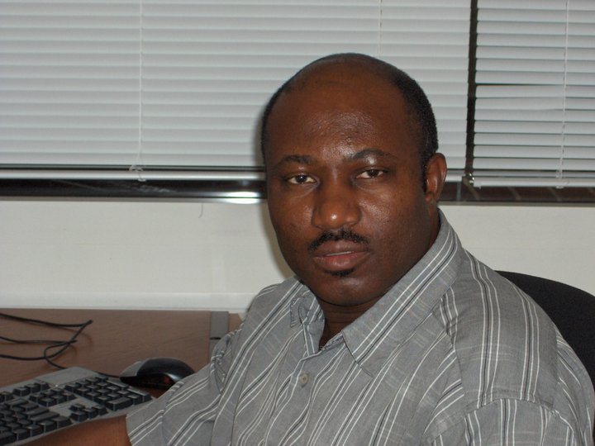 M. Eng, B.Eng Chemical Engineering

Engr Herbert has over 25 year of professional experience in Oil and Gas sector in Nigeria and United States of America with specialization in Environmental management. Herbert believes that safe environment is key to poverty reduction and development sustainability. He has passion for clean environment. He joins IFEHS team to fight for clean environment.

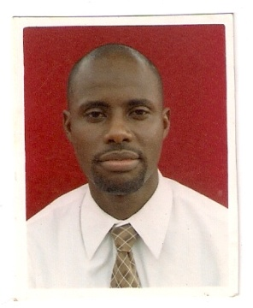ABDULLAHI ABUBAKAR Bsc Business Admin

Abu is a committed development worker with over twenty years of partnership with Muslim youths in several portfolios and believes that youth empowerment through education, peace building, good health, and environment is key to a secure future, free of poverty. He is a philanthropist committed to putting smiles on faces of the afflicted.

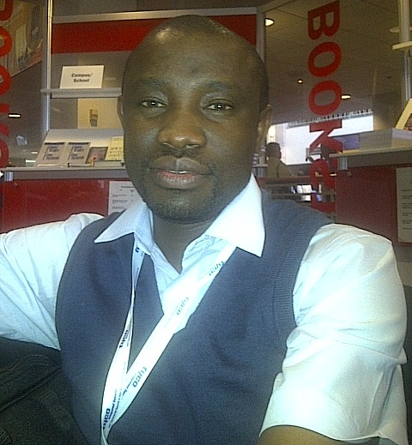 Charles Bassey, PhD

Charles Bassey is a graduate of University of Calabar Nigeria, where he pioneered sociological research in the area of gender and food security at post-graduate level and obtained a doctorate degree in Sociology, with specialist focus on development studies. He also obtained Foundation Course Certificate in Peace Practice from the Institute of African Studies Peace (Conflict Studies Programme), University of Ibadan under the sponsorship of IDASA and USAID. He is currently studying for an MSc in Risk, Crisis and Disaster Management at the University of Leicester, United Kingdom.

Dr. Bassey working career traverses teaching, industrial relations/trade union administration, corporate security and banking, with areas of professional interests that include social development, security, organization design/strategy, research and risk management. A certified ISO 27001 (Information Security) Lead Implementer, Charles is a member of several professional bodies, including International Sociological Association, Association of Certified Fraud Examiners, Association of Social Economics, American Anthropological Association, Society for Risk Analysis, The Security Institute (UK) as well as ASIS International, the Abuja Chapter of which is chaired by him.

Charles has participated in several training programmes in Israel, United Kingdom and the United States of America and also presented papers at different forums within and outside the country. He has volunteered his skills in youth mentoring, facilitation and life-building consultancy in addition to providing consultancy services for government and non-governmental agencies, including Open Society Initiative of West Africa (OSIWA) and MacArthur Foundation Population Programme’s Fund for Leadership Development Project. Dr. Bassey joins the Advisory Board of IFEHS with a professional background in the areas of development research, food security and risk management to provide strategic reengineering ferment to the work of IFEHS.

Charles envisions “a world of radiant people living their best” and his personal mission is “to discover, nurture and enliven excellence for human development.” He loves reading and writing creative pieces in addition to blogging as a means of staying sane.

IFEHS OPERATIONAL TEAM
Engr. Virginia Uzoma Ifeadiro (Executive Director)
Virgy holds a Bachelor degree in Agric Engineering and Msc in Social Work. She is an expert in Gender/vulnerable group, social development, humanitarian assistance and poverty alleviation. She has extensive public and private sector experience with over 15 years of practice in International and national organizations. She has developed several programs aimed at empowering women, children and youths for poverty reduction.
She has several fellowship awards including; World Bank, Netherlands Government, MDG Ambassador, Harvard EDX School on Improved Livelihood through poverty reduction Member Institute of Chartered Trustee Nigeria, Parishioner of honour 2008 by St Mary’s Catholic Church Karu, Abuja Nigeria, Daughter of Millennium 2000 by Nawfija Community. She also has written several published and unpublished articles.
Her mission is to empower women, children and youth for self-sustainability and influence policies that affect them in addition to promoting individual, secular philanthropy for development in Nigeria. She is passionate about Women, Children and Youth (The Vulnerable.)

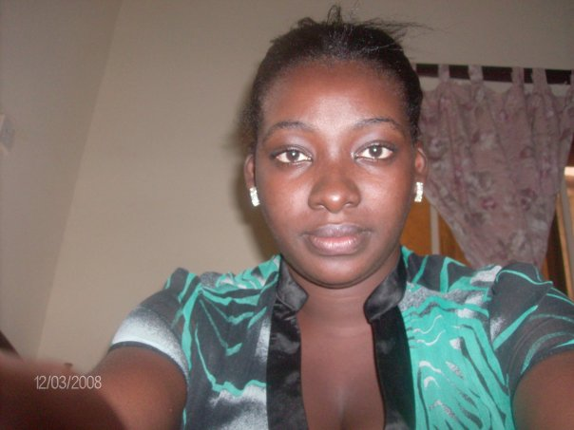 Oto Elaoje Sophie Msc, Bsc Accounting
Sophie holds a BSc and MSc in Accounting from Benue state University and ABU Zaria respectively. She has eight years of experience in accounting in private, public and development sector and has undergone several professional trainings with several institutions and professional bodies. Sophie believes that accountability and transparency is key to development.

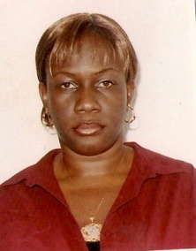 Ifeoma Nwosu, MBA BSc (Program Manager)
Ifeoma is a social worker with over 15 years of experience in development field. She has implemented and managed several projects funded by CIDA, EU, USAID, DFID, UNDP, Henreigh Boll, Oxfam before joining IFEHS CONSULTING as the Program Manager. She believes that with little touch to humanity, the world would be a better place.

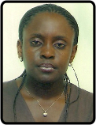 IJEOMA A. IZUKA (Communications OFFICER)
Ijeoma, holds a B.Sc in Mass Communication from Imo State University Owerri and a M.A in Law and Diplomacy from University of Jos, Plateau State, Nigeria. She has banking and media experience having worked for Citizens International Bank, Nigerian Telecommunications Ltd (NITEL) and Plateau Radio-Television Corporation (PRTVC).
An avowed humanitarian, with passion for the welfare of the needy particularly women and children, Ijeoma believes IFEHS offers a veritable platform for helping addressing incidence of poverty and enhancing human development in present day Nigeria. A member of Nigerian Institute of Management (NIM).

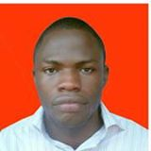 Simon David. SSCE (Office/Admin Assistant)

Simeon is a passionate office assistant that volunteers in all sectors of the project. He puts smiles on faces by doing his work with passion.

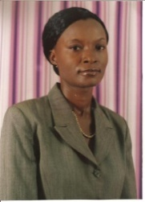 Regina Amala Chukwudozie. (MSc, BSc Agric Econs)
Amala Chukwudozie is an agricultural specialist with over fifteen years of experience in Agro business management. She holds B.Eng/MSC Agric Economics from Federal University of Technology Owerri. She has done a lot of research in Agro allied services. She has managed several farms with proven profit.
She believes that Youth and Women empowerment in Agriculture is a key issue in poverty reduction.
CONSULTING for IFEHS to empower women and youth through sustainable Agriculture

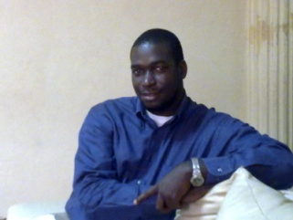 DR CHIDIEBELE OKAFOR. Coordinator, Health Programs. (Volunteer)
Dr Chidi is a practicing clinician in Abuja, Nigeria, earned his bachelors’ degrees in medicine and surgery from the University of Port Harcourt, Nigeria. He has worked with health institutions within the secondary and tertiary levels of health care in Southern and Northern Nigeria.
He yearns for a society in which health care delivery is adequate and of easy access to all. He is driven by a strong desire to engage communities in wellness practices and disease prevention and advocates better empowerment of communities through implementation of community- directed intervention programs as used for the administration of ivermectin in rural communities and more recently vitamin A, insecticide treated nets and anti-malarials.
He is a keen volunteer who strongly believes that the spirit of self- help within communities will go a long way in improving our quality of life

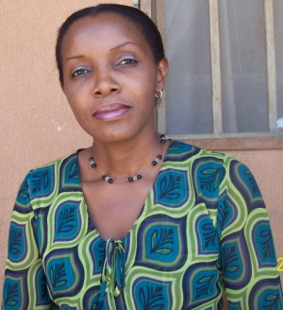 DR AMAKA NNOPU (Volunteer)

Dr Amaka Nnopu is an Optometrist with six years of experience in community eye health especially with the under privileged.
She believes in the importance of early Eye/Vision Screening especially pre-nursery children for early detection, treatment and management.
Also believes in management and treatment of avoidable causes of blindness, glaucoma, etc is the best method of eye management.
She joined IFEHS in rendering humanitarian services to vulnerable women, children and youth in reduction of poverty.

Contact:

National Office
FF 24 Citi Centa Plaza
Karu.
Opposite Noble Height Accademy.
Abuja .
Virgy 08036042326, virgyifeadiro@yahoo.com, vifeadiro@ifehs.org, info@ifehs.org www.ifehs.org

Edo Office
No 1. Warake Street.
Auchi. Edo state
Goddfery Iriye. 07014838557

Enugu Office
No 1-3 Isukwuato street
Uwani
Enugu
Ebuka Mba 08039238387

Anambra Office
No. 1 Igwenagu Close
Oko-Umunze Road
Nawfija
Izuchukwu. 08030996689

