New Hope Waves Education Academy

The background of the challenges to form this Education Academy

The real needs of this vulnerable community is that it has no school that provide free and quality for vulnerable children and most of the children are out of school as the poor guardians/parents cannot afford even a school minimal fee due to high poverty, unemployment and other social challenges.

The community of Maramba has more than 60,000 people and most of them are children from ages of 4-15 years with less than 5 schools public and community which cannot accommodate most of these children so we will also reduce the problem of the teacher to child ratio which is high as well as over enrollment of more than 100 children in one classroom been attended by one teacher both in the public and community schools.

The guardians/parents less than 5% are in formal employment and most of them do odd jobs such as crushing building stones for sales, maids and more of the women sale eggs, vegetable on their heads and streets, run small shops and some of girls ended up been married off at the young age, some prostitution due of skills and education and some of these girls have a number of children without supporting fathers so we will also provide education to children.

The New Hope Waves Education Academy

The Preschool and Primary school (Education Academy) which will aim at providing free basic and quality education to vulnerable children in the nearby communities such as Ngwenya, Namatama, Zecco, Burton and Malota (Maramba)

The Education Academy will be providing education for children from 2 years to 15 years starting from Preschool and Grades 1-7 whose aim to make children to learn how to read and write in English as well as excel in the higher education levels.

Mission Statement: Educate, Inspire and Empower Vulnerable Children for the Better Future

Vision Statement: New Hope through an informed, educated and responsible crop of citizens.

The Education Centre will work with the children who are out of school as more than 3 out of 5 children between the ages of 4-15 years are not in school so we will provide preschool and primary education from grades 1-7 all for free so that we will ease the burden of education in the vulnerable families that can afford only one meal in a day and most of the parents are not employed and some of the children are orphaned by HIV/AIDS been cared by their old poor grandmothers who cannot afford to pay for their education and provide their proper meals.

The Education Academy will accommodate more than 300 vulnerable and orphaned children who will have basic education from the most vulnerable communities to improve the literacy levels and acquire quality education for a better future.

The statistics about Zambian population is that 16 million live in the country, 86% live in poverty under less than a dollar per day and 41% of the children are malnourished so we will also provide school feeding program as most of the children are coming from very poor homes and community that cannot afford decent meals, the feed program will improve their performance of children in class as well as to curb children staying away from school as their guardians cannot affordable to snack for them at school and an early meal at home.

The Education Academy will be a harbor of children activities that are aimed at improving the education and a safe environment during some afterschool programs that will create a defined future for the community of children to an informed and productive society geared to break the cycles of poverty, disease and social challenges

The Education Academy intends to start its operations in April, 2019 at the location to be designated within Maramba as we have been offered a conducive space to purchase and below is the property that we need for our Education Academy so accessible for the vulnerable children in Maramba and so close to the most vulnerable communities such as Ngwenya, Namatama, Zecco, Burton, Mbita and Malota.

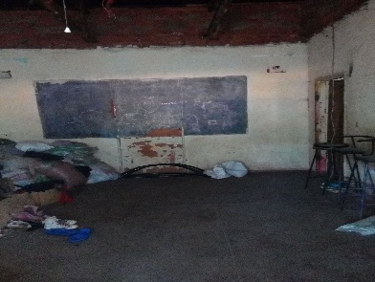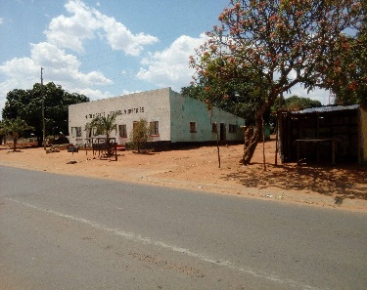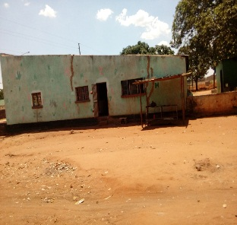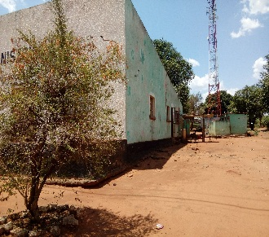
The Education Academy currently need passionate people who can help us to fundraise money to purchase and own this property for vulnerable children so that we will turn into our Education Academy as when we have own space it will be ease the pressure of renting a property which will be expensive for us to provide free and quality education as well as motivate or pay our staff to work well with the vulnerable children. We will work to renovate it and put all the equipment in place for children to learn and excel in a better and well maintained space.

The property has 6 rooms which will turn into classrooms to provide school learning and playing space for the number of vulnerable children who are out of the school who earnestly need free basic and quality education for a better future.

The Education Academy needs US$ 20, 000 to purchase this property so you can see some of the photos above so we need you to share our humble request with your families, friends and people who have a heart to change the face of our vulnerable community through education.

Any amount of money will be appreciated towards this noble cause so you can send via the organization bank account or safe means of international money transfers (Western Union)
For more details: email us at auldridgechibbwalu@yahoo.co.uk or info@newhopewaves.org
The bank details
New Hope Waves Zambia
Bank: BancABC Zambia
Bank Account: 3065031872017
Branch: Livingstone Branch
Swift Code: FMBZZMLX
Bank Code: 20 00 00
“There is no better gift that you give vulnerable children than giving them education and safe space to grow in all spheres of their lives” by Auldridge Chibbwalu, President and Founder of New Hope Waves

