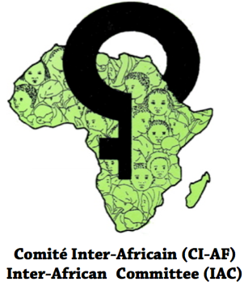

Reduce medicalization of Female Genital Mutilation
by 50 midwives in Guinea

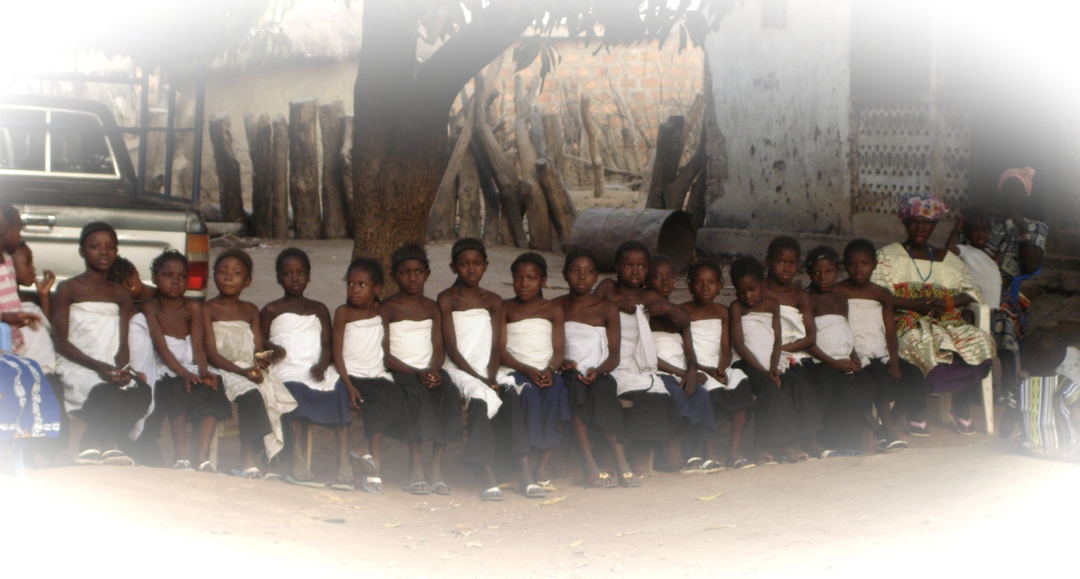

Submitted by the Inter-African Committee (IAC)
in collaboration with GlobalGiving

February 2018

Introduction
Female genital mutilation (FGM) violates a girl's right to have control over her own body. Traditionally considered essential for marriage and inclusion in the community, it is an extreme and violent way in which girls are controlled and disempowered. At least 30 million girls will be at risk of FGM in the next decade with more than 3 million in Africa affected each year. In Africa thousands of girls are concerned by child marriage where women’s health rights are usually violated, subjecting them to physical, psychological, emotional, and financial abuse.
The Protocol to the African Charter on Human and Peoples’ Rights on the Rights of Women in Africa (adopted by the African Heads of States), the UN General Assembly Resolution A/RES/67/146 and A/RES/69/150 ''Intensifying global efforts for the elimination of female genital mutilations '' and the first Girls Summit, which was held in July 2014 in the United Kingdom with the objective of mobilising domestic and international efforts to end FGM and child, early and forced marriage (CEFM) within a generation, have acknowledged that women and girls have the right to live free from violence and discrimination and achieve their potential in life. The role of IAC and other like-minded organizations that include among others the African Union Commission (AUC) and the United Nations Economic Commission for Africa (ECA) is to support and accelerate global efforts to end harmful practices that affect the health of women and children. Doing this will help preserve girls' childhoods, promote their education, reduce their exposure to violence and abuse, and allow them to fulfil their potential in life.

The World Health Organisation estimates that approximately 100-140 million girls and women around the world have undergone female genital mutilation. FGM is the partial or total removal of the clitoris (clitoridectomy), the removal of the entire clitoris and the labia minora (excision), or in its most extreme form, the removal of all external genitalia and the stitching together of the two sides of the vulva (infibulations) for non-medical reasons. FGM is performed on underage girls without anaesthesia and with crude instruments, such as razor blades, which are more often than not sterilized. Whilst most of the girls and women affected live in 29 African countries, some also live in parts of the Middle East and Asia. This practice is also found among immigrant population groups in Europe, the United States, Canada, Australia and New Zealand. FGM is usually practiced on girls between the ages of 4 and 12, although in some traditions it is done to babies a few days old or as late as to women just prior to marriage.

FGM is a gross violation of the fundamental rights and health of women and girls with serious repercussions on their lives. The physical and psychological effects of the practice are extensive and often irreversible, affecting in particular their reproductive and mental health and wellbeing. Furthermore, FGM reinforces the inequalities suffered by women and girls in the communities where it is practiced and must be addressed if the health, social and economic development needs of girls and women are to be met.

FGM continues largely because in practicing communities there are strong enforcement mechanisms put in place to make sure that all girls undergo genital mutilation.
This enforcement includes rejection of non-mutilated women as marriage partner and immediate divorce if a woman manages to conceal such a fact, derogatory songs, forced excisions, and fear of the unknown through curses and evocation of ancestral wrath, thereby violating the health of girls and women.
The Sustainable Development Goal 5 of the Agenda 2030, on achieving gender equality and empower all women and girls, calls for the elimination of all harmful practices, such as child marriage and female genital mutilations. This is further re-emphasised in the African Union’s Agenda 2063.

About the IAC
The Inter-African Committee on Traditional Practices Affecting the Health of Women and Children (IAC) was established in 1984, to address the issues of FGM and other harmful practices at community, national, regional and global levels. It was decided upon and formed by African delegates to a seminar organised in Dakar, Senegal by a United Nations NGO Working Group on Traditional Practices based in Geneva, with the support of UNFPA, UNICEF, WHO and the Ministry of Health of Senegal. It was formed at a time when female genital mutilation was a highly controversial and a ‘sensitive’ issue for discussion and there was a critical need for an African regional voice to be heard in an international campaign against FGM.
  - Vision, Mission and Objectives
The Vision of IAC is to see a society in which African women and children fully enjoy their human rights to live free from harmful traditional practices.
The Mission of IAC is the promotion of gender equality and the contribution to the improvement of the health status, social, economic, political, human rights and quality of life of African women and children through the elimination of harmful traditional practices and the promotion of beneficial ones.
Its main objectives are to:
- Prevent and eliminate traditional practices that are harmful to the health and human development of women and girls.
- Promote and support those traditional practices that improve and contribute to the health and human development of women and children.

The headquarters of IAC is in Addis Ababa, Ethiopia, where it is registered as a non-profit organisation and it has a liaison office in Geneva, Switzerland. The IAC has national chapters, referred to as National Committees, in 29 African countries. The IAC links to African population groups in the Diaspora through its 19 Affiliates/Group Sections throughout the world (Belgium, France, United Kingdom, Spain, Germany, Sweden, Norway, Italy, the Netherlands, Canada, USA, New Zealand, and Japan).
  - Structure
The IAC is organised as follows:
- A General Assembly consisting of all the National Committees;
- The Executive Board (consisting of members from 5 African countries elected by the General Assembly + 6 Zone Coordinators in Africa and 3 Zone coordinators abroad (America, Asia, New Zeeland and Europe);
- The Executive Direction (secretariat) that includes The Executive Director and all technical staff in Addis Ababa and Geneva;
- National Committees;
- Scientific Committee; and
- Thousands of volunteers participating in the work of IAC in all the countries.

Organizational Structure of IAC
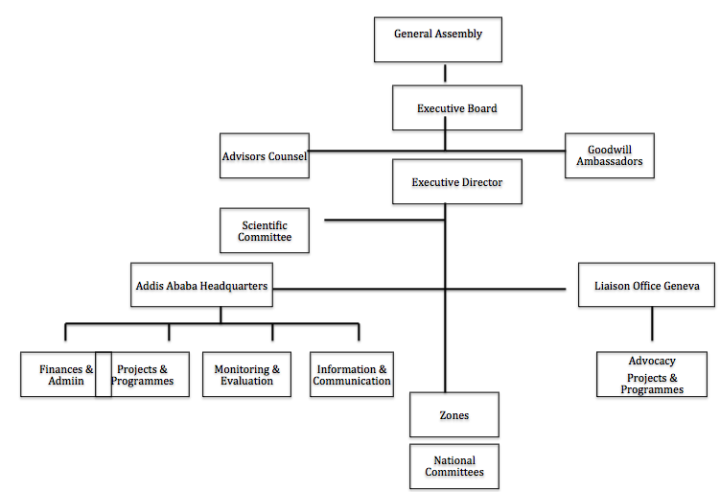

  - Achievements/Milestones
The IAC enjoys consultative status with the United Nations (UNECOSOC) and holds an observer status with the African Union. It works in partnership with UNFPA, WHO and UNICEF and is a member of the NGO network affiliated to the International Organisation of Francophone countries. The IAC collaborates with several international organisations active in the field of the protection of women and children.

Working within the framework of the 1979 United Nations Convention on the Elimination of All Forms of Discrimination Against Women (CEDAW) and with a number of partners, IAC has made a major contribution in raising awareness at all levels of policy on harmful practices, particularly female genital mutilation, and in advocating for their recognition and/or integration in various United Nations and regional treaties as well as in statements and declarations of major UN conferences on women. These include:

- 1984: Convention against torture and other cruel, inhuman or degrading treatments or punishment;
- 1990: United Nations Convention on the Rights of the Child (article 24.3):
- 1990: African Charter on the Rights and Welfare of the Child;
- 1993: United Nations Declaration on the Elimination of Violence against Women (Res. 48/104, 48 U.N. GAOR)
- 1994: International Conference on Population and Development (ICPD) (Cairo)
- 1995: United Nations 4th World Conference on Women (Beijing)
- 1997: WHO Regional Plan of Action to accelerate the elimination of FGM;
- 1997: Joint WHO/UNFPA/UNICEF Statement for the elimination of FGM (updated in 2008);
- 1999: United Nations Resolution, ECOSOC, A/RES/53/117 on FGM;
- 2003: Protocol to the African Charter on Human and Peoples’ Rights, on the Rights of Women (referred to as the Maputo Protocol).

In 1990, the IAC General Assembly, during its meeting held in Addis Ababa, voted to adopt the terminology female genital mutilation and its acronym FGM to replace the euphemism ‘female circumcision’ FGM has since been in usage by the United Nations, African governments and the international community.

In February 2003, the Inter-African Committee organised an International Conference on “Zero Tolerance to Female Genital Mutilation” that led to three major outcomes:

- Adoption of the declaration of the 6th of February as an International Day of Zero Tolerance to Female Genital Mutilation;
- Adoption of a call on African Heads of State requesting their personal commitment and involvement in the struggle for the elimination of female genital mutilation;
- Adoption of a Common Agenda for Action on Zero Tolerance to FGM for joint efforts with different actors (governments, UN institutions, parliamentarians, legislators, policy makers, NGOs…) to coordinate their approaches and harmonise activities under the coordination of the Inter-African Committee.

Other achievements/milestones include:

- Upon the initiative of IAC, the United Nations General Assembly adopted unanimously the resolution A/RES/67/146 and A/RES/69/150 ‘’Intensifying global efforts for the elimination of Female Genital Mutilations’’ on 20 December 2012;
- In 1998 (Banjul, The Gambia), in 2001 (Dar-es-Salam, Tanzania), in 2005 (Egypt and Burkina Faso) and in 2007 (Abidjan, Côte d’Ivoire), IAC organised four symposia respectively for religious leaders who created a Network of African Religious Leaders against FGM and for Development. This network has developed a practical guide for advocacy and sensitization on female genital mutilation by means of the Holy Scriptures.
- In 2000, the Inter-African Committee initiated the creation by young people from its 29 member countries, an African Regional Network of Youth for the elimination of female genital mutilation (FGM). The second forum of this network was held in November 2006, in Addis Ababa, and it resulted in the formulation of a youth program for both national and regional levels.
- The 2008 regional youth forum that was held in Accra, Ghana, further reaffirmed the commitment of African youth who designed a workable plan of actions for the fight against FGM and other harmful traditional practices at regional as well as national and local levels.
- In the 29 African countries where FGM is prevalent, the IAC National Committees and other development partners have intensified actions to prevent the practice at the local level.

In 2014 IAC partnered with ECA to disseminate information on the UNGA Resolution A/RES/67/146 and A/RES/69/150 so as to: a) increase awareness and sensitize governments on domestic and international legal frameworks banning FGM; b) facilitate the sharing of best practices, including monitoring, for governments responsible for ensuring compliance with the law, and for activists engaged in promoting the implementation of existing laws; as well as c) reinforce the commitment of the states involved in the project to ensure that the commitment showed in adopting the Resolution.

IAC has also established a Scientific Committee to:
- Give scientific support to activities, projects and programs;
- Make scientific analysis of results; failures and successes;
- Provide scientific support in designing, implementing, monitoring and evaluation of activities;
- Carry out operational and fundamental research on HTPs/FGM.

As a result of all the efforts made by IAC, the taboo surrounding FGM has been broken, as nineteen African countries have passed laws prohibiting FGM. As part of the culmination of extensive community outreach sessions, several public ceremonies have been observed where traditional excisers have laid down their knives and communities have openly made a declaration against FGM. Statistics also show that the practice of FGM is dropping among the younger generation, an indication that the work for its elimination is paying off. In spite of all these significant achievements, the practice of FGM still continues because behavioural change is always slow and persistent. More work still needs to be done so as not to reverse the trend.
- The Theory of Change
The program of work of IAC was developed and will be scrutinized within a theory of change, which maps out project initiatives through 6 stages. These stages are:
- Identifying long-term goals,
- Backwards mapping and connecting the preconditions or requirements necessary to achieve these goals and explaining why these preconditions are necessary and sufficient,
- Identifying basic assumptions about the context,
- Identifying the interventions that will be performed to create the desired change,
- Developing indicators to measure the outcomes necessary to assess the performance of the initiative,
- Writing a narrative to explain the logic of the initiative.
The TOC process hinges upon defining all of the necessary and sufficient conditions required to bring about a given long term outcome, using backwards mapping that requires planners to think in backwards steps from the long-term goal to the intermediate and then early-term changes that would be required to cause the desired change. This creates a set of connected outcomes known as a “pathway of change”. A “pathway of change” graphically represents the change process as it is understood by the initiative planners and is the skeleton around which the other elements of the theory are developed.
The approach is designed to encourage very clearly defined outcomes at every step of the change process. Users are required to specify a number of details about the nature of the desired change — including specifics about the target population, the amount of change required to signal success, and the timeframe over which such change is expected to occur. This attention to details often helps both project partners reassess the feasibility of reaching goals that may have initially been vaguely defined and, in the end, promotes the development of reasonable long-term outcome targets that are acceptable to all parties.
Outcome mapping has the following strengths:
- The articulation that change is not linear and attributable to one specific intervention, but rather is the culmination of multiple interacting factors, provides a fuller picture of what change really looks like and how it is catalysed.
- Participatory learning and reflection processes that encourages greater respect for diversity as well as honour multiple voices and feedback in developing organizational planning and reflection cycles.
- Using a graduated system of progress markers helps organizations to think strategically about their bottom-line hopes for program outcomes as well as their best-case scenarios. This level of detail can help enhance program planning and strengthen implementation activities.

- Project: Reduce medicalization of Female Genital Mutilation by 50 midwives in Guinea
  - Introduction on medicalization of FGM

Medicalization of female genital mutilation is any mutilation performed by a health professional in or outside a health facility or by a “non” health professional within a health structure.
Medicalization of FGM is a perverse consequence of the first stage of the fight which was entirely focused on the medical and health aspects of the practice. Indeed, the arguments used from the start, in the years 1970-1980, stressed the fact that FGM was practiced under septic conditions, without anesthesia, with serious medical and sanitary consequences such as infections, hemorrhagic shock, septicemia, infertility, etc.
Whereas the medical-sanitary entry point allowed to draw the attention of the populations in a rapid and effective manner, the scientific description was so good that it led to the following indirect conclusion:” Why not do it in hospitals to reduce the damages?”

The reaction among the populations to this argument was immediate: Perform FGM under “safe” medical-sanitary conditions, i.e. in a hospital and in addition by a health professional.
It should be added that the health professionals (midwives, nurses, traditional birth attendants…) receive a remuneration to perform the practice.

Facing the huge difficulties to change peoples’ behavior regarding FGM, the activists also adopted a strategy called “pretending”. This consisted in working with health agents who pretended to perform the “operation” on the girls brought to them but in fact the clitoris had only been slightly pinched.
The synergy of these different considerations led to the creation of an extremely serious phenomenon within the problem of female genital mutilation: medicalization.

It is regrettable to note that when the traditional excisers are laying down their knives, health agents are taking over. At the peak of our fight against medicalization, we are confronted with what can be called “the phantom exciser”. Whereas the traditional exciser, surrounded by myths and proud of her supernatural powers, publicly dances in front of the line of mutilated girls, the medical practitioner turns away from the crowd and the celebrations since she knows that she has acted against medical deontology and against her primary mission: to protect and save lives.

That is why the Inter-African Committee has developed a specific strategy to fight against medicalization.

  - Strategy to fight against medicalization of female genital mutilation

It is important to note that whereas the sensitization of the populations and the traditional excisers requires quite a lot of time, that of health agents should be easier taking into account their mission and level of education. As such, the fight against medicalization should be carried out as follows:
- Strict application of the rules of medical deontology within all health structures and, consequently, the total ban on the practice of FGM by health agents, and in health centers by non-health agents. Health ministries and national medical councils should take administrative measures, e.g. withdrawal or suspension of diplomas or authorizations from those who practice medicalized FGM.
- Total enforcement of the anti FGM legislation where it exists and, as proposed by the IAC, severe legal sanctions for guilty health agents.
- Continued training, information and sensitization of health personnel and their involvement in the anti-FGM campaign. Indeed, experience from the field often shows that the level of knowledge about female genital mutilation among health agents is inaccurate or overestimated.
This is the reason why the Inter-African Committee created the African network of health professionals against female genital mutilation, similar to the networks of religious leaders, of media professionals, of youth and of traditional communicators.

It is also the reason why Inter-African Committee is submitting this project in Guinea to GlobalGiving

The prevalence of Female Genital Mutilation is 97% in Guinea; Moreover 30% of FGM are performed by midwives. In 2016, the World Health Organization and its partners including Inter-African Committee has developed a guideline on the management of health complications from female genital mutilation. Midwives being the most practitioners of medicalization, the project will sensitize and train 50 of them to stopping performing FGM and to use the WHO guideline for taking care of the victims.

Purpose of the Project
The purpose of the project is to enhance the reproductive health of girls and women in Guinea through the elimination of harmful traditional practices (HTPs) in general, and Female Genital Mutilation (FGM), Child Marriage (CM) and Violence against Women (VAW) in particular.

Implementation Strategy
The project will be implemented by the Inter-African Committee and its branch in Guinea CPTAFE (Cellule de coordination sur les pratiques traditionnelles affectant la santé des femmes et des enfants by:
- Involvement of the target groups in the designing, programming, implementation, follow-up and evaluation of activities on FGM;
- Integration of the project activities into national programs of development;
- Ownership of the project by communities at the local level for sustainability
Overall Objective: To reduce the prevalence of FGM by 10% in 29 Guinea in 3 years.

- Objective 1: To identify, sensitize, train and build capacity of 50 midwives who are performing FGM medicalization in order to convince them to stop the practice and to become agent of positive change;
- Objective 2: To disseminate and implement the WHO guideline for management of health consequences of FGM in 50 health centres and hospitals;
- Objective 3: To bring care to at least 100 victims of FGM

Capacity Building for National Committees (NCs): This program of work is based on the assumption that thematic activities will be principally implemented by the national committee in Guinea and that IAC will play more of a facilitative role, the central issue of which is Capacity Building.

Activities
Activities | Outputs | Output indicators | Target | Outcome | Outcome indicators
- Identify 50 midwives who are performing FGM medicalization | 50 midwives who are performing FGM medicalization | # of midwives performing FGM medicalization identified | Midwives performing FGM medicalization | 50 Midwives performing FGM medicalization identified | # of midwives performing FGM medicalization effectively involved into the project
- To hold a workshop for sensitizing and training 50 midwives and using the WHO guideline on management of health consequence of FGM | 50 midwives who are performing FGM medicalization | # of midwives performing FGM medicalization participating to the workshop | Midwives performing FGM medicalization | 50 midwives who are performing FGM medicalization  Sensitized and trained | # of midwives performing FGM medicalization effectively sensitized and trained
- To give 50 medical toolkits to the 50 midwives for taking care to at least 100 victims. | 50 taking medical toolkits available | # of medical toolkits | 50 Midwives performing FGM medicalizationand 100 victims of FGM | 50 midwives equipped and ready to use the medical kits | # of medical toolkits available and # of victims
- Monitoring and evaluation | IAC headquarters and national branch Guinea CPTAFE | # of visits of IAC headquarters and CPTAFE | 50 midwives trained

Logical Framework
Verifiable indicator | Means of verification | Assumption / Risks
At least 10% reduction of the prevalence of FGM in Guinea | Country health system reports;  DHS;  Media reports  Evaluation reports  Research papers  Content of interviews with victims and perpetrators | Assumption:  - The existence of National Committees of IAC in Guinea  - The commitment and political will at international, regional and national levels  - The involvement of Ministry of health  Risks:  - Lack of peace & and security  - Delay in the disbursement of the funds

Assessment of Risks
Risks | Mitigation
Lack of peace and security in the country | If this case occurs in a country, IAC will reschedule the planning of activities according to the situation of  the country. Priority for redefining the activities place will be given to  the same country in consultation with the donors and the NCs.
Delay in the disbursement of the funds | The IAC HQ & National branch will do the maximum effort to submit activity and  financial reports on time. In line with this IAC will be closely in touch with  the donor to solve the problem.

Proposed Monitoring and Evaluation Framework
A comprehensive monitoring and evaluation system, with check-lists, indicators and means of verification as shown in the logical framework will be followed strictly to ensure that it is thoroughly and regularly assessed throughout the implementation period. The evaluation is intended principally for learning and accountability purposes and will concentrate on internally agreed evaluation criteria including: relevance, efficiency, effectiveness, impact, sustainability, coverage, coherence and coordination.
The implementation of the project will be monitored on the basis of timely and regularly collection and reporting of data. For this purpose, semi-annually and annual monitoring and reporting cycles will be strictly followed.
The reports should give a summarized comparison of planned activities and achieved outputs and utilization of resources. The preparation of the monitoring report is the responsibility of the Program Officers assisted by the IAC Scientific Committee.
IAC will arrange quarterly review meetings. The most important assessment of the review meeting ought to be monitoring & and evaluating the execution of the work set for the year according to the designated time table; whether the performance corresponds with the budget; sustainability of the organization; in-depth analysis of the implementation of strategies, planned activities, projects and related problems.
The findings, lessons and recommendations derived will be shared with key stakeholders and donors, and then used to inform future programming.

Duration: The project will be implemented in 1 year.

Budget (US Dollar)

No. | Items | Unit cost | Quantity | Frequency | Total
1 | Identification of 50 midwives (transport & DSA) | 2 200 | 1 | 1 | 2 200
2 | Workshop for sensitizing and training of 50 midwives
2.1 | Location hall conference | 500 | 1 | 3 | 1 500
2.2 | Transport & Daily Subsistence Allowance | 60 | 50 | 3 | 9 000
2.3 | Honorarium trainers | 300 | 2 | 3 | 1 800
2.4 | Subtotal Workshop for 50 midwives |  |  |  | 14 500
3 | Printing of WHO Guideline | 66 | 55 | 1 | 3 630
4 | Medico-surgical Kits | 380 | 50 | 1 | 19 000
5 | Intervention of 50 midwives for care for 100 victims | 25 | 100 | 1 | 2 500
6 | Monitoring, Evaluation & learning | 3 500 | 1 | 1 | 3 500
7 | Total |  |  |  | 45 330
8 | Management fees (7%) | 3 173 | 1 | 1 | 3 173
 | Grand Total |  |  |  | 48 503

