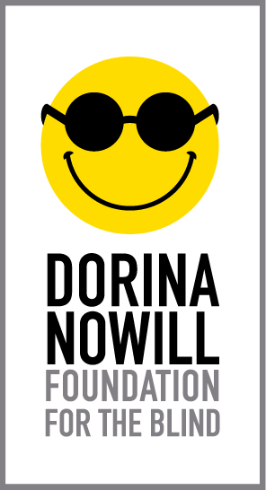

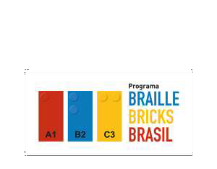

REPORT

The main actions developed by the LEGO® Braille Bricks Brazil Program in November and December 2021 were:

- Course to train educators to use LEGO® Braille Bricks in three cities in the state of São Paulo
- Participation in events
- Dissemination

- Distribution of LEGO® Braille Bricks kits
- Elaboration, publication and distribution of the LEGO® Braille Bricks kit user manual
- Distribution of educational kits for the Trainee Program

Course to train educators to use LEGO® Braille Bricks in three cities in the state of São Paulo.

- Course conducted from: 09/21/2021 to 12/13/2021 (Modules I, II and III)
- Workload: 100 hours
- Cities involved: São José do Rio Preto (SP), Presidente Prudente (SP) and São Paulo (SP)
- Number of schools: 519
- Number of participants: Total 865
- (São Paulo – 717), (Presidente Prudente – 56) and (São José do Rio Preto - 92)

The educators' training course started on 09/21/2021 with the introduction of the digital platform, where the trainees had the opportunity to get to know how it works, as well as the actions already developed by the Program.

Ten web conferences lasting two hours each were held, totaling twenty hours of live sessions. These virtual meetings were conducted by specialists in different themes, giving the trainees the opportunity to present their doubts and experiences.

The eighty hours of activities developed in the virtual environment dealt with the planning and execution of a pedagogical intervention project with the use of LEGO® Braille Bricks to be developed in schools with students with and without visual impairment.

The following are the course contents:

 | Activity | Date or period | Type
Module I | Activity 1: Previous knowledge. | 09/21 to 10/04/2021 | Activity directly on the platform
 | Web conference 1: (inaugural class)  - History and perspectives of the Braille Bricks Brazil Program.  - Introduction to the Virtual Learning Environment. | 09/29/2021 | Live
 | Activity 2: Case studies on blindness and low sight. | 10/05 to 10/11/2021 | Activity directly on the platform
 | Web conference 2: Learning about visual impairment and pedagogical practices using the LEGO Braille Bricks resource. | 10/06/2021 | Live

Module II | Activity 3: Quiz with crossword puzzle, word search, connect words | 10/12 to 10/18/2021 | Activity directly on the platform
 | Web conference 3: Fundamentals of reading and writing for visually impaired children. | 10/13/2021 | Live
 | Activity 4 (individual, pair or trio): Exploration of the LEGO Braille Bricks kit and recording of reflections. | 10/19 to 10/25/2021 | Activity directly on the platform
 | Web conference 4:  - What is the Braille System?  - Lego Braille Bricks and Math | 10/20/2021 | Live
 | Activity 5: Problem scenarios involving orientation and mobility concepts. | 10/26 to 11/01/2021 | Activity directly on the platform
 | Web conference 5: Orientation and mobility. | 10/27/2021 | Live

Module III | Activity 6 (group): Initial proposal of the strategic intervention plan. | 11/02 to 11/08/2021 | Activity directly on the platform
 | Web conference 6: Clarification about the Intervention Plan. | 11/03/2021 | Live
 | Continuation of Activity 6: Critical commentary reflecting on the proposals of at least 2 groups | 11/09 to 11/15/2021 | Activity directly on the platform
 | Web conference 7: The ludic and the Braille System: a possible equation? | 11/10/2021 | Live
 | Activity 7: Redesign the plan based on peer comments and tutor feedback. | 11/16 to 11/22/2021 | Activity directly on the platform

 | Web conference 8: Intervention plan: challenges, doubts and strategies. | 11/17/2021 | Live
 | Activity 8: Posting records of the plan's execution. | 11/23 to 11/29/2021 | Activity directly on the platform
 | Web conference 9: Reflecting on the educator's role in inclusion | 11/24/2021 | Live
 | Activity 9: Reflection on the plan's execution | 11/30 to 12/06/2021 | Activity directly on the platform
 | Activity 10: Satisfaction survey and presentation of the follow-up schedule
 | Recovery | 12/07 to 12/13/2021 | Activity directly on the platform

Images:
- Web conferences with images of the speakers
- Practical experiences
- Home page of the course's virtual learning environment
- Participants' comments

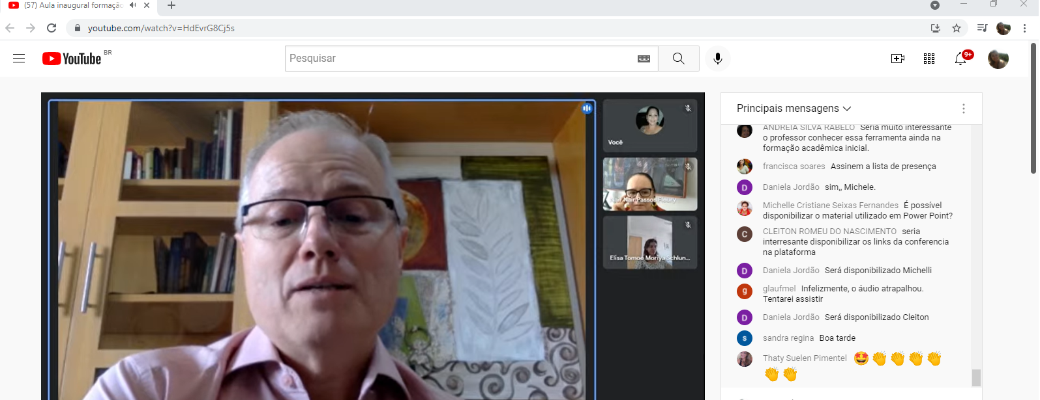

Image 1

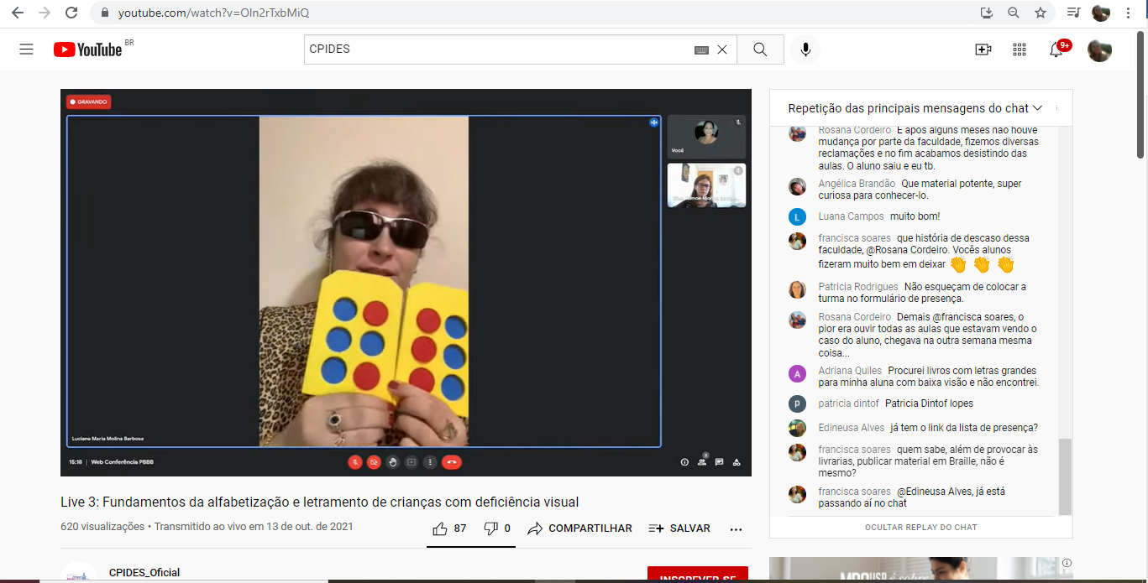
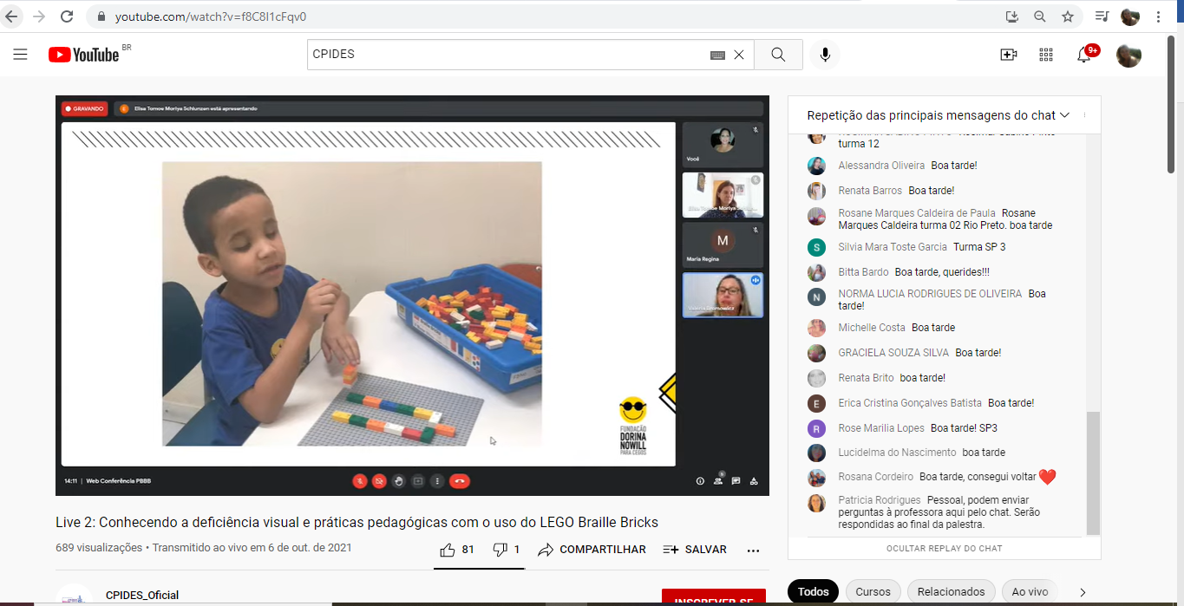

Image 3
Image 2

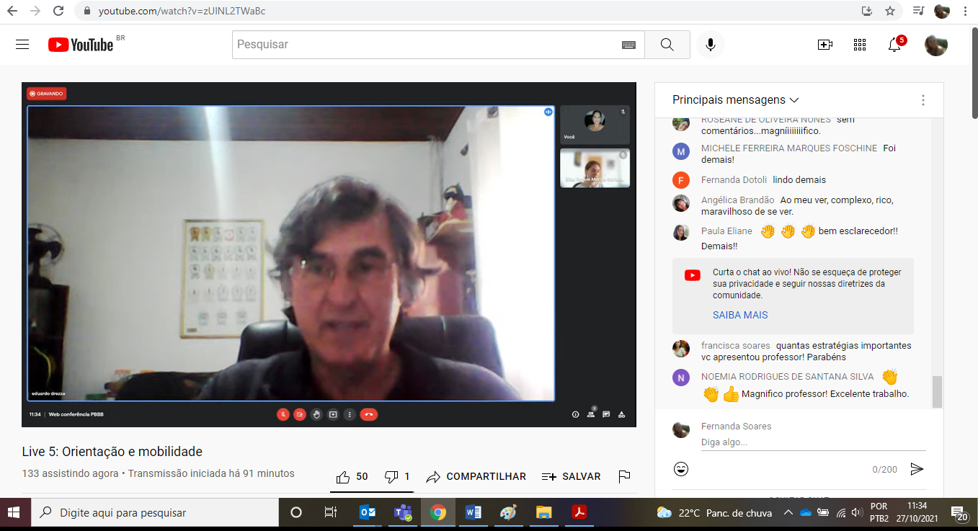
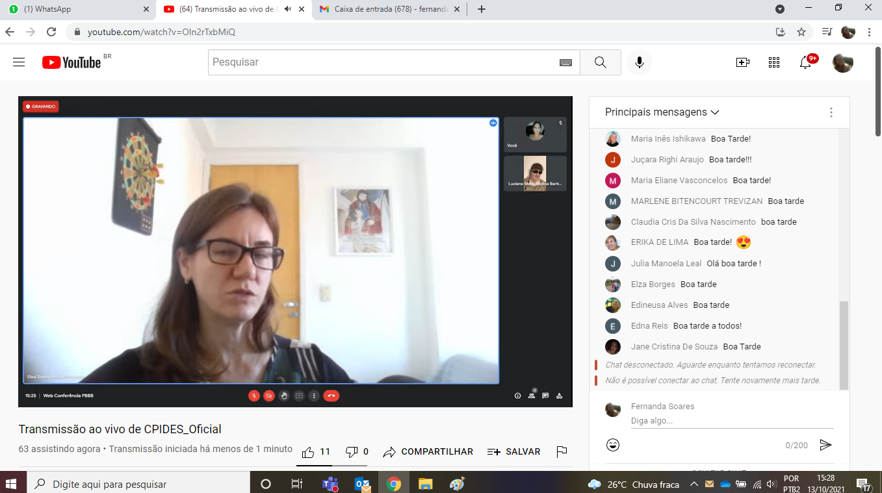

Image 5

Image 4

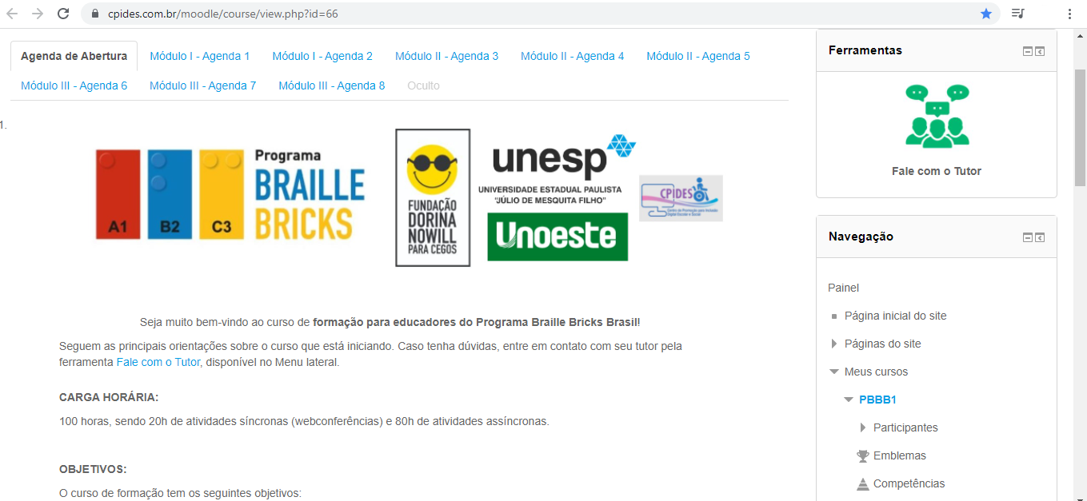

Image 6 - Home page of the course's virtual learning environment

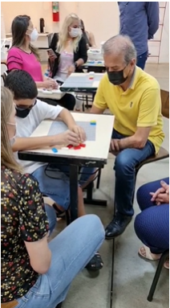
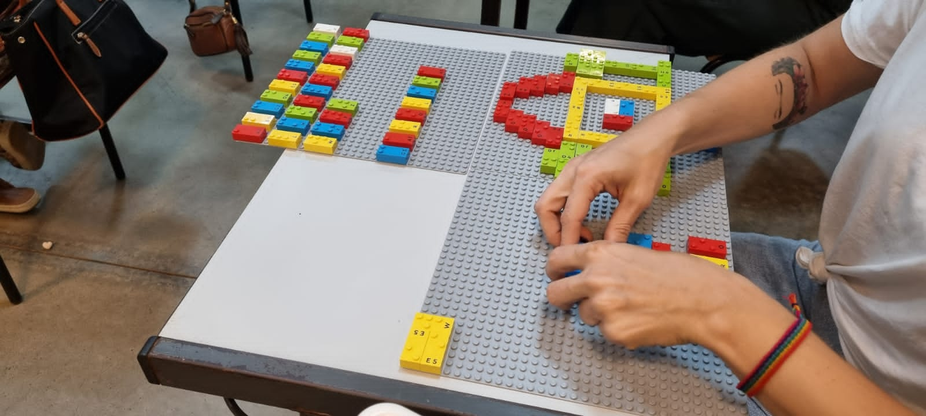
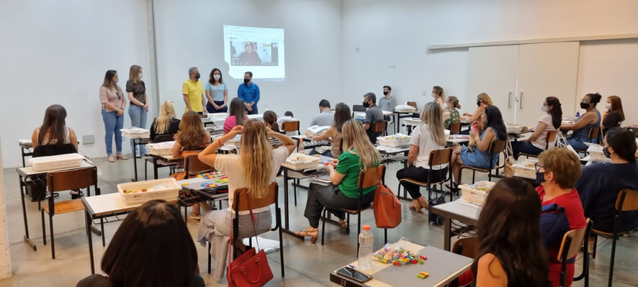
Image 9
Image 8
Image 7

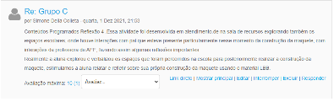
Image 11

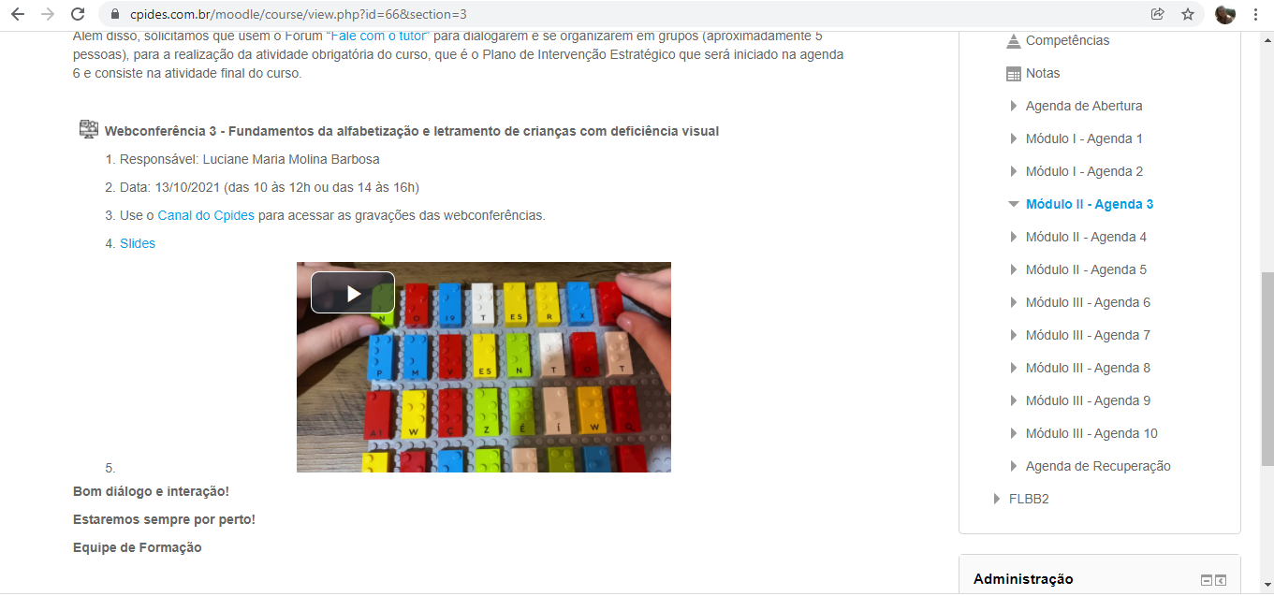
Image 10

Date: 11/23/2021
Event: WARNER Media Webinar.
Representatives: Alexandre Munck, Ane Olesen and Regina Fátima Oliveira

DISSEMINATION

Date: 11/14/2021
Action: Post about the LEGO® Braille Bricks Brazil Program on Facebook on National Literacy Day.

Date: 12/21/2021
Action: Interview for World Braille Day - 01/04/2022 - Boa Vontade TV

2021 HIGHLIGHTS

DISTRIBUTION OF LEGO® BRAILLE BRICKS KITS

- Number of kits distributed in 2021: 2,079.

DISTRIBUTION OF EDUCATIONAL KITS FOR THE TRAINEE PROGRAM

- Number of kits distributed: (150 custom bags, 150 notepads with braille cover, 150 custom sales)

ELABORATION, PUBLICATION AND DISTRIBUTION OF THE LEGO® Braille Bricks KIT USER MANUAL

- Formats: Braille, audio and digital

Number of copies in Braille: 1,000
Number of audio copies: 1,000
Digital: published on the Hotsite

The main actions developed by the LEGO® Braille Bricks Brazil Program in the first month of 2022 were:

Dialog with 21 cities to establish a partnership in the educators' training program:

- Salvador – BA
- Bataguassu – MS
- Campo Grande – MS
- Nova Andradina – MS
- Amparo – SP
- Barueri – SP
- Bauru – SP
- Campinas – SP
- Diadema – SP
- Guararema – SP
- Guarulhos – SP
- Itapecerica da Serra – SP
- Jandira – SP
- Limeira - SP
- Osasco – SP
- Poá – SP
- Ribeirão Pires – SP
- Santo André – SP
- São Bernardo do Campo – SP
- Suzano – SP
- Vinhedo – SP

- Organization for the delivery of LEGO® Braille Bricks kits to all the cities that took part in the dialogs;

- Pedagogical planning for the LEGO Braille Bricks training course for professionals in municipal education schools with visually impaired students.

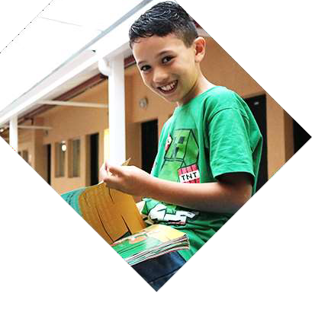
Dorina de Gouvêa Nowill (in memoriam): Emeritus and Lifetime President
Francisco Henrique Della Manna: President
Alexandre dos Santos Oliveira Munck: Superintendent

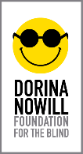

FUNDRAISING
+55 (11) 5087-0999 | ext. 0982
parceria@fundacaodorina.org.br

Street: Doutor Diogo de Faria, 558 – Vila Clementino
ZIP CODE: 04037-001 – São Paulo/SP – Brazil

+55 (11) 5087-0999

FOLLOW US ON SOCIAL MEDIA

