Vision of Community Development association (VoCDA)

Project proposal on "Tuchi Girls school attendance promotion through school furnishing", In Oromia National Regional State, east shewa zone, Dugda district, Ethiopia
Submitted to: Global giving for September fund Raising Campaign

Addis Ababa,
Ethiopia
August 2017

Project Description

Title: Tuchi Girls school attendance promotion through school furnishing,

Purpose: To improve girls school attendance and quality of targeted community school services through furnishing of the impeded school,

Implementing Organization: Vision of Community Development Association,

Submitted to: Global Giving for September fund raising campaign

Total project Cost: $ 40,075.00 US dollar
Global giving campaign share: US dollar 30,725 (76.67%)
VoCDA's share: US dollar 7,825 (19.53%)
Community share: US dollar 1,525 (3.8%)
Note: as per the current exchange rates $1UD=23 Ethiopian birr
Duration: one year (November 2017 to October 2018)
Location: Tuchi-dambal rural kebele in Dugda district, East Showa zone of Oromia Regional State/ Ethiopia

Contact Person: Dessisa Kabeta (executive Director)

Address: Akaki-kality sub-city, District /Kebele 6, kaleb building/House No. 224,
P. O. Box, 27771/1000, Addis Ababa
Tel. 251-911-67-35-71/251-114334698-night
Emails: info@vocda.org, vcda2003@gmail.com
Skype: dessisa2041

Addis Ababa, Ethiopia,

ACRONYMS

NFE Non Formal Education
NFPE Non Formal Primary Education
ACCESS Appropriate, Cost effective Centers of Education with in
School System
VoCDA Vision of Community Development Association
DPPC Disaster Prevention and Preparedness Commission,
MLC Minimum Learning Continuum
MLO Minimum Learning Out comes
UPE Universal Primary Education
PTEC’s Parent Teachers Education Committee’s
HTP Harmful Traditional Practices,
PA peasant association(sometimes/interchangeably called kebeles), which means the lowest administrative body of government in Ethiopia,

Table of Contents

Titles pages
Project Description 1
ACRONYMS 1
Table of Contents 1
I. EXCUTIVE SUMMARY 1
II. About Implementing Organization 1
III. Back ground to the project Area 3
3.2 Problem Analysis 4
3.3 Project Goal 5
3.4 Project Specific Objectives 5
3.5 Implementation Strategies 5
3.6 Schools furnishing Activities 6
IV. Project Management and Working Principles 6
4.1 Community’s contribution and Participation 7
4.2 RESULTS/OUT PUTS 8
4.3 INDICATORS 8
4.4 Training Activities 8
a. Community Awareness raising workshops 8
b. school construction 8
V. OPPORTUNITIES AND CONSTRAINTS 9
5. 1 Opportunities 9
5.2 Constraints 9
VI. Sustainability and Phase out strategy 9
VII. MONITORING and EVALUATION 9
a) Monitoring Indicators; 10
b) Evaluation indicators; 10
VIII. Management and Reporting of the project 10
IX. ESTIMATED PROJECT BUDGET 10
Appendix 1. Budgetary Breaks Down for the Year (2007) 11

I. EXCUTIVE SUMMARY
In Ethiopia the distribution of social infrastructure particularly school/educational opportunities has been found at poor level in that most schools are low facilitated where students have no desks, tables and chairs are missing in most rural elementary schools. On top of this to promote girls school attendance and raise their educational achievements girls and boys have no different latrines in the schools. All these infrastructural low facility has contributed greatly to the low educational attainment of mainly girls in most rural areas and this project area in particular.

Taking this lack of educational facility of the locality into account VoCDA has decided to undertake the issues through different actors’ participation and looking for fund. In this case the realization of this project believed to bring about significant changes in the educational attainment of the locality children especially girls by making the learning process more appealing and attractive. In addition to school facility the installation of the water points in the school compound help the locality children to get drinking water in their compound as they come from different drought prone areas where drinking water supply is very limited to some areas of the kebeles especially to those family members who are found at the vicinity of water line that was stretched from local water points.

The project planned to be completed within one year period from its commencement time on. The fund required for the project execution would be $40,075USD where the costs covered by different concerned parts (community, VoCDA and Global giving campaign raising).

II. Implementing Organization
Vision of Community Development Association (VoCDA) is non-profit making, non-political humanitarian development oriented secular indigenous organization. It has been undertaking various community development activities in the area of alternative basic education, adult litracy learning through reflection approach, women empowerment through promotion of SHG and food security through promoting of small scale irrigation in chronically drought affected area of Dugda, Dodota, Arsi-Nagelle and Adamitulu jido kombolcha districts of east of oromiya National regional state since 2003.

The initiative for organizing VoCDA originated from a professional interdisciplinary group comprising of development/economics studies, medical science, and social studies and workers who have extensive experience in development programs and or worked with poor and vulnerable communities.

Vision: To see prosperous communities where all community members use their capability and livelihood asset to realize a sustainable livelihood,

Mission: To empower poor, women and vulnerable households, to bring about sustainable development and positive social transformation; and promote human dignity for all citizens,

Mission Objectives:

Objective 1.
- To ensure that vulnerable households secure sustainable livelihood

Objective 2.

- To ensure that local level community institutions are able to adopt sustainable natural resources use and management

Objective 3.

- To ensure that vulneTuchi le groups (women, girls, children, youths and elders) are economically and socially empowered that enable them to bring equity and equality at household, community and national level.
- To promote and ensure quality and accessible education for all,

Governance and Management Structures of VoCDA is as follows:

S/N | Governance Structure | Membership | Overall Responsibility
1. | General Assembly | All member and organization’s personnel/staff | Highest supreme governing body of the Organization.
2. | Board (Executive Committee) | 7 members | The Board provides guidance overlook activities per plan
3. | of Senior Management team | 5 members | Day-to-day activities of the project
4. | The Project & general Staff | The rest of the staffs, (7-persons) | Day-to-day activities of the project

Projects implemented by the Organization so far: these are some the major project undertaken, however, not the exhaustive list of all project undertaken/ting by the organization,
Note: all currencies in this table are in local currency Ethiopian birr.
No | List of Project Names | Year  Started | Year  Completed | Donors | Budget  In Birr | Location | Beneficiaries
1 | Haroressa women grain grinding mill & Dirich school furnishing | March 2006 | August 31, 2008 | Netherlands Global giving | 180,000 | Oitu Basuma rural kabele of Adamitulujido kombolcha district | 60 women groups and about 350 school aged children of the locality
2 | Meki-Oitu Women income generation schemes capacity building | April 2005 | March 2006 | German development Service (DED) | 46,250 | Adamitulu-jido-kombolcha Oitu-basuma PA and Meki town | 90 women members and their respective family's
3 | Hurufa school capacity building or funishing | April 2008 | March 2009 | BEN-Ethiopia | 105,000 | At Hurufa PAs same district above | 350 school aged children’s
4 | Household Dairy Enhancement Project  In Oitu locality | June 2006 | May 2008 | Helvetas-Swiss Association for international cooperation | 159,826 | 3 PAs of Meki town surrounding | 1,864 community members (80 HH beneficiaries)
5 | Environmental rehabilitation in Northern Langano and Abjata lakes areas | November 2007 | February 2013 | UNDP/GEF/SGP | 950,000 | 5 rural kebeles of Adamitulu jido kombolcha district | 1500 targeted women’s and majority of the kebeles dwellers
6 | Girls educational attainment enhancement project, | April 2007 | December 2010 | Action Aid Ethiopia | 316,000 | 5- rural kebeles in Adamitulujidokombolcha and Arsi-nagelle district s | 1,250 school aged children’s out of which 45% were girls,
7 | HH food security attainments enhancement (through SS irrigation and women IGA) | October 2008 | On going | Dan Church Aid | 3,034,000 | Two rural kebeles of Arsi-nagelle district | 400 women’s and 200 men
8 | Women empowerment through literacy and IGA | June 2009 | On going | Dvv.IWEP program | 1,445,000 | 6 rural kebeles of adamitulujidokombolcha district | 406 women
9 | Women’s economic empowerment | October 2010 | On going | KNH small grant program (CF) | 287,800 | 2 rural kebeles of adamitulujidokombolcha district | 112 women HH heads
10 | Girls empowerment through education | April 2008 to March 2010 | Completed | Action aid | 450,000 | 5-rural kebeles | 4,580 school aged children's out of which 45% were girls,
11 | Small scale irrigation for livelihoods enhancement | October 2009 January 2012 | Completed | DCA/Dan Church aid | 4,250,000 | 2 rural kebeles | 650HHs poor family,
12 | Livelihoods and value  chain for honey producers | August 2013 to December 2015 | Completed | SNV/Netherlands development organization | 2,760,000 | 4rural kebeles | 1100HH head poor farmers
13 | Environmental Rehabilitations and livelihoods enhancement | June 2013 November 2016 | Phase 1 completed | Tree aid UK | 3,250,000 | 5-rural kebeles | 850HHs head poor farmers
14 | Natural resources conservation and livelihoods enhancement | June 2017 | Phasse-2 On going | Tree Aid UK | 7,254,000 | 7-rural kebeles | 2520HHs head poor farmers
15 | Women socio-economic empowerment and disaster risk mitigation | September 2016 | On going | CoSAP/  KNH/EU | 458,000 | 4 rural kebels | 1100-HH poorest women

VoCDA is legally re-registered as Ethiopian resident charity and has signed operational agreement with the Federal democratic republic of Ethiopia ministry of justice (society and charity agency). As well as made project agreement on different projects with the Oromia Education Bureau, Agriculture, water and women and Children's affairs and finance and economic development bureaus).

III. Back ground to the project Area

The target area for the envisaged project is situated on the southern direction of Meki town capital of the district. The Tuchi-dambal PA is consists of total population of 4,025. The kabale is located at the south direction of Meki town at the distance of 20 km. Though it lies very close to the Addis Ababa, the capital town of Ethiopia, on Moyalle highway the locality is characterized by very low socio-economic infrastructure. It is also characterized by high soil erosion, land degradation, severe deforestation, and drought. As a result of this hunger and poverty are the main frequent phenomenon that affected the livelihoods base of the locality community.

The economy of the locality is mainly based on subsistence mixed farming practices with high tendency towards traditional livestock production until the very recent time. Most of the inhabitants of the locality were leading a semi-nomadic way of life. Most of the time, the area faces severe shortages of food due to lack of adequate rainfall. Food insecurity is endemic both at household and community level. The locality is predominately settled by the Oromo. Altitudinally, the locality lies at 1500 - 1600 meters above sea level and the temperature ranges between 25⁰c - 30⁰c. Topographically the greater part of the locality is characterized by flat plains, hilly and mountainous features prevail in the western part of the locality where it borders with southern nation nationality and peoples state.

With respect to educational coverage the locality community has got access to elementary schools thanks to the non-formal centers constructed by NGOs and government schools constructed in the locality. By now there are about two elementary government run schools in the kebele that serves more than 1000 children’s of the locality. Though it is hard to say the school coverage is 100% the locality school access is better in comparison to other locality. However, the quality of the schools found at very poor condition. There floor is not cemented, no students desks, no sufficient classrooms to accommodate the whole locality school aged children’s as of the school directors and kebele administration information. No separate latrines and even well furnished sanitation rooms in the school compounds, as a result of this girls forced to drought out of schools.

3.1 Problem Analysis

The educational infrastructure and expansion in this particular kebele was very poor as that of the rural of Oromia, in particular and Ethiopia in general, along with its supportive service was at its lowest stage both in quality and quantity terms. The low education facility and expansion has greatly affected girls from attending schools than boys. This can be expressed in two way. On the one has low facility schools which lacks simple services like latrine ashamed girls not to go to same latrine with boys that is uncovered and open spaces. On the other hands lack of expansion which attributed to community traditions which hold girls in home than sending to schools in town/far places in fear of eloping. In the (Dugda), district of this project areas, 3-years ago the primary level enrollment rate at district level is male 9,929(99.29%) and female 9,794(97.94) all together 1,9723 which is about 97.57% where as the enrolment of the secondary school is male 2,137 female 1,605 and all together 3742.despite noticeable effort to increase primary enrolment ratio, there are still many school age children (mostly girls) who are out of school in most rural kebeles of the district .

On the other hand, the current condition of school facility in the locality and district as a whole justify that there are many quality based problems stated below:

- Lack of teaching materials and aids,
- Lack of student and teachers’ desks and black boards,
- The falling down condition of most of the classrooms,
- The very low school participation rate of girls because of cultural taboos and low facility girls prefer to dropout at early stages,

The impact of the existing formal education facilities is very much limited because of limitations in textbooks, lack of school and in sufficient numbers budget constraints and over crowding in one class room. All the indicators show that female school attendance and educational attainment are very low in comparison to that of males because of lack of facilities that hindering the bringing in more girls.

Effect of the Problems: All the problems are inter-linked and mutually reinforcing, and they demand an integrated approach, which considers them in totality, and address them accordingly. VoCDA believes that the educational standard of the particular society has an impact on the general socio-economic cultural and political set up of the society and has linear relationship. It is unlikely to achieve increased productivity, reduced population growth, self-reliance, eradicated HTP’s, good governance, self-confidence etc. in an illiterate and economically poor society. So to pave the way for development it is necessary and mandatory to have formal schools in the low facilitated locality. In this regard the furnishing of this school believed to improve the educational attainment of children in general and that of girls in particular. In addition to rising enrollment the quality of education would be improve taking into account the school furnishing would fulfill the needed facility for better school environment and pave the way for better learning outcomes.

3.3 Project Goal

The long term development objective of the project is to improve the girls school attendances and contribute to educational statuses development of the targeted community,

.4 Project Specific Objectives

The specific and short -term objectives of the project are:

- To furnish and construct latrines/classes in Tuchi elementary school so as to increase the educational quality in the locality,
- To make a conducive learning environment for girls and boys equally and promote gender sensitive educational approach,

3.5 Implementation Strategies

To make the planned objectives practical and visible VoCDA together with local community will form project committee’s as usual at kebele and school. As per the design in this project document the implementation of the project, the government line department also will undertake the activities of project monitoring, supervising and evaluating at each process of the project life. Especially the furnishing and construction part of the project to check whither it is going as per set objective or not. VoCDA through its head office and project education officer and social workers would mobilize the community with the project committee to participate on the schools community and make ready for materials purchase and preparations.

To increase the level of involvement of the community, education committees will be formed which have a major role in the establishment and running of the schools. Moreover, they will conduct quarterly community meetings on school construction in cooperation with school administrative bodies and teachers.

Concretization forum will be organized through PA education committees to enable the community to discuss on the importance of education, its role in the development, the need for girls education, non formal education approach and ways of creating sustainable means to provide formal education to children, women’s gender issues & encourage the participation of adults in each NFPE/ACCESS center to share ideas & experience formulating plans to improve existing educational system for two day at the beginning of the project.

3.6 Schools furnishing Activities

Through furnishing and finishing some already serving classes and construction of one more classes to develop the quality services of the school in the locality. Furthermore, effective implementation of this project envisages the achievement of positive influence on improving the quality of education and access of girls’ education.

The Tuchi already existing schools will be furnished and completed. The construction of the schools comprising of the following main activities:

- One blocks for staffs and offices comprising one store rooms floor cementing/flooring,
- 200 student desk purchase,
- 8 teachers tables and 12 chairs purchase,
- 4 plane board and or black board purchase,
- 1 additional learning class rooms constructions (an extension of existing 3 class rooms)
- Construction of 2 latrine/toilets for boys and girls separately,

IV. Project Management and Working Principles

The existence of the school at the locality has given the locality children good opportunity to attend the school in their vicinity. However, lack of sufficient facility in the school like furnishing and supplying different school materials were the current question of the local community and the local government. Furthermore, the furnishing and supplying of educational materials for this school has play a vital role in increasing the enrollment of both girls and boys students in the locality and minimize the dropout rate of both girls and boys. Beside this it has also a great contribution in assuring the quality of child’s education and motivation.

Some of the activities of the school furnishing will be under taken by community using locally available low cost materials and the remaining furnishing cost would be VoCDA and Global giving raised fund used to buy materials like corrugated iron sheets, eucalyptus tree for roofing and poles, holly blocks for constructions, student benches, cements, tables and chairs for teachers and sands, skilled professional fees and cements. VoCDA will have the coordinating, supervising and controlling functions in the construction process. It is expected that the construction of the centers will take six to nine months. Up to the finishing of the constructions the teaching and learning process will be commenced at already constructed centers/classes as before.

VoCDA will enhance its involvement in achieving the universal primary education for all (Sustainable development goal), which is one of the basic human rights. It will also work with other similar agencies that the UN convention on the rights of the child is being promoted or implemented. VoCDA believes that this project will only be successful if it is properly managed and will be developed. Hence, organizational arrangement and management would be structured with various entities in order to accomplish pre-designed tasks of the project. The beneficiaries would participate in the project management as to ensure the success of the project and promote self-management by the community members so that they can easily make viable and sustainable the project after realization. To this end direct assistance and frequent monitoring will be undertaken by VoCDA and government education office to ensure the sustainability of the project. To assist and follow the activity of the project in nearby, VOCDA’s field or branch office would established within a radius of close proximity to the beneficiaries to facilitate that the project is smoothly operating. Furthermore, institutional sustainability will be ensured through the strengthening of beneficiary based structures and encouraging a democratic culture from village to the community level.

Moreover, good work relationship and partnership will be developed with pertinent local government offices such as education office and district/wereda administration which have direct relationship with the project to ensure the sustainability of the project. Close relationship and partnership will be made between VoCDA and the government stakeholders and/donors, throughout project cycles from inception to evaluation stage of the proposed project.

4.1 Community’s contribution and Participation

Community contribution is the most important and reasonable issues so as to assure the sustainability of the project and to attain the desired objective of the project. In this regard the contribution of the community will be in labor, cash and the selection of school administration and community mobilizing committee at kabale and school level. These committees will undertake activities of organizing and mobilizing the community for school construction and other social infrastructures fulfillments, especially on the community share work to be done.

The community has shown their willingness, commitment and high interest in education when they voluntarily construct centers for a non-formal basic education in the past few years, which were being run by our organization in the 6 rural kebele and already hand over to the local government office . Currently in the same manner the community also showing its keen interest to furnish and up grade the existing school through expressing its interest to VoCDA project men during this project needs assessment.

4.2 RESULTS/OUT PUTS

1. Increased number of children attending formal education, out of which 50% expected to be girls)
- Gross educational participation rate of girls in primary level will be increased,
- School facility and favorable learning environment will be available at the respective kebele,
- Locality’s educational quality and status rose
- Students drop out rate especially Girls minimized and enrolment increased,
- the school community would get water services in their school compound,

4.3 INDICATORS

- Increased gross school participation rate of community’s students in the locality,
- Increased school participation of girls,
- Finished and furnished, bought and put in place materials and classes and latrines constricted,

4.4 Training Activities

a. Community Awareness raising workshops

To increase the level of involvement of the community and feeling sense of ownership, parent teacher committee (PTC) will be formed. The committee will have major role in school construction and mobilizing the community for the work. PTC will identify & locate rooms for schools constructions, define school construction schedule & mobilize with kabele administration committee. They will serve as social development cadres during project sensitization workshops.

These committees will be selected by the community to effectively manage school construction and each activity in the school and also to encourage community members to send children to schools and follow up the subsequence of girl’s education in especial attention ’. Moreover, the committee has comprised 7 men among which 3 should be women conduct monthly community meeting & monitor the progress of construction work at the kebele level.

Concretization forum will be organized through PTC’s to enable the community to discuss the importance of education, in their vicinity, its role in development and ways of creating sustainable means to provide basic education to their children etc.

b. school construction

As it is stated in the project proposal the construction of the school have two parts. The first part to be undertaken by the community and the remaining especially locally unavailable materials would be supported by project fund. The high technical part like floor cementing and the like works will be contracted out to the professional/s.

V. OPPORTUNITIES AND CONSTRAINTS

5. 1 Opportunities:

- Existence of full community participation,
- Availability of rich experiences and appropriate expertise in the market.
- Good Government attention for quality of education and to construct elementary schools in each rural kebele,

5.2 Constraints:
1. Unexpected increment of the price of the construction materials due to the
current market situations,
- Dependency on short term and small-scale financial support,
- Endemic drought in the target area,

VI. Sustainability and Phase out strategy

Since the inception of ACCESS centers in this project area the community was fully participating on center construction and management. Furthermore, the government is also focusing on similar approach to promote the educational status in each PA particularly first cycle elementary schools are under attentions. At the Regional level strong linkage and mutual support from the district and regional education offices has been secured, previously when VoCDA was undertaking non-formal basic education centers in different kebele including this kebele and currently when VoCDA undertaking need assessment from community and concerned education office of the district. On top of that there is a global primary education for all objective at 2015 to reach with primary education all school aged children’s that forced all of us who are concerned with educational development.

Thus community’s need and government willingness to spread/open primary schools at all rural kabeles would give the sustainability to these schools. Since the Government is already cover all running costs and assigns teachers and teaching aids with some administrative costs and the school community from among the community would lead the supervision and other administrative tasks, there is no much doubt on the sustainability of the school in the area.

By and large, the strategy that is followed and believed by VoCDA to phasing out strategy is that, building the human capacity through various training, workshops, experience sharing visits, educational status upgrading and women’s right advocacy rendered to beneficiaries will upgrade & strengthen the beneficiaries project management capacity and understanding about the current and future sustained need of education & its impacts and make them to be committed to manage and implement the project in the absence of any external bodies. To this end VoCDA and government office will organize community project committee or parents representatives who overlook the now and future implementation of the school in the locality in addition to already assigned school teachers in the locality.

VII. MONITORING and EVALUATION

The effective implementation of the programs envisages the achievement of improved living condition, educational status, & sustainable community development. Therefore, to measure the achievement of desired objectives, VoCDA together with the community & concerned government institution will monitor & evaluate regularly the programs against desired objectives from the beginning as well as at the end of the project and/or on the fiscal year basis. The day-to-day activities of the project will be monitored by VoCDA and the community PTC’s and school administrators where as with donor agencies & government offices on quarterly basis. Moreover, evaluation will be made progressively & at the end of the project life period on team basis to assess the achievements of desired objectives and impact of the programs in general. In the process of monitoring & evaluation the following indicators will be used.

a) Monitoring Indicators;

- Community participation both in labor and materials as necessary,
- Number of class rooms and staff rooms furnished and new constructed,
- Number of desks, chairs, tables and blackboards supplied,
- Number of latrine/toilet constructed,

b) Evaluation indicators;

- Quality of schools furnished in terms of Oromia education Bureau standard,
- Number and quality of materials bought and supplied,
- Community satisfaction on constructed schools.

VIII. Management and Reporting of the project

VoCDA’s Head Office in Addis Ababa is the apex of the intended project. The Office facilitates the support of concerned government offices and donors and communicates on the feedback of the implementation progress of the project.

Government Offices at District level (education Office) will also play a great role in the project supervision and rendering technical supports to the construction works.

The facilitators trained by VoCDA at kebele levels are also responsible to facilitate the construction activities in the respective PA in collaboration with project officer and the community committees.

With respect to Reporting, our reporting includes financial and activity report. The monthly activities report will be done at kabele by facilitators to the project officer. The project officer also prepares a month financial and activities report and send to the VoCDA head office and district line departments. In its turn VoCDA head office will report activities and financial report to the concerned government offices and donor on quarterly or bi-annual bases depending on the agreement reached.

IX. ESTIMATED PROJECT BUDGET

The total project costs for the envisaged project is $40,075US Dollar. It is expected that the shall be community participation in terms of financing part of the project costs particularly in covering constriction and other costs by supplying local materials and unskilled labor.

The overall one year project cost for each component is indicated in subsequent tables.

Appendix 1. Budgetary Breaks Down for the Year (2017/18) for
Schools Furnishing and Equipping Project
Currency in US Dollar
No | Description | units | Qnt | VoCDA Share | Global giving Share | Community Share | Total cost
1 | PERSONNEL  a. Full time project officer at 8,800 Birr/month. | Person | 1 | 4,591 | 0 | 0 | 4,591
2 | Project office rent cost share | Months | 12 | 2,087 |  |  | 2,087
3.1. | Workshops for 8 participants from government office (education office, kebele & wereda administrators, women’s affairs,) x birr70/psn/d x 2 ds, per diem for them | Pers. | 6 | 49 | 0 | 0 | 49
3.2 | Per diems for 36 community representatives and school committees from 3 kabeles 35 birr/person | ‘’ | 36 | 110 | 0 | 0 | 110
3.3 | Refreshment for 46 participants 5 birr/psn 2 sessions at Meki town | ‘’ | 46 | 40 | 0 | 0 | 40
3.4 | Per diem for 2 trainers x birr80/psn/d x3ds including transportation days | ‘’ | 2 | 21 | 0 | 0 | 21
3.5 | Stationery for trainees 5/psn/60 | Lumps |  | 13 | 0 |  | 13
3.6 | Hall rent for 6 days 250birr per day | days | No | 22 | 0 | 0 | 22
3.7 | VoCDA training facilitators 2men x70x4dys | ‘’ | ‘’ | 12 | 0 | 0 | 12
 | Sub Total |  |  | 6,945 | 0 | 0 | 6,945
4 | CONSTRUCTION and OTHER COSTS  additional class rooms construction (support iron sheet & eucalyptus trees)
 | - School furnishing costs
 | 1. Iron sheet purchase (105 ironsheetX2classesX225birr for additional 1 class room and 2 latrines | No. | 155 | 0 | 1,525 | 0 | 1,525
 | 2. Eucalyptus trees & trace-membranes for roofing, including different nails, | 250 | 0 | 0 | 1,630 | 0 | 1,630
 | Grilled windows and doors) purchase, | No | 6 | 0 | 1,700 | 0 | 1,700
 | 100 Students desks purchase including transport | No | 100 | 0 | 6,525 | 0 | 6,525
 | Hollow blocks for wall constructions including transport | No | 3,850 | 0 | 2,525 |  | 2,525
 | Cements for constructions including transport | Quint. | 155 | 0 | 2,525 |  | 2,525
 | teachers tables and chairs including transport | No | 20 | 0 | 1,610 | 0 | 1,610
 | sand for flooring | car | 12 | 0 | 2,650 | 0 | 2,650
 | blackboards and duster | No. | 6 | 0 | 220 | 0 | 220
 | stone for flooring 18 cars | car | 18 | 0 | 3,930 | 0 | 3,930
 | professional labor costs of the construction s | Contr. |  |  | 8,500 | 0 | 8,500
 | Paints for the school furnishing | Gallon | 35 | 0 | 990 | 0 | 990
 | Land excavation and paving lands for constructions | lumps | 0 | 0 | 0 | 1,525 | 1,525
 | Materials for latrines equipments | Lumps |  |  | 1,250 | 0 | 1,250
 | Sub-total |  |  | 6,945 | 30,725 | 1,525 | 39,195
6 | Monitoring and Evaluation
 | project supervision costs monthly and quarterly (by government, VoCDA and stakeholders 6 persons 70 birr for 20 days),  Evaluation costs 8 persons for 2 days  materials guarding fees (9 monthsx150 birr)  Project Office rent (300/month)  Office utilities (650/month)  Fuel for supervision and evaluations 600 birr | Days  ‘’  person  months  month  ‘’ | 20  2  1  12  12  12 | 0  0  157  340  122  261 | 0 | 0  0  0  0  0  0 | 157  340  122  261
 | Sub-total |  |  | 880 | 0 | 0 | 880
 | Total Project Costs |  |  | 7,825 | 30,725 | 1,525 | 40,075

Appendix II. Project Action Plan
School furnishing project
The project implementation time table would be stated as follows.
No | Activities | Implementer/s | Time | Place | Out come | Remarks
I | General Conduct:
2 | Project design and securing fund | VoCDA | During the first one month of the first quarter |  | Fund secured | Project done
II | Schools construction and Training
1 | Community representatives orientations on the commencement of the project and its task | VoCDA & district admin & education offices | The second month the first 2 weeks | At Meki town | Awareness creation training for 150 community members
2 | Whole community orientations and Identification/selection of PTA members | PA Administrators & VoCDA | The last two weeks of the second month | At Tuchi PA | PTA members identified & community’s project awareness raised
3 | Materials for schools furnishing and finishing supply and contract out to professionals | Community & VoCDA, | The second quarter ,the second two months, | At Tuchi PA | The Tuchi school ready for furnishing | With community participation
4 | Completing of furnishing and finishing of schools | VoCDA community | The last three four months of the fourth quarter | At Tuchi kabele | 3 schools will be ready for formal teaching and learning process | Schools facilities secured in the kabeles
5 | Project supervisions by concerned stakeholders | VoCDA, district Education office, PTEC’s, and donors/others | Each quarter of the project life | At each kebeles | To see the appropriate running of the project as per the planned
6 | Final evaluations | All stakeholders | Last month of project ending | At Tuchi kabele | To see the impact and outcome of the project

Fig shows while community took part in school constructions in their locality through local materails and labor contributions
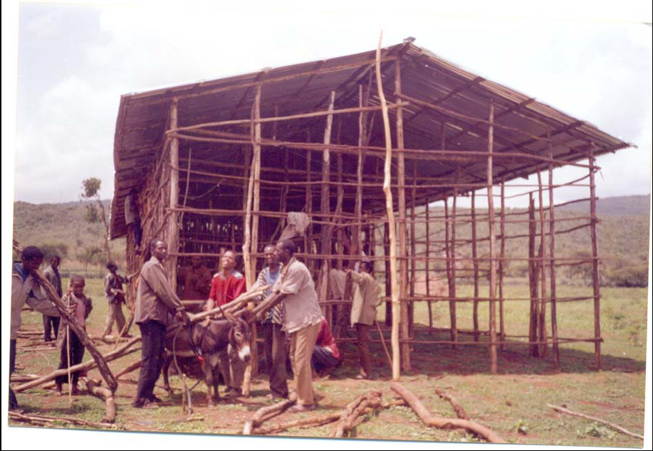
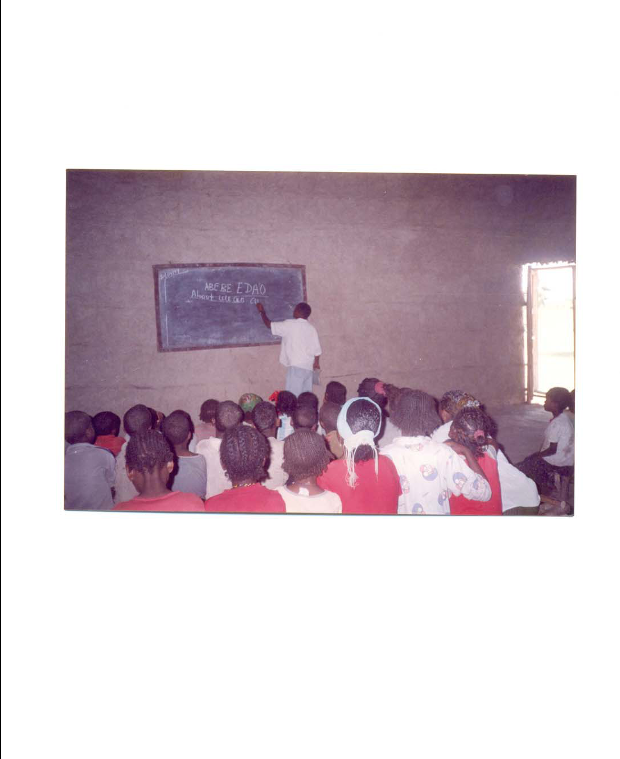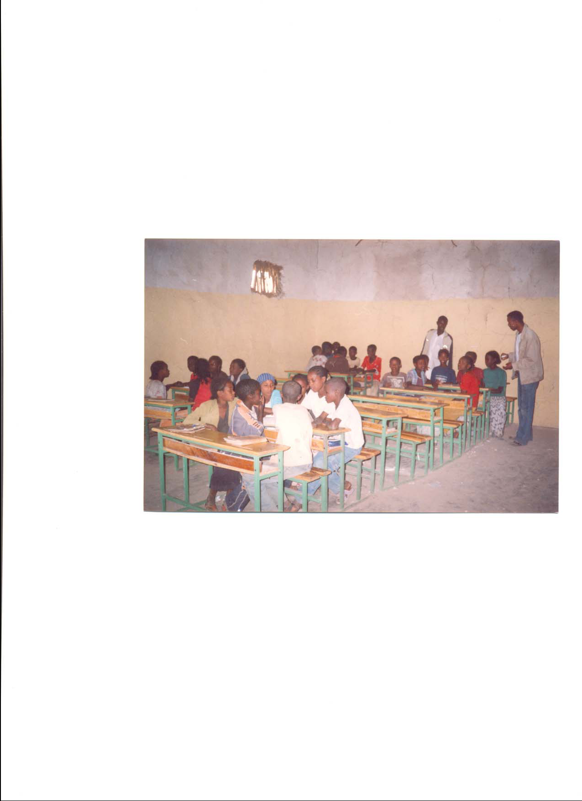

Figs shows while chider's attending schools in their locality,

