Mini managers work prevention in their community

Background:
Peru was affected by the phenomenon of the child at the beginning of 2017, due to the heavy rains that this generated, most of the coastal zone of Peru was devastated by this phenomenon, many places in our country were affected but the Trapiche area the most economic, material and social losses.
The town of Trapiche, located at the height of kilometer 39 and a half of the Canta wagon, was about to disappear due to the overflow of the Chillón River. The town of Trapiche was isolated for several weeks, unable to meet their needs, likewise about 100 homes in Trapiche Bajo (Las Brisas) suffered damage to their structures, most of the population of Las Brisas was devastated.
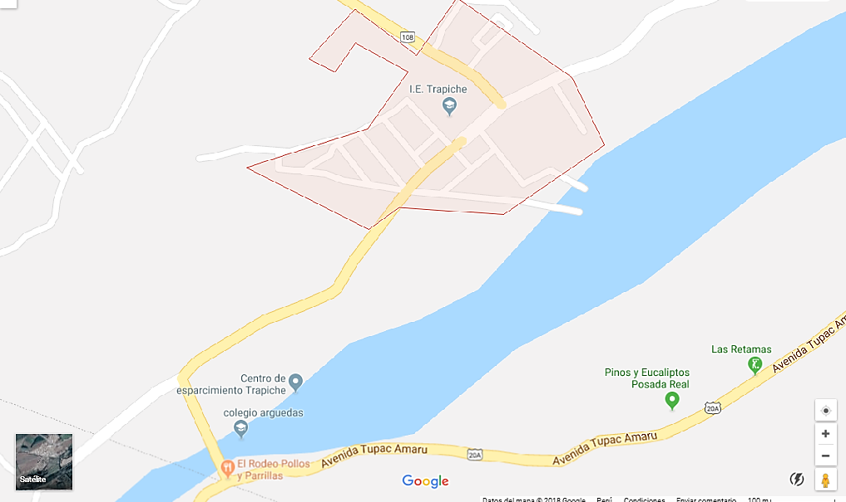

Fuente: Googlemaps

Problem:
Girls and boys between the ages of 10 and 16 in the trapiche area (La brisas) are affected emotionally and psychologically by the disasters left by the phenomenon of the coastal child.
Target Population:
The situation in the Trapiche Zone overwhelmingly affected its inhabitants, which is why in this project our target population includes 70 girls and boys between the ages of 10 and 16 in the area of Trapiche (Las Brisas) in vulnerable situation after of having been affected by the phenomenon of the coastal child.

General Objective:
Identify girls and boys between the ages of 10 and 16 years of the Trapiche Zone (Las Brisas) who have or have not been through natural disasters, who have the potential to strengthen their leadership skills and social commitment to their community, and to be able to train an organization or brigades that helps to prevent and raise awareness about disaster risk management in order to protect the life, health and social, physical and economic integrity of the people who belong to this community.
Resultados Esperados:
• 70 girls and boys trained with their capacities of leadership and social commitment empowered.
• Girls and boys organized in brigades to raise awareness in their community
• Parents aware of the theme of Disaster Risk Management
• The community of Las Brisas conscientized and organized to prevent future disasters.
Activities:
• Coordination with the population of the Trapiche Zone (Las Brisas) for meetings with residents and with the Municipality of Santa Rosa de Quives
• Coordination with parents or heads of Las Brisas family to hold a workshop with their daughters
• Coordination with the representative of the educational institution "Juan Velazco Alvarado"
• Development of soft skills strengthening workshops and knowledge in disaster risk management in community spaces
• Development of workshops on strengthening soft skills and knowledge in disaster risk management in the educational institution
• Organization of the youth brigades in the community of Las Brisas
• Collective simulation activities for brigades in disaster situations
• Installation of the youth office for disaster risk prevention and management

Long-term Impact:
• Creation of a juvenile commission for the prevention of risks and disasters in the school I.E "Juan Velazco Alvarado" and in the neighborhood council of the Zona de trapiche (Las Brisas)
• 70 empowering girls and boys on the topic of disaster risk management.
Rode | Activities
$ 100  $ 100  $ 50  $ 4000  $ 4000  $ 1000  $ 4000  $ 2000 | • Coordination with the population of the Trapiche Zone (Las Brisas) for meetings with residents and with the Municipality of Santa Rosa de Quives  • Coordination with parents or heads of Las Brisas family to hold a workshop with their daughters  • Coordination with the representative of the educational institution "Juan Velazco Alvarado"  • Development of soft skills strengthening workshops and knowledge in disaster risk management in community spaces  • Development of soft skills strengthening workshops and knowledge in disaster risk management in the educational institution  • Organization of the youth brigades in the community of Las Brisas  • Collective simulation activities for brigades in disaster situations  • Installation of the youth office for disaster risk prevention and management
$ 15 250 | Total

