HELP EDUCATION WITH HUMANITY (HEH)
Name of organization | Tribal Culture and Rural Development Agency
Title of proposed project | “Lift Me Up” School Project proposal for funding
Amount needed | $ 99,810.56
Location of implementation | Chandel, Manipur, India
Point of contact, Phone, Address | Mr.  Mobile Phone No: +91 7629 011 306,7085306779  Japhou bazaar Riverlane, District Headquarter,  Chandel, Manipur, INDIA.  P.O: Chandel  Pin – 795 127
Please insert here the Photo of the place where you want to build the Classroom

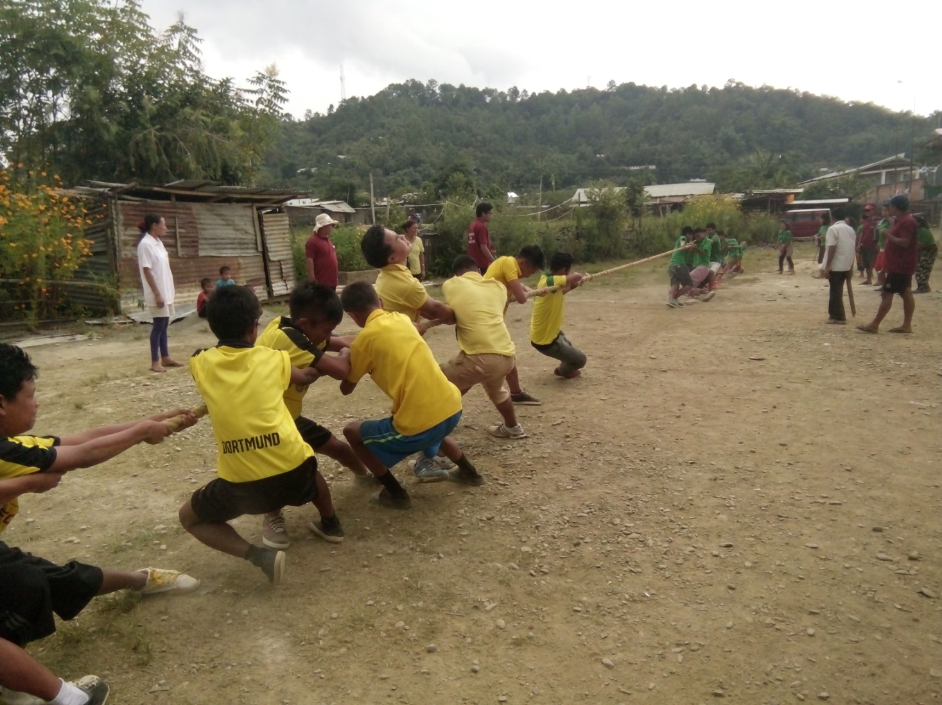

EXECUTIVE SUMMARY (200 character limit)

Oriental Academy, an English medium school with a motto “ Blossom with Discipline” is run and established by an Organisation called “Tribal Culture and Rural Development Agency” which provides education to rural and poor tribal children in the most backward district, Chandel in the State of Manipur, INDIA.

The School has been providing quality education to the children of Tribal’s who cannot access education due to poverty and ignorance by their parents. The objective of the school is to mould children in the best way and to develop their hidden talents with holistic approach to education, and providing them to learn joyfully with humanity. 40% of the students in the school are supported on full scholarship provided by the Ministry of Minority and Other Backward Classes (MOBC), Government of India and the Department of Tribal Welfare Government of Manipur. 10% of the students are supported by this organization. The rest of the students pay a nominal and subsidized fee.

Under this project the school wants to help out to another 200 students of remote area tribal children to have access to quality school education by building 5 more class rooms, reduce the school drop out of the area by providing school bus for attending schools on time avoiding long distance walk, continue to provide scholarship to the tribal children by working together with MOBC and Tribal Welfare Department of Manipur, make the students have access to Information & Communication Technology through Computer Courses by installing 20 more computers and provide space and learning friendly furniture to ensure quality education in the school through this project.
The Agency shall continue to generate awareness to the ignorant villagers, motivate and closely work with the local communities, other NGOs, Government Departments and local authorities and make the community generate sense and fully support.
PROJECT RATIONALE

Chandel district of Manipur is one of the remotest and poorest districts. Still there are many families living below poverty line (BPL) and are unable to send their children to schools for education in spite of free primary schooling offered by the government because parents wants their children to help them in earning the families daily bread.

Though the government schools provide free education there is no quality education in majority of the government schools in the district. Some of the factors are – no proper school buildings in many of the schools. If there is school building there is want of proper furniture, Teachers, Teaching materials, etc. In schools where there are good schools building and teachers are in place there will not be proper teaching materials and very poor school management.

Therefore students many students drop-out from their schools, many children have no access to school education, and many students who are attending schools are in schools without quality education. The result is that Parents run after private schools for their children education. Private schools put every possible effort to provide quality education. However, private schools due to lack of resources are unable to intake many poor and needy students.

Therefore proposal of construction of 5 classrooms to accomdoate 200 poor and needy children to provide quality education at minimal fees, providing pick-up and drop services for the poor and needy students living within the distances of 3 to 7 kms from the Agency’s school by schools bus, supporting the school classrooms with learning friendly furnitures – Desk & Chairs, Teaching & exhibition boards, Teachers Desk & Chairs and providing Computer supported education for school children with friendly furntitures and training for unemployed youths and government servants in Computer/ICT for self employment for this poor, remote and uneducated or poor literacy pocket is justified.

Problem Statement

The state of Manipur can be geographically divided into two areas: the hills and the valley. The hills comprises of 5 districts while the valley comprises of 4 districts. Chandel belong to the hill districts of Manipur. As per 2011 census Chandel district recorded a literacy rate of 71.11 percent, out of which 77.78% are males and 63.96 percent are females. Chandel district stand the lowest in literacy rate among all the nine districts of Manipur battering only Tamenglong district.

In recent years, various steps and measures have been undertaken in the form of meaningful partnership of the Central and the State Government. Among them, it is worth mentioning that Sarva Shiksha Abhiyan (SSA) was launched in the state of Manipur in 2005. SSA is an initiative to universalize and improve the quality of education through decentralizes and specific planning and a process based, time bound implementation strategy.
Though the state as well as the central government pumped in a large amount of money towards education, most of the government schools in the hill districts are still without proper classrooms, laboratory and lavatory facilities, benches and desks, blackboards and dusters.

93.33% schools owned a building although the physical condition of the elementary schools in this district is far from satisfactory. The remaining 6.67% schools conducted their classes in a rented building. Dilapidated school building conditions without proper fencing was observed in most of the elementary schools in Chandel district. Only 32.14% of the elementary school buildings were pucca type while 39.30% were semi pucca and 28.56% were kaccha types. Further, 73.33% of the school headmasters were not satisfied with the condition of their school buildings. 44.45% headmasters also stated that they faced problem in organising co-curricular activities owing to paucity of space.

Classrooms and its furniture
There were 94.44% elementary schools having separate classrooms for all standards, while the remaining 5.56% schools conducted classes in a large room without partition. However, the conditions of the classroom partitions were quite unsatisfactory. Classroom partitions were made of bricks in 33.33% schools, plywood in 11.11% schools, mud in 10.00% schools, bamboo in 6.67% schools and temporary partition such as removable tin and plywood in 33.33% schools. Majority of the schools did not have sound proof partition between the classrooms posing disturbances for the teachers as well as students.

The elementary schools under study provided benches and desks in their classrooms. 82.22% elementary schools provided black or white board, 53.33% and 45.56% elementary schools provided chairs and tables respectively. And, only 11.11% elementary schools provided cup-boards. The study showed that there was shortages of furniture in the district as some of the elementary schools were running without blackboard, chairs, tables and cup-boards.

It was revealed that majority (75.56%) of the elementary schools were provided with teaching staff room. However, only 36.67% elementary schools provided headmaster’s room and 28.89% schools provided office room. 4.44% elementary schools provided non-teaching staff-room, and 17.78% schools provided computer room. It was also revealed that there was shortage of rooms for different staffs in most of the elementary schools. And in this age of technology where computers are the basic requirements for students there was no computer facility in majority of the elementary schools in the district.

Enrolment Position
Status of student’s enrolment is one of the most important factors indicating the quality of any institutions. The position of student’s enrolment increased every year in 63.33% of the elementary schools. It remained constant in 23.33% schools and decreased every year in 5.56% schools. However, student’s enrolment was not consistent in 7.78% elementary schools.

Enrolment of students is highest in private management schools followed by government schools, and government aided management types. Regarding reservation, 64.44% elementary schools provided reservation for physically challenged children.

Objectives

Under this project the school wants to help out to
- another 200 students of remote area poor and needy tribal families to have their children access to quality school education by building 5 more class rooms,
- reduce the school drop out of the area by providing school bus for attending schools on time avoiding long distance walk,
- continue to provide scholarship to the tribal children by working together with MOBC and Tribal Welfare Department of Manipur,
- To facilitate & provide quality education, Computer Subjects/courses and ICT courses will be strengthen by installing 20 more computers;
- To provide ICT training courses to unemployment youths during class-off time for self employment and to Government Servants to enhance their job performance.
- Provide quality education environment classrooms by installing locally made Desk & Chairs for students and Teachers.
- The Agency shall continue to generate awareness to the ignorant villagers, motivate and closely work with the local communities, other NGOs, Government Departments and local authorities and make the community feel the importance of quality education and make them fully utilized the available educational enhancement resources for enhancement of the overall education of the district.

Strategies of implementation;
The Applicant Agency’s management Committee and School Managing Board shall jointly draw policies and strategic plan to make this project a grand success. The strategic action plan and management of the Project will cover the areas – mobilization of NGOs, villages, Government departments, NGOs, Community Based Organisations (CBOs) and general public on quality education, importance of Community & parents participation in education; resource mobilization, management of Schools bus, Training on Computer courses for unemployed Youths, Church Leaders, Government Servants, Women organization Leaders for self employment and for enhancing the performance of the personell and Organisations/departments.

Expected Results
- Quality education for 200 students delivered through creation of students friendly
learning spaces ( 5 standard class rooms for 200 students with standard learning friendly furniture);
- 5 classrooms constructed, furniture & computers Installed and school bus purchased is utilizing at its maximum;
- more than 200 students living 2 to 7 kms distance (from neighboring villages of Chandel) from the Oriental Academy school have access to quality education (schooling) through School Bus service.
- More than 600 students have access to computer education ( and they acquire knowledge in computer and its courses, and some pursue computer subject);
- More than 200 unemployed youths are trained in computer courses/ICT for self employment and at least 30% of the youths (both male & female) trained got self employment.
- Improved standards of life among teaching staff at Oriental Academy.
- Increased enrolments up to 200 students and enhancement of habitable classrooms.
- The school bus service & computer education propelled itself from the fees and donations, collected.
- The image, rapport of the Organization and the School increases - recognized by general public and Government ( and the good work of the Agency & School is published in News Papers by people) more government departments/Institutions enters into partnership with the Applicant Agency.
7. Deliverable
Monthly physical, financial and narrative reports of the project will be submitted monthly. The report will include progress of construction works, number and quality of furniture purchased, model and other specifications of the schools bus and the details of the benefits received by the students and teachers, materials purchased, challenges faced and community support.
Project Beneficiaries
The project will provide direct benefit to at least 50 tribal students, reduced the burden of these Students’ parents
Monitoring and Evaluation
Monitoring will be done in two levels. The first level will be by any Agency/Department /Institution entrusted by the Donor Agency for monitoring the project. 2ndly, internal monitoring. That is the activities and progress of the project will be regularly supervised and monitored by the Management of the Implementing Organization. Monitoring will be done quarterly based on the indicators specified by in the project proposal. Evaluation will be done soon after the completion of the project period.

Project sustainability
Minimal/concessional admission and monthly fees will be collected from better-have families. Students who enjoy bus services will also pay fees monthly/fortnightly/quarterly that will be utilized for the maintenance of the bus. Night and holiday classes on computers will be organized for government employees and other interested non-students charging fees so that the fees so collected will be utilized to pay the honorarium of teachers.
The schools rapport with the people, students, and government will increased and many students from the better-condition families will come to study, and the fees of which, by itself will be able manage the school and continue to provide free & concessional education to the poor and needy children.
The Organisation and the School management will develop policies and strategy for sustenance of the project and propelling the school and its services for the poor and needy by itself.
Untiring motivation, mobilization will be done in the villages, churches, government departments, and other organizations/institutions to support for imparting quality education. Fund raising through donations,
9. Collaboration
This specific project will be implemented by the applicant agency without collaborating to any other Agency. But the agency will mobilize, coordinate and continue to work with Government departments, existing Donors, local communities, Parents and other stake holders for the success of the project and to achieve the objectives, mission and vision of the organization.
10. Community Contribution
The members of the organization, the parents of students, local village, teachers, and other staff of the organization along with the students are willingly awaiting to contribute their time, energy and other resources that can be extended towards this project for proper implementation and successful completion of the project.
Monetarily there shall be assistance from the parents of the students in the form of monthly subscriptions or fees (minimal, affordable and willingly decided) such as bus fare, school fees and contributions.
11. Capacity
The Tribal Culture and Rural Development Agency is one of the pioneers amongst the NGOs in the district in the fields of Education, community mobilization, environment and rural development. It has acquired rich experience working with various tribal communities, Government departments and other NGOs. The agency has …… Teaching faculty, ……….administrative staff and ……… field staff headed by the experienced and qualified Secretary of the Society working with fullest dedication and commitment to achieve the goals, mission and vision of the Agency.

12. BUDGET PROPOSAL

Sl.  No | Budget Heads | No. | Rate in  INR(₹) | Amount in INR (₹) | Amount in US $
A | COMPUTERS:
1. | All in one PC: Lenovo - (Core i3 (6th Gen)/4 GB DDR4/1 TB/Free DOS) | 20 | 41,000 | 820,000 | 12,649.87
B | CLASSROOM CONSTRUCTION: 5 Rooms
1. | Construction of Classrooms as per Indian standard Norms: Space - 1.11 m² per students with furniture. 40 students per room ( 44.40 sq.m ). 5 such rooms to be constructed | 5 | 6,40,000 | 32,00,000 | 49,365.35
2. | Electrification | 5 | 7,500 | 37,500 | 578.50
C | FURNITURE
1. | Furniture: Wooden desk & Bench; Locally made: 100 pairs | 100 | 6,000 | 6,00,000 | 9,256.00
2. | Teachers: Table & Chair : 5 pairs, LOCALLY MADE | 5 | 7,500 | 37,500 | 578.50
3. | Class room Boards | 10 | 8,000 | 80,000 | 1,234.13
4. | Furniture for computer – table & chair, locally made | 20 | 6,000 | 1,20,000 | 1,851.20
D | School Bus (TATA or Ashok Leyland) : 51 Seated inclusive of GST , Registration & Transportation | 1 | 15,75,000 | 15,75,000 | 24,297.01
 | GRAND TOTAL |  |  |  | 99,810.56

