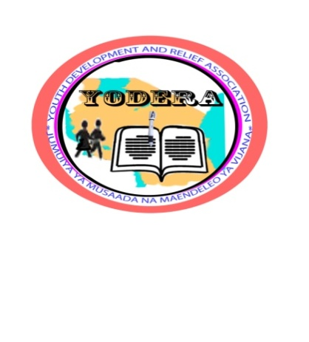
YOUTH DEVELOPMENT AND RELIEF ASSOCIATION (YODERA), KIGOMA, TANZANIA

Youth Development and Relief Association (YODERA) as an organization for line of work within the field of youth development that is a non-profit, non-trade organization, non-religious, non-political and non-governmental organization, and believes that development of youth is an indispensable human right. YODERA is a registered Non-Governmental Organization (NGO) under Non-Governmental Organizations Act, 2002 with Registration No. 06NGO/00005815 accessible by the Ministry of Community Development, Gender and Children on 11th September 2012.
Vision
“To foretaste every youth is unique and valuable culturally, socially and economically” in the community.
Mission
“To diligently and astutely harness the youth to foster and sustain development, it shall equally empowers youth and children through education, fighting against drug abuse, excessive drinking, HIV and AIDS. Furthermore, YODERA provides different skills but not limited to youth entrepreneurship, environmental conservation, improved farming, and small scale animal husbandry for improvement of their social economic welfare.
Core Values
- Punctuality, Dedication, Dignity, Respect and Sensitivity
- United efforts with teamwork, mutual co-operation and sharing
- Building capacities and knowledge to open our eyes to opportunities
- Equality and inclusion regardless of gender, ethnic group or other social divisions
- Accountability, Commitment, Honesty and Transparency in our intentions and activities

OBJECTIVES

- To ensure all children, especially, most vulnerable children and youth are access to better education
- To fight against drug abuse and excessive drinking for amongst youth
- To join efforts with other key stakeholders for controlling sexually transmitted diseases (STDs) including HIV and AIDS for youth
- To build youth vocational skills and entrepreneurship so that they can participate fully in development activities, and hence, improve their social economic welfare
- To build youth capacity for proper participation in environmental conservation interventions, sustainable agricultural practices, livestock keeping and improved fishing.

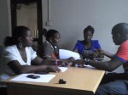

YODERA DEVELOPMENT AND RELIEF ASSOCIATION (YODERA).
YODERA Members of Staff on their morning situation discussion. June 3rd, 2017

BOARD OF TRUSTEES
S/N | NAME AND DESCRIPTION | TITLE
1 | Cosmas Hezwa | Chairperson
2 | Mwamini Joshafat | Secretary
3 | Abubakar Issa | Member
4 | Devotha Mussa | Member
5 | Mariam Yusuph | Member
6 | Shauri Ramadhan | Member

YODERA STAFF
S/N | NAME | STATUS (FULL/VOLUNTEER) | TITLE
1 | Isack Credo | Full-time | Executive Director
2 | Halima Said | Part-time | M&E Officer
3 | DorotheaAlexanda | Full-time | Project Officer
4 | Stephen Hinduka | Part-time | Field Officer
5 | Frank Mrisho | Full-time | Accountant

Youth and Children Education
- Construction of nursery, primary and secondary schools
- Construction of vocational skills training centers (metal fabrication, carpentry, tailoring, saloon, ICT)
- Providing youth with social accountability, self-esteem and awareness and human rights education
Achievements
YODERA already secured 10 Ha. From village government for youth vocation center school construction in Kigoma rural
YODERA has already secured 50M x 25M squared areas for children nursery and day care construction in Kigoma-Ujiji Municipal.
Youth Entrepreneurship
- Conduct youth training on entrepreneurship development
- Support to youth initiatives
Achievements
So far, YODERA in collaboration with local government has trained more than 119 youth on entrepreneurship development.
YODERA supported a youth group with 19 members with working tools (manual tailoring machines and shoe making needles and strings for improving their self-employment opportunities in Kazuramimba village, in Kigoma rural.

Fighting against youth drug abuse and excessive drinking, and HIV and AIDS.
- Research on drug abuse and facts dissemination through relevant stakeholders
- Awareness creation through mass media and IECs for use
- School based education for drug abuse, excessive drinking and HIV and AIDS

Achievements
YODERA has distributed 10,704 IECs (brochures, leaflets and postures with community educative messages on effects of youth drug abuse, excessive drinking and, HIV and AIDS.

YODERA has collaborated with more 73 local government leaders in public meetings while addressing youth drug abuse, excessive drinking and, HIV and AIDS.

YODERA organized 36 radio programs talk shows whereas a total of 667 youth participated.

YODERA has reached more that 23 with a total of 17,003 schools’ children with education on effects of youth drug abuse, excessive drinking and, HIV and AIDS.

Environmental Conservation
- Initiating youth programs concern mass awareness on environment and environmental conservation.
- Support youth groups’ initiatives on environmental conservation initiatives.
Achievements
YODERA has organized a total of 11 youth radio talk shows on matters concerned with the environmental conservation initiatives
YODERA has supported 7 youth groups with tree nursery inputs and 51 improved beehives in Matendo village in Kigoma rural
Improved youth Farming practices, animal husbandry and fish culture
YODERA has trained and supported a total of 61 youth on improved farming practices
YODERA has trained and supported a total of 13 youth on improved small-scale animal husbandry
YODERA has trained and supported one youth group on improved fish farming

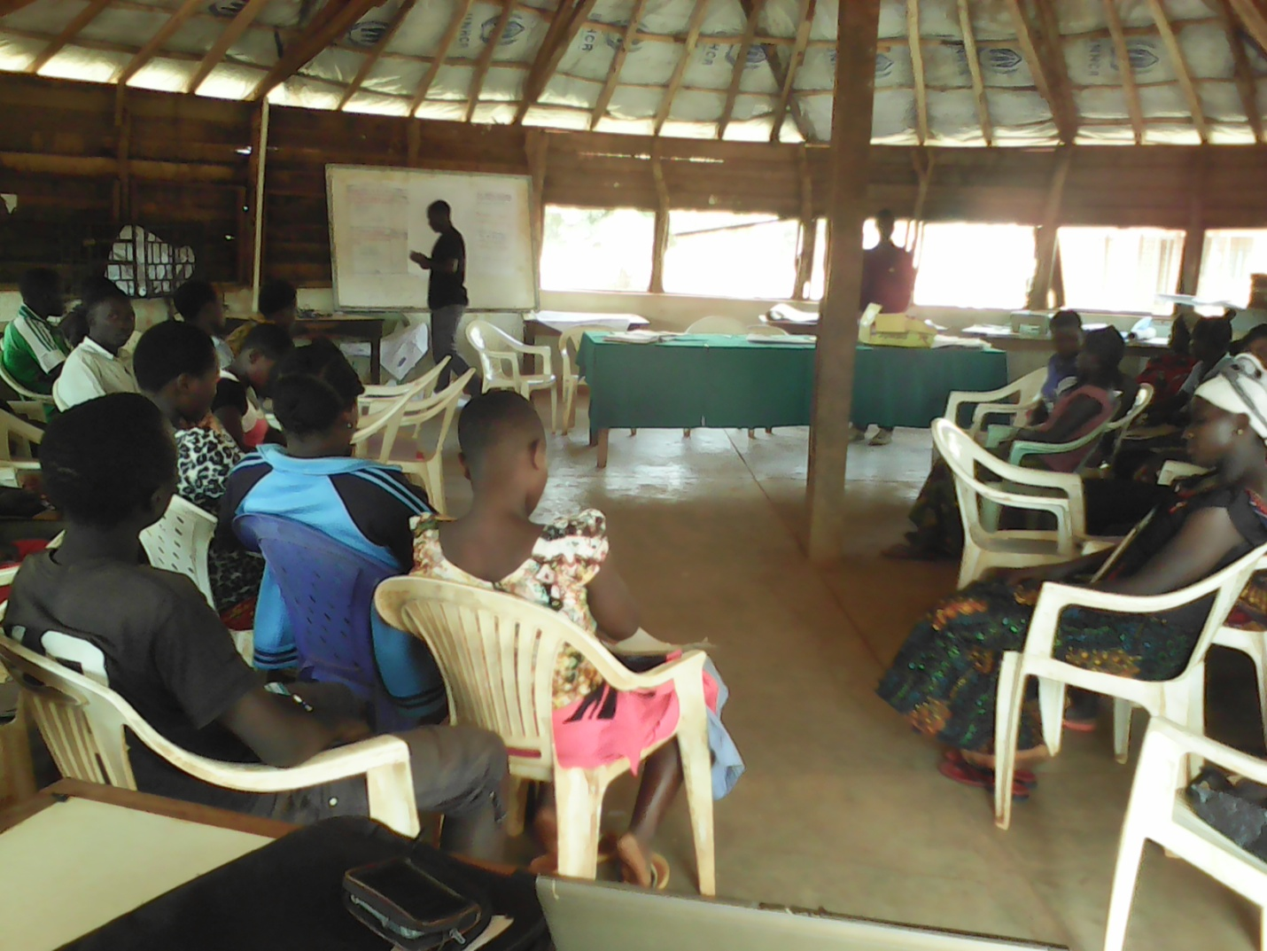

Above: Participants listening during the training session on youth entrepreneurship development which was held at Mwamgongo hall center in Mwamgongo ward, Kigoma rural on 31st July, 2015.

Kigoma-Ujiji Non-Governmental Organization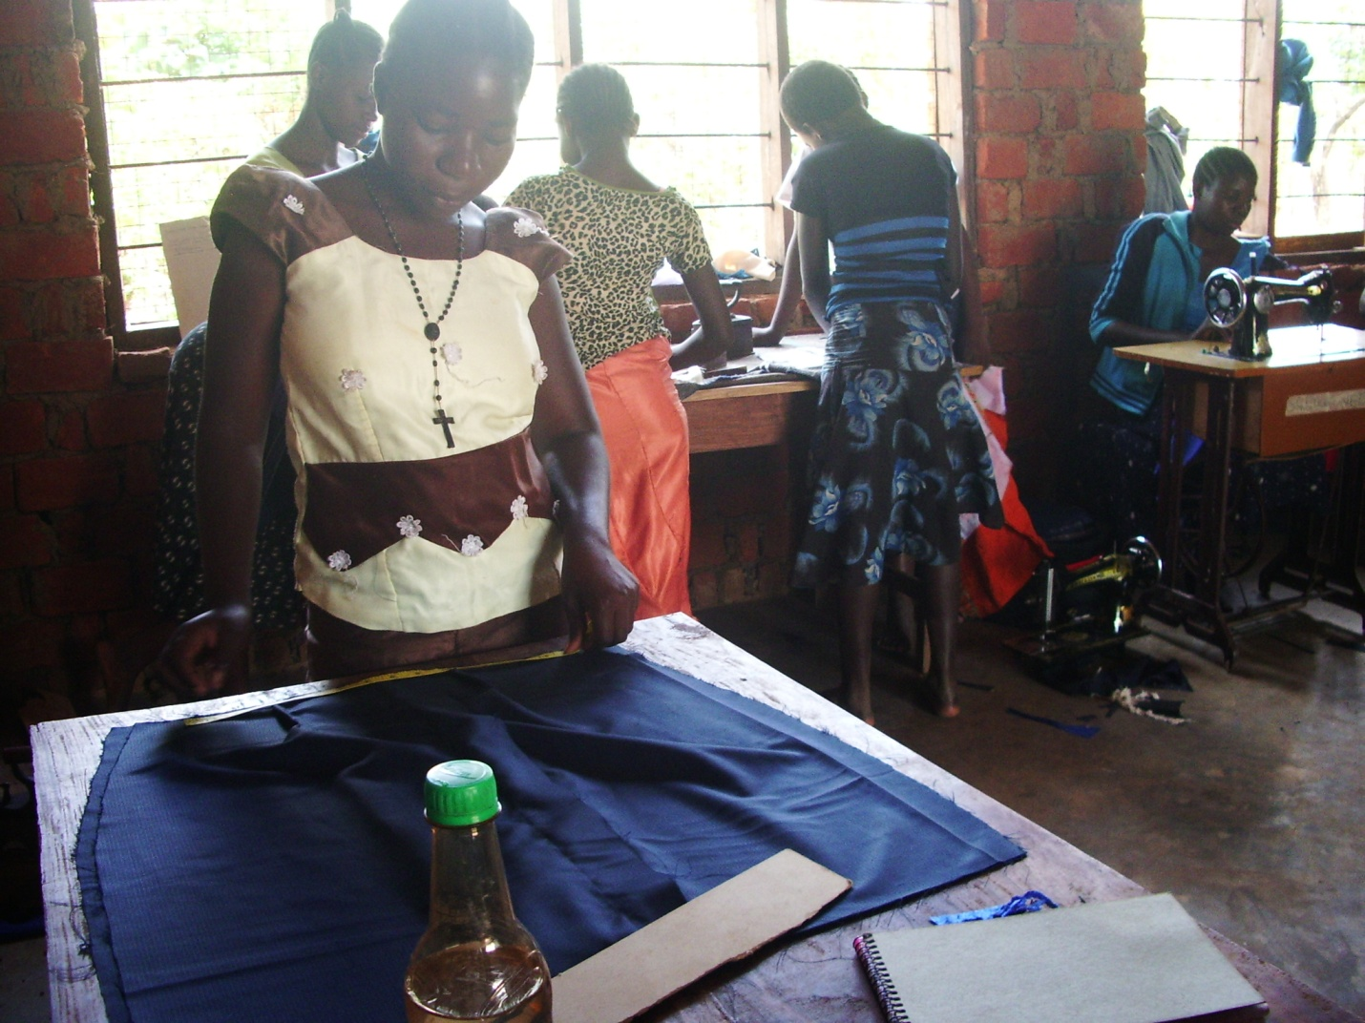

Above: Female youth are in tailoring activities in at Bugamba youth training center in Bugamba village in Kigoma rural in 2015

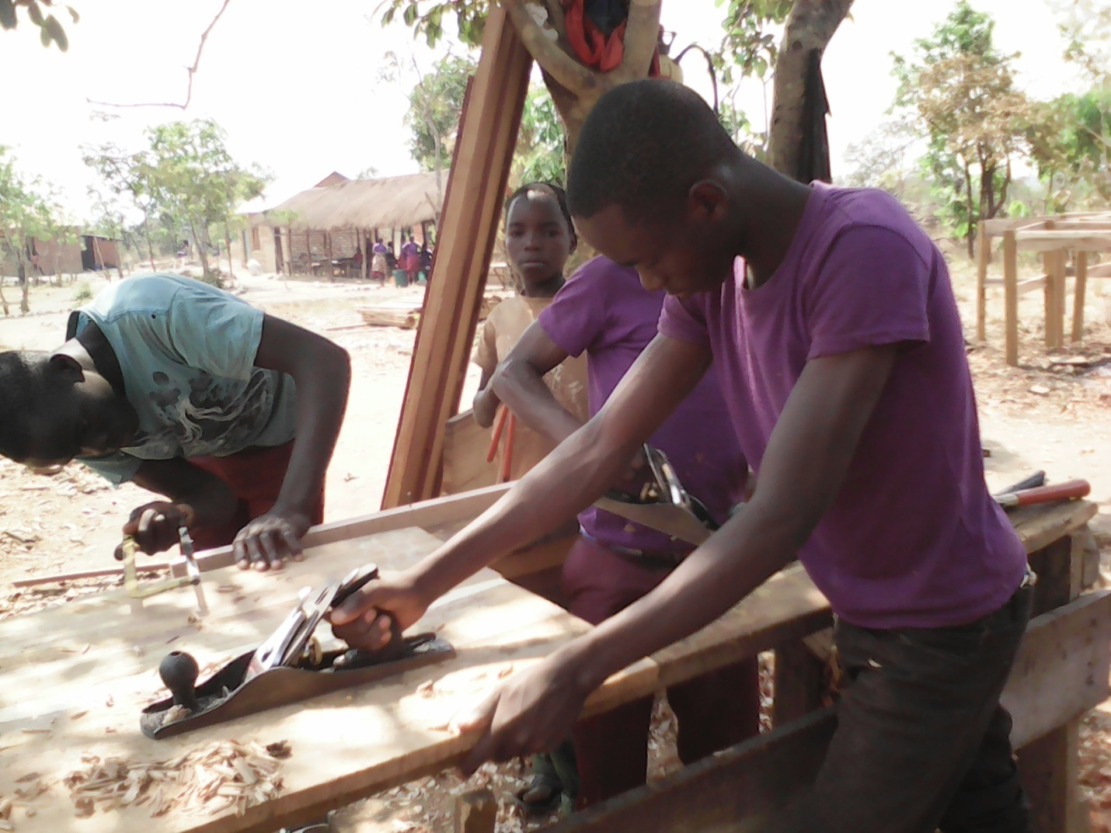
Youth participating in carpentry training practical at Bugamba carpentry training center in Bugamba village, Kigoma rural in 2015
Existing Networks
Kigoma-Ujiji Non-Governmental Organizations Network (KIUNGONET)
Kigoma and Kasulu Non-Governmental Organizations Network (KIKANGONET)
Kigoma AIDS Campaigns Organizations Network (KACON)
Tanzania Youth Forum

Contact Information
Executive Director
Youth Development and Relief Association (YODERA)
Katubuka area, along the airport road,
P.o. Box 645, Kigoma
E-mail: yodera2.kigoma@gmail.com
Mob: +255 762 999163

