Brochure of Women Rights Action Group
(WRAG)

Who We Are:
Women Rights Action Group (WRAG) is a not-governmental women-led organization established in Kigoma, Tanzania. WRAG empowers women to enhance sustainable equitable and human development for discriminated, underserved and marginalized remote women through access to Education, Women Economic Empowerment and maternal health and HIV/AIDS education.

Our Vision

To live in a World where there is a social justice, equality and respect of women human rights.

Our Mission

Improve women social economic welfares while promoting women human rights and fighting against HIV and AIDS in the community.
GOAL AND OBJECTIVES:
- Promote women and girls human rights and fight against HIV and AIDS.
- Advocate on women and girls human rights by influencing the government to ensure that it shall supervise over and protect their basic human rights.
- Support women and girls through capacity building and ensuring that there is adequate availability of resources.
- Collaborate closely with Government, women and girls human activists’ stakeholders at national and international levels in the process and effort to control and prevent women human rights violation and the spread of HIV and AIDS.
- Provide a conducive environment that will empower women and girls to acquire sustainable knowledge and skills in the exchange of information, experience and ideas among themselves and community groups and non-governmental organizations (NGOs) for the purpose of promoting self-development at village, ward, and district, regional and national levels.
- Provide psychosocial services for women and girls who for one way or another have been affected by women human rights violation.
- Publicize policies that advocate justice and equally services geared at providing solutions to problems women and girls health wise, socially, economically and politically.
- Enhance solidarity and cooperation within groups that implement plans, programme and projects for the control and prevent spread women and girls human rights violation.
- Provide a mechanism for establishing WRAG structures and branches at the village, ward and district, regional and national levels.
- Cooperate with institutions and various News Media in extending the frontiers of communication and community sensitization on promotion women and girls human rights.
- Improve women and girls social welfares in the community.
- Improve women and girls’ education in the community. Improve women and girls economical welfare in the community.

Core Values
- We are committed to promote gender equality and empower women and girls, and to removing any barriers that prevent full participation of women and girls in the public and political life.
- We believe in full and inclusive participation by all and that every person, man, women or community has the right and responsibility to contribute their talents, skills and resources to the work we do, for and with them.
- We are committed to promote full and equal access to social services, education, legal and health-care services, economic opportunities and decent work, for all Palestinians, specially marginalized women and children, they need our support to recognize their rights, achieve their basic needs; and ensure their participation in the elaboration and implementation of policies that effect their development, with full respect for their cultures, traditions and social norms.
- We believe that community participation is an essential part of the process of good local governance, and community development. Therefore we consider participatory approaches as an critical instruments of our Association.
- We are committed to work with marginalized communities, improve their lives, alleviate their suffering and develop a vision for change that will make a meaningful difference in their lives.
- We consider partnership as one of our key organizing principle; we are, therefore, committed to developing, maintaining and nurturing partnerships, including alliance and linkages- with institutions and individuals who identify our vision and mission.

BOARD OF DIRECTORS
S/N | NAME AND DESCRIPTION | TITLE
1 | Asteria Josephat | Chairwoman
2 | Mary Kessy | Secretary
3 | Asha Abdallah | Member
4 | Zubeda Ngozi | Member
5 | Paulina Kwezi | Member
6 | Stella Joramu | Member
7 | Consolata Malewa | Member

WRAG STAFF
S/N | NAME | STATUS (FULL/VOLUNTEER) | TITLE
1 | Mary Kessy | Full | Executive Director
2 | Sheila Zuzu | Full | Accountant
3 | Pili Mazola | Full | Programs Coordinator
4 | Sonza Kashonyola | Volunteer | Women and Children HIV and AIDS Control Officer
5 | Mashallah Josi | Volunteer | Women and Children Social Economic Development Officer
6 | Sikuzani Juma | Volunteer | Women and Children human rights-Officer
7 | Semeni Paulo | Volunteer | Street Children and Orphans Welfare Officer

Programs/Projects
Women, girls and children health
- -promote primary health care
- -support medical supplies and equipment for health facilities in rural areas
- -Promote mosquito treated nets for women, girls and children
So far, WRAG has reached more than 51,013

Women, health and children education
- -Support school infrastructure, facilities and equipment (desks, classroom and toilets, computers, training materials for pupils with disabilities and non-disabled ones
- -Empower girls with sanitary pads, capacity building on menstrual hygiene, Management and reproductive health education for improved performance and self esteem.
So far, WRAG has reached more than 73,097 beneficiaries

Women’s human rights
- Organize dialogue meeting for women, girls and government leaders on importance of deploying participatory approach, women and girls’ role and responsibility for implementation of women’s human rights, transformative leadership, stigma reduction skills.
- Use women arts and sports on addressing women’s human rights
- Organize trainings for women and girls on issues affecting women’s human rights
- Use mass and social media
- Use IEC materials
So far, WRAG has reached more than 113,985 beneficiaries

Women social economic welfare
- To conduct women and girls capacity building trainings on entrepreneurship, marketing, value added values, financial management, budgeting, crop production, small scale animal husbandry, water management, food processing, soap and sanitary pads production and marketing, fish pod management,
- Support women savings and credit schemes
- Use publications/booklets
- Conduct researches on women social economic issues
- Use women changing agents in project implementation and management
So far, WRAG has reached more than 35,102 beneficiaries

HIV and AIDS
- To organize capacity building training and support initiatives of women and girls with HIV and AIDS
So far, WRAG has reached more than 172,114 beneficiaries

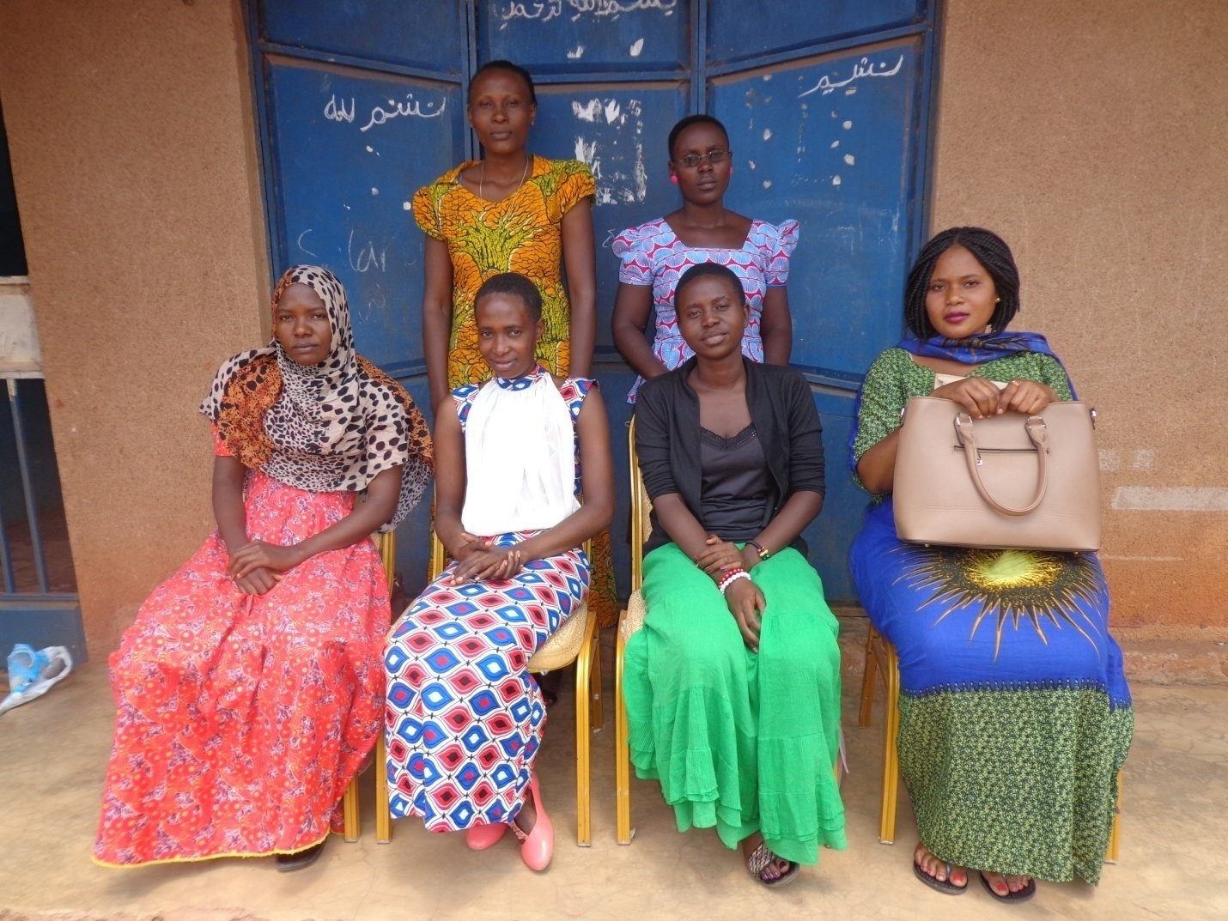
Monica Sendeka a training facilitator posses for a photo with participants during the training session on women methods of sustainable agriculture, water management, income-generating activities, environmental protection and marketing, community life and women leadership., savings and credit management which was convened in Mtego wa Noti, Uvinza district as from 17th July 2017 to 21st July 2017 organized by WRAG under financial support from AWDF.

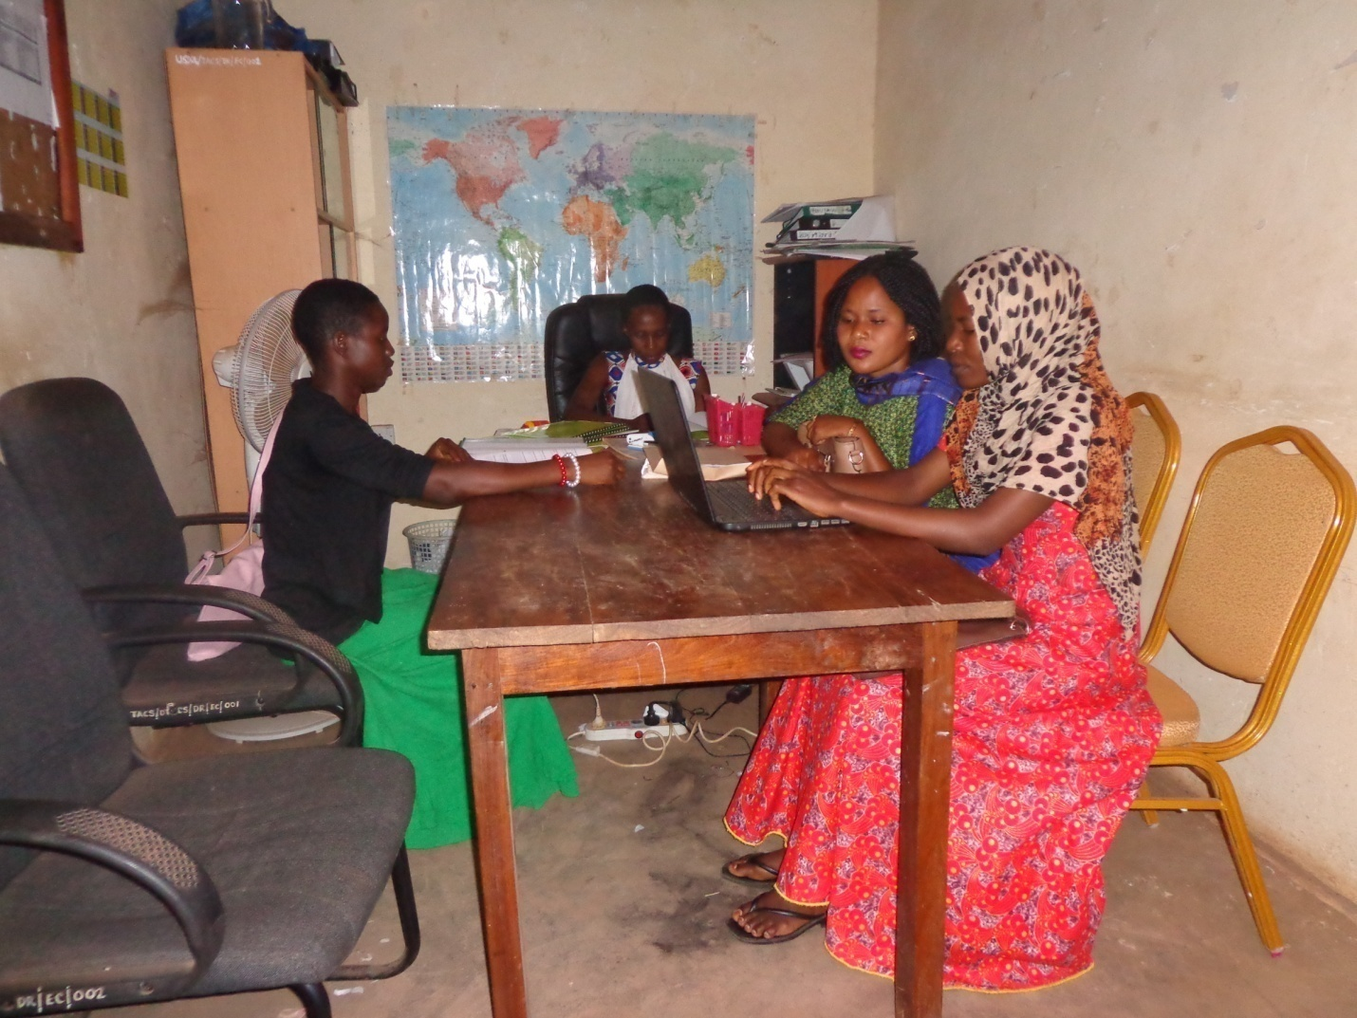
WRAG’s Executive Director and training facilitators taking a photo during the training session on women methods of sustainable agriculture, water management, income-generating activities, environmental protection and marketing, community life and women leadership., savings and credit management which was convened in Mpeta, Uvinza district as from 31st July 2017 to 4th August 2017 which was organized by WRAG under financial support from AWDF.

Tra
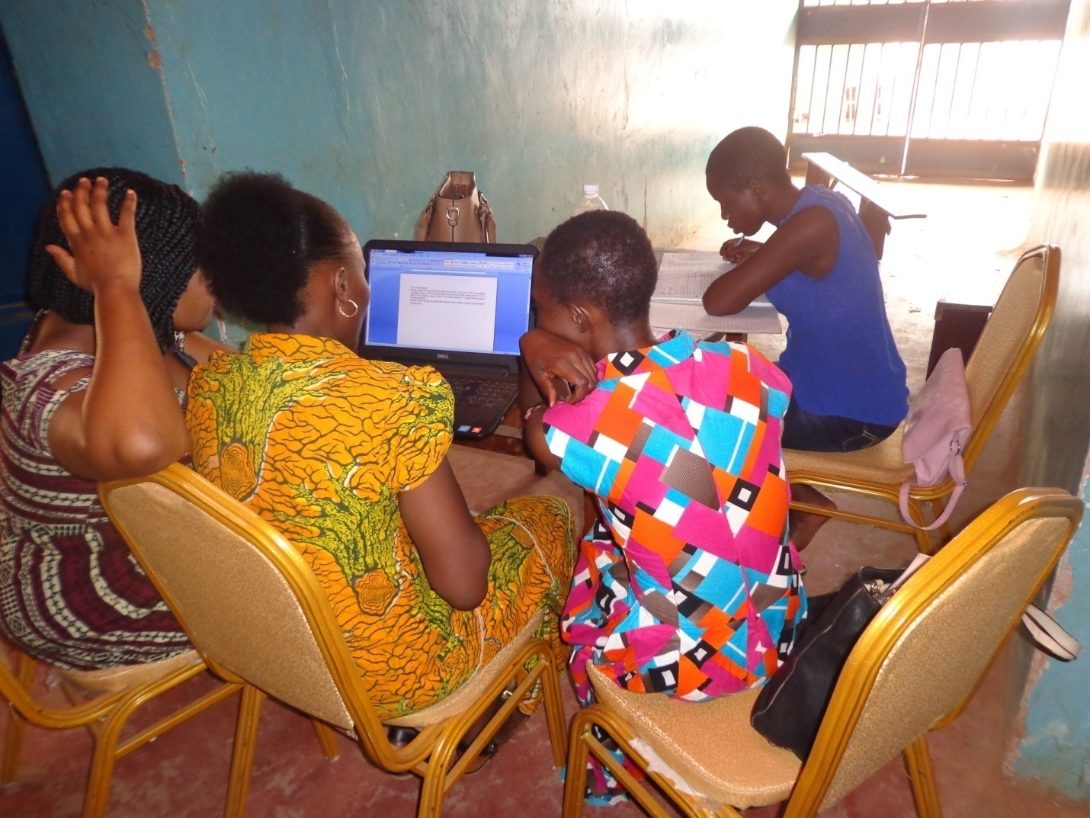
Executive Director clarifying for the participants during the group discussion in Itebula ward in Uvinza district in the training on women methods of sustainable agriculture, water management, income-generating activities, environmental protection and marketing, community life and women leadership., savings and credit management which was convened in Mpeta, Uvinza district as from 31st July 2017 to 4th August 2017 which was organized by WRAG under financial support from AWDF.
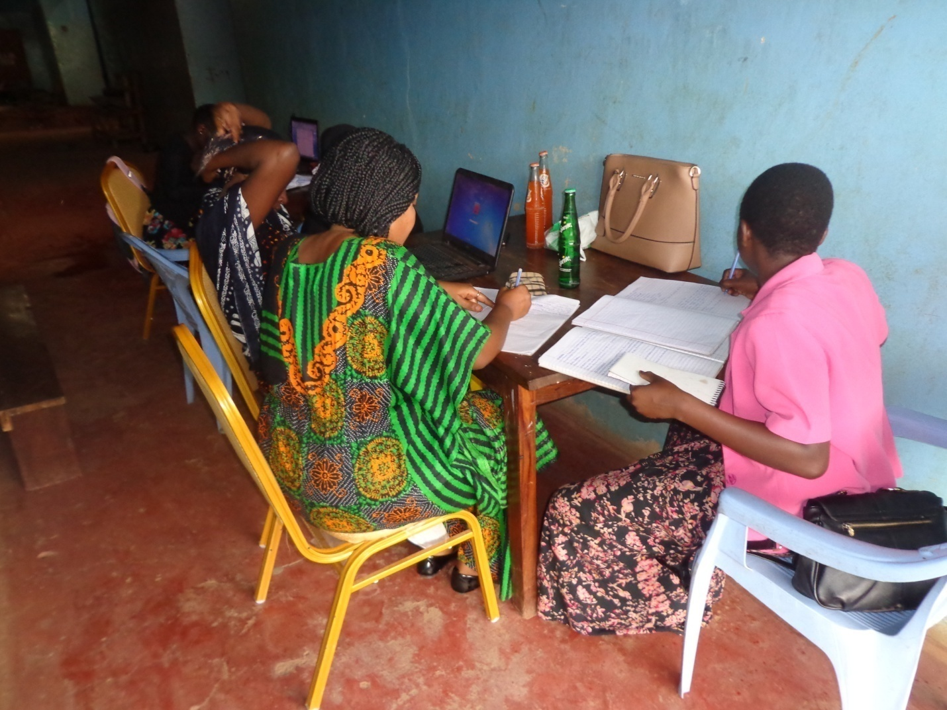
WRAG’s staff and facilitators during training evaluation and planning session before starting training session on women methods of sustainable agriculture, water management, income-generating activities, environmental protection and marketing, community life and women leadership., savings and credit management which was convened in Mpeta, Uvinza district as from 31st July 2017 to 4th August 2017 which was organized by WRAG under financial support from AWDF.
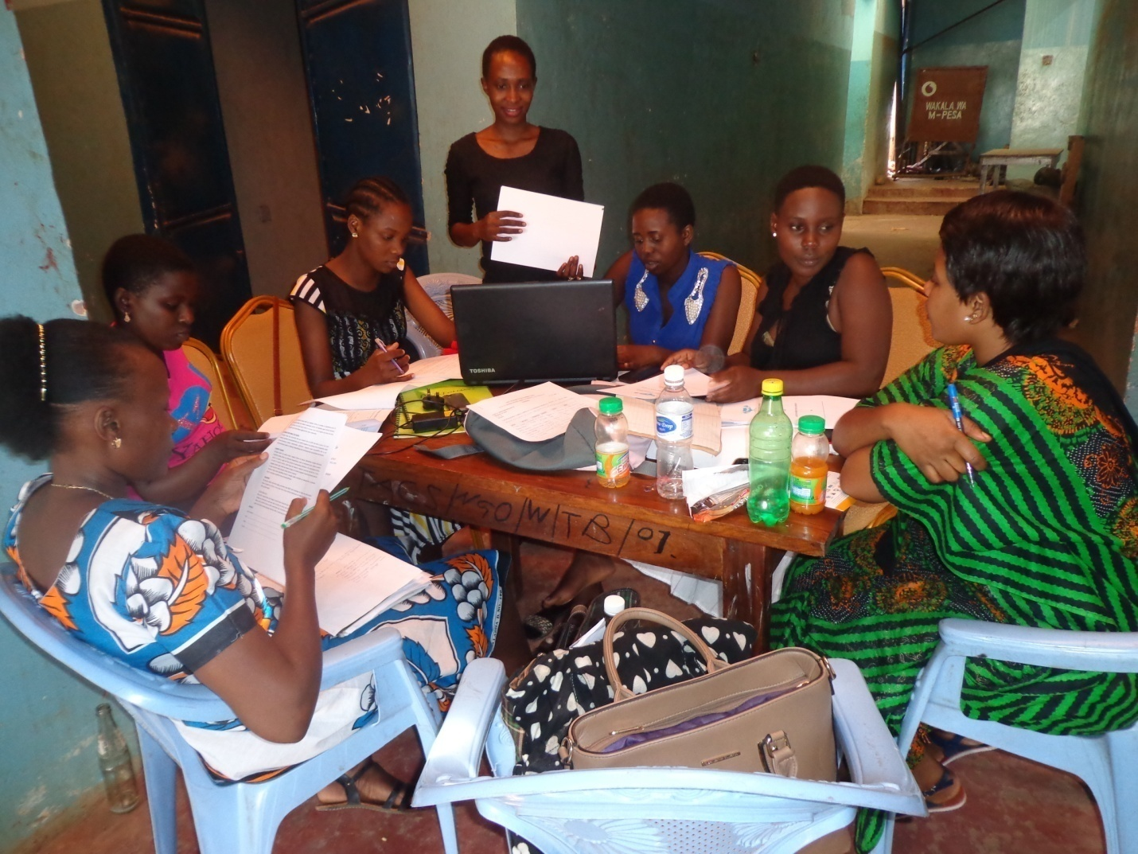
WRAG’s staff, volunteers and facilitators during training evaluation and planning session before starting training session on women methods of sustainable agriculture, water management, income-generating activities, environmental protection and marketing, community life and women leadership., savings and credit management which was convened in Itebula, Uvinza district as from 14th August 2017 to 18th August 2017 which was organized by WRAG under financial support from AWDF.

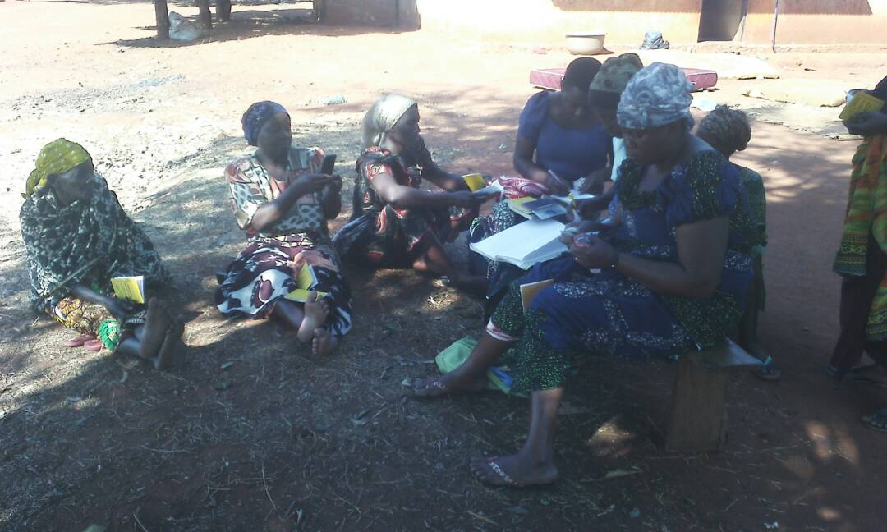
Group discussion during the training on training session on women methods of sustainable agriculture, water management, income-generating activities, environmental protection and marketing, community life and women leadership., savings and credit management which was convened in Itebula, Uvinza district as from 14th August 2017 to 18th August 2017 which was organized by WRAG under financial support from AWDF.
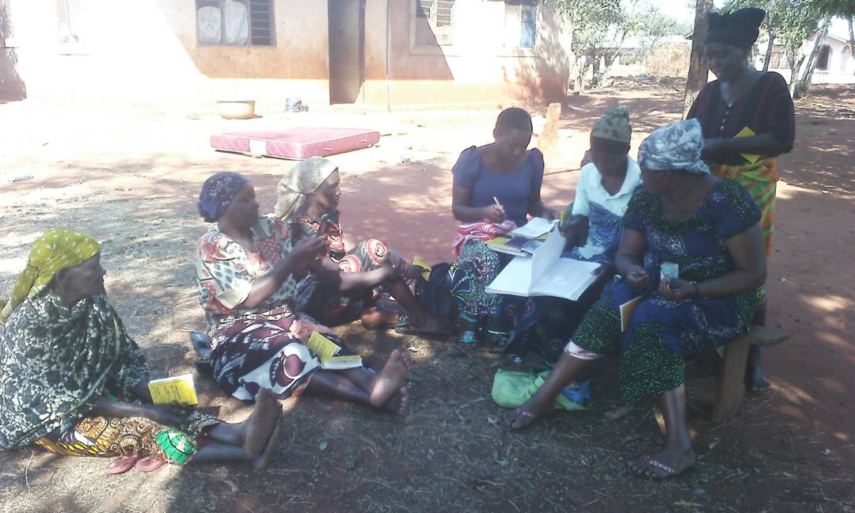
Group discussion during the training on training session on women methods of sustainable agriculture, water management, income-generating activities, environmental protection and marketing, community life and women leadership., savings and credit management which was convened in Itebula, Uvinza district as from 14th August 2017 to 18th August 2017 which was organized by WRAG under financial support from AWDF.
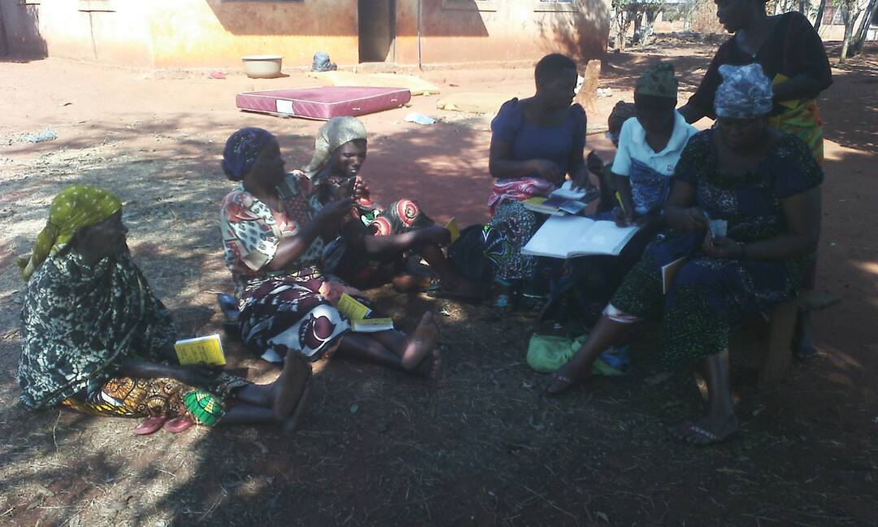
Group discussion during the training on training session on women methods of sustainable agriculture, water management, income-generating activities, environmental protection and marketing, community life and women leadership., savings and credit management which was convened in Itebula, Uvinza district as from 14th August 2017 to 18th August 2017 which was organized by WRAG under financial support from AWDF.
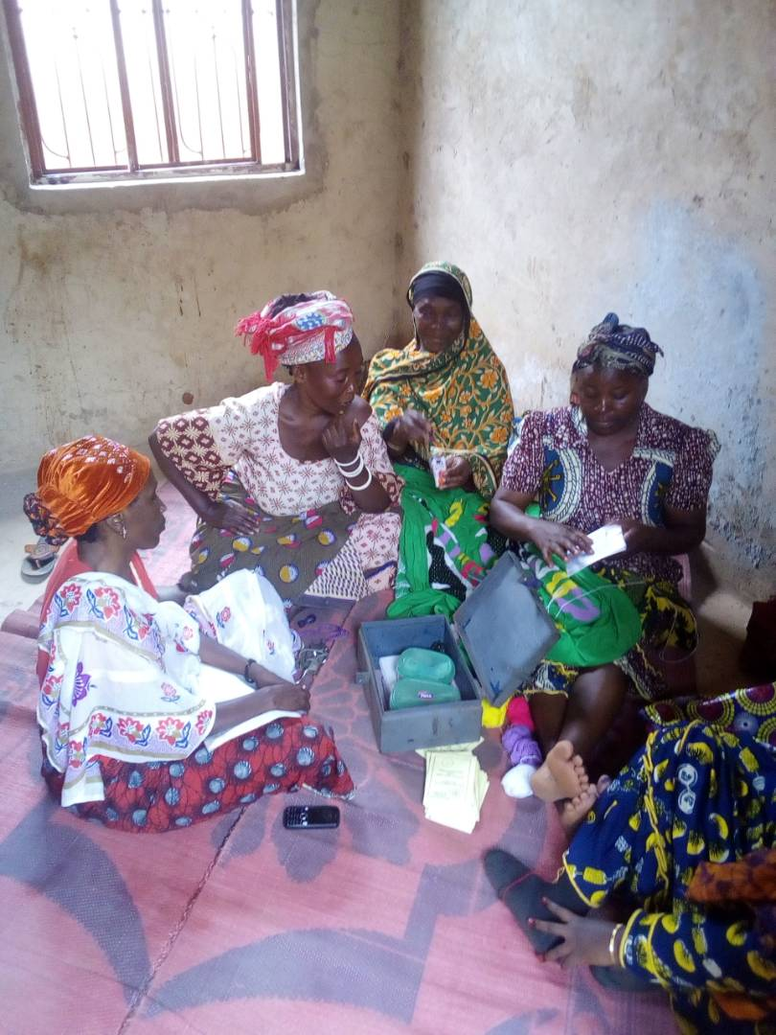
Group discussion during the training on training session on women methods of sustainable agriculture, water management, income-generating activities, environmental protection and marketing, community life and women leadership., savings and credit management which was convened in Itebula, Uvinza district as from 14th August 2017 to 18th August 2017 which was organized by WRAG under financial support from AWDF.

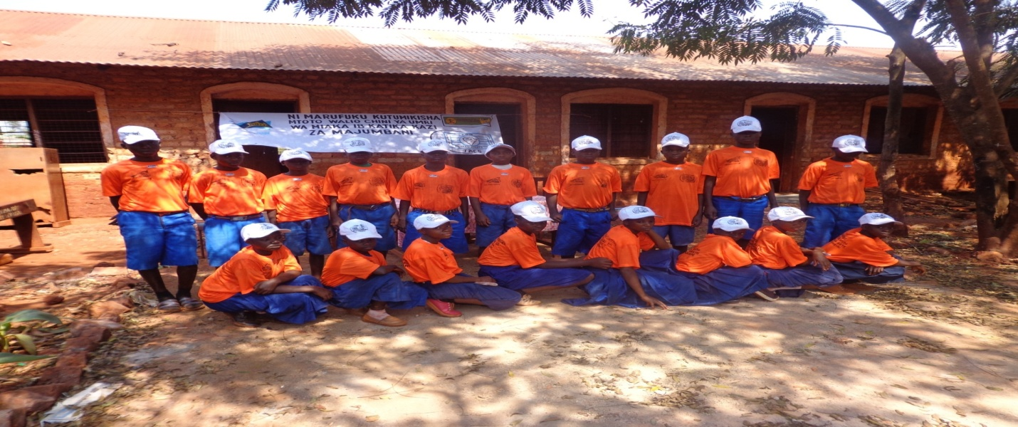
Above: School health club at Asante Nyerere Primary School which, addressing sexual and reproductive health and rights was formed under facilitation of WRAG in 2016 in Uvinza district, Tanzania.
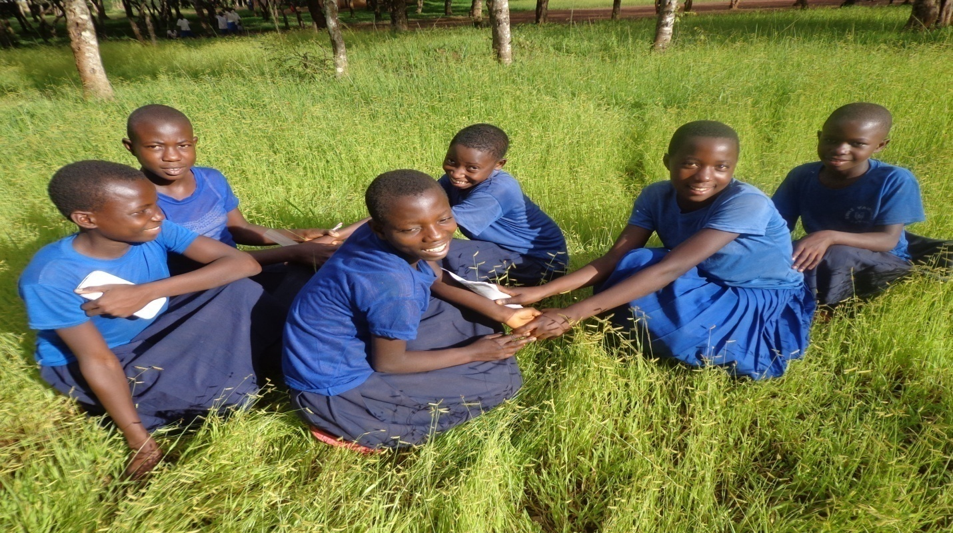
Above: School health club at Asante Azimio Secondary School which, addressing sexual and reproductive health and rights was formed under facilitation of WRAG in 2016 in Uvinza district, Tanzania.
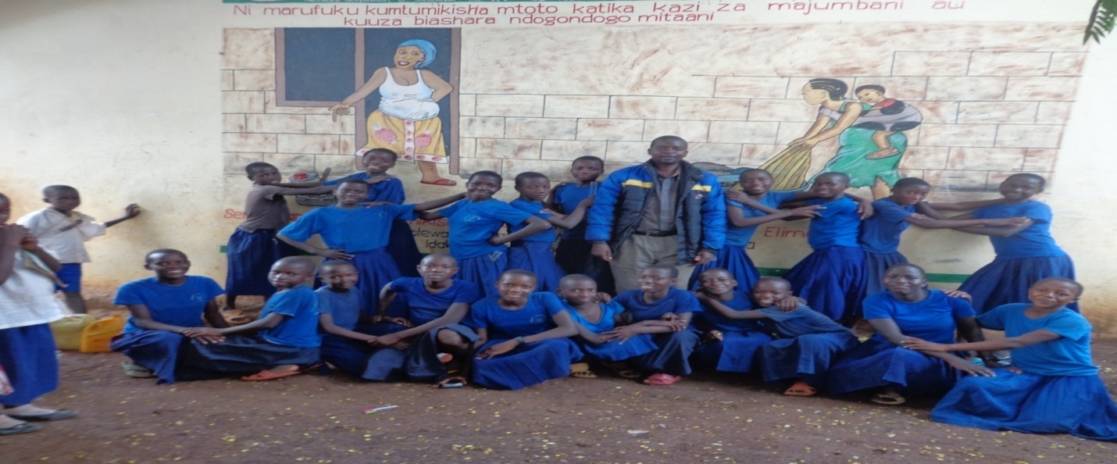
Above: School health club at Asante Sunuka Secondary School which, addressing sexual and reproductive health and rights was formed under facilitation of WRAG in 2016 in Uvinza district, Tanzania.

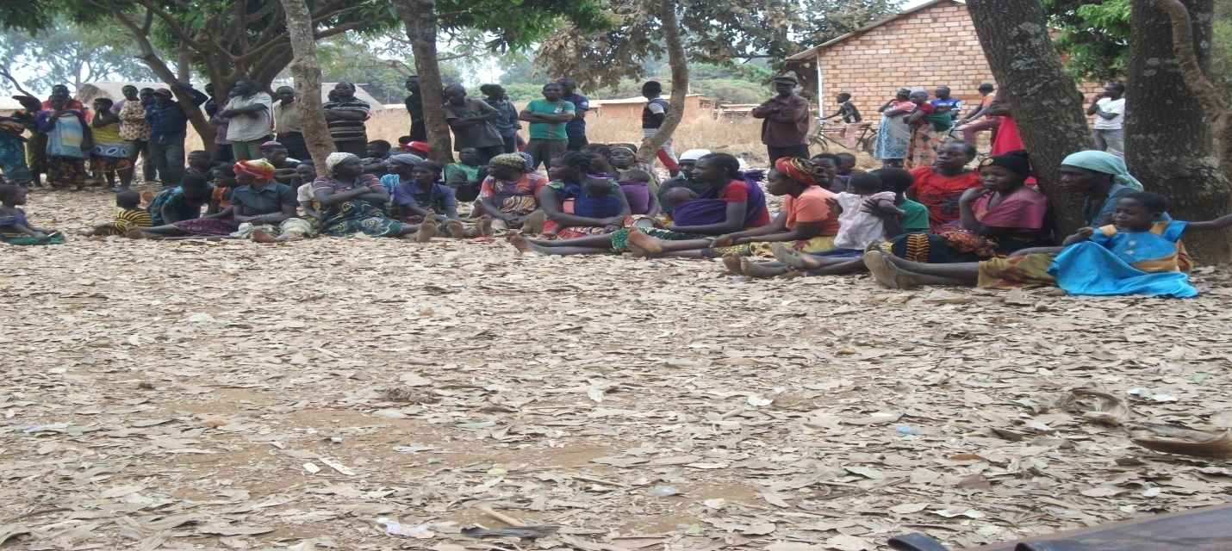
Above: Meeting of villagers during the campaigns against women and children violence in Muzenze village in Buhigwe district in 2016, which was facilitated by WRAG

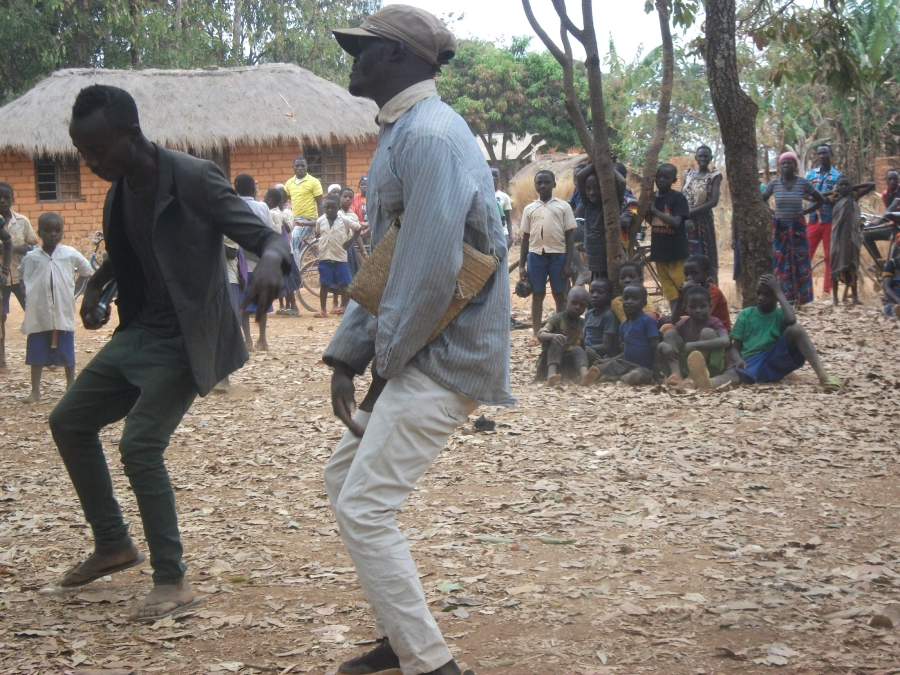
Above: Youth cultural group entertains during the campaigns meeting against women and children violence in Buhigwe village in Buhigwe district, 2016

Existing Network
Kigoma-Ujiji Non-Governmental Organizations Network (KIUNGONET)
Tanzania Gender National Program (TGNP)
Kigoma and Kasulu Non-Governmental Organizations Network (KIKANGONET)
Kigoma AIDS Campaigns Organizations Network (KACON)
Tanzania Women Forum

Contact Information
Att: Executive Director
Women Rights Action Group (WRAG)
Majengo Street, Katubuka ward, Near to Mwanga Market, along Lumumba road
P.o. Box 509, Kigoma
Tanzania
E-mail: wragroup@yahoo.co.uk
Mob: +255 766 863378

