Name of the Corporation: DEBES CREER EN TI (DCET)

Project Title: Spanish Adult Basic Literacy Immersion/Transition to ESOL/Civics/Citizenship program for Seniors in Irving, TX

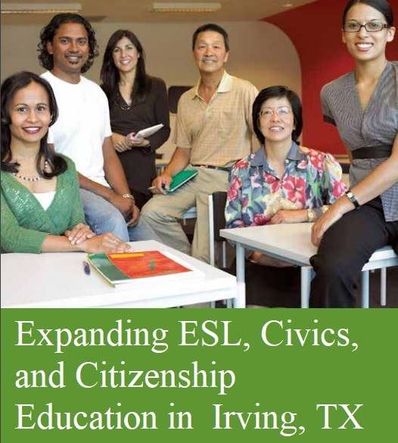

Amount Requested: $13,500.00

Category: Education, Civic Participation, Community, Migrant Community
Background
Debes Creer en Ti/Believe in Yourself, Inc. (DCET) is a non-profit organization based in Irving, Texas, founded in 1997. It was officially incorporated in 1998, as an Educational, Cultural and Charitable, 501(c)3 non-profit organization accredited by the Internal Revenue Service, under employment number: 31-164-0064.

Mission
The mission of DCET is to provide Literacy programs and support other educational and cultural initiatives that prepare immigrant, Hispanic/Latino youth and their families to improve the quality of their lives and enable them to contribute economically and culturally to their diverse communities. DCET serves as a bridge to help families in participate fully in the variety of health, legal, human, and social services, and education programs available in order for them to become productive members of society.

Issue, Opportunities and Problems:

Our Adult Basic Literacy Transition ESOL program assists adult Senior students in Irving, Texas. Main objective is to get them ready to be more productive citizens in USA and to overcome the English as Other Second Language (ESL) barrier. DCET offers the PLAZAS COMUNITARIAS Spanish Literacy curricula component along with ESOL, Civic and Citizenship classes while providing the basic foundation to learn advance English. "Plazas Comunitarias" (PLACOM) initiative, is a Mexican-based curricular that offers a way to bridge students who cannot learn English as, he/she does not know how to read/write Spanish yet. Some of them have not completed their elementary and high school education. PLACOM provides from Basic Literacy curricula to college preparatory and awards a graduation certificate validated by the Mexican Department of Education. There are six modules per grade and textbooks and videos to support the program. Textbooks reach subjects in Language Arts, Mathematics, Science and History in Spanish The program is available to anyone who speaks Spanish and is recognized by U.S. institutions of higher education and it's aligned with Texas Department of Education standards. The program reaches Spanish speaking illiterate senior immigrants in the U.S. so that they could start, or continue their education. DCET provides computers and volunteer tutors to work with students assisting them with ESOL Citizenship and Civic classes. This unique program is a Spanish immersion program, which offers a valid high school diploma, and citizenship preparation. The program has 5 study groups, each group meets for two hours a day, five days a week. Study groups meet all year round - Classes are offered on Fridays and Saturdays for two hours.

Problem to be addressed

The illiteracy problem is hard to solve as the growing number of monolingual Hispanic immigration is also growing every day. In Irving, illiteracy is accompanied by a steady and high rate of school dropouts. It is a fact, that there are very limited ESL classes for recent immigrants and their children in the city, who find it very hard to advance in their process of assimilation and acculturation.

DCET addresses the needs of those economically disadvantaged families who are dependent upon some form of public assistance because they lack the functional literacy skills to be able to secure better paid jobs in the workforce. These are serious problems to be considered if Hispanic/Latino immigrants limit from learning English as a second language:

· Parents cannot facilitate child’s English language acquisition;

· Children will lack proper early language development;

· Parents cannot communicate with school personnel;

· Parents will not model learning values & positive attitudes & behavior toward schools.

**Children of low socioeconomic families account for one-quarter of all young children in Irving, Texas. Children come into school systems in need of language assistance and acculturation. In addition, many adults live in communities in which the culture is Hispanic and the dominant language to be is Spanish. This has resulted in millions of Hispanics being functionally illiterate and millions of young children not having the prerequisite language experiences to be able to succeed in school.

DCET hopes to address the needs of new immigrants by offering English as a Second Language (ESL) classes in three levels, and other Literacy initiatives that will reduce the problem of illiteracy among our target population, which in its majority are Hispanic adults.

Nationally speaking 40% of all Hispanic dropouts leave school before the 10th grade and the average student who manages to graduate from high school has achieved only a 7th grade competency level, 97% were from illiterate parents. (As per statistics of National US census, year 2000.)

Only 9% of Hispanic students graduate from college Source: DRI/McGraw-Hill, May 2001.

According to the Employment Commission of the State’s Business Advisory Commission, there were almost 630,000 Hispanic 20 to 24 year olds who had dropped out of school earlier. Many of these dropouts are included in data that supports the claim that 22% of the U.S. Spanish speaking population is completely illiterate.

Unless there is a dramatic improvement and pro-activity to fight illiteracy, the effect of the same, will be profound for both Hispanics and the entire city of Irving.
It is very important to offer this immersion Spanish Literacy program that includes ESL/Civics and Citizenship classes at DCET
It is important to offer this program in order to address the needs of our senior citizen immigrants helping to reduce the problem of illiteracy among a great amount of Hispanic senior citizens 50+ that never learned how to read/write in their own language: Spanish. If a senior person cannot write/read it is impossible for him/her to learn how to write/read another language and pass the English, History, Government test in order to become a Citizen of this Country. DCET closed this gap while including Spanish Literacy immersion program in our Citizenship/Civics/ESL curricula. If we don’t assist this segment of the community, these group of citizens will be deprived from being active voters and receive benefits earned from working many hard and long hours while being legal residents. This is a very important factor to consider.
These are the two main GOALS of our Citizenship program
Main Goal: To continue providing Adult Basic Literacy Transition ESOL program for economically disadvantaged Hispanic/Latino seniors. This DCET Literacy initiative will benefit the citizens of Irving while providing an economic betterment by implementing this Literacy Transition ESOL program, which will result as a gateway to better jobs & greater income for participants.

Goal #1 To serve a successful English as a 2nd Language program while linking the Plazas Spanish Literacy program to ESOL, GED and Citizenship classes while motivating students and their families with Parenting skills workshops, Information and Referral support & other Literacy initiatives.
Outcome Indicators Goal 1
- 70 students will be reached by the end of the program.
- 65% will not withdraw out of the program & will graduate after a year.
- 70% of these participants after one year of attending the classes will successfully obtain their Spanish Literacy Diploma, their ESL level 1 Diploma and their Citizenship Preparation Diploma.
80% of the students attending regularly will demonstrate an increase in learning English in their everyday conversation. These outcomes will be reflected on pre & post assessments, which will also include a self-esteem and self-confidence delivery.
Goal #2 To provide a friendly school environment for immigrant families who have never attended, or left school many years ago. The program will also provide a place for our target population to develop leadership, citizenship, peer mentoring, and teamwork, problem-solving & community service skills through the learning of a second language.

Outcome Indicators Goal 2
- 60 students by the end of the calendar year, will join our monthly parenting skills workshops, & will improve their parenting and, social skills, self-esteem and self-confidence, while meeting an attendance goal of 80%.
- 60% of the participants will learn how to overcome challenges & barriers and build leadership skills.

Measuring the impact of this Project
Standardized measures, Participant Survey, and other Performance Evaluations
Criterion: Extent to which methods of evaluation include the use of objective performance measures that are clearly related to the intended outcomes of the project and will produce quantitative and qualitative data to the extent possible.
Methodology: We use a pre-test evaluation once the students enrolled in the program, this help us to determine attitudes of all participants in the program. We measure using standardized instruments and track behavioral performance indicators, like: Positive identity, overcoming feelings, getting along with other students, pro-social attitudes, purpose and sense of future. After three months of completing the program, with a programmatic completion rate of at least 90% or more, we test students again, every quarter to help us determine their progress in these areas.

Post-Evaluations help us to determine improvements in student’s behavior and progress in the areas of Literacy, Civics, Family Communication, Respecting DCET’s Code of Ethics, Enthusiasm for learning, psychological needs, etc.

Monthly Evaluations: Students also help us evaluate the effectiveness of the program’s overall impact. This allows us to ensure compliance with DCET’s objectives and requirements of our contract.

Anecdotal Records are collected every time we offer a workshop. Assessments are completed on at least 95% of the students and their families attending our monthly bilingual workshop and mentoring sessions that we offer during the year.

Individual Portfolios are compiled with photos of participants in order to keep an accurate file system in our computer. Our Online Database documents all updates regarding hours of study, absences, workshop attendance, and the overall progress of the student.

Progress Reports - Program outcomes are issued and documented after each test. Pre and Post tests are performed in order to evaluate progress of student.

Why this project is important and it Matters to our supporters and the whole world?

All support for education is intrinsically relevant because education is the vehicle of progress of promotion and development of any society in the world.
the support for education becomes more relevant when is directed to sectors of the population that most need it. Our Hispanic community in Irving, Texas requires this additional support as its growth of illiterate population keeps on growing disproportionally, representing a challenge to the progress of this city.

Unfortunately, our Latino/Hispanic students currently have the lowest levels of studies in comparison to white, Asian and African American students. Irving is at the bottom of the pyramid. That is the relevance of our educational intergenerational literacy and mentoring programs at DCET. Our programs are geared towards who needs it the most. we at DCET acknowledge that education is the major component to progress in any socio-economic level in the world.

We want to encourage you to help us receive any dollar that can make a difference in the progress of our city. Assisting the funding for our ESL/Citizenship/Civics program will allow seniors to learn how to read/write in Spanish so they can learn English as a second language and then pass the citizenship test.

We need instructional material, and a dedicated tutor to allow helping students make a dream come true. We are optimistic to match the amount you hopefully will allow for us to be granted for this 10-month period program. this will benefit this target market and their families with the conviction that we are increasing productive members of society in Irving, Texas.

Expanding ESL, Civics & Citizenship Education in Irving, TX will impact as follows:
- We will empower parents to become American citizens and be language teachers for younger children
- Senior Citizens will be Civic Involved
- Senior Citizens being nationalized will become active voters
- Senior Citizens being nationalized will become more productive as Members of Society

Supporting Education and becoming DCET Literacy Partner
You as a supporter assisting the Literacy and Community needs of our Hispanic/Latino community will receive:
- Recognition at our August, 2018 Graduation Recognition Reception
- A Certificate of Appreciation recognizing you as our DCET Literacy Partner
- Your donation is a tax deductible charitable contribution as DCET is a 501©3 nonprofit Corporation under IRS license 31-1640064
- Your name or logo will be included in our DCET website HOME page
- Social Media posts on Facebook, Twitter and Google will be published for a whole year

DCET is trustful because it improves the Workplace or Community:
All the DCET Educational and Cultural programs designed since 1987 are committed to save lives and are making an enormous difference in many people. This legacy will leave a shelter for Hispanic/Latino immigrants and other immigrant families to succeed in a new country while becoming productive members of society. students are offered unique free educational opportunities benefiting the Dallas/Fort Worth area through strong partnerships such as TEC de Monterrey University in Monterrey, Mexico - DCET became a TEC CCA Centro Comunitario de Aprendizaje (Community Learning Center) This partnership started in 2000. This partnership is to be able to provide English as a Second Language, GED, Computer and Citizenship classes to her students. There was a gap she saw: Illiterate Seniors not being able to become citizens as they couldn’t write/read Spanish and difficult them to learn English. The PLACOM partnership with the Department of Education in Mexico has helped many seniors become legal citizens
Other Literacy and Community and Mentoring programs help her students understand about “How to Start a Business”, “How to deal with Family Violence,” “Learning about avoiding Drugs and Alcohol,” etc. There has been many, many DCET success stories and graduates who have benefit for 22 years of this free courses.
DCET organization’s track Awards and Honors
2003 Resolution of Recognition by Dallas Public Schools Board of Education
2004 Excellence in Education Award by Dallas Mayor Laura Miller.
2004 Community Volunteer of the Year award by DFW International
2005 Community and Professional Service Award by Irving Hispanic Chamber of Commerce
2006 May 16th, Elvia Wallace-Martinez Day Proclamation by Grand Prairie City Council
2006 Women of Spirit Award by National Jewish Congress
2006 Real Women Award Honoree by Girl Scouts of America
2012 Received the Friendship Award by the DFW Asian American Citizens Council (DFWAACC)
2014 “Outstanding Contributions to the Arts and Education” by Oak Cliff Coalition for the Arts
2015 “Excellence in Education” by Excelencia Empresarial Hispana (EEH)
2015 “Best of Irving Award in the Community”
2016 Nominated “Leadership Champion” by Excelencia Empresarial Hispana (EEH)
2017 Nominated “Best nonprofit entrepreneur” by Excelencia Empresarial Hispana (EEH)
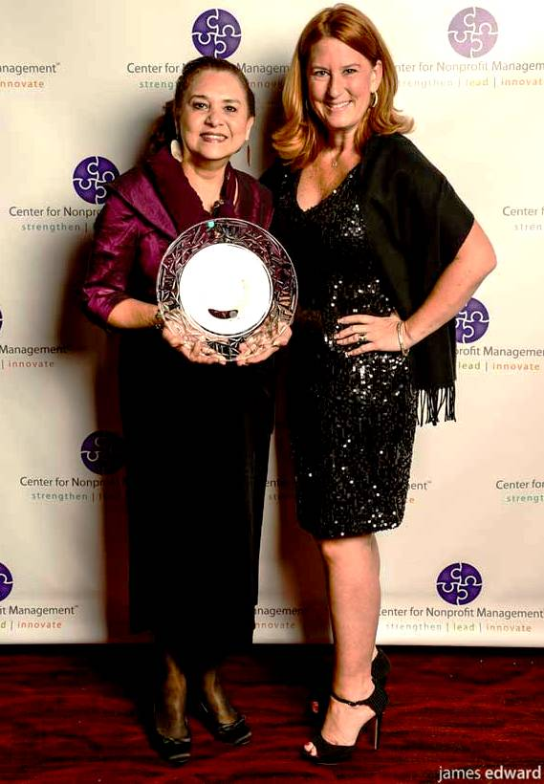
2017 Women of Distinction Award by TAMMCC, Austin, TX for Excellence in Education.

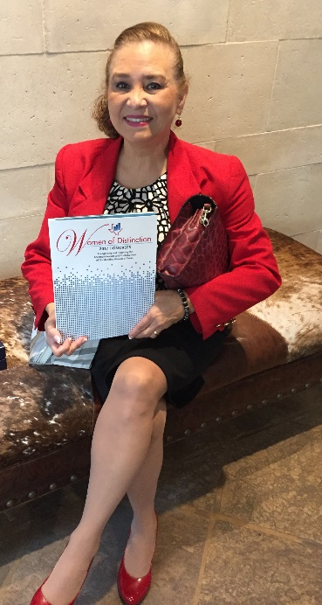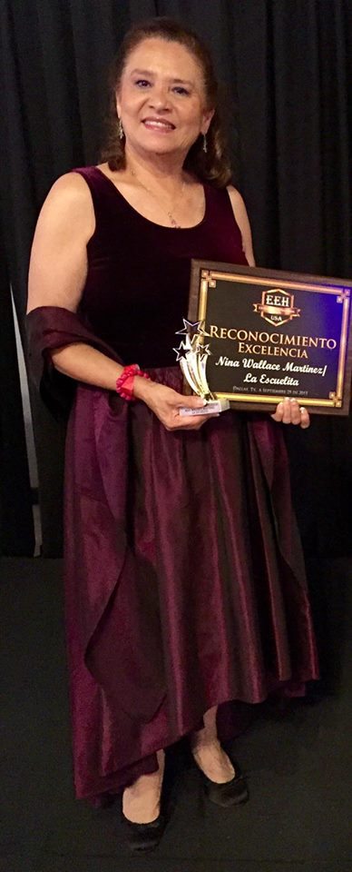

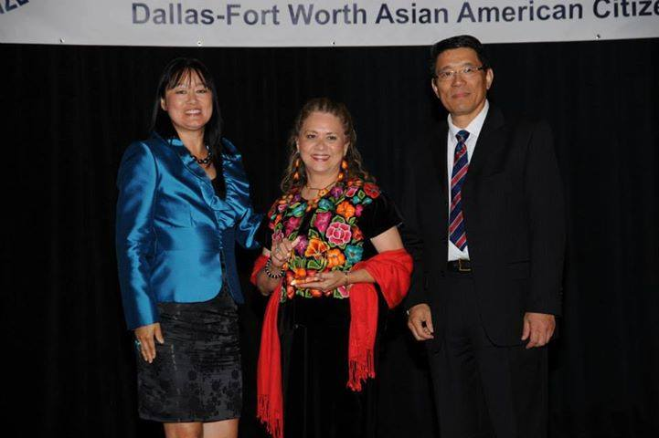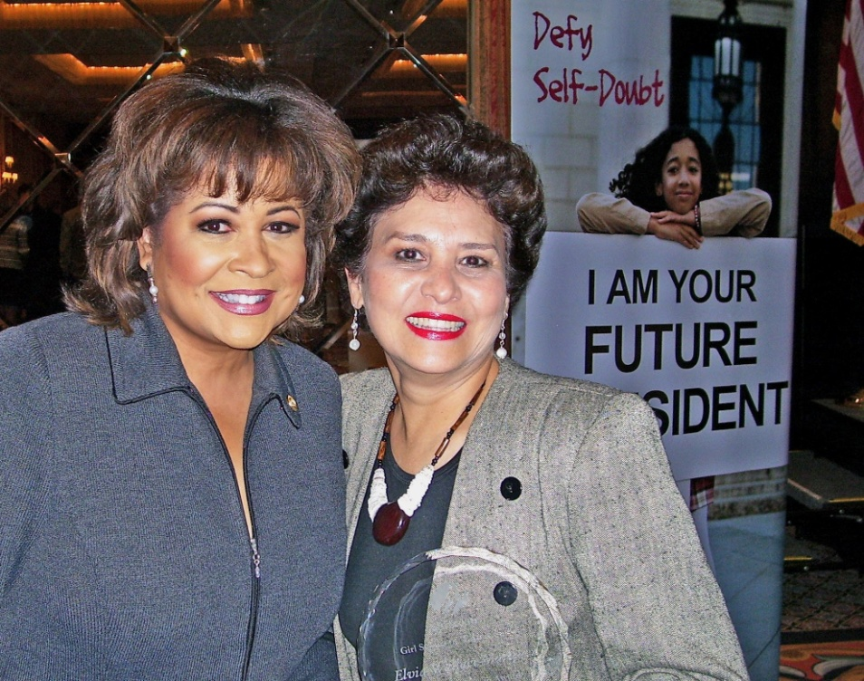

Potential Challenges:
Education is the main pillar of support for the sustained progress of any society in the world. If a society has to move forward it has to be an educated society. Community learning centers such as LA ESCUELITA of DCET are essential for the progress of our Society, especially for the Hispanic community, because, even though we are the fastest growing community in the United States, unfortunately we have the lowest rates of students dropping out of school and not reaching graduation.
Citizenship classes for senior citizens are especially very important.
adult’s younger students Upon reaching the age of adults will have more difficulty in coping with the challenges of life. our Literacy programs: English as a second language, elementary and Junior High School in Spanish and GED which is the equivalent of high school, are very important in order to enter college

Building trust in DCET’s supporters
Please check our transparency and our credibility through GUIDE STAR and GREAT NON Profits.
The key to build trust among our DCET potential donors is operating with full transparency and Standards of Excellence

DCET is a National Platinum-Level GuideStar participant, demonstrating its commitment to transparency!

https://www.guidestar.org/profile/31-1640064 Download Report

DCET is a National 2017 TOP RATED nonprofit (Read reviews from our Partners, CLICK Link below to read reviews)
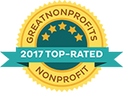
https://greatnonprofits.org/whitelabel/reviews/debes-creer-en-ti

Risk factors if we operate with a poverty mentality
Charity which happens to be the 3rd largest industry in the world, solves the biggest problems of poverty, hunger, education, etc. DCET fundraises strategically with the idea that we cannot operate with a poverty mentality - We are innovators – our mission saves and transforms lives. however, without money we cannot accomplish our mission - Money is oxygen!! If we don’t have the air, that we need, the finances that allow us to continue and expand our mission… we can die! Our Mission: (To provide literacy, workforce development programs, and other educational, cultural, mentoring and community initiatives for underserved low and moderate income immigrants, in its majority Hispanic/Latino families) …will not be accomplished. If we don’t have the finances to support our programs, we cannot bring our mission to work. We just won’t make it after 22 years…!! Our legacy will die!
Before they bury us we want to see some of these problems solved - we have to come up with innovator ways to secure the budget towards EDUCATION. YOU ARE THE ANSWER to social progress in Irving! Please become our Literacy Partner and help us fund our Literacy, Mentoring and Community Programs. We need your support!
Obstacles we might face trying to achieve your goal and a plan to overcome these challenges.
If we don’t work hard to fulfill our mission and work as a team with our board of directors, literacy partners, volunteers, school districts, community colleges, libraries, and other nonprofit organizations as well as corporations and individual donor we will not be able to survive and afford the operational expenses and program expenses of our learning center. A 2016-17-18 Strategic development plan is being review as well as our and Fundraising Plan.
The key in order to achieve our goals and overcome challenges is operating with full compliance and manage our special events with the proper planning and organization.
Budget for Project:
Program Curricula  - Teaching Adults Spanish Literacy Curricula (70 books @ $18.40)  - Citizenship Ready for the Interview student book (70 CD’s @ 20.00)  - https://www.newreaderspress.com/citizenship-passing-the-test#productDetail_components  - Civics and Literacy Student book curricula  - Literacy Skills Audio CD  - Teaching ESL to Adults Curricula (70 books @ $18.40)  - https://www.newreaderspress.com/teaching-adults-esl#productDetail_components | 1,288.00  1,400.00  1,022.00  1,022.00  1,288.00
Program Supplies  - Manila folders, copy paper, pens, pencils, notebooks, dry erase markers, binders, highlighters, erasers, Sharpie permanent markers,  - 70 dictionaries, (0582511550) Longman Diccionario Pocket Latin America  https://www.barnesandnoble.com/w/longman-diccionario-pocket-para-estudiantes- latinoamericanos-longman-staff/1100840229  - Jazz Chants by Carolyn Graham –28 Student books and 28 CDs/cassettes  (Click here for more information) | 412.00  770.00  934.94
Printing Cost  - 1,200 Black ink color stock Promotional fliers @ 0.6 cents  - Laser Printer Toner cartridge, (laser Office Depot® Brand OD42XM (HP42X) Black ink MICR Toner C)  - 500 (Front/Back) Printing Instructional brochure (Black ink color stock)  - Print Enrollment forms, Activity Sheets, Evaluations, Teacher/student agreement, Code ethics/values of DCET (350 sheets, black ink, color stock) | 72.00  403.07  60.00  91.00
Technology (Through TechSoup for nonprofits)  - 15 Computers upgrade to Windows 10 Operating System  - 15 Computers upgrade to Office Professional Plus for nonprofits | 150.00  40.00
End of year Graduation Recognition Reception  Rental graduation robes, finger food, cookies, punch, name tags, certificates of accomplishment, ice, napkins, cups, small disposable plates and forks, fruit. | 450.00
Training Cost  Contract labor Instructor/Facilitator  2-hrs/week (Mon/Wed) x (176hrs @$22.00/hrs.) for 26 weeks | 3,872.00
Pre-Post Assessment Tools  - Best Plus tests administrations  - Other administrator’s scoring Tool kits and material www.cal.org/bestplus/start.html#pricing  - Test Administrator Guide (includes TEST CD’s)  - Best Plus Technical Report (BP-3900-007)**  - Test Administrator Scoring Refresher Toolkit (Available in DVD format)  - Shipping and Handling  **The BEST Plus Technical Report outlines the development of BEST Plus as a computer-assisted assessment of oral language proficiency in adult English language learners. It includes complete information on the following: the theories | 430.00 390.75  30.00  25.00  150.00  19.99
GRAND TOTAL | $13,500.00
Photos - Videos of Senior students preparing to receive their Naturalization status after a 10 month course at DCET
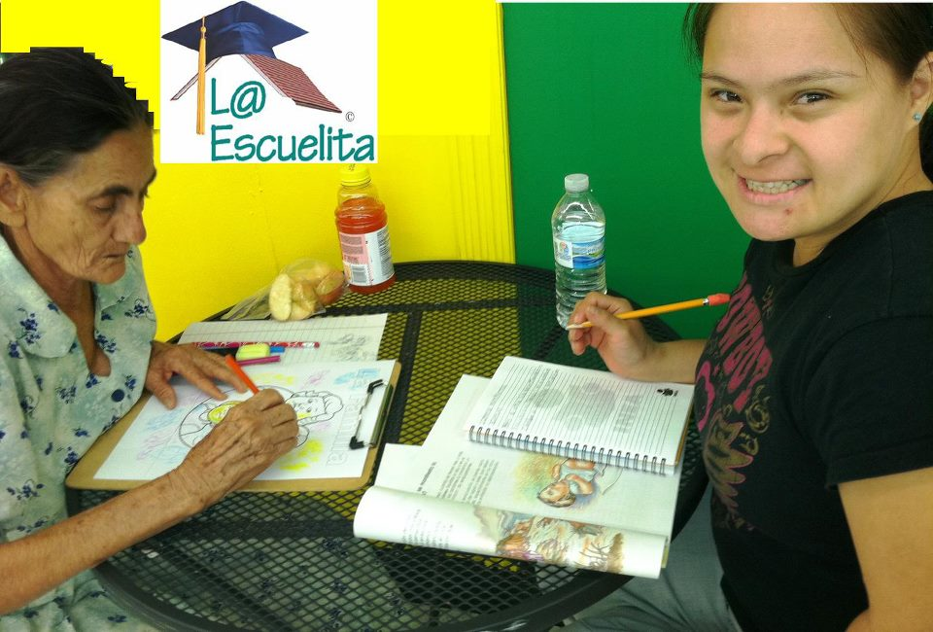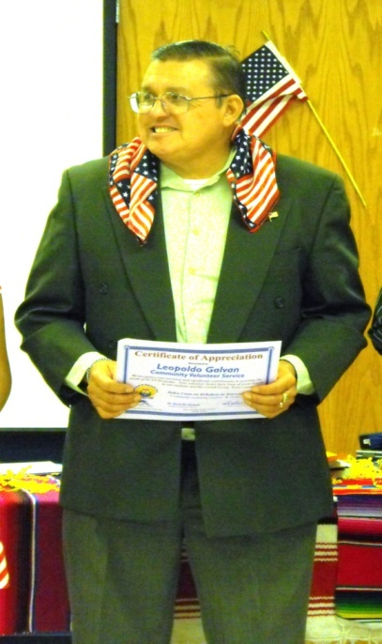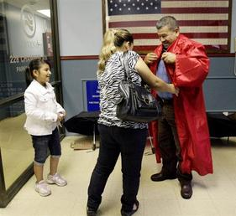
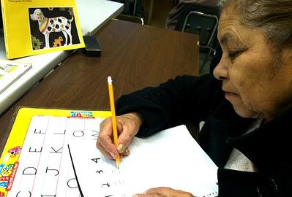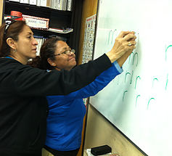

VIDEOS:
CLICK ON THESE LINKS:
https://www.youtube.com/watch?v=R878SVjdpwY
https://www.youtube.com/watch?v=s9NIOr0iLis
https://www.youtube.com/watch?time_continue=10&v=27A8Qkq8q_c

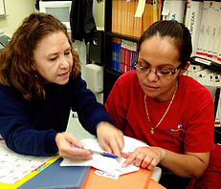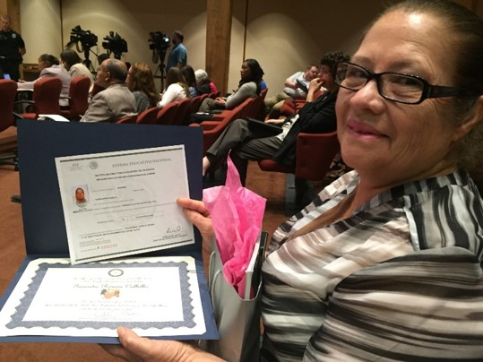
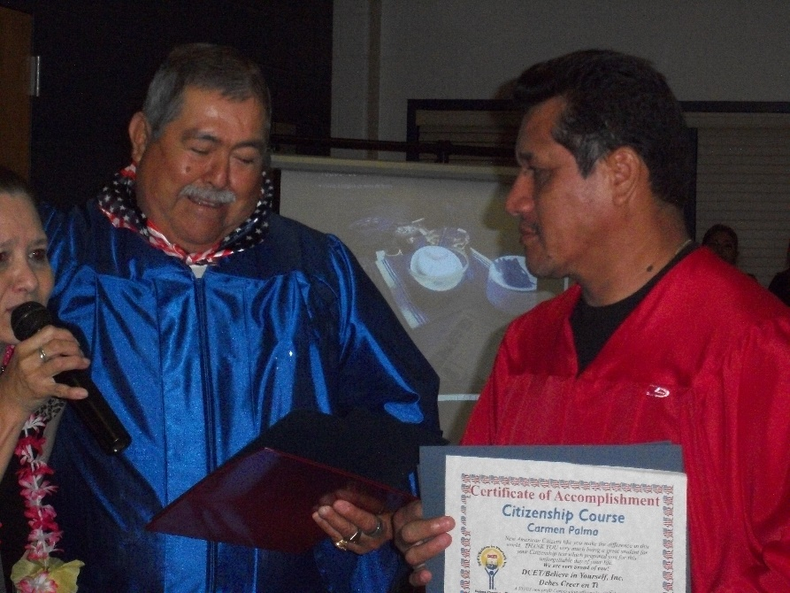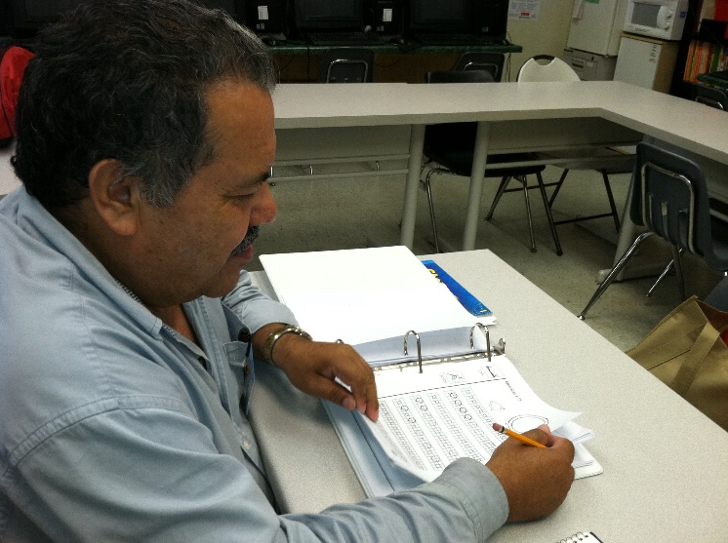

From our Board of Directors, thank you for considering assisting our Citizenship Program
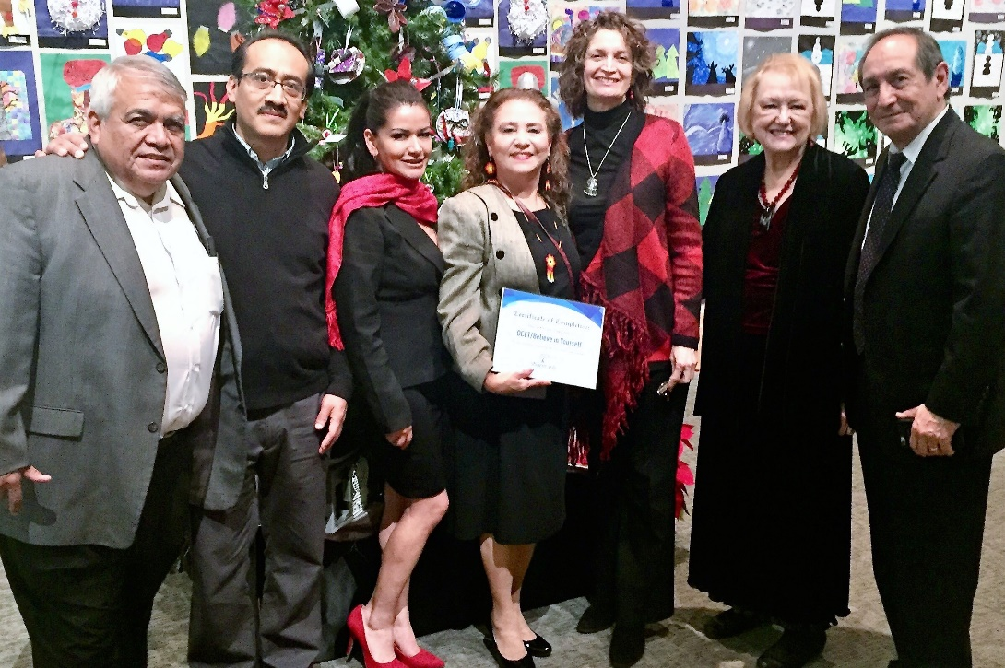
Please visit us:
www.dcenti.org
https://www.facebook.com/laescuelitadedcet/
https://www.facebook.com/DCETBelieve-in-Yourself-Inc-297946823416/
https://twitter.com/dcenti1
https://plus.google.com/+FounderofDCETElviaWallaceMartinez/posts
https://www.linkedin.com/in/dcet-inc-elvia-wallace-martinez-0a7b506
https://www.youtube.com/channel/UCvEex4IlJH9qTk4l-FiiCWw

