World Vision Taiwan
Quarterly Report to Hualien Earthquake
05/18/2018

Ling and her family members were extremely terrified by this huge earthquake. Despite none of Ling’s family member got injured during the earthquake, it was scary enough that they dare not stay at home. They went to a temporary shelter and stayed there.
World Vision Taiwan’s professional social worker delivered first-time aid and accompanied Ling’s mother to home. Moreover, with World Vision Taiwan’s subsequent financial aid, Ling’s family could get their life back on track.

- Overview

On February 6, 2018, a 6.4 magnitude earthquake hit Hualien, a large eastern city of Taiwan. The strong earthquake and the following strong aftershock left people in terror. Buildings lean and roads crack, and the highway locked down due to security concerns. At that time, residents in affected area suffered not only from property lost, but psychological impact as well.

With strong commitment to emergency relief, World Vision immediately sent 30 social workers to the damaged areas - including Hualien City and other affected towns - to assess the degree of damage and establish Children Friendly Center for affected households.

- Needs assessment

- This earthquake put some disadvantaged households that World Vision Taiwan was helping into even worse economic situation. With education aid, financial aid, furniture repair and school supply, the households and children could get back on track.
- Some signs of psychological trauma were observed among the children, we quickly set up Children Friendly Center in response.

- Achievements
- Established two Children Friendly Center at Hualien Gymnasium and Chunghwa elementary school from Feb 7 to Feb 14, providing temporary shelter and children caring.
- Helped 530 children finish schooling registration with education aid. 134 households were relieved from immediate economic pressure with financial aid. 14 households had their furniture repaired with our help. Children from 100 households were provided with school supply.

- Beneficiaries

- Households: 148
- Children & Community members: 1,017 (530 children and 487 local residents)

- Expenses & beneficiaries

Items | Expenses (NTD) | Beneficiaries | Description
Children Friendly Center*2 | 16,448 | 487  children
Financial aid | 402,000 | 134  households | 3,000 NTD for 134 disadvantaged households.
School supply | 200,000 | 100  households
Furniture repair | 140,000 | 14 households | 10,000 NTD for qualified affected households.
Education aid | 3,975,000 | 530  children | 7,500 NTD for qualified affected children, 7,500 NTD for each.
Sum | 4,733,448 NTD

- Pictures

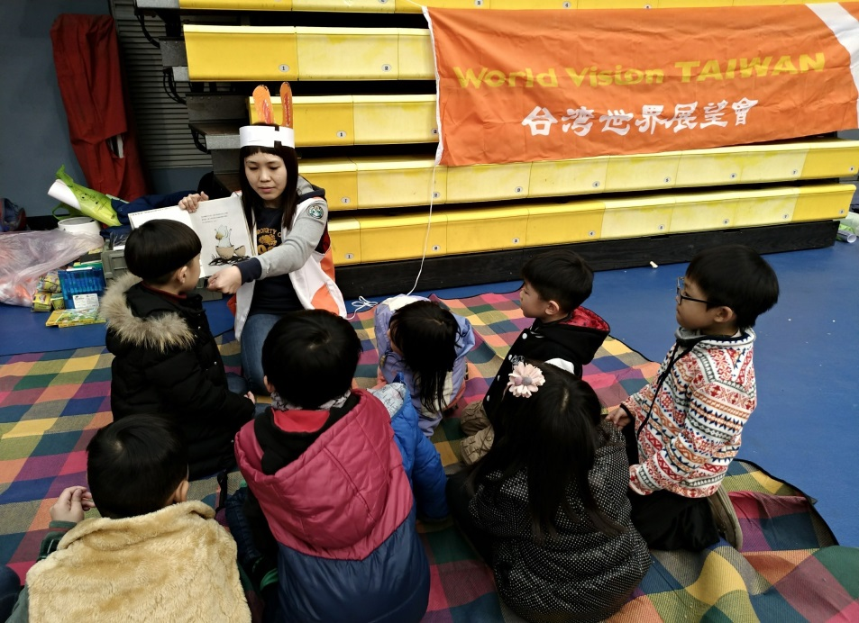 |  | - Children Friendly Center  - Duration: 2/7-2/14  - Place: Hualien Gymnasium  - Content:  Set up Children Friendly Center, providing emotional support for children through games, painting and other activities. Counseling resources involved if necessary.
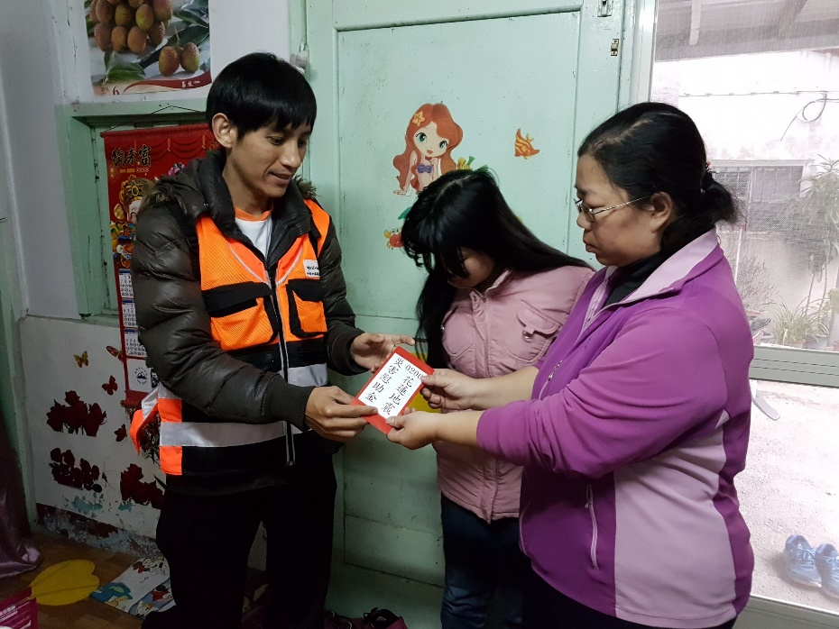 |  | B. Financial aid  - Duration: Feb-Mar  - Place: household  - Content:  Social worker delivering financial aid at the scene.
Cracked toilet | New toilet purchased with aid | C. Furniture repair  - Duration: Feb-Apr  - Place: household  - Content:  Repair damaged furniture or purchase replacement
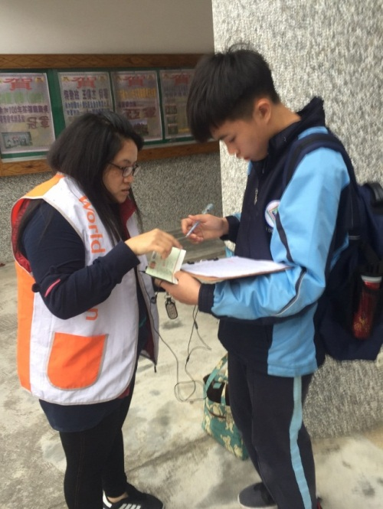 |  | D. Education aid  - Duration: Feb-Dec  - Place: campus  - Content:  Provide affected disadvantaged children with education aid

