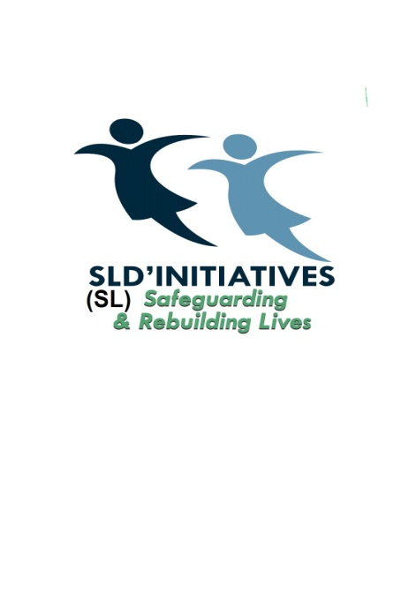

Sierra Leone Development Initiatives (SLDI)

Sierra Leone Development Initiatives (SLDI) is a non-governmental, not-for-profit organisation that is dedicated and committed to the fundamental human rights of vulnerable girls and women in Sierra Leone through the promotion of gender equality and gender equity. SLDI seeks to achieve its objectives by using a two-pronged approach:

- Direct services to vulnerable girls and women in Sierra Leone, focusing primarily on ending all forms of violence against them, access to effective sexual and reproductive health and HIV services, alternative livelihoods and education and skills training that they will unleash their potentials, and become valued citizens in their country.

- Raising awareness, and campaigning on issues affecting women and girls with a keen focus on inequality, social injustice and human rights, promoting activities to foster understanding between people and gain public support, conduct research and publicising the findings with regards to human rights violations on vulnerable girls and women in Sierra Leone.

MISSION STATEMENT
SLDI’s mission is to provide innovative and competent support to needy communities in Sierra Leone such as, stimulating local development initiatives especially among the disadvantaged and safeguarding the human rights of vulnerable girls and women in the country.

OUR VISION
A Sierra Leone with communities where girls are free from all forms of violence, live valued and dignified lives and have access to free and confidential sexual and reproductive health services.​

SLDI’s MOTTO
“Safeguarding and Rebuilding Lives”

OUR WORK
Although SLDI’s mandate is to support vulnerable women and girls in Sierra Leone, however, most of our beneficiaries are sex workers as they suffer human right violations on a daily basis. They are also the most marginalised. SLDI therefore, promote equality, social justice and human rights and in particular the elimination of exploitation and abuse of vulnerable girls and women in Sierra Leone.

We provide for our variety of services for our beneficiaries:

- We support sex workers to exit sex trade through rehabilitation programme which involves person centred case work and development programmes. For those that are very young and want to go back to school, we enroll them back in school. Older girls and women that want to learn skills such as vocational training are enrolled in institutions to train on any skills of their choice. We support the girls and women even after their education giving them employment support as well and have an alumni for those that are graduated and are now self sufficient to become mentors to new beneficiaries and also to prevent relapse.

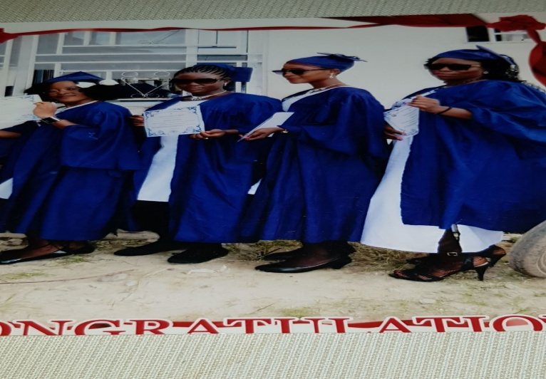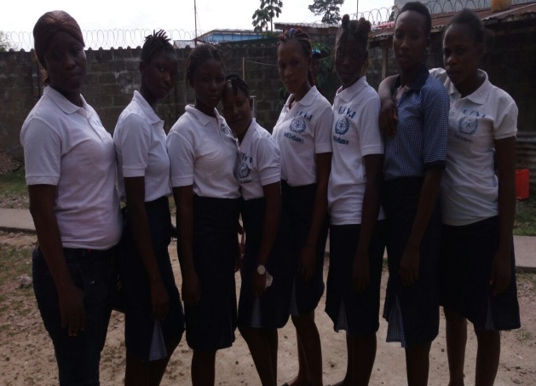

SOME OF OUR BENEFICIARIES GRADUATED IN SOME OF OUR BENEFICIARIES AT THEIR
DECEMBER 2017. INSTITUTION.

- We also provide sexual and reproductive health and HIV services. We organise workshops for girls and women especially those in the sex trade. This is very crucial because according to research by the National AIDS Secretariat in Sierra Leone, Sex workers contribute 39.9% of new infection. We also conduct outreach by visiting hot spots, hotels and mining areas where sex work is prevalent. We distribute safe sex kits, educational leaflets and conduct HIV tests which is free.

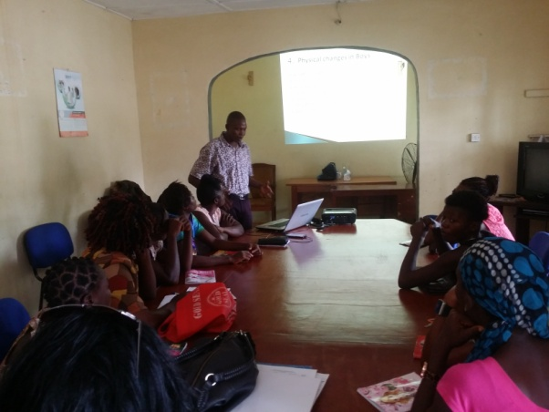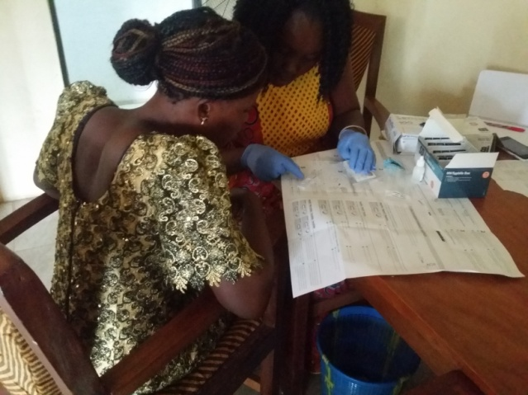
ONE OF OUR WORKSHOPS HIV TESTING

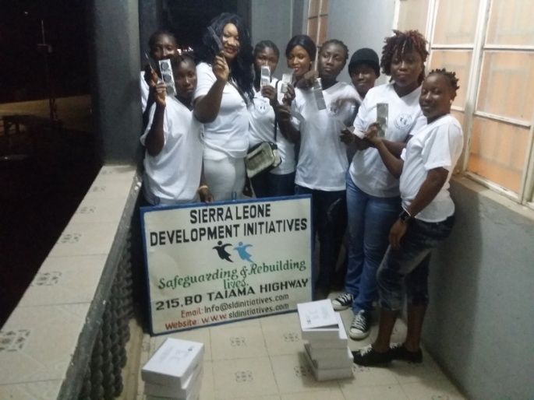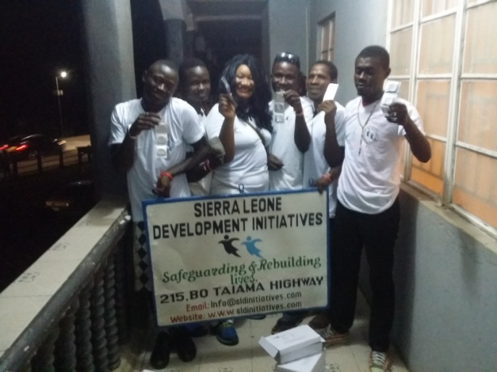
PREPARING FOR OUTREACH ENGAGING MEN TO COMBAT RISKY
BEHAVIOUR

- We raise awareness on gender base and sexual violence to increase women and girls knowledge of the issue especially those who are victims of SGBV violence. We empower them with information and sign post them to relevant services.
- We also sensitise the community on the importance of supporting human rights and health issues and for them to foster a caring and peaceful society free from sexual gender based violence.

Contact Person: The Chief Executive Officer
Tel: +447702766438
Email address: info@sldinitiatives.com
Website: www.sldinitiatives.com

Sierra Leone Office: 215 Bo/Taima Highway
Bo City
Bo District
Tel: +23276605101

