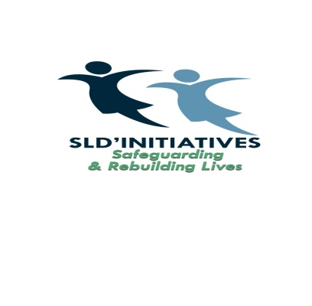
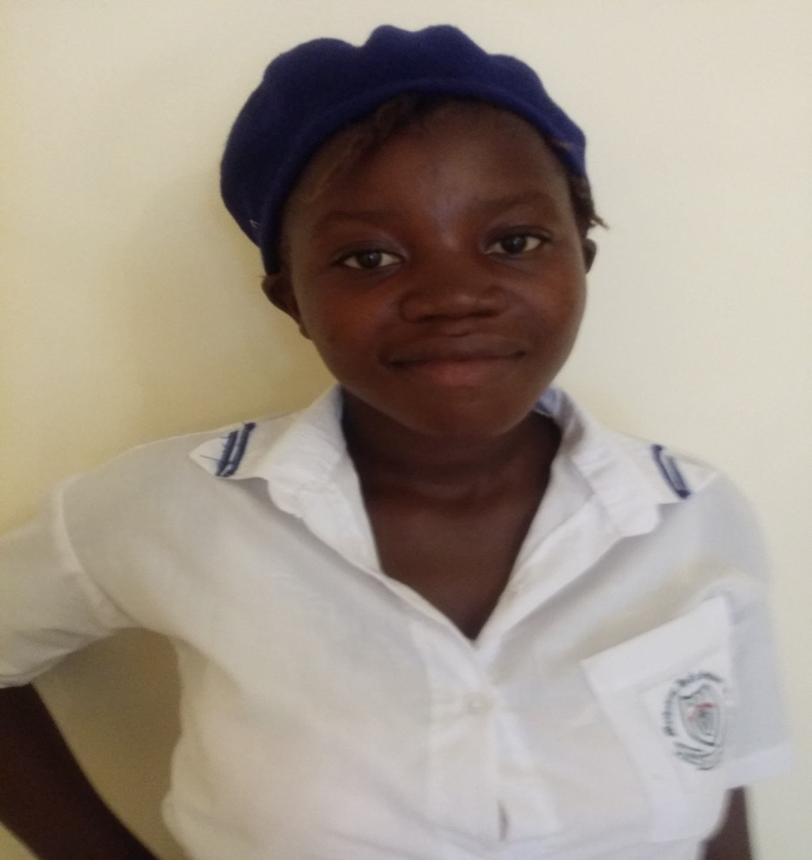
Tenneh in her school uniform
Tenneh is a 17 year old girl who has benefited from Sierra Leone Development Initiatives (SLDI) project activities and programmes in the city of Bo, Sierra Leone. Tenneh was living with her mother in a small village in Sierra Leone as her dad is deceased. Tenneh attended primary school in her village however, her mother cannot afford the costs associated with school when she got to secondary school. She had to drop out of school. A lady from the village then promised Tenneh and the mother that she will take Tenneh to the city of Bo to live with her and put her in education. Tenneh and the mother were very delighted that she was going to have the education she wanted.
Unfortunately, when Tenneh went with the lady, she did not keep to her promise. She did all the domestic chores in the house and will sell for the lady the whole day. She was also abused by the lady physically for the slightest thing. She was so badly beaten one day that she had to run away and started living on the streets. At the age of 13, Tenneh was living on the streets without money or food and she started sexwork. As a sex worker, she endured both physical and sexual abuses on a daily basis but continued as she was using the money from her sexwork to pay her fees. She got pregnant at the age of 14.
She had no antenatal and no one to guide and support her throughout her pregnancy till she gave birth. She continued doing sexwork to sustain herself and her son who was very difficult for her as she was not making enough money and her homelessness exasperated her vulnerability.
SLDI came in contact with Tenneh at the age of 16. She went through counselling and support and got enrolled back into education. SLDI further found a family that was willing to give Tenneh a home and help her with her son when she goes to school. SLDI continue to support Tenneh and her son till now. Tenneh is now in 6th form and is aspiring to be a nurse. There are so many girls all over Sierra Leone who are just like Tenneh. SLDI is working for them to rebuild their shattered lives and eventually live independently.

