**PROJECT PROPOSAL on**

**Socio-Economic Empowerment of Widows through Micro-Enterprises to LIVE THEMSELVES AND educate their children**

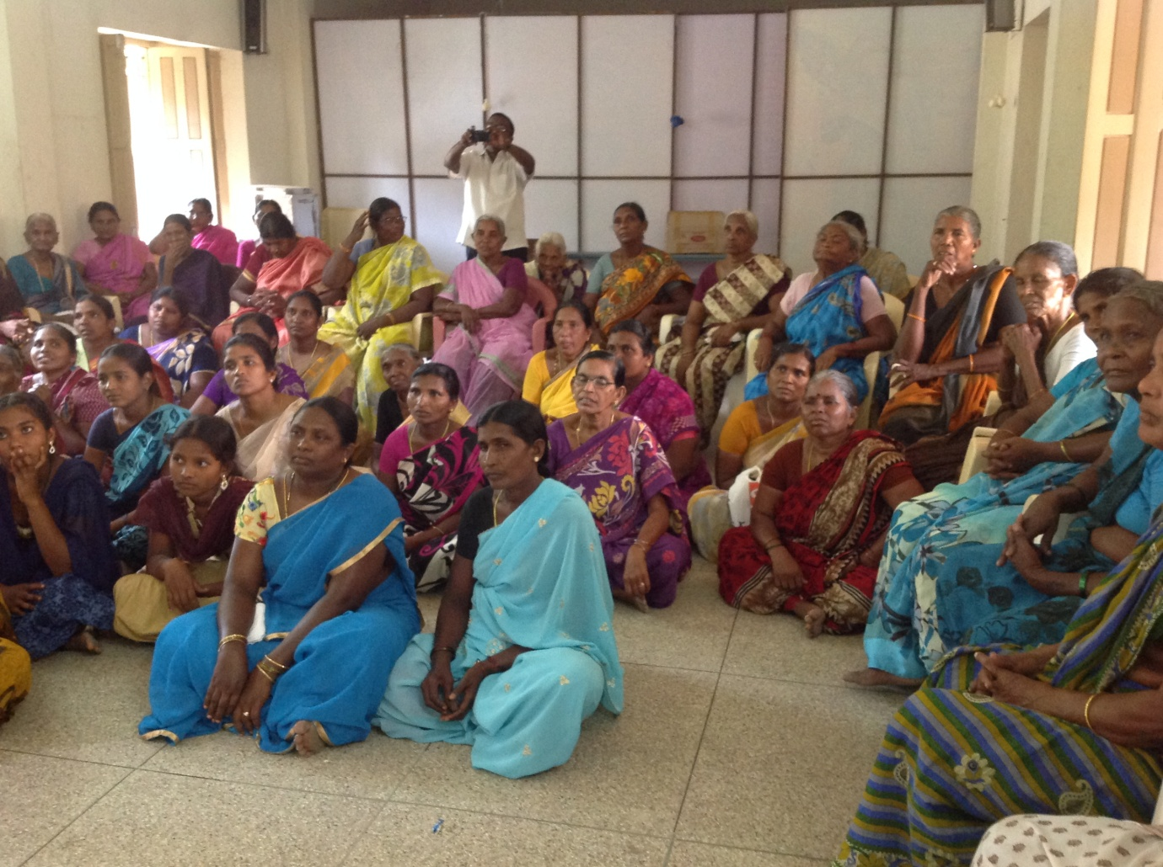

1. Project title:

Socio-Economic Empowerment of 20 Widows through Micro-Enterprises to educate their children at Rentachintala, district of Guntur, India.

1. **Name of the Applicant and Organisation:**

Ms. K. Thomasamma, President

Development Society for Poor (DSP)

Rentachintala Post & Mandal

Guntur 522 421, Andhra Pradesh, India

Phone Number: 0091-9985512014, 0091-9652013570

E-Mail: [dsociety2005@gmail.com](mailto:dsociety2005@gmail.com), Website: <http://www.developmentsocietyforpoor.org>

1. **Legal Status of DSP**

Registration Number : 876/2005 dated 29th December 2005

Registration under FCRA : 010190525

PAN Number : AACTD1821G

Unique Id. (DARPAN) No. : AP/2017/0169673

1. **Address of the Bank with Account Number**

**Account No. 117801000009645**

**Swift Code: IOBAINBB028**

**IFSC Code:** **IOBA0001178**

**Name of the Account Holder: Development Society for Poor (DSP)**

**Name of the Bank: Indian Overseas Bank**

**Address of the Bank:**

Bishop House Compound, Chandramoulinagar,

Guntur, 522007, Andhra Pradesh, India

1. **Nature of the Organization**

The Development Society for Poor (DSP) is a social service organization working for the socio-economic development of the Scheduled caste (SC) and the Scheduled Tribe (ST) communities, irrespective of their caste, creed and religion. However, it focuses on the rural poor, agricultural labourers, marginal farmers, women and children, particularly the girl child. The DSP is committed to people’s participatory development processes. People concerned and affected are involved in the entire process of project identification, development, execution, monitoring and evaluation. Projects adopt a bottom up approach and are evolved at the community level.

1. **Geographical Conditions of the Project Area:**

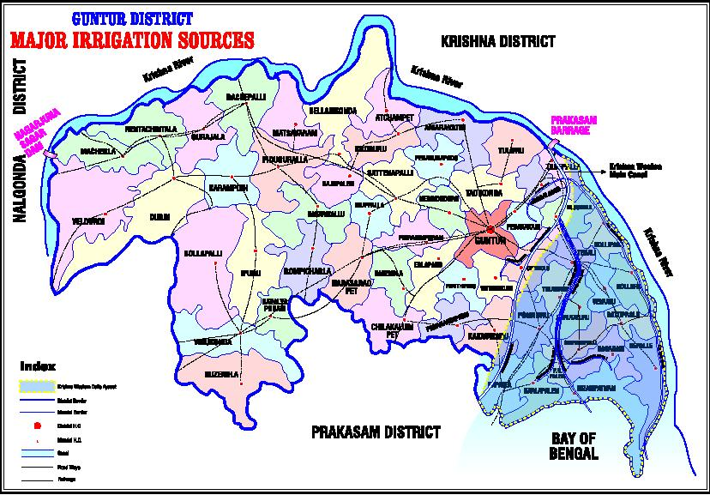

Project Location: Rentachintala Administrative Division

Location: The project is located at Rentachintala Mandal in Guntur district. Geographically the Guntur District is situated in the Eastern part of the State having for its boundaries the districts of Krishna and Nalgonda on the North, Prakasam and Mahabubnagar districts on the West, Prakasam district on the South, and Krishna district and the Bay of Bengal Sea on the East. The geographical area of the District is 11,391 square kilometers, which amounts to 4.14% of the total area of the State.

Climatic Conditions: The climate is extremely hot during summer months from March to July. The temperature goes up to 50° degrees centigrade and temperate during the cold season with 25° degrees centigrade. Rainfall is occasionally deficient.

Environmental Condition: The environment is rather pleasant with a very few small and medium industries. The industries are around 8 – 10 kilometers away from Guntur city. Soap manufacturing factory, cotton ginning mills, jute factory, tobacco are some of the industries.

Socio-economic Situation: The socio-economic situation of Guntur city is very backward. It has a population of over 651,382. The people belong to all communities. The city lacks basic facilities out of which clean drinking water is a major problem.

1. **Project Background Description**

**Census of the Project group:** According to 2011 census there are over 5.6 crore widows in India and the incidence of widowhood in India is the highest in the world. The Guntur district has a staggering number of 969,858 widows of whom 64.8 per cent are below 40 years of age and the number is rising.

Among these 20 widows most of them belong to the Scheduled caste and the Scheduled tribe communities popularly known as the DALITS or untouchables. They are socially and economically marginalized and the poorest of the poor.

The Scheduled caste, Scheduled tribe and backward communities are the lowest in the social structure of society. They are socially marginalized, the poorest and the most exploited. The physically challenged persons belong to these communities. These unfortunate people are deprived of the basic necessities of life. They live in the slums in small makeshift sheds amid filth and squalor in a highly deplorable state of life. These unfortunate people languish in poverty and starvation resigned to their fate.

1. **Project Specific Objective**

To empower widows from backward class communities socially and economically, improve their standard of living and thereby enable them to take care of their children, particularly their daughters.

1. **Specific purpose:**

Financial assistance to start small business enterprises for economic and overall development.

1. Project Description

The project rationale is to assist 20 widows aged between 18–40 living a miserable state of life without any means of livelihood. They belong to the DALIT community, socially marginalized, poorest and the most exploited.

**The women have lost their husband to HIV/AIDs, Cancer, and Tuberculosis and farmers suicides shattering their lives and that of their children. These unfortunate women are faced with the prospect of raising families all by themselves in a patriarchal society. The social security cover provided is meager.**

They find it hard to make living because of their loneliness. We propose to assist them to set up small business enterprises such as vegetable selling, provision shop, fruit shop etc., which will enable the widows to earn their living, improve their socio-economic situation, become self-reliant and lead a decent life and educate their children.

1. **Beneficiaries**

20 widows from SC, ST and backward communities.

1. **Planned activities:**

The plan of micro-enterprises will be discussed to improve the economic situation with the 20 widows. Guidance will be given to them to choose appropriate micro-scheme as per their aptitude. The assistance of the technical person will be taken to give them initial training before the scheme commences.

1. **Expected results:**

* The improvement in the economic status of the beneficiaries.
* The positive social transformation of the group in the socio-economic spheres.
* The number of families that would obtain livelihood support.
* The extent of benefits accrued by the target group, monthly income, rise in standard of living, per capita income

1. **Project Budget**

Cost to set up a small shop Rs. 20,000

Seed money to purchase fruits/vegetables etc., Rs. 30,000

Instruments for business (scales and other items) Rs. 5,000

Total Amount required for one person Rs. 55,000

For 20 persons 20 * Rs. 55,000 Rs. 11, 00,000

Local Contribution Rs. 5000 * 20 persons Rs. 100,000

Requesting contribution Rs. 10,00,000

1. **Monitoring/follow-up and project sustainability**

The most important component of the micro-enterprises will be continuous and regular monitoring ensuring that the funds extended to the beneficiaries are not misused. Records maintained on the benefits accrued by the beneficiaries from the assistance received, ability to procure basic essentials, education, monthly income, per capita income will be the monitoring tool.

The project is environment friendly and will contribute immensely towards the technical, economical, financial, socio-cultural and institutional sustainability.

1. **Impact of the Project**

The annual income of the widows will improve gradually and the widows will have work even during the agricultural slack season. The confidence levels of the widows will be enhanced that nothing is lost and they can improve their lives. The widows will be socially and economically transformed and all their children will have nutritious food, quality education and good health care. The widows will lead a safe and secure life with confidence and will gain social recognition.

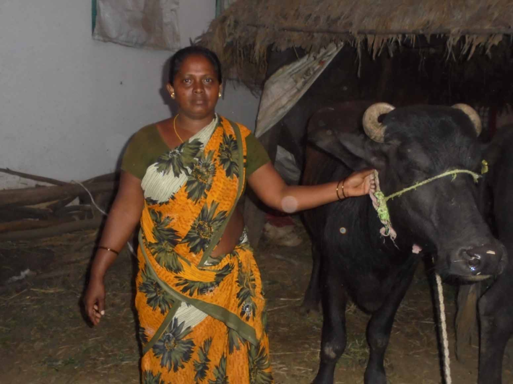 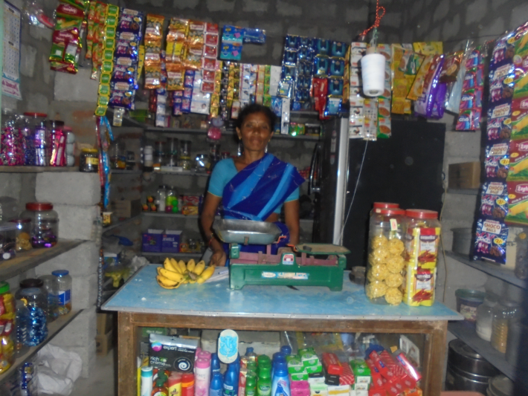

**Mrs. K. Thomasamma**

**President, Development Society for Poor**

**Guntur, India**