Support Women's Peacebuilding in Pakistan (SW2Ps)

4th Quarterly Progress Report

November 2018 – March 2019

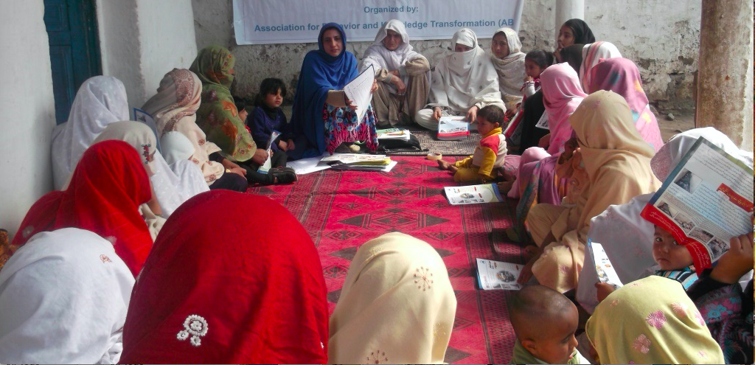
Women community awareness session on Right to Vote

Association for Behaviour and Knowledge Transformation (ABKT) www.abkt.org

- Basic Information:

Project Title: Support Women’s Peacebuilding in Pakistan
Project Target Area: Three Districts (Lower Dir, Upper Dir and Malakand)

Project Target Group: Emerging Women leaders and Elected Women Councilors

Organization’s Name |  | Website (if any) |  | Organization’s E-mail
Association For Behavior and Knowledge Transformation (ABKT) |  | www.abkt.org |  | info@abkt.org  abkt.pakistan@gamil.com
Street Address, City |  | Country | Office Phone(s) | Office Fax
House 46, street 45, G-13/2, Islamabad |  | Islamabad | 0092-51-23 23 281 | 0092-51-23 23 281
Point of Contact | Title | Work Mobile | Point of Contact’s E-Mail | Skype ID (if any)
Ms. Shad Begum | Executive Director | 0345-9002768 | shadbegum@gmail.com | shad.begum
Dates covered by this report |  |  | Report Submission Date
May 22nd, 2018 to August 20th, 2018 |  |  | August 20th , 2018

- Project Summery:

This project aims are to increase women's political participation in the face of extremism and conflict in Khyber Pakhtunkhwa (KP) and the Provincially Administered Tribal Areas (PATA). Women are underrepresented at all levels of decision-making and their needs related to the conflict are not being sufficiently addressed in these areas. This project will empower women through documentation, political training, and the creation of a forum where they can voice their concerns to policymakers. This project is focusing on three districts of Khyber Pakhtunkhwa (KP) and the Provincially Administered Tribal Areas (PATA) including Dir Lower, Dir Upper, and Malakand. However, the project will start implementing initially from Dir Lower.

- Accomplished Activities during the 4th quarter of the project:

- Coordination and networking meetings of Gender Responsive Action Forum (GRAF) were facilitated. Members shared their issues and problems and developed and actions plan to resolve them together.

- Members from GRAF arranged 12 awareness sessions in 16 villages on the importance women right to vote in their communities.
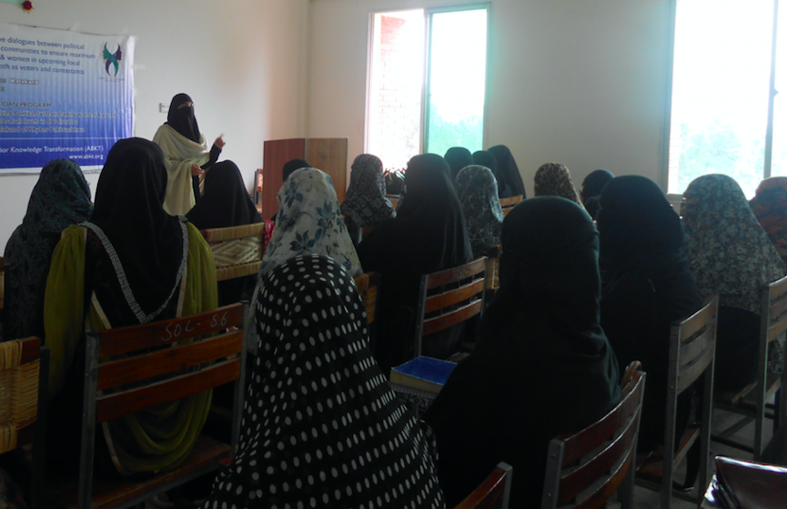

- Awareness sessions on District Committees on the Status of Women (DCSW) were conducted for women and girls in village Kalpani and Banragi. The Chairperson of Lower Dir DCSW Ms. Najma Falak shared the information and mandate of the committee with Women.

- Two days of training on women rights and existing laws in the country to protect women rights were conducted for 18 members of the GRAF. The GRAF members became aware of the existing laws and frameworks that protect women rights.

- Project monthly progress review and planning meetings were held both in the head office and field office Lower Dir. During the meeting project progress was reviewed, challenges were discussed and an action plan was reviewed and finalized for every next month.

- Challenges faced and mitigation strategies applied:

The project design is based on integrated approach in terms of the relevancy of its activities sequel and effect. The total estimated budget of the project is 50,000 USD; against this budget until now the Global Giving has wired around 6,000 USD. The project team discussed the funding challenge and to tried their level best to reorganize the activities according to the received funds, making sure to do not disturb the logical order of the project. As per above given facts, it was decided to establish and also make functional the GRAF forum and later on organize the rest of the initiatives gradually.

