Support Women's Peacebuilding in Pakistan (SW2Ps)

2nd Quarterly Progress Report

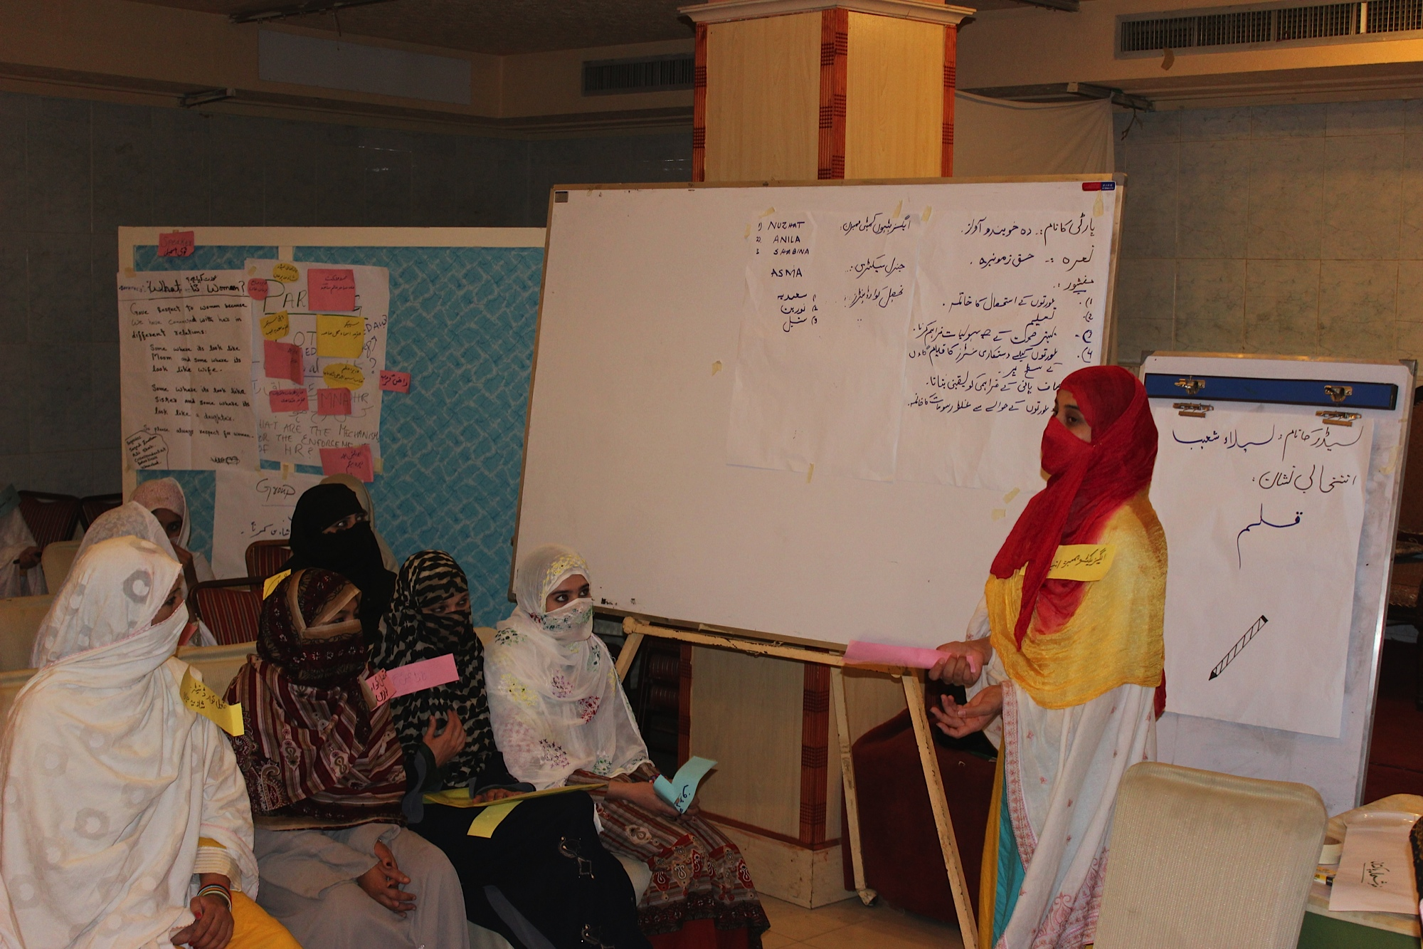
June 2018 – August 2018

Association for Behaviour and Knowledge Transformation (ABKT) www.abkt.org

- Basic Information:

Project Title: Support Women’s Peacebuilding in Pakistan
Project Target Area: Three Districts (Lower Dir, Upper Dir and Malakand)

Project Target Group: Emerging Women leaders and Elected Women Councilors

Organization’s Name |  | Website (if any) |  | Organization’s E-mail
Association For Behavior and Knowledge Transformation (ABKT) |  | www.abkt.org |  | info@abkt.org  abkt.pakistan@gamil.com
Street Address, City |  | Country | Office Phone(s) | Office Fax
House 46, street 45, G-13/2, Islamabad |  | Islamabad | 0092-51-23 23 281 | 0092-51-23 23 281
Point of Contact | Title | Work Mobile | Point of Contact’s E-Mail | Skype ID (if any)
Ms. Shad Begum | Executive Director | 0345-9002768 | shadbegum@gmail.com | shad.begum
Dates covered by this report |  |  | Report Submission Date
May 22nd, 2018 to August 20th, 2018 |  |  | August 20th , 2018

- Project Summery:

This project aims are to increase women's political participation in the face of extremism and conflict in Khyber Pakhtunkhwa (KP) and the Provincially Administered Tribal Areas (PATA). Women are underrepresented at all levels of decision-making and their needs related to the conflict are not being sufficiently addressed in these areas. This project will empower women through documentation, political training, and the creation of a forum where they can voice their concerns to policymakers. This project is focusing on three districts of Khyber Pakhtunkhwa (KP) and the Provincially Administered Tribal Areas (PATA) including Dir Lower, Dir Upper, and Malakand. However, the project will start implementing initially from Dir Lower.

- Accomplished Activities during the first quarter of the project:

- Profiling of 10 women leaders and 10 elected women councilors was finalized for leadership capacity building program in two target districts of the project i.e. Lower Dir and Malakand.

- Profiling of 10 women leaders and 10 elected women councilors was finalized for leadership capacity building program in two target districts of the project i.e. Lower Dir and Malakand.

- Gender Responsive Action Forum (GRAF) was initiated in two of the districts. Each district chapter is compromised of 10 women leaders and elected women councilors.

- Training manual for leadership training was completed. During the next quarter, the training will be conducted.

- On July 25th the general elections were held in Pakistan. To ensure women right to vote and to report the observation and recommendations to the Election Commission of Pakistan about women voting on the Election Day, GRAF members were trained about the election observation protocols during the month of June.

- To ensure the maximum turnout of women voters on the Election Day, GRAF members conducted 30 awareness sessions in different parts of the two districts with above 500 women voters. The turn out on the Election Day was historic.

- Project monthly progress review and planning meetings were held both in the head office and field office Lower Dir. During the meeting project progress was reviewed, challenges were discussed and an action plan was reviewed and finalized for every next month.

- Challenges faced and mitigation strategies applied:

The project design is based on integrated approach in terms of the relevancy of its activities sequel and effect. The total estimated budget of the project is 50,000 USD; against this budget until now (2nd quarter) the Global Giving has wired around 4,835 USD. The project team discussed the funding challenge and to tried their level best to reorganize the activities according to the received funds, making sure to do not disturb the logical order of the project. As per above given facts, it was decided to establish and also make functional the GRAF forum and later on organize the rest of the initiatives gradually.

