Promoting Women’s Leadership in Pakistan (PWLP)

13th Quarter Progress Report

September 2021 December 2022

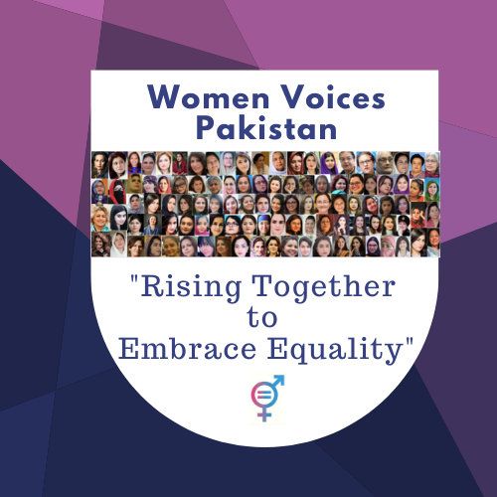

Association for Behaviour and Knowledge Transformation (ABKT) www.abkt.org

- Basic Information:

Project Title: Promoting Women’s Leadership in Pakistan (PWLP)
Project Target Area: Khyber Pakhtunkhwa, Pakistan

Project Target Group: Emerging Women Leaders

Organization’s Name |  | Website (if any) |  | Organization’s E-mail
Association For Behavior and Knowledge Transformation (ABKT) |  | www.abkt.org |  | info@abkt.org  abkt.pakistan@gamil.com
Street Address, City |  | Country | Office Phone(s) | Office Fax
House 46, street 45, G-13/2, Islamabad |  | Islamabad | 0092-51-23 23 281 | 0092-51-23 23 281
Point of Contact | Title | Work Mobile | Point of Contact’s E-Mail | Skype ID (if any)
Ms. Shad Begum | Executive Director | 0345-9002768 | shadbegum@gmail.com | shad.begum
Dates covered by this report |  |  | Report Submission Date
July 2020 to September 2020 |  |  | 3rd November, 2020

- Project Summery:

The project aims to promote women's leadership role in development in the face of extremism and conflict in Khyber Pakhtunkhuwa. Women are underrepresented at all levels of decision-making processes in all most every sector. Facts and findings in the education, health and employment sectors show that women needs and challenges are not being sufficiently addressed, because majority of the leadership is male dominated.

This project will invest in building and strengthening women’s leadership through training, advocacy and networking to promote women’s leadership.

Accomplished Activities during the 13th quarter of the project:
- Women Voices has been continuously highlighting women's and girl’s challenges and issues both online and offline.
- Mapping of women and girls led initiatives across Pakistan is in process. Due to COVID most of our activities got delayed. In 2022 we launch Women Voices official website and will start publishing profiles, articles, stores and achievements of women and girls from different sectors.
- Women Voices is building networking with like-minded organizations and networks to work in collaboration on different initiatives for 2022 to feature, connect and amplify the voices of women and girls.
- Women Voices will launch a series of online conversation about women and girls issues, challenges and achievements in 2022 across the country. We are making necessary preparations for it.
- Project monthly progress review and planning meeting was held both in the head office in Islamabad. During the meeting project progress was reviewed, challenges were discussed and an action plan was reviewed and finalized for every next month.
Challenges faced and mitigation strategies applied:
- The project design is based on an integrated approach in terms of the relevancy of its activities sequel and effect. However, due to the lack of sufficient donations, we have revised this project’s activities and budget also to ensure focused and impactful work despite funds issues. We are really looking forward to friends and well-wishers around the world, to join us in this important cause of promoting women's leadership by making donations. No support is small, each and every contribution matter, please.

