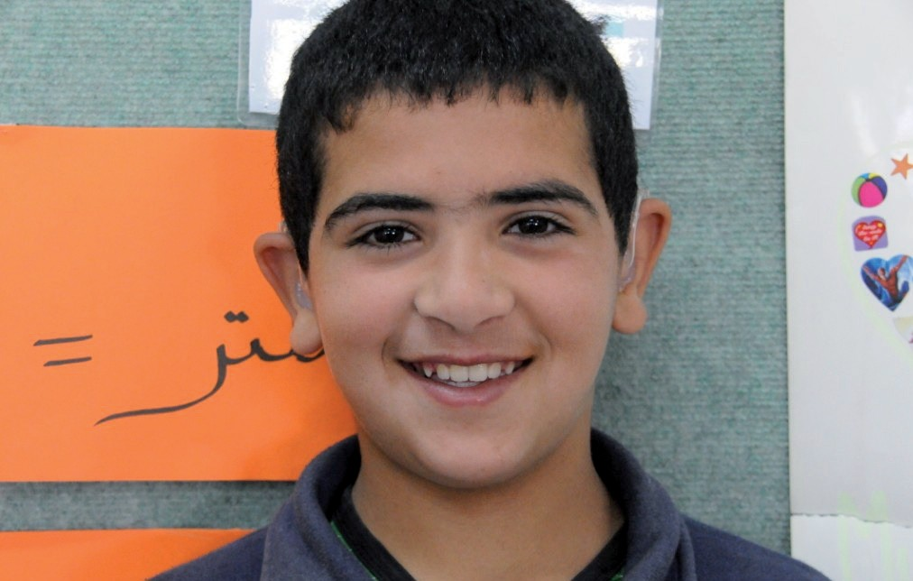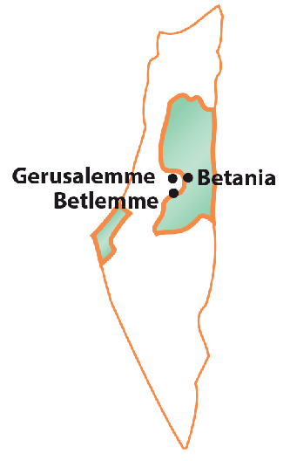
Palestine

CHILD PROTECTION
,
Intervention areas: Education and Training andaTrainingiStrUZione e FormAZione

Project “A silent voice” cod. PAL003S

The project supports children with hearing disabilities who attend the Bethlehem Effective Institute where, through specialized educational and scholastic paths, they can receive an adequate education, thus being helped in the process of social integration. Many children, living away from school, have difficulty attending classes regularly so we have also activated a transport service to guarantee them the possibility of reaching the institute.
In Palestine many children have hearing-related disabilities. The main cause is related to the consanguinity of the parents: the marriage between cousins is a widespread habit in these territories. For these children, specialized school courses are required in which, alongside the teaching of traditional subjects, the techniques of communication and comprehension of language are also learned. The Effetà center has been doing this important service for over forty years. Many Palestinian families, unfortunately, living in difficult economic conditions, do not have the possibility to support the entire cost related to education and transport and thus allow their children to attend the center.
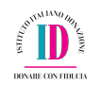

Insieme ai bambini del mondo
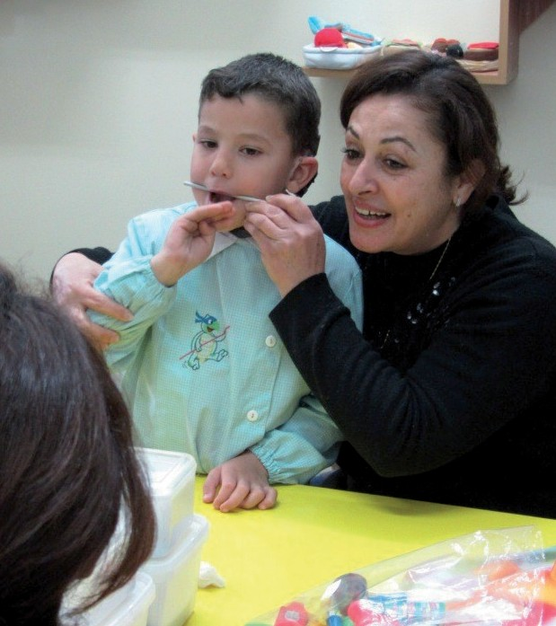
Project objectives
- Promote and disseminate the right to education and training.
- Ensure the social integration of children at risk of exclusion.
- Contribute to the school transport expenses of children from deprived families.

Project beneficiaries
- 20 children with hearing disabilities.

Project advantages
In addition to guaranteeing children with hearing difficulties, the opportunity to attend classes regularly and to learn how to communicate more easily with others. The project also has the advantage of promoting a sense of responsibility in the beneficiary families who are aware of of the need for education for their children, and thus they commit themselves to what they can to cover the remaining costs of education and transport.

How we help

The project is managed in collaboration with the Congregation of the Master Sisters of Santa Dorotea, Daughters of the sacred hearts of Vicenza.

The Effetà center addresses the problem of deafness by offering a series of specialized services. A part of the services is aimed at children and their families in order to make the deafness problem more and more aware and to accompany them in the economic and relational difficulties that they gradually encounter. Another part is aimed directly at children: it is a kindergarten and one of the obligation in which, thanks to appropriate methodologies, the child is given a suitable education and is taught how to interact and communicate despite the physical handicap. Aleimar supports some children through the coverage of school fees, transport and for acoustic rehabilitation.
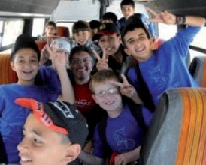
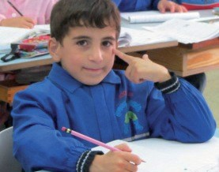
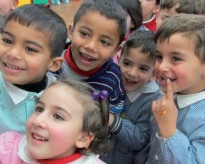
What you can do

With 20€
You can support a month of school transport for a child

With 25€
You can contribute in buying didactic material.

With 75€
You guarantee a month of schooling for a child.

Always indicate in the reason for the donation the project code: PAL003S
Gruppo Aleimar onlus - via Curiel, 21/d - 20066 melzo (mi) tel. 02.95737958 fax 02.95712273 e-mail: info@aleimar.it - www.aleimar.it
banca Prossima (Gruppo intesa SanPaolo) IBAN: it 69 U 03359 01600 100000100565
Credicoop Cernusco sul naviglio IBAN: it 65 F 08214 33400 000000050023 c.c. postale n.: 29095205 - cod. fisc.: 91526820153
all contributions and donations made to Gruppo Aleimar onlus are fiscally deductable

