Friends Women’s Association

MAY 2022 Report

Table of Contents
Friends Women’s Association 1
MAY 2022 Report 1
ACTIVITIES 2
Caring for HIV Positive People (CHIVPP) 2
Improving Women’s Reproductive Health (IWRH) 2
Rape Survivors’ Support (RSS) 6
MEDICAL TEAM 12
CONSULTATIONS 12
LABORATORY 12
FAMILY PLANNING 12
PRENATAL CONSULTATION (PNC) 13
ANTI-RETROVIRAL SITE 13
PHARMACY 13
PSYCHOSOCIAL TEAM 13

COVID-19 AND NTASEKA CLINIC
In the month of May, Friends Women’s Association has continued to apply covid restrictions restrictions at Ntaseka Clinic for both the staff and the beneficiaries’ protection.

ACTIVITIES

Caring for HIV Positive People (CHIVPP)
In the month of May, medical follow-up and home visits were done for our HIV positive people.

Improving Women’s Reproductive Health (IWRH)
FWA community health workers and FWA staff have continued to educate men, women and young people on the importance of birth control.
On May 29, 2022, a discussion group of 20 Young Girls leaders who are in the two committees of two young girls' self-help groups (SHGs), was organized to discuss on sexual and reproductive health and the continuation of the collaboration.
Midwife Augustin HARUSHIMANA, and Doctor NIBONA Alexia were facilitators!
The discussion group started on the presentation and all the participants are some of the laureates from different universities and others are still students in different universities.
The objective of the discussion group was to listen attentively to these leaders of others to find out how we can help them in general but also with regard to sexual and reproductive health. The purpose is to consolidate a solid group of young girls better trained and informed about daily life and sexual life in particular in preparation for a special meeting or conference with all the young girls who are members of the FWA SHGs. After a short discussion, we came up with the following:
- Meet every last Sunday of the month with a topic of the day from 3 p.m. to 4 p.m. with these 20 young Leader girls
- Topics are scheduled as follows:
➢ June 26, 2022: choice of spouse and career orientation
➢ July 31, 2022: intimate hygiene and infections
➢ August 28, 2022: Entrepreneurship
➢ September 25, 2022: How to take care of your chosen partner (CARE)
➢ October 30, 2022: prevention of unwanted pregnancies
➢ November 27, 2022: infertility
➢ January 29, 2023: New Year's party together and Evaluation
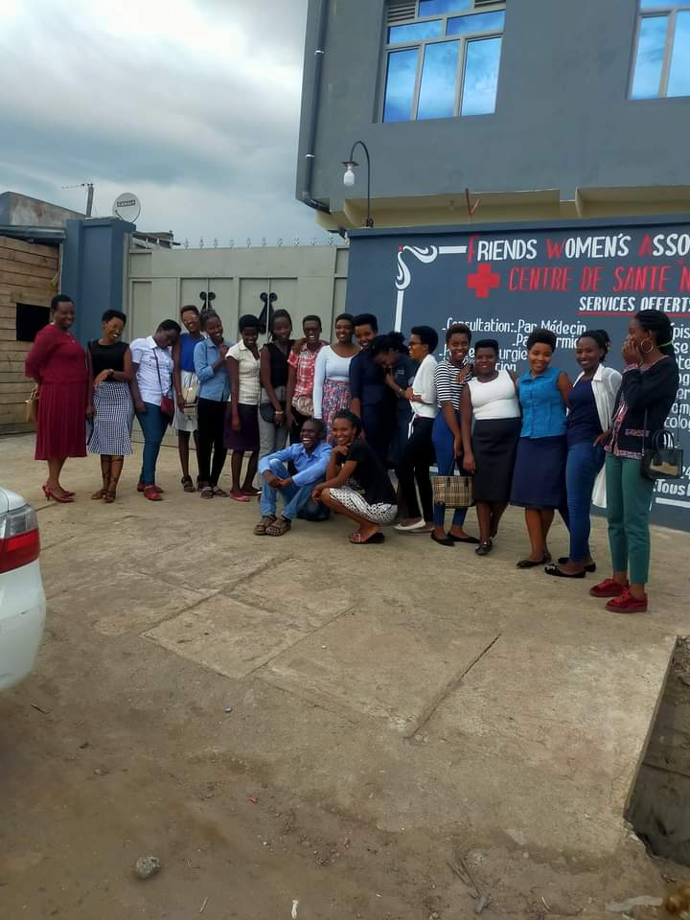
I am the President of one of the Self Help Groups. I attend a university. There are plenty of questions that young girls have without answers. We are afraid of our future homes if we observe what is happening in many homes now. I really appreciate what FWA does for Young girls. I ask you to follow up rigorously in every way in order to be a good example for my friends. As young girls, we need to take charge of our own future. But to achieve this, we need support (Chemsa)
Challenges :
1. Need for the Budget for these meetings
2. Need for Specialist Facilitators according to topics
3. Need of an organizational chart or details of the Young Girls department at FWA to frame those activities that are currently being done under sexual and reproductive health
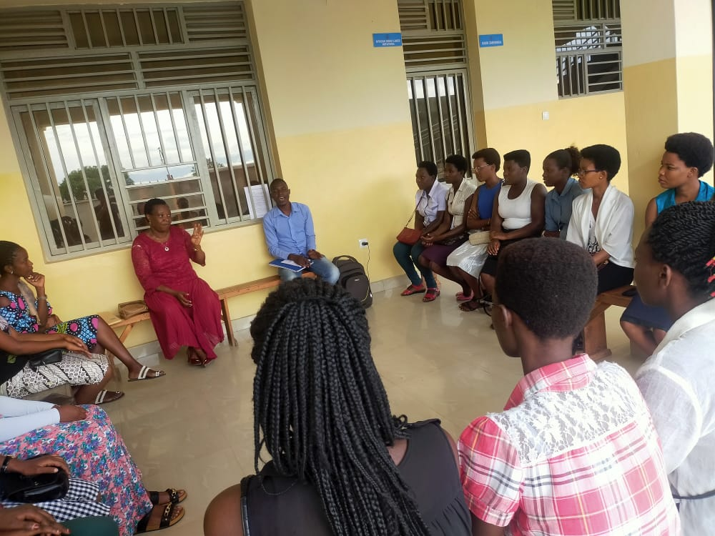
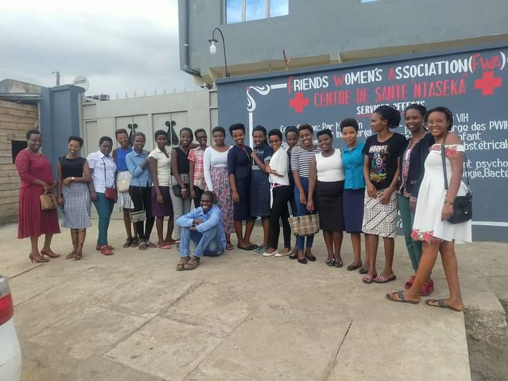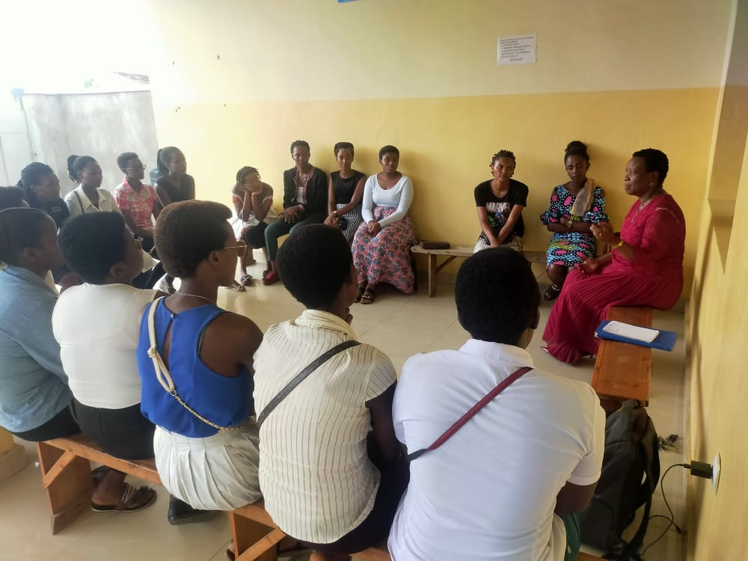

Rape Survivors’ Support (RSS)
In the month of May, the Rape Survivors Support program had different activities: the supervision of Self-Help Groups (SHGs) and Rice Harvest for the Growing Rice Project. At the end of May 2022, we had a total of 152 SHGs in Kamenge, Bujumbura Mairie province for a total of 3588 women and 30 SHGs for 738 women in Nyabiraba commune, Bujumbura province.
ABOUT NEW SHG
No | Name of SHG | Month of creation | Member Number | Created by
1 | GIRITEKA | May | 25 | Claire
2 | GATEKA | May | 25 | Claire
3 | EGERABANDI | May | 25 | GUDURA

SHG Total Number: | 152

Self-Help Groups Evaluation
No | About sharing | Number of SHG | Total
1 | Total money saved | 2 | 6,435,000
2 | Total Credit granted | 2 | 5,290,300
3 | Total interest | 2 | 3,758,700
4 | People who didn’t paid | 2 | 8
5 | Total money not refunded | 2 | 346 800

As the table above shows, in the month of May 7 SHGs were evaluated and the results were as follows;
- Savings made by the 2 SHGs were: 6 435 000 BIF
- Credits granted by the 2 SHGs were: 5 290 300 BIF
- Interest generated by 2 SHGs credits : 3 758 700 BIF
- People who have not paid back : 8
- Total money not refunded : 346 800 BIF

Classification of SHG

Active | Less Active | Sick | Total
2 | 0 | 0 | 2

After evaluation it was found that all 2 SHGs are active
On May 30 to June 1st, 2022, there was a three-day trauma healing workshop for 20 GBV survivors.
“I was raped at 13 by a boy that I considered as a brother; I was doing some cleaning work in his room as usual and he raped me and I immediately got pregnant. This man gave me drugs to have an abortion and I refused.
When my elder sisters found that I was pregnant, they called for justice and this man was imprisoned. Then his sister gave the money to the judges and He got out of jail. This man's sister convinced me to say that I love this man in order to live together. She lied to me that she is going to take me to Europe and I accepted.
Because of this decision my family hated me, beat me, cursed me and refused me to go near their house.
Arrived in the house of this man, I suffered all forms of violence; he beat me, he raped me, he brought other women into our room, sometimes he threw the food I had prepared on the road in front of our neighbors.
I hated so much that man that I couldn't be able to look it in his face; even to have sex I begged him to use the position where I couldn't see him in his face.
I began a small potato business which helped me to live alone with my two children at the age of 15. I became an independent and beautiful woman. The man envied me and wanted to start life together again. When he was presenting his proposal to me I took a stone and I threw him in his face and the blood flowed; I said to myself; a man who ruined my youth, for me deserves to be killed. I will never forgive him. Thank you for this workshop where I got an opportunity to cry”
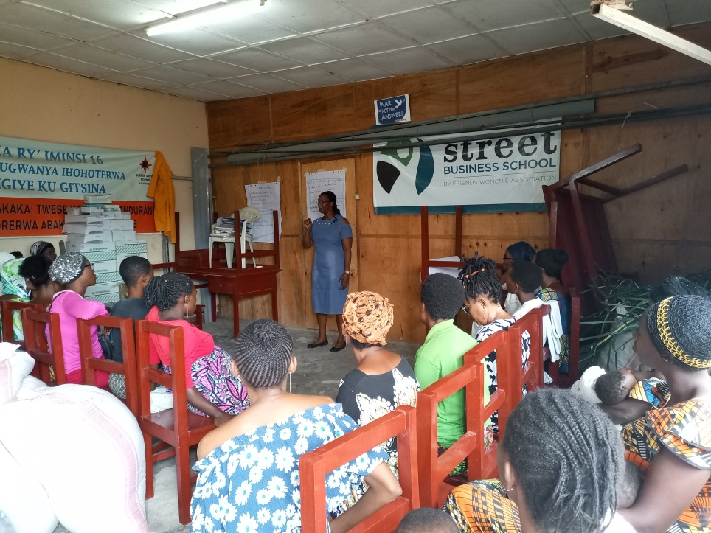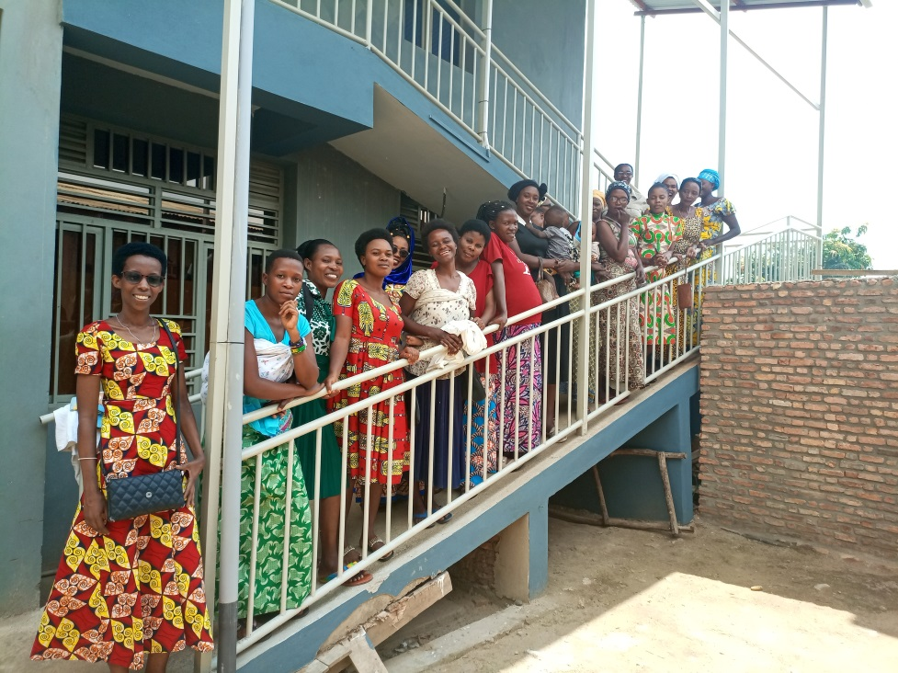
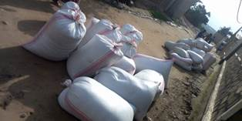
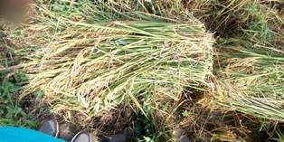
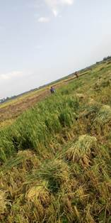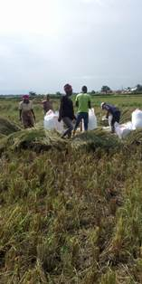
Rice Harvest
ACTION ON GENDER-BASED VIOLENCE (AGBV)
In the same month of May, FWA has continued to implement the project sponsored by the United Nations Peace Building Fund "Connecting the Global to the Local: Strengthening Women's Leadership for the Localization of the United Nations Security Council Resolution 1325 (2000) on "Women, Peace and Security".
In the month of May, the followng activities were done:
- Follow-up of the action plans of the communes of Bubanza Province and those of Bujumbura province for activity 2.3.4: Establish a mechanism by which analysis and early warning information are shared between the network and institutional decision-makers for rapid response (Early Warning and Early Response: EWER)
In Bubanza, we met with two representatives per commune of the EWER teams. According to their report:
• The total of the conflicts encountered were 88, including 51 related to gender-based violence (GBV), four conflicts related to politics, four conflicts related to security, 15 land conflicts and 14 other conflicts (witchcraft, poisoning , conflicts within savings and credit groups)
• Their interventions as EWER teams: For GBV prevention, Women and young girls need socio-economic empowerment. That’s why EWER teams did sensitization of young girls and women so that they join savings and credit groups (Bubanza). EWER teams also supported GBV victims towards justice (Bubanza), organization of meetings at hill level so that women can denounce cases of GBV (Mpanda), intervention for a woman unjustly accused of having killed her own child until she is released from prison (Gihanga)
• EWER teams have worked in close collaboration with the local administration and especially the communal administrators, the socio-cultural advisers and the chiefs of the hills
• They have been informed about the conflicts either by a local leader, one of the parties in conflict or one of them (member of the EWER team)
• The challenges encountered: false witnesses, lack of transport and communication costs
• Recommendations: capacity building for EWER teams, giving EWER teams tools to use such as leaflets on the concept of EWER, providing transport and communication costs to EWER teams
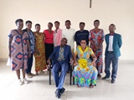
Representatives of Bubanza EWER teams
In Musigati, there is a 13-year-old girl who left the house at night and ran away to her grandmother. As she cried loudly during the night, we went to her grandmother's house and asked why the child was crying. She said she was tired because her father raped her every day by having sex with her. The next day we took the child to the hospital. The doctor confirmed that it was a reality. Now the child's father is imprisoned. (Musigati EWER team)
In Bujumbura province, according to their report,
• The total of the conflicts encountered were 69, including 20 related to gender-based violence (GBV), seven conflicts related to security, 11 land conflicts and 31 other conflicts (witchcraft, poisoning, conflicts within groups of savings and loans, conflicts within cooperatives, conflicts within churches). Some disputes were referred to the courts, to the police or to the administrator.
• Their interventions as EWER teams: Listening attentively to victims (Mubimbi, Babezi, Isare, Mugongo-Manga, Mutambu and Nyabiraba), accompanying victims of GBV towards justice (Mubimbi, Kanyosha), organization of dialogues on hill level on poisoning (Kanyosha), accompanying those who were poisoned to healthcare facilities (Kanyosha), organization of meetings with hill chiefs (Nyabiraba), visits to parties in conflict to promote reconciliation (Mutimbuzi), organization of dialogues within families where husband and wife are in conflict (Mubimbi), Sensitization for the legalization of marriage (Mukike), In Mutimbuzi within the camps for the displaced, there were conflicts between young people and the most aged. Through a dialogue, the EWER team advised them to work together
• They worked in close collaboration with the local administration and especially the communal administrators, the socio-cultural advisers, the zone chiefs and the chiefs of the hills
• They have been informed about the conflicts either by a local leader, one of the parties in conflict or one of them (member of the EWER team)
• The challenges encountered: lack of transport and communication costs, the work requires endurance because there are times when a conflict can take more than three days, the parties in conflict who accuse the EWER teams of taking sides.
The recommendations: capacity building for EWER teams on different subjects, giving tools to EWER teams, equipment to use such as mobile phones, umbrellas, raincoats, briefcases, including one lawyer per province in this project because the victims often have limited financial means, give transportation and communication costs to the APRP teams
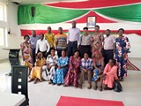
Bujumbura EWER Team representatives
- For Activity 3.1.4: Select and support innovative artisanal/non-agricultural IGRs/IGAs initiated by young girls in vulnerable situations (school dropouts, girl-mothers, displaced, repatriated and others, FWA has organized meetings with the leaders of the selected Income Generating Initiatives (IGI) in order to develop together the necessary budget according to the needs. We also bought the material presented as needed by each IGI.
- For activity 2.2.3, FWA organized intergenerational dialogues on healing from trauma caused by wounds of the past in the province of Rumonge on May 12, 2022 at the CRS centre, in Gitega on May 17, 2022 at CPF Rehoboth and in Bujumbura Mairie on May 20, 2022 at Kings Conference center. In Rumonge the total participants were 60, including 32 women and 28 men. In Gitega, there were 58 participants including 34 women and 24 men while in Bujumbura Mairie 48 participants including 32 women and 16 men

MEDICAL TEAM

CONSULTATIONS
Our medical doctors consulted with 48 cases, including 8 adults (4 men and 4 women), 3 children (all of them were girls), 10 HIV positive people and 27 pregnant women for ultrasound. The nurse received 229 patients including 152 adults and 76 children.

LABORATORY
In the month of May, apart from HIV voluntary testing, there were a total of 280 tests.
Test | Test completed | Positive | Negative
G.E.  Malaria test | 54 | 23 | 31
Quick malaria test | 50 | 21 | 29
ECBU  Urine test | 23 | 8 | 15
Selles  Stool test | 26 | 6 | 20
Pregnancy | 36 | 14 | 22
Sero-widal  Typhoïd fever | 7 | 2 | 5
Glycémie  Diabetes | 18 | 8 | 10
RPR VDRL  (Syphilis) | 15 | 0 | 15
Complete Blood Count | 22 | 12 | 10
Hepatitis B | 1 | 0 | 1
Hepatitis C | 4 | 0 | 4
Viral Load | 24 | 1 | 23
Total Tests: 280

FAMILY PLANNING
439 people received contraceptives from FWA’s nurse, including 246 old cases and 240 new ones. 347 received the contraceptive injection, 58 were given contraceptive pills, 20 received male condoms, 2 received UID and 12 received implants.

PRENATAL CONSULTATION (PNC)
In May, 34 women came for prenatal consultation (PNC), including 15 who came for PNC 1, 14 for PNC 2, 3 for PNC 3 and 2 for PNC 4.
27 pregnant women came for the ultrasound test.

ANTI-RETROVIRAL SITE
At the end of May, we had 330 patients under retro drugs followed at NTASEKA clinic, including 267 women and 63 men.

PHARMACY
Regarding medications, FWA was able to purchase the minimum needed medicine.

PSYCHOSOCIAL TEAM
In the month of May, 72 people were tested for HIV and received pre and post HIV test counselling. Both the two people detected HIV positive were women with 4% of seropositivity.
Total Number of People Tested: | 72
Total Number of Women Tested: | 51
% of People Tested Who Are Women: | 71%
Average Age: | 30
Median Age: | 27.5
Total HIV+ : | 2
Total HIV- : | 70
Number of Women HIV+ : | 2
Total % Seropositivity: | 3%
% of Women Tested Who Are HIV+: | 4%

