Friends Women’s Association

SEPTEMBER 2022 Report

Table of Contents
Friends Women’s Association 1
SEPTEMBER 2022 Report 1
ACTIVITIES 6
Caring for HIV Positive People (CHIVPP) 6
Improving Women’s Reproductive Health (IWRH) 6
Rape Survivors’ Support (RSS) 6
MEDICAL TEAM 10
CONSULTATIONS 10
LABORATORY 10
FAMILY PLANNING 10
PRENATAL CONSULTATION (PNC) 10
ANTI-RETROVIRAL SITE 11
PHARMACY 11
PSYCHOSOCIAL TEAM 11

COVID-19 AND NTASEKA CLINIC
In the month of September 2022, Friends Women’s Association has continued to apply covid restrictions restrictions at Ntaseka Clinic for both the staff and the beneficiaries’ protection.
A NEW CAMERA
FWA has finally purchased a very good camera under the support of Segal Family Foundation. It will be useful for both good photos and short video. We will no longer hire someone else to take the pictures when we have a particular event.
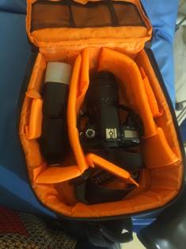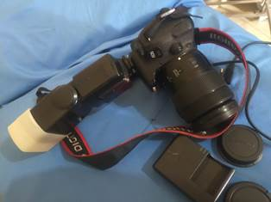
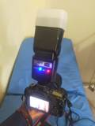

Some pictures taken with the new camera:
1. Ntaseka clinic lab technician with Alexandra
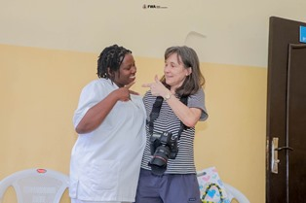
2. Some of the FWA staff with Alexandra
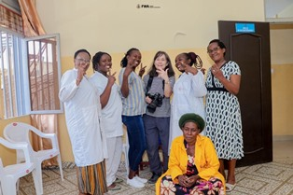
On September 26, 2022, Alexandra Buxbaum, a specialist photographer from Chicago, US visited the Friends Women’s Association. The purpose was to take good pictures to support our efforts. Then, we took advantage for her to teach our person in charge of communications (Augustin) how to make good photos when you are inside or outside a building.
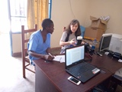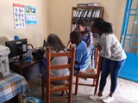
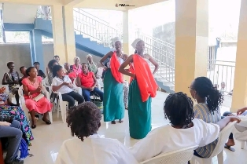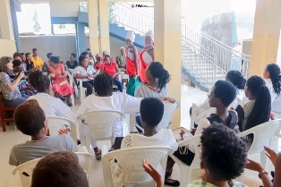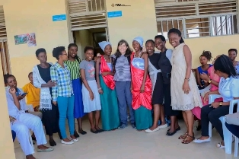
Tugire Urukundo young girls Self-help group danced for our special guest on September 26, 2022
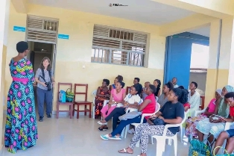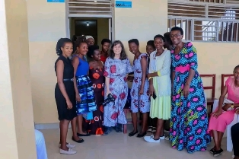
The young girls self-help group in charge of clothing styles
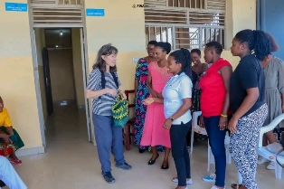
Tuzoba Ico twigize self-help group producing handmade baskets

On September 29, 2022 delegates from the ministry of National solidarity, social affairs, human rights and gender visited farms where the FWA will support BATWA Self-help groups to grow potatoes together. They are living at Bubaji hill, Nyabiraba commune in Bujumbura province.
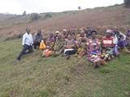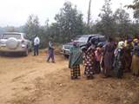

ACTIVITIES

Caring for HIV Positive People (CHIVPP)
In the month of September, medical follow-up and home visits were done for our HIV positive people.

Maternity Ward Building
Although we still need medical equipment, we have started to have new born babies at Ntaseka clinic.
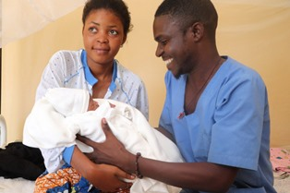
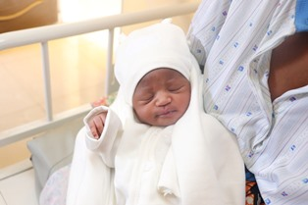
A new born at Ntaseka clinic

Improving Women’s Reproductive Health (IWRH)
FWA community health workers and FWA staff have continued to educate men, women and young people on the importance of birth control.

Rape Survivors’ Support (RSS)
In the month of August, the Rape Survivors Support program had different activities: the supervision of Self-Help Groups (SHGs) and evaluation and one trauma healing workshop. At the end of August 2022, we had a total of 154 SHGs in Kamenge, Bujumbura Mairie province for a total of 3638 women and 35 SHGs for 863 women in Nyabiraba commune, Bujumbura province.
- SHGs
ABOUT NEW SHG
No | Name of SHG | Month of creation | Member Number | Created by
1. | SANURA | September | 25 | Isabelle

SHG Total Number: | 154
SHGs Evaluation
As the table shows, in the month September 4 SHGs were evaluated and the result are as follows;
No | Description | Number of SHG | Total
1 | Total money saved | 4 | 14,764,600
2 | Total Credit granted | 4 | 15,337,900
3 | Total interest | 4 | 12,760,500
4 | People who didn’t paid | 4 | 19
5 | Total money not refunded | 4 | 1,527,500

Classification of SHG
After evaluation it was found that;
Active | Less Active | Sick | Total
3 | 0 | 1 | 4

- HROC Workshop (September 26-28)

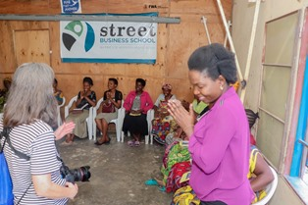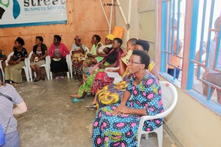
In 1993 my family and I took refuge in Rwanda. In 1994 we returned to Burundi, we found our house destroyed and we built a small straw house. We suffered marginalization because we were very poor. They called us “pygmies”. I was 16 years old and I was very touched by this discrimination in my community and I decided to go to the rebellion soldiers.
After war, I was among the demobilized soldiers. I got married to a man and we had 4 children together and then he died.
After his death his family made me suffer the worst; my husband's family took away my 4 children and threw me out because we lived in the family plot. I started drinking a lot of beer to calm myself down.
Now, from morning until night I live in the cabaret; I mean I have become an alcoholic. In this cabaret men use to rape me when they find me drunk. I tried to give up to alcohol but it's stronger than me. Thanks for inviting me to this workshop to have a chance to share my sad story.
ACTION ON GENDER-BASED VIOLENCE (AGBV)
In the month of September 2022, under the support of Quaker Service Norway (QSN), two groups of GBV survivors who initiated income generating activities were identified to support their small projects. Both of them will raise pigs. The half-way 2022 reports were produced and sent to QSN.
In the same month of September, FWA has continued to implement the project sponsored by the United Nations Peace Building Fund "Connecting the Global to the Local: Strengthening Women's Leadership for the Localization of the United Nations Security Council Resolution 1325 (2000) on "Women, Peace and Security". we carried out field visits in all the seven provinces (Bubanza, Cibitoke, Bujumbura, Bujumbura Mairie, Gitega, Makamba and Rumonge) to monitor and evaluate the work done by the Psycho-Social Assistants (PSA) within their various communities. The main objectives were:
1. Deepen the notion of trauma healing
2. Understand how the workshops have benefited both the PSA and the community
3. Understand the challenges encountered by the PSA and the recommendations
4. Networking with local government officials and the Family and community development counselors
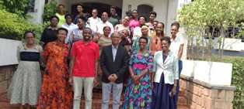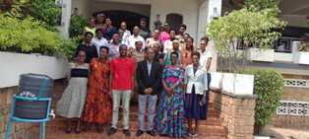
Group photo at Chez Andre, Bujumbura Mairie
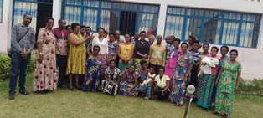
A group photo at CRC RUMONGE

MEDICAL TEAM

CONSULTATIONS
Our medical doctors consulted with 178 cases, including 73 adults (45 men and 28 women), 18 children (10 boys and 8 girls), 17 HIV positive people and 70 pregnant women for ultrasound. The nurse received 271 patients including 200 adults and 71 children.

LABORATORY
In the month of September, apart from HIV voluntary testing, there were a total of 292 tests.
Test | Test completed | Positive | Negative
G.E.  Malaria test | 45 | 12 | 33
Quick malaria test | 39 | 5 | 34
ECBU  Urine test | 15 | 13 | 2
Selles  nStool test | 25 | 24 | 1
Pregnancy | 54 | 17 | 37
Sero-widal  Typhoïd fever | 41 | 12 | 29
Glycémie  Diabetes | 15 | 4 | 11
RPR VDRL  (Syphilis) | 6 | 0 | 6
Complete Blood Count | 21 | 7 | 14
Hepatitis B | 6 | 0 | 6
Hepatitis C | 4 | 0 | 4
Viral Load | 21 | 1 | 20
Total Tests: 292

FAMILY PLANNING
616 people received contraceptives from FWA’s nurse, including 236 old cases and 380 new ones. 360 received the contraceptive injection, 76 were given contraceptive pills, 50 women received sayana press, 110 received male condoms, 2 received UID and 18 received implants.

PRENATAL CONSULTATION (PNC)
In September, 67 women came for prenatal consultation (PNC), including 20 who came for PNC 1, 21 for PNC 2, 11 for PNC 3 and 15 for PNC 4.
70 pregnant women came for the ultrasound test.

ANTI-RETROVIRAL SITE
At the end of September, we had 330 patients under retro drugs followed at NTASEKA clinic, including 267 women and 63 men.

PHARMACY
Regarding medications, FWA was able to purchase the minimum needed medicine.

PSYCHOSOCIAL TEAM
In the month of September, 96 people were tested for HIV and received pre and post HIV test counselling. Out of them, two women were detected HIV positive with 2% of seropositivity.
Total Number of People Tested: | 96
Total Number of Women Tested: | 78
% of People Tested Who Are Women: | 81%
Average Age: | 27
Median Age: | 24
Total HIV+ : | 2
Total HIV- : | 94
Number of Women HIV+ : | 2
Total % Seropositivity: | 2%
% of Women Tested Who Are HIV+: | 3%

