Friends Women’s Association

OCTOBER 2023 Report

Table of Content
Friends Women’s Association 1
OCTOBER 2023 Report 1
ACTIVITIES 7
Caring for HIV Positive People (CHIVPP) 7
Improving Women’s Reproductive Health (IWRH) 8
Rape Survivors’ Support (RSS) 8
MEDICAL TEAM 9
CONSULTATIONS 15
LABORATORY 15
FAMILY PLANNING 16
PRENATAL CONSULTATION (PNC) 16
ANTI-RETROVIRAL SITE 17
PHARMACY 17
PSYCHOSOCIAL TEAM 17

COVID-19 AND NTASEKA CLINIC
In the month of October, Friends Women’s Association has continued to apply covid restrictions at Ntaseka Clinic for both the staff and the beneficiaries’ protection.
INTERNATIONAL EVENTS
FWA national coordinator attended the Unarmed Civilian Protection (UCP)/Accompaniment international gathering in Geneva on October 8 to 12, 2023.
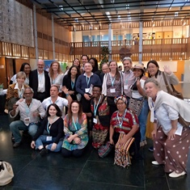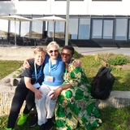
A group photo after attending the UCP/Accompaniment gathering in Geneva
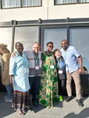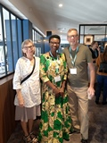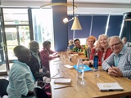
Photo 1: From left to the right: Elzabeth, Mel, Parfaite, Georgia
Photo 2: From left to the right: Maryanne, Parfaite and Randy Janzen (My tPeace studies and Unarmed Civilian Protection teacher and mentor at Selkirk College, Catslegar, BC, Canada
Photo 3: Small group during the Geneva gathering
Then she was one of the two keynote speakers at the 60th anniversary of Quaker Service Norway at the Friends Meeting in Oslo, Norway on October 14, 2023.
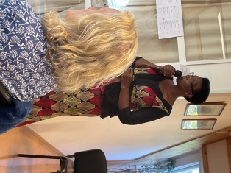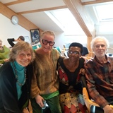
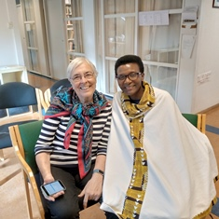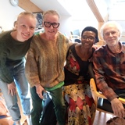
In Oslo on October 14&15, 2023 at the Norway Friends Meeting

On October 19-22, 2023, Quaker Peace Network Burundi hosted the Quaker Peace Network Africa gathering at Nonara Beach Resort hotel in Bujumbura, Burundi. Different Quaker peace organizations were represented. They were from eight countries, including Burundi, Rwanda, the Democratic Republic of Congo, Uganda, Kenya, South Africa, Zimbabwe and Norway.
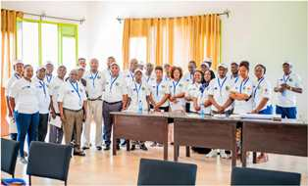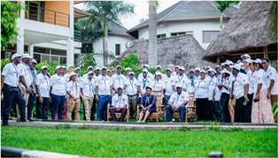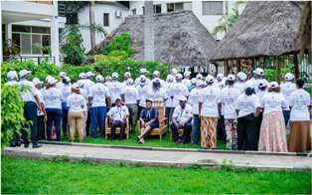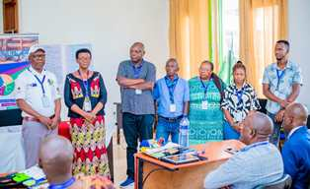
The New QPN Africa leadership including Parfaite Ntahuba as the incoming clerk
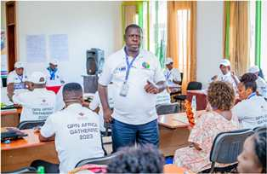
International panel
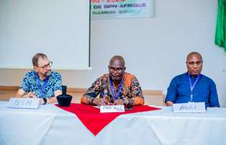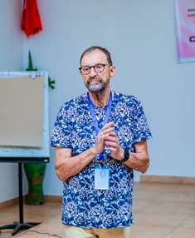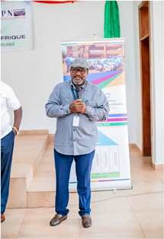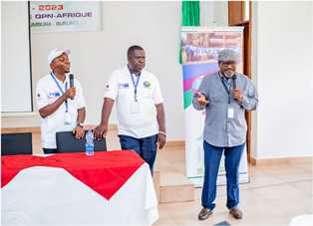
AFSC represented at the gathering by the AFSC Burundi New Country Representative
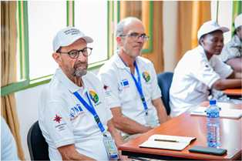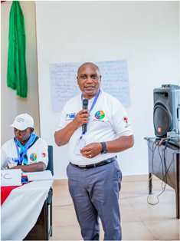
QSN represented at the gathering AGLI of the FPT represented at the gathering
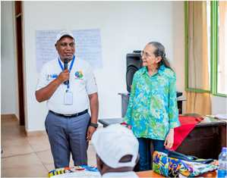
GIZ represented at the gathering
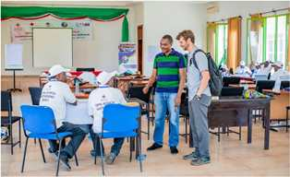
MCC visiting during the QPN Africa gathering
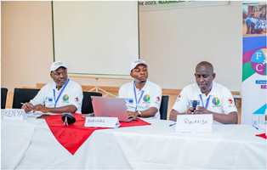
Presentation of Peace Initiatives Panel per country

ACTIVITIES

Caring for HIV Positive People (CHIVPP)
In the month of October, medical follow-up and home visits were done for our HIV positive people.
One small field was bought for our HIV positive beneficiaries. The goal is the sustainability of the food insecurity program. We will grow food there and/or raise pigs as an income generating activity for our HIV positive beneficiaries. The field is located at Muyange hill, Mutimbuzi commune, Bujumbura province. After the field visit, the main recommendation from the beneficiaries, staff, FWA founders and executive committee is to buy another field to have a bigger one because of the importance of the program.

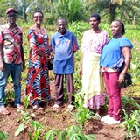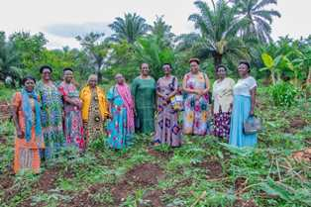
The first picture includes some of the Ntaseka clinic beneficiaries and staff. The second one includes both FWA ecutive committee and the FWA founders. They were visiting the field.

Maternity Ward Building
Although Ntaseka maternity ward still needs some medical equipment; both the delivery and the hospitalization services are currently functional.

Improving Women’s Reproductive Health (IWRH)
FWA community health workers and FWA staff have continued to educate men, women and young people on the importance of birth control. ​

Rape Survivors’ Support (RSS)
In the month of October, the Rape Survivors Support program had different activities: the supervision of Self-Help Groups (SHGs) and one trauma healing workshop at Ruvumvu in Bubanza province. At the end of October 2023, we had a total of 159 SHGs in Kamenge, Bujumbura Mairie province for a total of 3763 women and 43 SHGs for 1063 women in Nyabiraba commune, Bujumbura province.
- SHGS
TOTAL SHGs
No | Name of SHG | Month of creation | Member Number | Created by

SHG Total Number: | 159+43=202
- HROC workshop ( October 30-Novemebr 1st, 2023)

In the month of October, one trauma healing workshop for victims of GBV was held in Bubanza province at Ruvumvu Friends Church.

Story

“My name is Nicelate, I got married in 2004 and I have 8 children now. When I gave birth to my third child I started to experience the worst in my marriage; my husband married another woman.
My husband and I had worked hard to build a business but all was gone because of this woman. I have been imprisoned many times unjustly because I couldn’t keep quiet, I was trying to defend myself; I use to speak loudly to claim my rights.
My husband's family tells me that I have nowhere to go and it's true because I am an orphan. When he comes home from his second wife, he comes for violence. He doesn't give us anything to eat; I must take care of my children alone; food, clothes, school fees , even if it comes to building our house it's me who has to repair the house.
Today my 3 children are no longer in the house, I don't know where they are at this moment. Maybe they have fled the quarrels which are always in our house. This saddens me too much.
This training helped me understand what I am experiencing and that if a child grows up in a trauma environment they will grow up traumatized. Now, I will try to protect my children”.

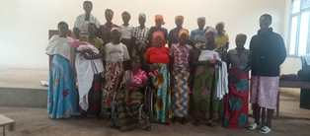
ACTION ON GENDER-BASED VIOLENCE (AGBV)
In the month of October, in the context of the project "Connecting the Global to the Local: Strengthening Women's Leadership for the Localization of the United Nations Security Council Resolution 1325 (2000) on "Women, Peace and Security", seven psychologists and 132 psychologists’ assistants have been receiving gender-based violence survivors for both listening and counselling. There was also a two-day meeting for the project coordination.
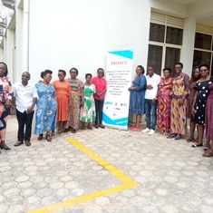
A group photo after the AFSC project coordinating meeting on October 27, 2023
On October 18th, 2023, there was a public event to raise awareness against gender-based violence (GBV). This event was organized by the FWA GBV survivors’ accompanists. It took place in Giheta commune, Gitega province. The public event was honoured by two special quests from Quaker Service Norway (QSN)
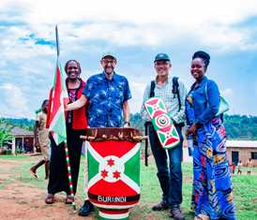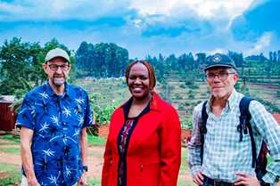
From left to right: Arnstein Finset (QSN board chair), FWA legal representative and Leo (QSN Board member)
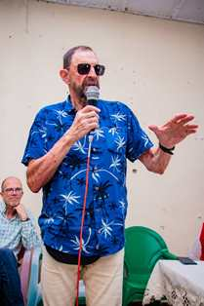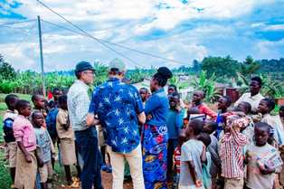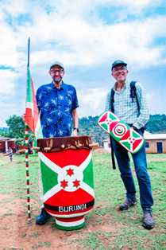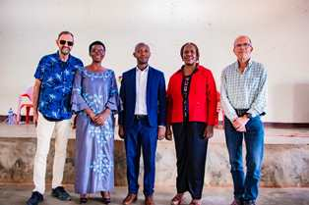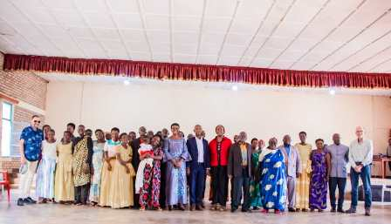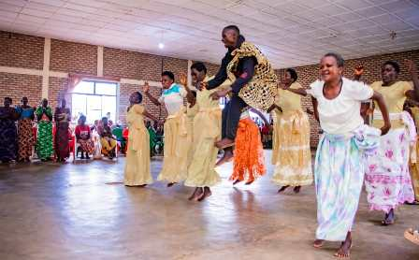
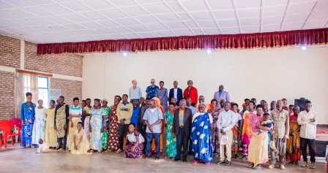
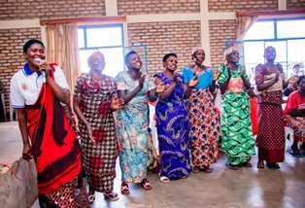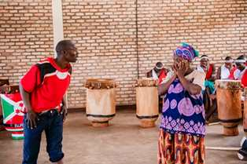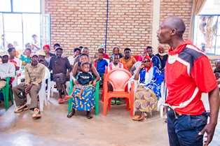
Threatening his wife
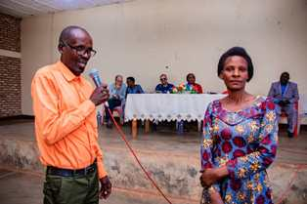
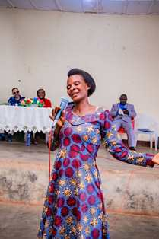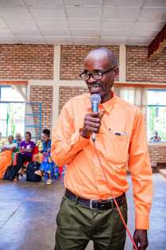
Life has now changed with the help of GBV survivors accompanists
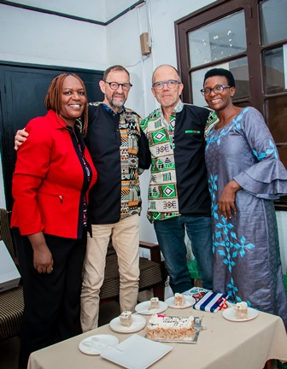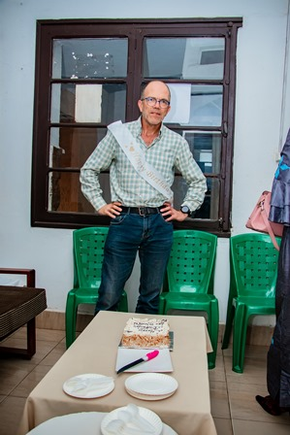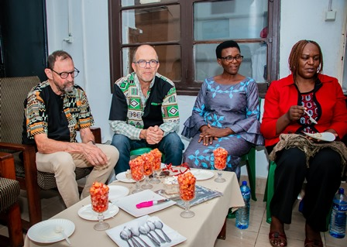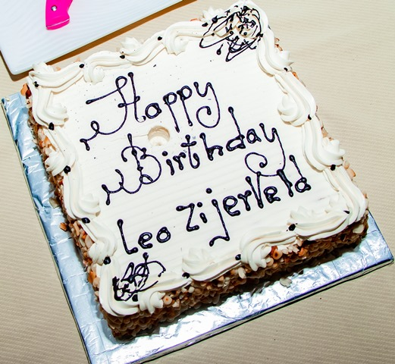
Happy birthday to Leo on October 18, 2023
On October 23rd, 2023, Arnstein Finset (the QSN board chair) and Leonardus Jacobus Johannes (Member of the QSN board) visited the FWA office in Kamenge.
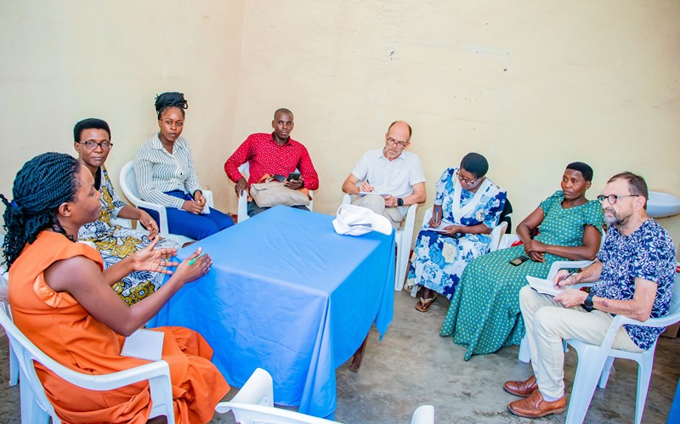
Meeting with FWA AGBV staff, GBV survivors Accompanists’ representatives and QSN board representatives
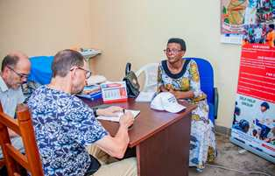
QSN at FWA office
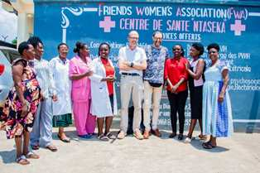
Some of the FWA staff with guests from QSN
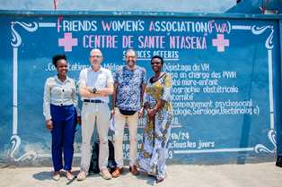

MEDICAL TEAM

CONSULTATIONS
Our medical doctors consulted with 206 cases, including 80 adults (37 men and 43 women), 15 children (7 boys and 8 girls), 22 HIV positive people and 89 pregnant women for ultrasound. The nurse received 249 patients including 183 adults and 66 children.

LABORATORY
In the month of October, apart from HIV voluntary testing, there were a total of 339 tests.

Test | Test completed | Positive | Negative
G.E.  Malaria test | 72 | 16 | 56
Quick malaria test | 26 | 7 | 19
ECBU  Urine test | 28 | 28 | 0
Selles  Stool test | 30 | 26 | 4
Pregnancy | 38 | 18 | 20
Sero-widal  Typhoïd fever | 33 | 13 | 20
Glycémie  Diabetes | 15 | 4 | 11
RPR VDRL  (Syphilis) | 20 | 1 | 19
Complete Blood Count | 45 | 16 | 29
Hepatitis B | 6 | 0 | 6
Hepatitis C | 6 | 2 | 4.
Viral Load | 20 | 1 | 19
Total Tests: 339

FAMILY PLANNING
600 people received contraceptives from FWA’s nurse, including 311 old cases and 289 new ones. 446 received the contraceptive injection, 67 were given contraceptive pills, 35 received male condoms at Ntaseka clinic while 30 received condoms in the community (These were distributed by Ntaseka clinic community health workers), 3 received UID and 19 received implants

PRENATAL CONSULTATION (PNC)
In October., 63 women came for prenatal consultation (PNC), including 18 who came for PNC 1, 21 for PNC 2, 9 for PNC 3 and 15 for PNC 4.
89 pregnant women came for the ultrasound test.
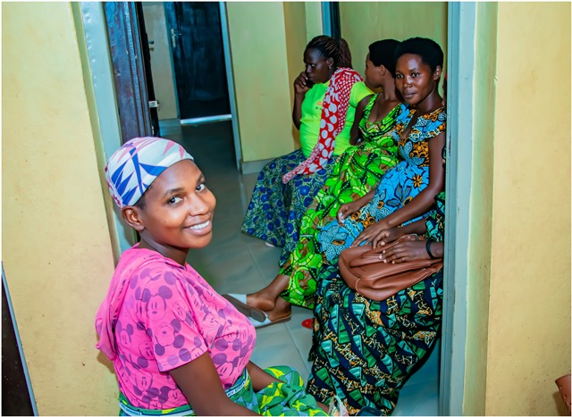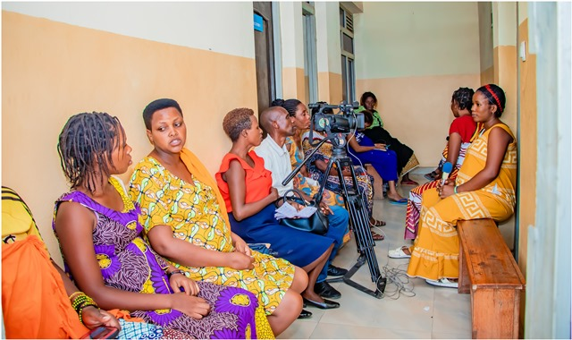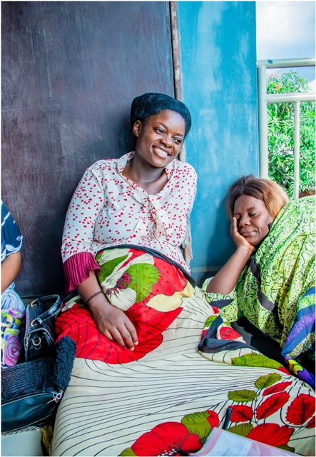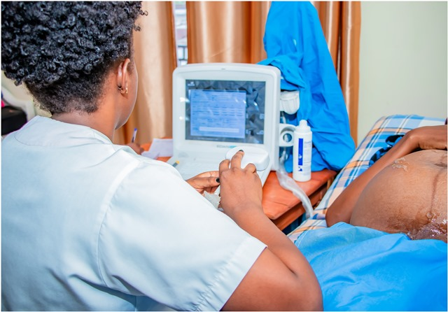
A group of pregnant women coming for the ultrasound test on October 20, 2023

ANTI-RETROVIRAL SITE
At the end of October, we had 330 patients under retro drugs followed at NTASEKA clinic, including 267 women and 63 men.

PHARMACY
Regarding medications, FWA was able to purchase the minimum needed medicine.

PSYCHOSOCIAL TEAM
In the month of October, 100 people were tested for HIV and received pre and post HIV test counselling. Out of them, three women were detected HIV positive with 3% of seropositivity.
Total Number of People Tested: | 100
Total Number of Women Tested: | 81
% of People Tested Who Are Women: | 81%
Average Age: | 27
Median Age: | 25.5
Total HIV+ : | 3
Total HIV- : | 97
Number of Women HIV+ : | 3
Total % Seropositivity: | 3%
% of Women Tested Who Are HIV+: | 4%

