Friends Women’s Association

OCTOBER 2024 Report

Table of Content
Friends Women’s Association 1
october 2024 Report 1
ACTIVITIES 2
Caring for HIV Positive People (CHIVPP) 3
Improving Women’s Reproductive Health (IWRH) 3
Rape Survivors’ Support (RSS) 3
MEDICAL TEAM 5
CONSULTATIONS 9
LABORATORY 9
FAMILY PLANNING 9
PRENATAL CONSULTATION (PNC) 10
ANTI-RETROVIRAL SITE 10
PHARMACY 10
PSYCHOSOCIAL TEAM 10

INTERNATIONAL CONFERENCE AND SPEAKING TOURS
On October 8-12, the Friends Women’s Association was represented at the international conference on mental health. The venue was the universit of Kisubi in Uganda.
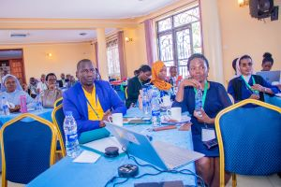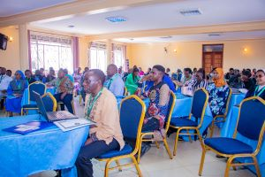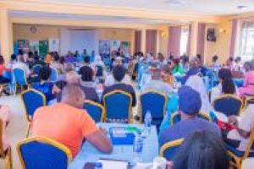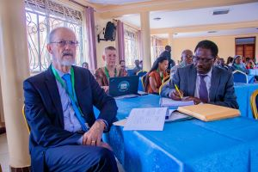
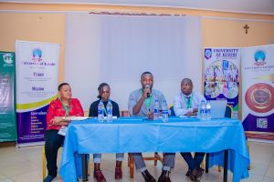
On October 20, 2024 the Friends Women’s Association National Coordinator came back from Canada after six weeks for speaking tours about the work the organization is doing in Burundi. Individuals and organizations from Canada, both Quakers and non Quakers are still committed to support the work of the Friends Women’s Association.

ACTIVITIES

Caring for HIV Positive People (CHIVPP)
In the month of October, medical follow-up and home visits were done for our HIV positive people.
Maternity Ward Building
Although Ntaseka maternity ward still needs some medical equipment; both the delivery and them, hospitalization services are currently functional.

Improving Women’s Reproductive Health (IWRH)
FWA staff and FWA community health workers have continued to educate both men and women on the importance of family planning.

RAPE SURVIVORS’ SUPPORT (RSS)

- SELF HELP GROUPS (SHGs)
ABOUT NEW SHG
No | Name of SHG | Month of creation | Member Number | Created by

SHG Total Number: | 63
Sharing
As the table shows, in the month October one SHG made a sharing and the result are as follows;
No | About sharing | Number of SHG | Total
1 | Total money saved | 1 | 3,650,000
2 | Total Credit granted | 1 | 2,730,000
3 | Total interest | 1 | 2,282,500
4 | People who didn’t paid | 1 | 0
5 | Total money not refunded | 1 | 0

Classification of SHG
After evaluation it was found that;
Active | Less Active | Sick | Total
0 | 1 | 0 | 1

- HROC Workshop ( October, 28- 30)

In the month of October one trauma healing workshop was held at Maramvya Friends Church for 20 gender-based violence survivors.
Story
“I married an alcoholic man. He came home at midnight and beat me while I did nothing. One day he beat me when I was pregnant and I had an abortion. This abortion left scars in my heart; I didn't want to be pregnant anymore.
Unfortunately I found myself pregnant again, and my husband married another woman whom I took as my mother. I got depressed and I looked for medication to try to abort but in vain. I planned to kill my child at birth or leave the baby in the hospital. The day I gave birth I looked at my child and I felt pity and regret. I accepted it; I decided to go home with my child.
This child reminds me at what level I am a bad mother, when I see him I feel like a criminal; I cannot forgive myself. My child is three years old, but he is always afraid when I leave him alone He does not accept and it saddens me and I feel myself guilty.
This workshop taught me that I am traumatized and that I must admit my weaknesses and agrees to begin the healing process”.

- THE WOMEN’S ECONOMIC EMPOWERMENT CENTER
Under the support of the Canadian Friends Service Committee (CFSC), have continued the construction work of the Women’s Socio Economic Empowement Center (WSEEC). The aim of this project is to avail training rooms and a temporary safe shelter for gender-based violence survivors at the FWA headquarters. This project will cost $200,000
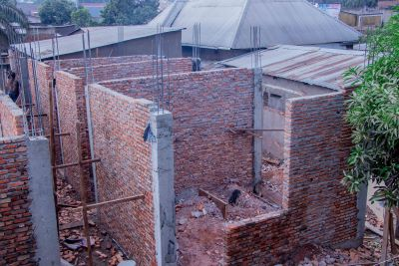

ACTION ON GENDER-BASED VIOLENCE (AGBV)
In the month of October, under the support of Quaker Service Norway, there was a training of trainers for selfhelp groups supervisors in Giheta commune in Gitega province. There was also a tree-day retreat for 20 gender-based violence survivors accompanists at MUGATUTU center in Gitega province.
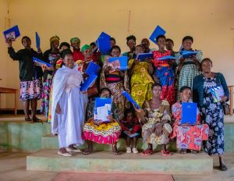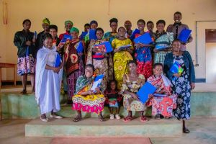
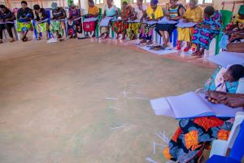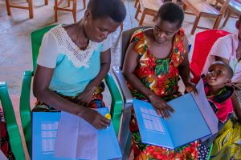
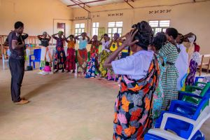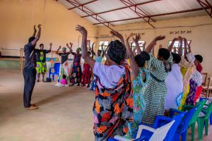
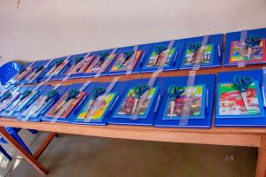
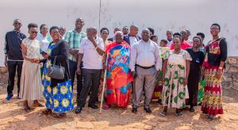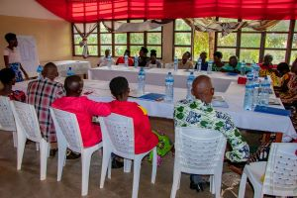
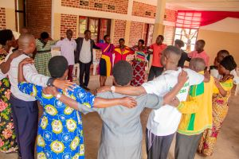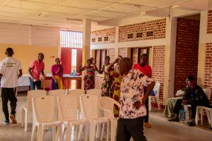
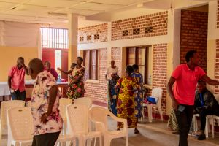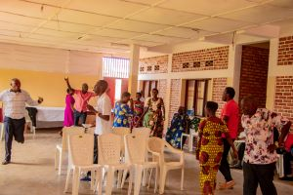
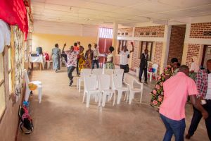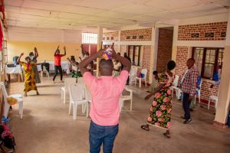
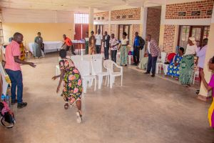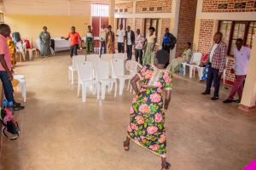
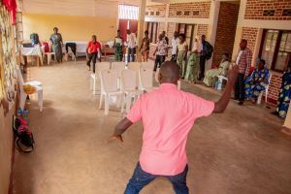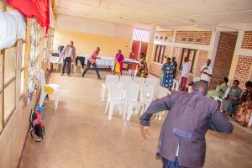
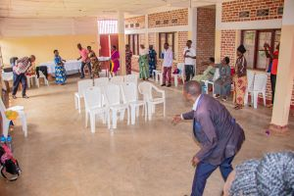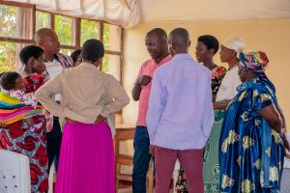

MEDICAL TEAM

CONSULTATIONS
Our medical doctors consulted with 153 cases, including 38 adults (15 men and 23 women), 7 children (4 boys and 3 girls), 52 HIV positive people and 56 pregnant women for ultrasound. The nurse received 263 patients including 178 adults and 85 children.

LABORATORY
In the month of October, apart from HIV voluntary testing, there were a total of 316 tests.

Test | Test completed | Positive | Negative
G.E.  Malaria test | 45 | 8 | 37
Quick malaria test | 46 | 6 | 40
ECBU  Urine test | 13 | 13 | 0
Selles  Stool test | 22 | 22 | 0
Pregnancy | 43 | 8 | 35
Sero-widal  Typhoïd fever | 44 | 13 | 31
Glycémie  Diabetes | 13 | 4 | 9
RPR VDRL  (Syphilis) | 19 | 3 | 16
Complete Blood Count | 29 | 15 | 14
Hepatitis B | 8 | 2 | 6
Hepatitis C | 6 | 0 | 6
Viral Load | 18 | 2 | 16
Total Tests: 316

FAMILY PLANNING
868 People received contraceptives from FWA’s nurse, including 587 old cases and 281 new ones. 548 received the contraceptive injection, 196 were given contraceptive pills, 97 received male condoms at Ntaseka clinic, 1 received UID and 26 received implants

PRENATAL CONSULTATION (PNC)
In October, 44 women came for prenatal consultation (PNC), including 15 who came for PNC 1, 15 for PNC 2, 6 for PNC 3 and 8 for PNC 4.
56 pregnant women came for the ultrasound test.

ANTI-RETROVIRAL SITE
At the end of October, we had 330 patients under retro drugs followed at NTASEKA clinic, including 267 women and 63 men.

PHARMACY
Regarding medications, FWA was able to purchase the minimum needed medicine.

PSYCHOSOCIAL TEAM
In the month of October, 63 people were tested for HIV and received pre and post HIV test counselling. Among the 7 people who were detected HIV positive, 6 of them were women with 11% of seropositivity.
Total Number of People Tested: | 63
Total Number of Women Tested: | 46
% of People Tested Who Are Women: | 73%
Average Age: | 30
Median Age: | 27
Total HIV+ : | 7
Total HIV- : | 56
Number of Women HIV+ : | 6
Total % Seropositivity: | 11%
% of Women Tested Who Are HIV+: | 13%

