Friends Women’s Association

NOVEMBER 2022 Report

Table of Contents
Friends Women’s Association 1
NOVEMBER 2022 Report 1
ACTIVITIES 3
Caring for HIV Positive People (CHIVPP) 3
Improving Women’s Reproductive Health (IWRH) 4
Rape Survivors’ Support (RSS) 4
MEDICAL TEAM 11
CONSULTATIONS 11
LABORATORY 11
FAMILY PLANNING 12
PRENATAL CONSULTATION (PNC) 12
ANTI-RETROVIRAL SITE 12
PHARMACY 12
PSYCHOSOCIAL TEAM 12

COVID-19 AND NTASEKA CLINIC
In the month of November 2022, Friends Women’s Association has continued to apply covid restrictions restrictions at Ntaseka Clinic for both the staff and the beneficiaries’ protection.
Under the support of Selkirk Colege, Castlegar, BC, Canada the FWA was represented by three people during the Unarmed Civilian Proteaction six-day workshop organized by Quaker Peace Network Burundi on November 21st to 26th, 2022 at Kinindo training Center (Former Sueden Mission)
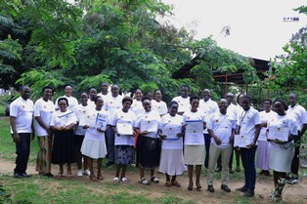
The graduates’ family photo
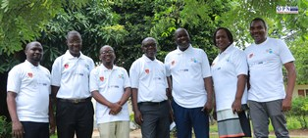
The QPN member organizations’ legal representatives (Except Louis Pasteur: the first in the left)
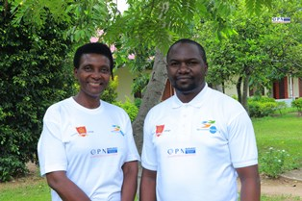
The two in-person facilitators
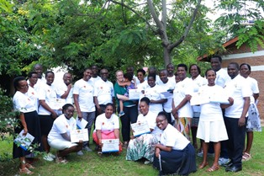
Honoured by the presence of Kristine, the former Quaker Service Norway (QSN) coordinator and now a board member of the QSN

ACTIVITIES

Caring for HIV Positive People (CHIVPP)
In the month of November, medical follow-up and home visits were done for our HIV positive people.

Maternity Ward Building
Ntaseka maternity ward still needs some medical equipment.

Improving Women’s Reproductive Health (IWRH)
FWA community health workers and FWA staff have continued to educate men, women and young people on the importance of birth control.
On November 27, 2022 there was a discussion group for young girls at Ntaseka clinic. They are members of three young girls' self-help groups (SHGs). Again, the topic was “women's entrepreneurship”. It was the second session. The objective is to have joyful and prosperous young girls in order to prevent unwanted pregnancies.
NTASEKA clinic Midwife Augustin HARUSHIMANA, Doctor NIBONA Alexia and Doctor Marie Salomé CISHAHAYO were present for coaching! Miss Nadia and Tiroryinka Fiona were facilitators.
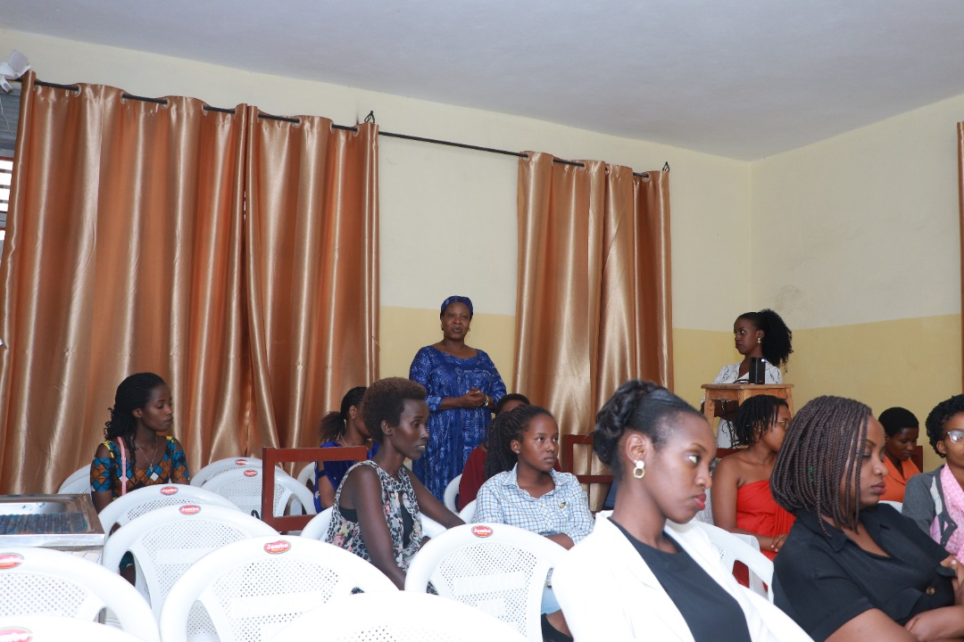
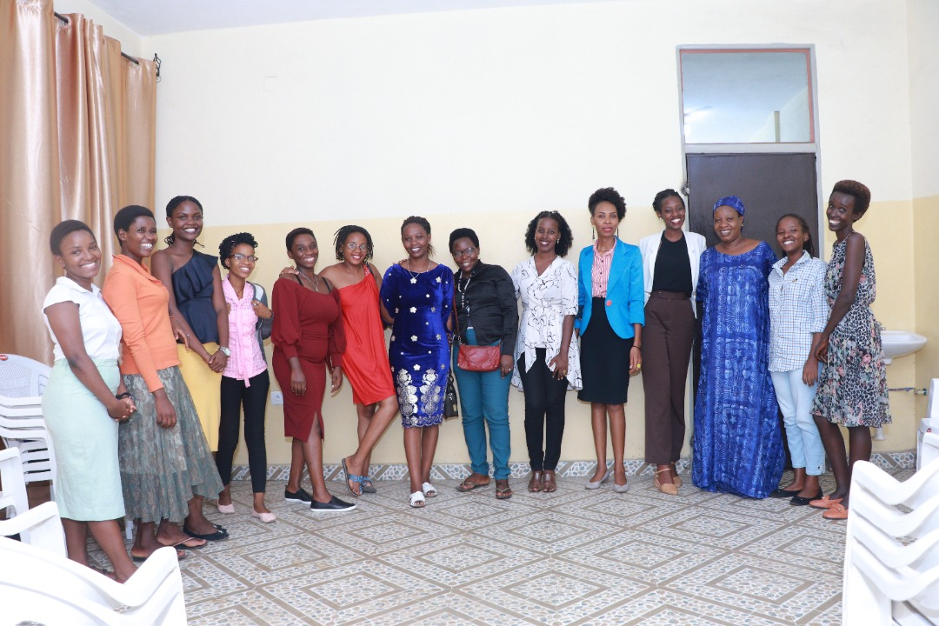
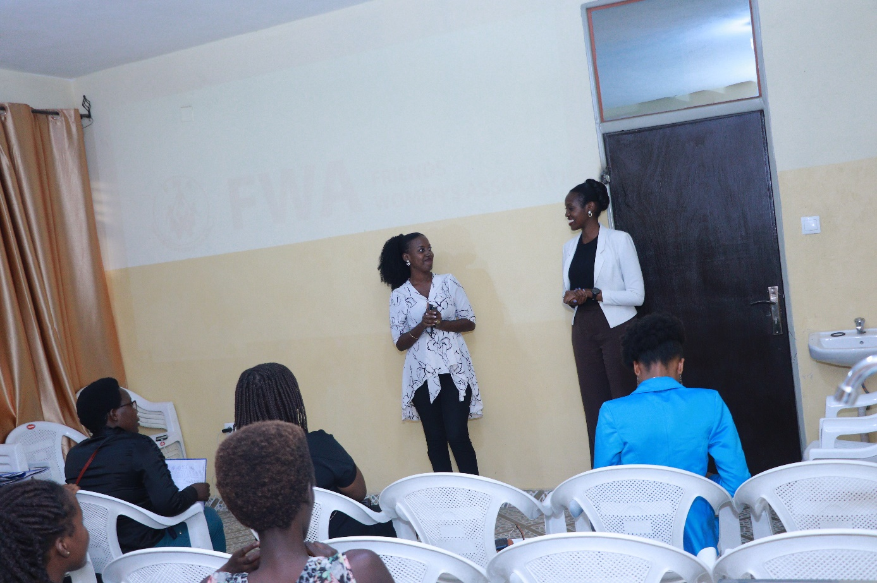
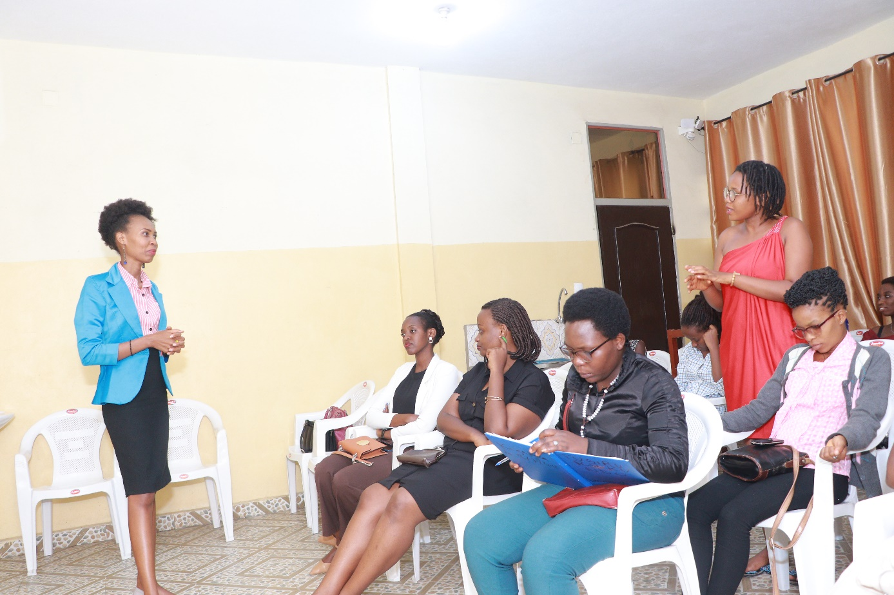

It is a group of young girls who are members of three self-help groups of young girls. They are there every last Sunday of the month to discuss and share ideas and experiences around a theme according to the plan already established in the framework for the promotion of sexual and reproductive health.
- My name is Chancel. I am 24 years old and I am a member of “TUZOBA ICO TWIGIZE SHG”. I grew up having a passion for being a trader. Indeed, my mother is a merchant. Every time I came home from school, I went to help my mother at all costs. As for her, she chased me away but I did not accept. I studied banking and insurance but I felt unsatisfied. I then set up my small business which is currently developing well. What I just discovered here in this workshop is that you can sacrifice off-duty hours to build a business. Also, there is the difference between a business and a company. It reassured me that I have to work hard to achieve my dreams, to build relationships to have coaches by my side, to work for others not for the salary only but to have experience. Thank you Fiona and Nadia as well as FWA for this opportunity of these two sessions on entrepreneurship. Thank you for sharing your testimonials. I just discovered now that by starting small, you can achieve great things.
- My name is Kentia. I am 20 years old, I am a member of NKOMEZI SHG.This training on entrepreneurship has just opened my eyes to my untapped talents. After the first session, I started to exploit my talents. I have just understood that being rich does not happen overnight, you have to work on your vision and it is not a title of society or social rank either; it's not my future husband's property as well, but it's my own life. And I just understood that capital is none other than the arms, the brain, and the practice of the theories that circulate in our heads and with courage and perseverance, we finally become rich.
- My name is Clarisse; I'm 24 years old; I am a member of TUGIRE URUKUNDO SHG. I had friends who talked a lot about business. However, we stood idly by. Every time my friends said that a girl cannot be independent in life, hence it is useless to have a lot of money. After the first session we did here, I rushed to my friends to repeat what I heard and here we are with this second session we have already defined our vision and our objectives. We have already laid the foundation of our company and with your testimonies, dear facilitators, I have just understood many things, among other things, that despite the challenges girls and women face, especially pregnancies, menstruation, dependency linked to culture and religion, and such, there are women and girls who have successfully set up businesses.
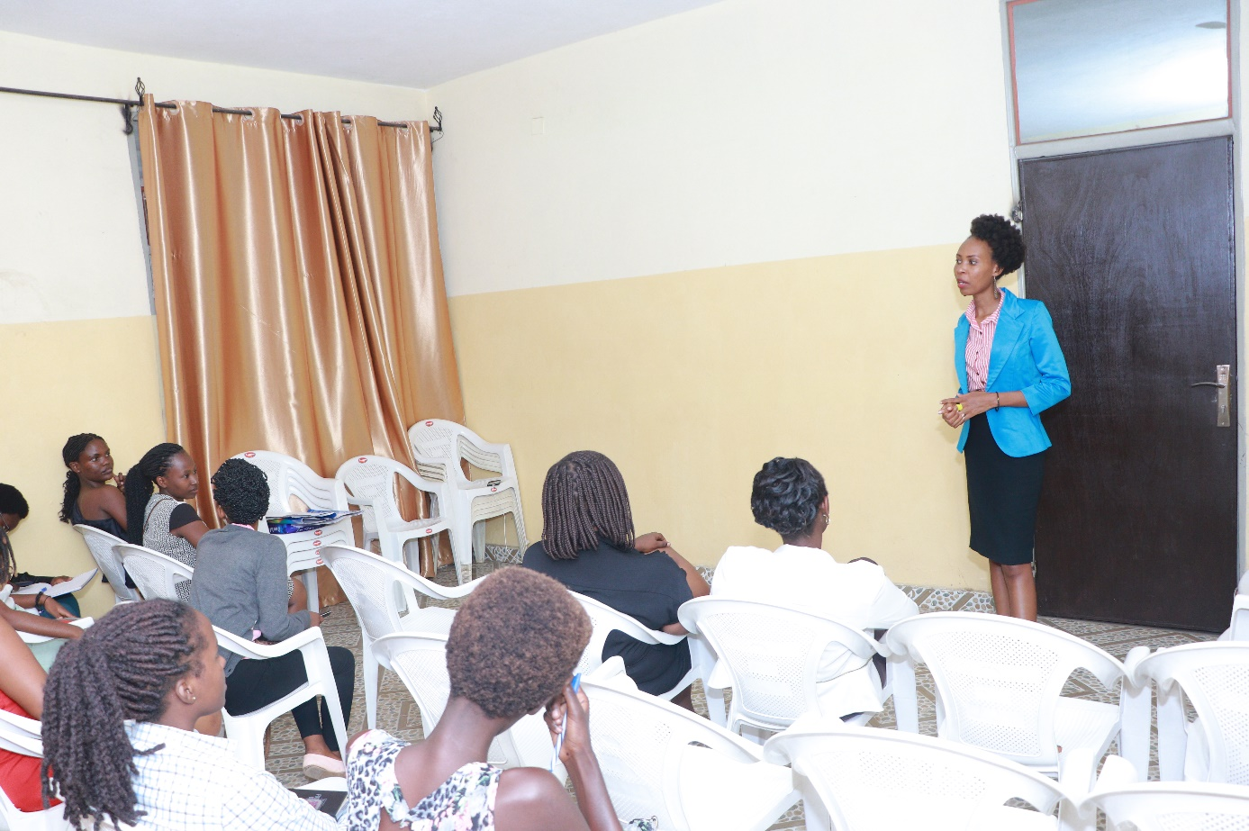
Recommendations:
- That FWA do follow up and coach us about our our business in order to guide us
- Many such sessions should be organized not only for girls but for women also
- We need to do Gala evenings with FWA partners to demonstrate our products and then Fiona at Nadia's companies can help us grow too
- That FWA organizes learning visits to learn from each other

The last Sunday of January 2023 (January 29, 2023) will be reserved for the sharing of meals among the girls members of the 3 SHGs who spent the year 2022 together. We ask FWA for financial support for the success of this event.

Rape Survivors’ Support (RSS)
In the month of August, the Rape Survivors Support program had different activities: the supervision of Self-Help Groups (SHGs) and evaluation and one trauma healing workshop. At the end of August 2022, we had a total of 154 SHGs in Kamenge, Bujumbura Mairie province for a total of 3638 women and 35 SHGs for 863 women in Nyabiraba commune, Bujumbura province.
- SHGs
ABOUT NEW SHG
No | Name of SHG | Month of creation | Member Number | Created by

SHG Total Number: | 154
SHGs Evaluation
As the table shows, in the month November 6 SHGs were evaluated and the result are as follows;
No | About sharing | Number of SHG | Total
1 | Total money saved | 6 | 18,655,270
2 | Total Credit granted | 6 | 17,945,000
3 | Total interest | 6 | 14,583,100
4 | People who didn’t paid | 6 | 4
5 | Total money not refunded | 6 | 665,200

Classification of SHG
After evaluation it was found that;
Active | Less Active | Sick | Total
4 | 2 | 1 | 6

- HROC Workshop
Under the support of Global Giving Foundation, from November 29th to December 1st, there was a three-day trauma healing workshop for 20 GBV survivors. The venue was the Ntaseka clinic training room.
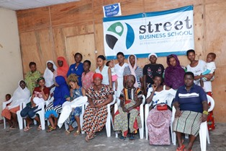
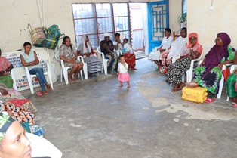
Testimony
My name is Rose. I live in violence, now there is 20 years ago; I said to myself that I have to be a strong woman in order to protect my children.,
After being disappointed by my husband who accused to have sex with his friend, there is no longer peace in our household. I suffered too much violence but I refused to be a victim, when He wants conflict I choose peace.
He uses to tell me that my son is my husband. He is not even afraid to say it in public, “what shame!” Now I sleep on a machete, He always terrorizes me saying that he will kill me one day. He told me: “I have already killed you, it remains to bury you”.

I was able to buy a plot and to build a house in Tenga without his support; I asked him to help me make bricks, and he refused; rather we live together in this house, and he wants to kill me.

When the kids hear us quarreling they come and grab that machete, so that he can’t kill me.
My heart has become hard. I don't think he will kill me.
As you said In JOHARI’s window, there are situation that we must surrender to God Who knows everything.
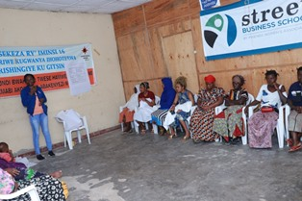

- Income Generating Activities
Income generating activities have continued. The handmade baskets project by young girls has continued at our FWA office. In the month of November 2022, two SHGs from Nyabiraba commune have started to grow potatoes.
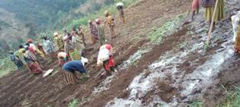
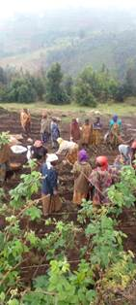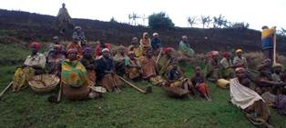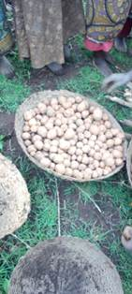

ACTION ON GENDER-BASED VIOLENCE (AGBV)
In the month of November2022, under the support of Quaker Service Norway, FWA has supported two groups of GBV survivors (a total of 20 people). They were given 10 pigs. This means that two people will share one pig.
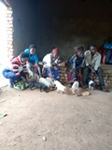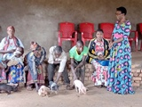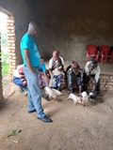
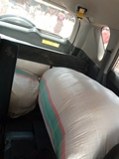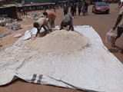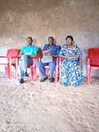

MEDICAL TEAM

CONSULTATIONS
Our medical doctors consulted with 191 cases, including 88 adults (31 men and 57 women), 24 children (15 boys and 9 girls), 23 HIV positive people and 56 pregnant women for ultrasound. The nurse received 287 patients including 182 adults and 75 children.

LABORATORY
In the month of November, apart from HIV voluntary testing, there were a total of 332 tests.
Test | Test completed | Positive | Negative
G.E.  Malaria test | 65 | 20 | 45
Quick malaria test | 47 | 10 | 37
ECBU  Urine test | 18 | 15 | 3
Selles  Stool test | 24 | 21 | 3
Pregnancy | 48 | 18 | 30
Sero-widal  Typhoïd fever | 46 | 16 | 30
Glycémie  Diabetes | 19 | 9 | 10
RPR VDRL  (Syphilis) | 21 | 4 | 17
Complete Blood Count | 30 | 9 | 21
Hepatitis B | 6 | 2 | 4
Hepatitis C | 5 | 1 | 4
Viral Load | 3 | 0 | 3
Total Tests: 332

FAMILY PLANNING
444 people received contraceptives from FWA’s nurse, including 169 old cases and 275 new ones. 297 received the contraceptive injection, 0 were given contraceptive pills, 143 received male condoms, 2 received UID and 2 received implants.

PRENATAL CONSULTATION (PNC)
In November, 53 women came for prenatal consultation (PNC), including 14 who came for PNC 1, 18 for PNC 2, 12 for PNC 3 and 9 for PNC 4.
56 pregnant women came for the ultrasound test.

ANTI-RETROVIRAL SITE
At the end of November, we had 330 patients under retro drugs followed at NTASEKA clinic, including 267 women and 63 men.

PHARMACY
Regarding medications, FWA was able to purchase the minimum needed medicine.

PSYCHOSOCIAL TEAM
In the month of November, 90 people were tested for HIV and received pre and post HIV test counselling. Out of them, two women were detected HIV positive with 2% of seropositivity.

Total Number of People Tested: | 90
Total Number of Women Tested: | 71
% of People Tested Who Are Women: | 79%
Average Age: | 29
Median Age: | 27
Total HIV+ : | 2
Total HIV- : | 88
Number of Women HIV+ : | 2
Total % Seropositivity: | 2%
% of Women Tested Who Are HIV+: | 3%

