Friends Women’s Association

MARCH 2021 Report

Table of Contents
Friends Women’s Association March 2021 Report 1
COVID-19 AND NTASEKA CLINIC 2
ACTIVITIES 2
Caring for HIV Positive People (CHIVPP) 3
Improving Women’s Reproductive Health (IWRH) 4
RAPE SURVIVORS’ SUPPORT (RSS) 15
MEDICAL TEAM 17
CONSULTATIONS 17
LABORATORY 17
FAMILY PLANNING 18
PRENATAL CONSULTATION (PNC) 18
ANTI-RETROVIRAL SITE 18
PHARMACY 18
PSYCHOSOCIAL TEAM 18

COVID-19 AND NTASEKA CLINIC
In the month March 2021, Friends Women’s Association has continued to apply Covid-19 restrictions at Ntaseka Clinic for both the staff and the beneficiaries’ protection.

MARCH 8, 2021
On March 12, 2021, as women-led organization which works for women, the FWA joined the world to celebrate the Women’s International Day.
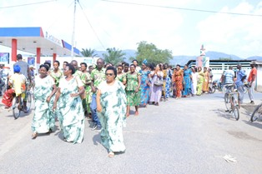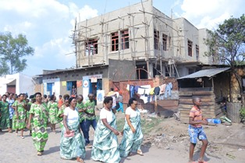
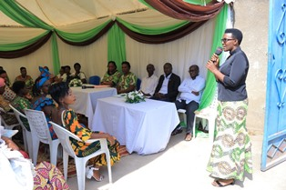
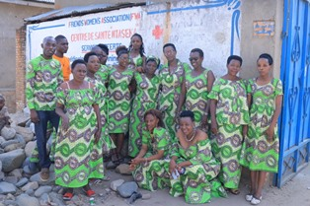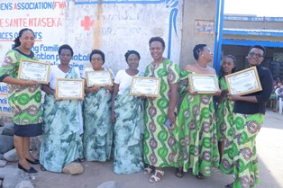

ACTIVITIES

Caring for HIV Positive People (CHIVPP)
In the month of March 2021, medical follow up and home visits were done for our HIV positive people.
Maternity Ward Building
In the month of March 2021, with the support from the Canadian Friends Service Committee (CFSC), we have started putting broth on the walls of Mtaseka clinic extension plus the control work. The next step will be the tiling of the building, installation of toilets and
showers.
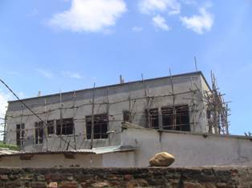
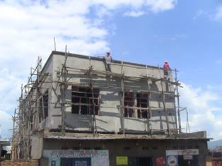

Improving Women’s Reproductive Health (IWRH)
Two discussion groups for young girls were done: on March 16, 2021 for the single mothers and on March 18, 2021 for sex workers.

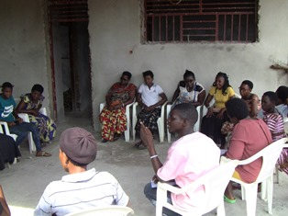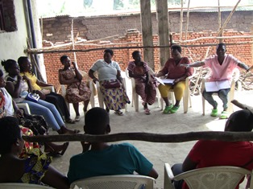
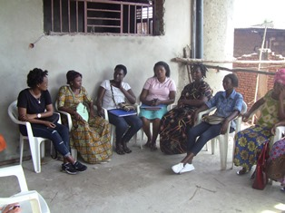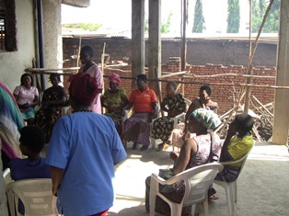
Facilitators were Augustin and Consolate
On March 26, 2021, in partnership with the Burundian Association for the Family Well-being (ABUBEF) the FWA has organized an outreach session to educate people from Nyarumanga in Buterere zone on the importance of birth control.
In the morning we did home visits.
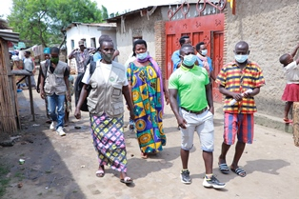

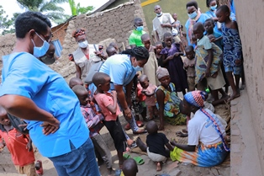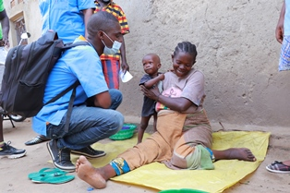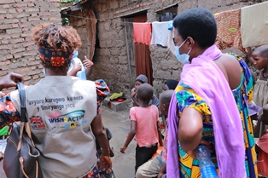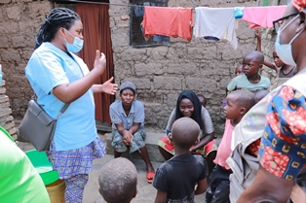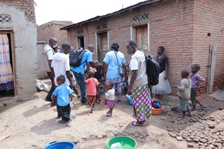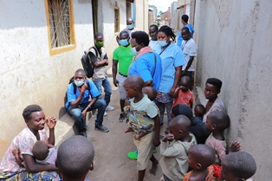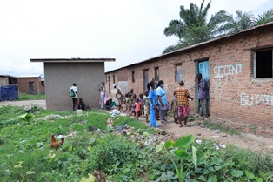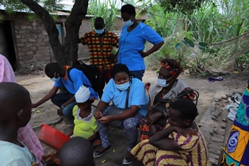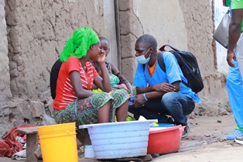
In the afternoon, we did mass sensitization. A total of 287 people were reached, including 223 women and 64 men.
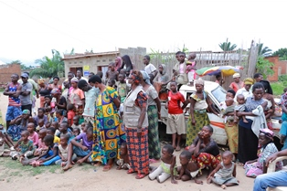
A short sketch played by FWA Community health Workers
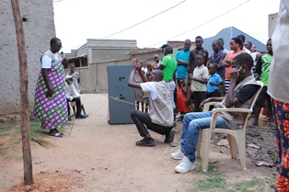
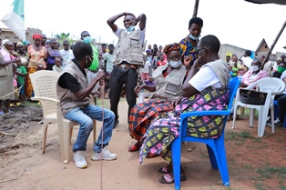
The music and dancing strategy
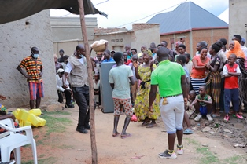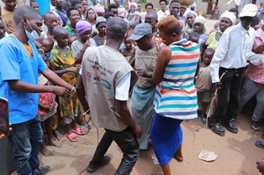
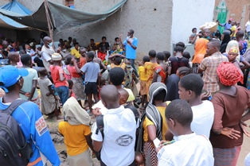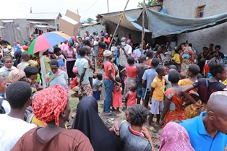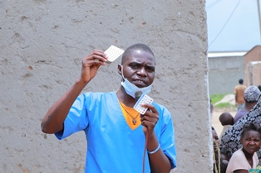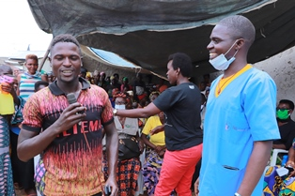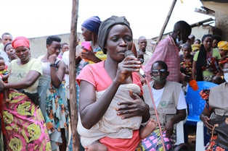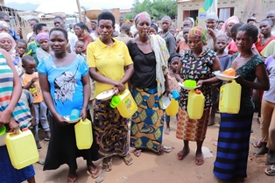
Small gifts to those who responded well
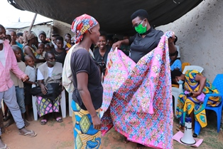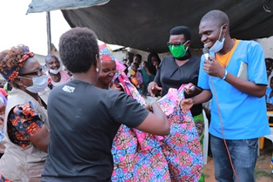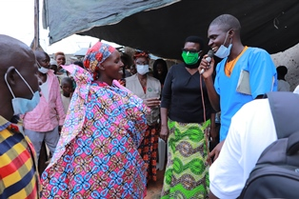

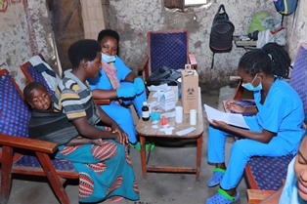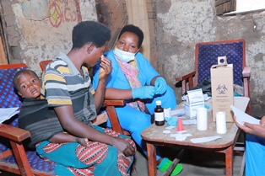
Some of the results:
- 30 men benefited from male condoms
- 6 clients received the contraceptive injection
- 4 clients received implant
- One man has been prepared for surgical contraception which will be done by ABUBEF after consensus with his partner
- 22 people were tested for HIV.
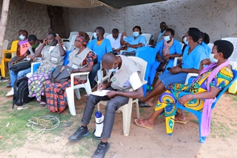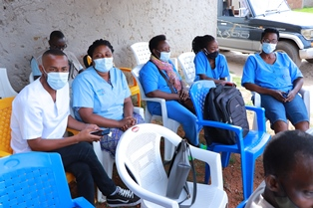

Rape Survivors’ Support (RSS)
In the month of March 2021, three new elf-Help Groups (SHGs) were created in Kamenge and three SHGs were created in Nyabiraba. At the end of March 2021, we had a total of 128 SHgs in Kamenge, Bujumbura Mairie province for a total of 3013 women and 11 SHGs for 263 women in Nyabiraba commune, Bujumbura province.
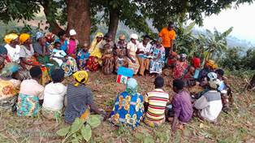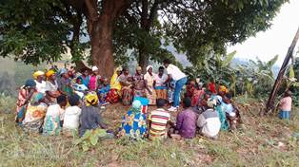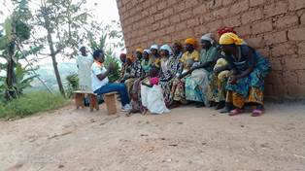

Trauma healing Workshop (March 16-18, 2021)
Facilitators: Gisele and Grace
“I was a girl who dreamed of having a good marriage like others. I lived here in Bujumbura and am a practicing catholic. I got to know a man who led us in the choir and he proposed me to marry him. For me, he was a man of my dream. I introduced him to my family and we got married legally.
I got pregnant and he took a 6 year old girl in our house saying that she is a maid. It was through her that I knew she was his child. I had a shock in my heart. I found out that he had a wife in the countryside with six children. Then conflicts started in our couple; he beat me, he insulted me, he does not pay the rent.
I ended up being separated from him because I no longer supported him. I just started my life alone with my child. I suffer but I had the courage in this workshop, while I was hearing the testimonies from other women who endured more than me I have felt that I must strugglr with life alone”
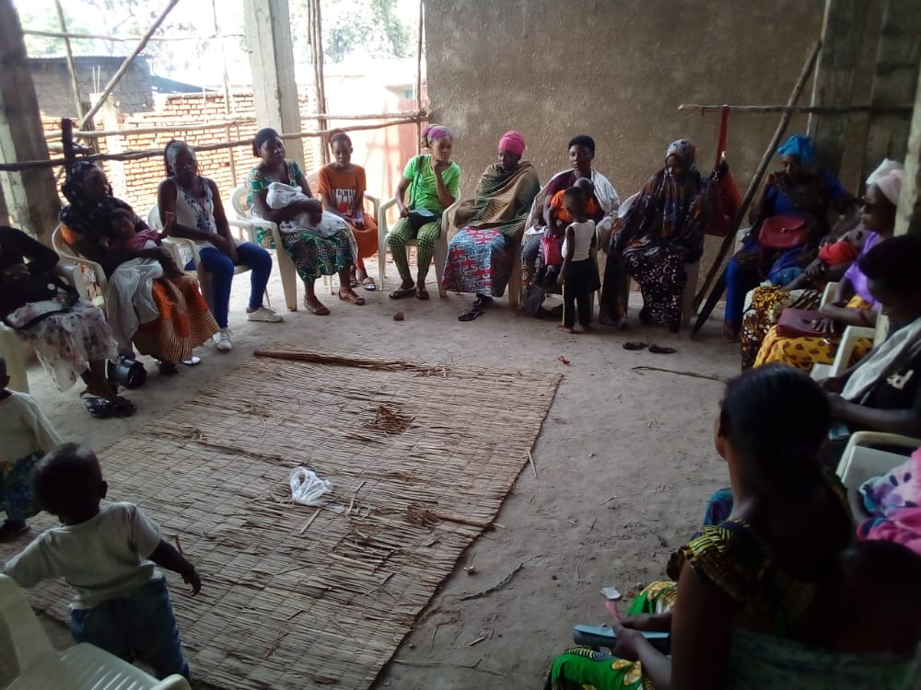.

ACTION ON GENDER-BASED VIOLENCE (AGBV)
In the month of March 2021, there was proposal writing to present to the Canadian Friends Service Committee (CFSC).

MEDICAL TEAM

CONSULTATIONS
Our medical doctors consulted with 118 cases, including 65 adults (30 men and 35 women), 6 children (4 boys and 2 girls), 27 HIV positive people and 20 pregnant women for ultrasound. The nurse received 262 patients including 197 adults and 65 children.

LABORATORY
In March 2021, apart from HIV voluntary testing, there were a total of 276 tests.

Test | Test completed | Positive | Negative
G.E.  Malaria test | 66 | 15 | 51
Quick malaria test | 32 | 10 | 22
ECBU  Urine test | 15 | 10 | 5
Selles  Stool test | 18 | 16 | 2
Pregnancy | 51 | 10 | 41
Sero-widal  Typhoïd fever | 28 | 11 | 17
Glycémie  Diabetes | 18 | 5 | 13
RPR VDRL  (Syphillis) | 20 | 1 | 19
Complete Blood Count | 23 | 14 | 9
Hepatite B | 5 | 0 | 5
Hepatite C | 1 | 0 | 1
Total Tests: 276

FAMILY PLANNING
549 people received contraceptives from FWA’s nurse, including 342 old cases and 207 new ones. 400 received the contraceptive injection, 58 were given pills, 60 received male condoms, 29 received implants, and 2 received UID

PRENATAL CONSULTATION (PNC)
In the month of March 2021, 46 women came for prenatal consultation (PNC), including 17 who came for PNC 1, 16 for PNC 2 and 7 for PNC 3 and 6 for PNC 4.
20 pregnant women came for the ultrasound test.

ANTI-RETROVIRAL SITE
At the end of March 2021, we had 330 patients under retro drugs followed at NTASEKA clinic, including 267 women and 63 men.

PHARMACY
Regarding medications, FWA was able to purchase the minimum needed medicine.

PSYCHOSOCIAL TEAM
In the month of March 2021, a total of 97 people received pre and post HIV test counselling and were tested for HIV. Out of the total number, 69% were women and six women out of the eight people detected HIV positive with 8% of seropositivity.
Total Number of People Tested: | 97
Total Number of Women Tested: | 67
% of People Tested Who Are Women: | 69%
Average Age: | 30
Median Age: | 28
Total HIV+ : | 8
Total HIV- : | 89
Number of Women HIV+ : | 6
Total % Seropositivity: | 8%
% of Women Tested Who Are HIV+: | 9%

