Friends Women’s Association

MAY 2024 Report

Table of Content
Friends Women’s Association 1
MAY 2024 Report 1
ACTIVITIES 2
Caring for HIV Positive People (CHIVPP) 2
Improving Women’s Reproductive Health (IWRH) 3
Rape Survivors’ Support (RSS) 3
MEDICAL TEAM 5
CONSULTATIONS 6
LABORATORY 6
FAMILY PLANNING 6
PRENATAL CONSULTATION (PNC) 6
ANTI-RETROVIRAL SITE 7
PHARMACY 7
PSYCHOSOCIAL TEAM 7

ACTIVITIES

Caring for HIV Positive People (CHIVPP)
In the month of May, medical follow-up and home visits were done for our HIV positive people.
Discussion Group for HIV positive people
On June 6, 2024, at the Friends Women's Association, a discussion group was organized in for Ntaseka clinic HIV positive beneficiaries. 64 people were present including 60 women and 4 men.
The objective was to strengthen compliance to have an undetectable viral load and to encourage people living with HIV to use family planning methods.
After sharing certain experiences, we have found that the beneficiaries did not know that the duration of certain methods decreases for women living with HIV because ARVs are stronger than these Family Planning products. Hence we need to increase awareness because most of them become pregnant while they are under contraceptive methods. Other obstacles are that some people change their physical address and do not respect appointments, hence unwanted pregnancies increase.
Testimony
I got pregnant while I was under family planning. I did not know that. I spent several months being sick without even going to the hospital. I went to the pharmacy, and I bought medicine but I couldn't get better. It was later that I found out that I was pregnant. I remember that I even insulted the providers at the Ntaseka clinic because I did not want to accept that I was pregnant. I accused them that they gave me fake medicines and that I understand why people have voluntary abortions. Now I understand that I must be very observant if I am under family planning, especially since ARVs are stronger than contraceptive methods. I thank Friends Women's association for their efforts because I have just learned a lot of things that I did not know. I encourage Friends Women's association providers to always share this information through discussion groups.
Recommendations
- Increase awareness about Family planning;
- Multiply discussion groups

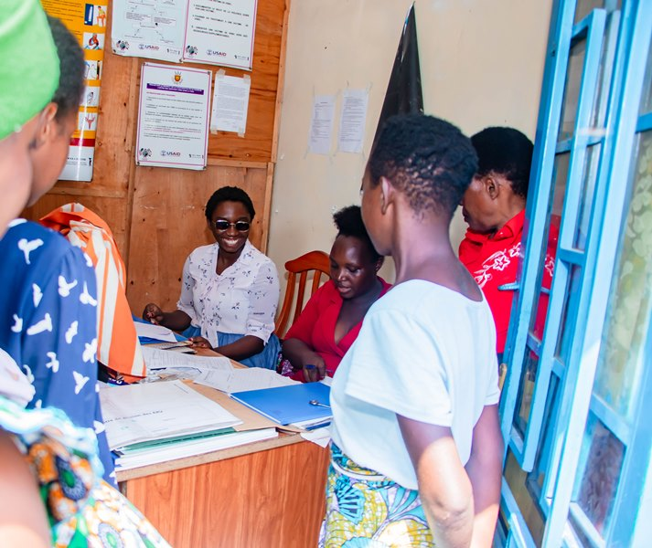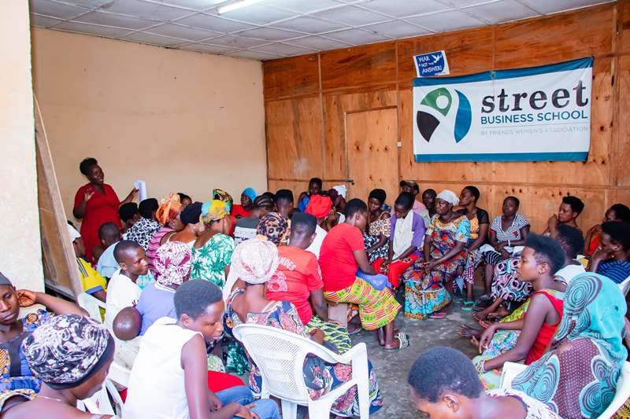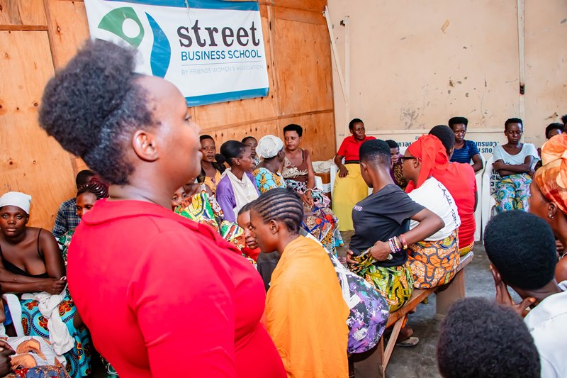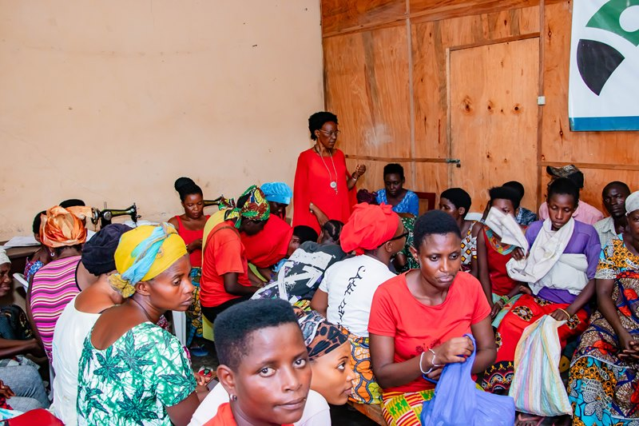

Maternity Ward Building
Although Ntaseka maternity ward still needs some medical equipment; both the delivery and the hospitalization services are currently functional.

Improving Women’s Reproductive Health (IWRH)
FWA community health workers and FWA staff have continued to educate men, women and young people on the importance of birth control.

Rape Survivors’ Support (RSS)
- SHGs EVALUATION
As the table shows, in the month May 4 SHGs made a sharing and the result are as follows;
No | About sharing | Number of SHG | Total
1 | Total money saved | 4 | 4,941,000
2 | Total Credit granted | 4 | 3,940,000
3 | Total interest | 4 | 2,790,200
4 | People who didn’t paid | 4 | 8
5 | Total money not refunded | 4 | 745,000
Classification of SHG
After evaluation it was found that;
Active | Less Active | Sick | Total
2 | 1 | 1 | 4

- HROC Workshops

In the month of May two workshops on trauma healing were organized at Ruvumvu in Bubanza province for Victims of Gender-Based Violence

Stories
“I married a man but I suffered trauma from the first childbirth, as we saw in JOHARI's window. I have a secret that no one else knows; my husband never buys me a fabric that is used to put a baby on the back (in our culture it is very important to buy this fabric as father). He buys everything necessary for the baby but he never buys this kind of fabric. I thought it was because I had given birth to girls but also for boys it was the same case.
He has often told me that I look ugly; that he made a mistake to marry me, that I am a stupid woman, he used to enjoy disgracing me in public and he beat me. I remained calm and easily forgave him because I am a Christian.
Something that has disappointed me and left a serious wound in my heart is that he left me with 7 very young children. I endured all these things to see that he would have pity on my children. Now, I live in poverty; I have a 2 month old child, and I am unable to work to feed my children.
I thank you for thinking on vulnerable people like us, I feel peaceful in my heart and I feel that I have recharged myself in this workshop.”

“My name is Odette, I am an unhappy woman; I married a husband who had two small children who were suffering from malnutrition. I remember how I often put them on my back even when I was pregnant, but my husband’s reward was the worst. Every week he has to beat me. If you look at my body, I have a lot of scars. He doesn't give us anything to eat, I know how hunger hurts. I have a child who is now 2 years old and has not yet walked. My husband has refused that we go to a medical doctor to see what is wrong with our kid.
I do everything to attract my husband, but it's rare that we have an intimate relationship with my husband. I know He has another wife. Sometimes when he comes back home, he tells me that I'm dirty, and that he has found another beautiful woman.
All this transformed me as you indicated into the signs of a traumatized person. I became aggressive towards my children and others. Sometimes I plan to take revenge in a wrong way. One day I should commit a crime but due to this training I understood my suffering and I think that I will be able to manage my depression in a good way to finally recover from trauma”
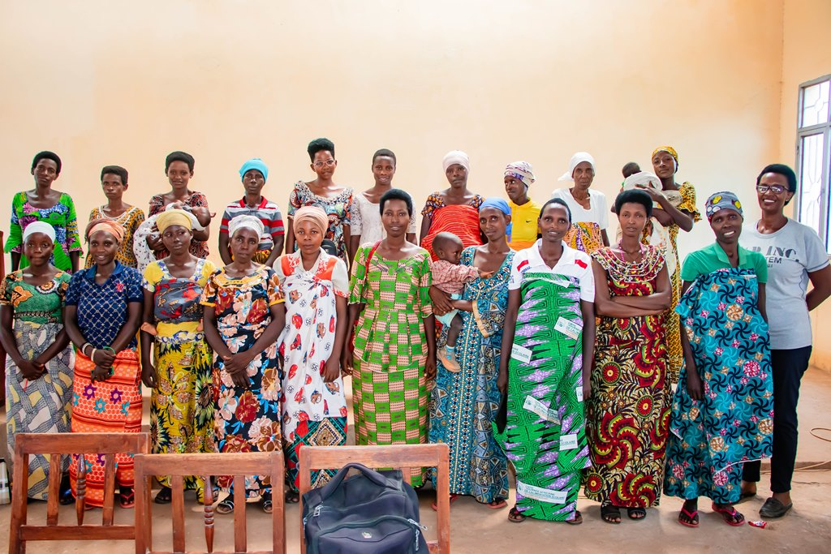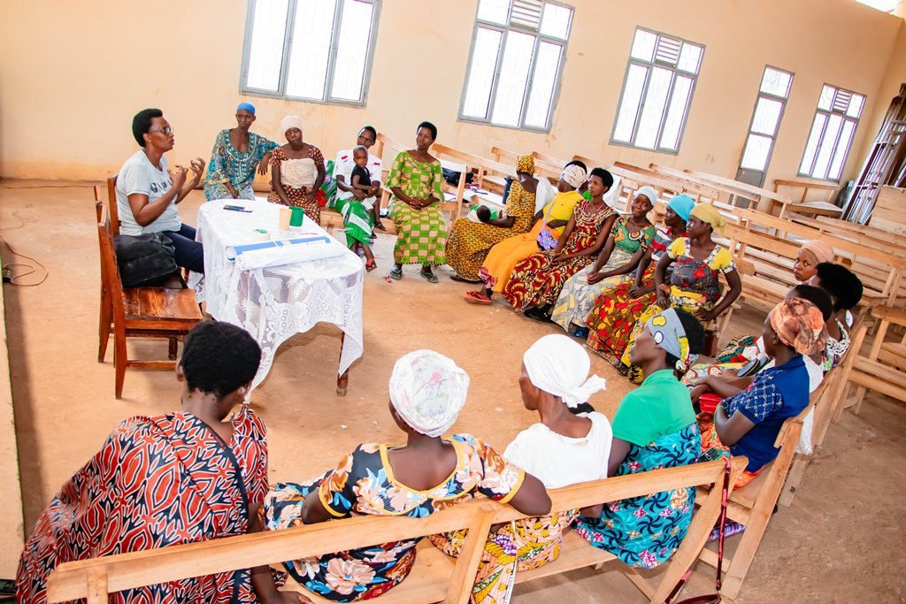

ACTION ON GENDER-BASED VIOLENCE (AGBV)
In the month of May, in the context of the project "Connecting the Global to the Local: Strengthening Women's Leadership for the Localization of the United Nations Security Council Resolution 1325 (2000) on "Women, Peace and Security", seven psychologists and 132 psychologists’ assistants have been receiving gender-based violence survivors for both listening and counselling. At the same time, the FWA identified if four provinces (Bubanza, Bujumbura, Cibitoke and Makamba) 20 small projects which will be supported before September 2024. They were initiated by women survivors of gende-based violence

MEDICAL TEAM

CONSULTATIONS
Our medical doctors consulted with 135 cases, including 24 adults (8 men and 16 women), 9 children (5 boys and 4 girls), 24 HIV positive people and 78 pregnant women for ultrasound. The nurse received 244 patients including 165 adults and 79 children.

LABORATORY
In the month of May, apart from HIV voluntary testing, there were a total of 356 tests.

Test | Test completed | Positive | Negative
G.E.  Malaria test | 55 | 14 | 41
Quick malaria test | 33 | 18 | 15
ECBU  Urine test | 20 | 16 | 4
Selles  Stool test | 17 | 16 | 1
Pregnancy | 41 | 7 | 34
Sero-widal  Typhoïd fever | 57 | 16 | 41
Glycémie  Diabetes | 16 | 3 | 13
RPR VDRL  (Syphilis) | 20 | 0 | 20
Complete Blood Count | 67 | 4 | 63
Hepatitis B | 4 | 1 | 3
Hepatitis C | 3 | 0 | 3
Viral Load | 23 | 1 | 22
Total Tests: 356

FAMILY PLANNING
530 people received contraceptives from FWA’s nurse, including 301 old cases and 229 new ones. 381 received the contraceptive injection, 81 were given contraceptive pills, 57 received male condoms at Ntaseka clinic, 1 received UID and 10 received implants

PRENATAL CONSULTATION (PNC)
In May, 58 women came for prenatal consultation (PNC), including 17 who came for PNC 1, 24 for PNC 2, 7 for PNC 3 and 10 for PNC 4.
78 pregnant women came for the ultrasound test.

ANTI-RETROVIRAL SITE
At the end of May, we had 330 patients under retro drugs followed at NTASEKA clinic, including 267 women and 63 men.

PHARMACY
Regarding medications, FWA was able to purchase the minimum needed medicine.

PSYCHOSOCIAL TEAM
In the month of May, 76 people were tested for HIV and received pre and post HIV test counselling. All the six people who were detected HIV positive were women with 8% of seropositivity.
Total Number of People Tested: | 76
Total Number of Women Tested: | 68
% of People Tested Who Are Women: | 89%
Average Age: | 27
Median Age: | 27
Total HIV+ : | 6
Total HIV- : | 70
Number of Women HIV+ : | 6
Total % Seropositivity: | 8%
% of Women Tested Who Are HIV+: | 9%

