Friends Women’s Association

MAY 2023 Report

Table of Contents
Friends Women’s Association 1
MAY 2023 Report 1
ACTIVITIES 2
Caring for HIV Positive People (CHIVPP) 6
Improving Women’s Reproductive Health (IWRH) 7
Rape Survivors’ Support (RSS) 7
MEDICAL TEAM 15
CONSULTATIONS 15
LABORATORY 15
FAMILY PLANNING 16
PRENATAL CONSULTATION (PNC) 16
ANTI-RETROVIRAL SITE 16
PHARMACY 16
PSYCHOSOCIAL TEAM 16

COVID-19 AND NTASEKA CLINIC
In the month of May 2023, Friends Women’s Association has continued to apply covid restrictions restrictions at Ntaseka Clinic for both the staff and the beneficiaries’ protection.
In the month of May, the FWA national coordinator was still in the US to attend the face-to- face meeting of the Friends Peace Teams and speaking tours as well.
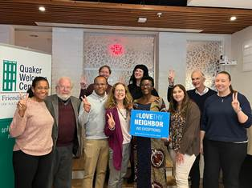
Parfaite Ntahuba at the Friends Committee on National Legislation (FCNL) in Washington DC on May 2, 2023

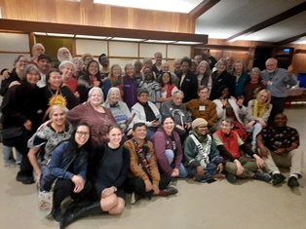
Group photo at the end of the FPT face-to-face meeting
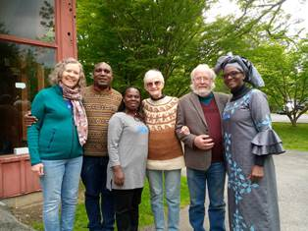
Parfaite Ntahuba is now the income co-clerk of the African great Lakes Initiative (AGLI) of the Friends Peace Teams (FPT)
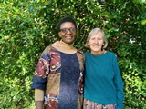
The Incoming AGLI co-clerks
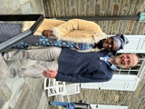
What a joy at the Western Friends School (Parfaite with Jonathan, a teacher of Quakerism at Western Friends School)

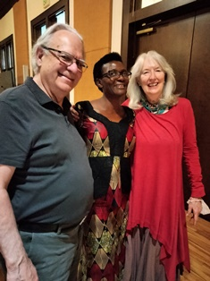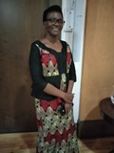
At Minneapolis Friends Meeting House on May 10, 2023
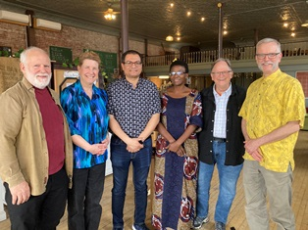
In Menomonie, WISCONSIN State on May 11. 2023 with a group of Quakers and Nonviolent Peaceforce staff and volunteers

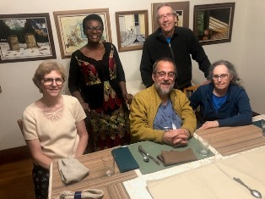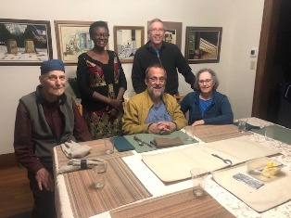
With some of the Quakers from Madison Friends Meeting at Linda’s house
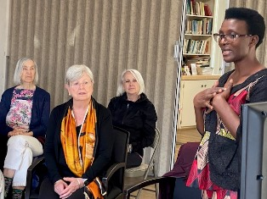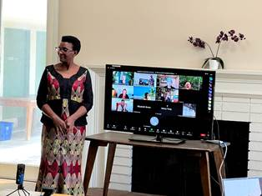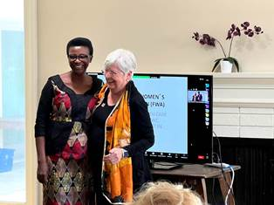
At Santa Monica Friends Meeting on May 21, 2023

ACTIVITIES

Caring for HIV Positive People (CHIVPP)
In the month of May, medical follow-up and home visits were done for our HIV positive people.
Under the support of the of the African Great lakes region, vulnerable children are supervised by volunteers through afternoon classes to strengthen their capacities. In the month of May, there was a meeting between FWA health mediator with the parents of the students to discuss about the grades of the students’ grades from the two first quarters of the school year.
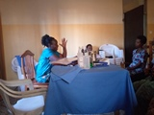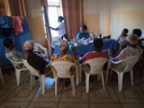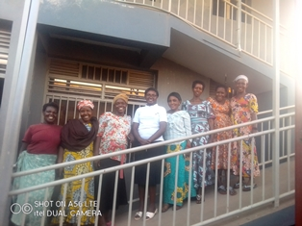
Maternity Ward Building
Although Ntaseka maternity ward still needs some medical equipment; both the delivery and the hospitalization services arecurrently functional.
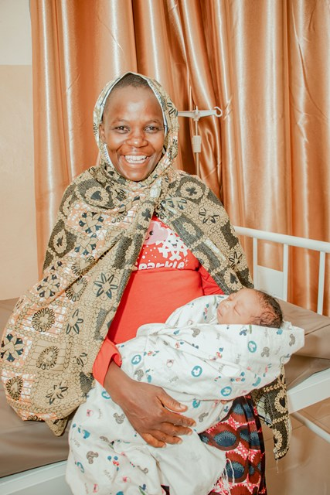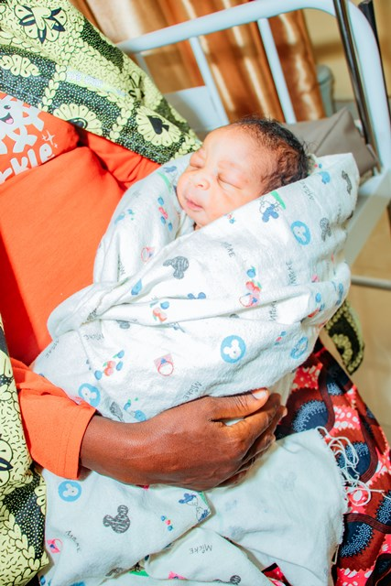
Babies born at Ntaseka clinic

Improving Women’s Reproductive Health (IWRH)
FWA community health workers and FWA staff have continued to educate men, women and young people on the importance of birth control. Two discussion groups were done at Ntaseka clinic, including one for young boys only and another one for both young boys and young girls.
On May 5, 2023, a discussion group of 20 young boys of childbearing age, children of women members of FWA Self-Help Groups (SHGs) was organized to discuss about sexual and reproductive health in general and Sexual responsibility in order to improve the families’ health with regard to the education of children in Burundi
The midwife Augustin HARUSHIMANA and Huguette INGABIRE were facilitators
The discussion group began with a survey of the participants regarding their lifestyle as young adolescents and the results were:
- All 20 participants are children of women members of FWA Self Help Groups
- 20/20 are students
- 8/20 are in Fundamental
- 12/20 are in Post Fundamental
- 20/20 are between 15 and 20 years old
- 20/20 never discuss sexual health with relatives or adults but the generation
- 04/20 are orphans and live with family members
- 8/20 have a girlfriend
- 20/20 have already heard the teacher talking about sexual and reproductive health.
- 6/20 accepted having had sex with their girlfriends by surprise

We discussed about sexual and reproductive health in general, the sexual life of young people in the neighborhood, the source of the information they have and some necessary information on the services of Ntaseka Clinic for young people as well as the contribution of parents and adults on improving the health of young adolescents. We then discussed mentoring how dads help young boys to be sexually responsible and live their vision.
Testimony:
I’m 19 years old. This is the first time that I openly hear this kind of dialogue on sex. Indeed, at school, we focus on exams and questions and not on understanding. Here the facilitators explain things well and give us the time to express ourselves even if we talk about false information collected from our friends and neighbors of the same generation. Please call me whenever you organize this kind of support group.
My name is Eddy. I’m 15 years old. I have just discovered that at my age I can impregnate a girl. I had tried one day to have intercourse my girlfriend because of the encouragement of my friends but when the day came, the girl told me that she got her periods. She was even older than me because she is 20 years old. Now I wonder if I impregnated her, was I really going to be called father of a child at 15? Thank you Ntaseka for these conversations I have a lot to learn. Today I have just understood that I must abstain to secure my future and wait for marriage. Please also call my friends because they don't know these things which are well explained here

Recommendations
- Organize a discussion group on May 31, 2023 to combine the two previous participants (young girls and young boys)
- Make more than two youth discussion groups per month
- Prepare peer educators for sexual and reproductive health at Ntaseka clinic
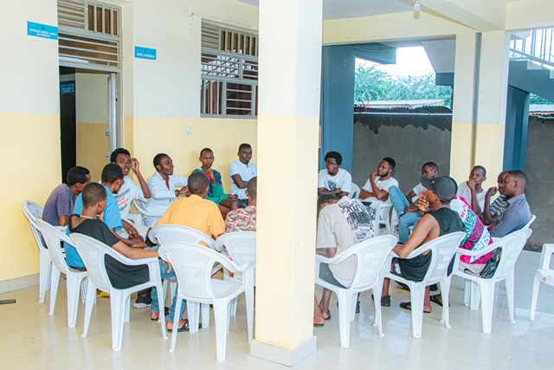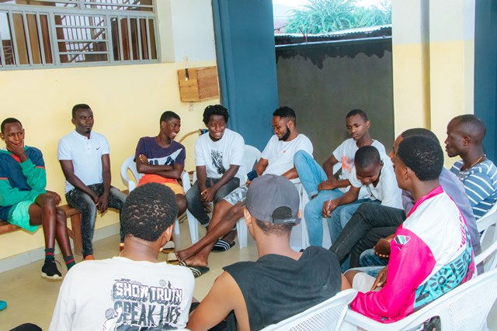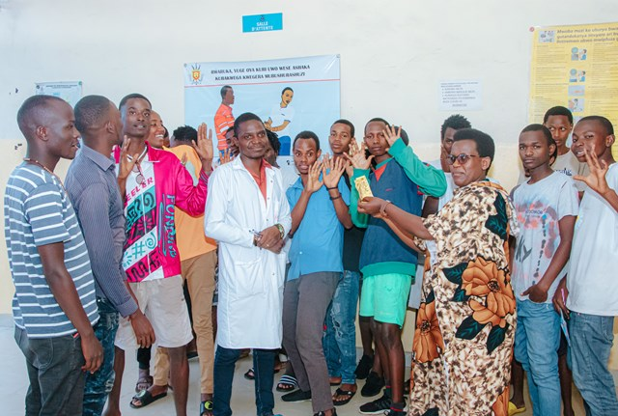

On May 31, 2023, a discussion group of 10 young girls members of SGHs, 10 young boys of childbearing age, children of women members of FWA SHGs was organized to discuss sexual and reproductive health in general and the income generating activities for girls and boys.
The Ntaseka clinic midwife Augustin HARUSHIMANA and Huguette INGABIRE were Facilitators
The discussion group began by recalling what had been discussed among girls only and among boys only. Then, the facilitators opened a discussion between the two groups to exchange different information.
After 2 hours of discussion, all participants concluded that:
- They want to build their future with dignity
- They will not accept advances from adults to have sex with them
- They will request information from parents and providers
- They will participate in workshops for teenagers and will always accept supervision

Testimony:
My name is Jessica. I’m 17 years old: Hello I did not believe that there is a place for such dialogues. I was always at home in my room taking my notes, and I didn't even know that I could express my ideas about sex publicly. Here I am, I have just said everything in front of 19 young girls and boys of my generation and these two service providers. Now I feel calm, thank you to those who organize this kind of discussion,

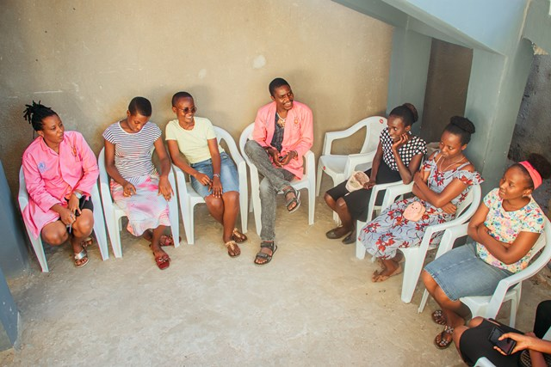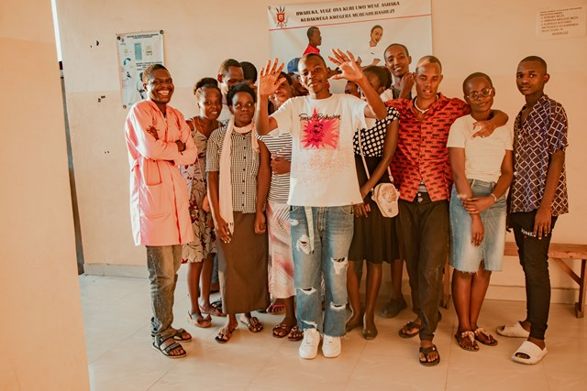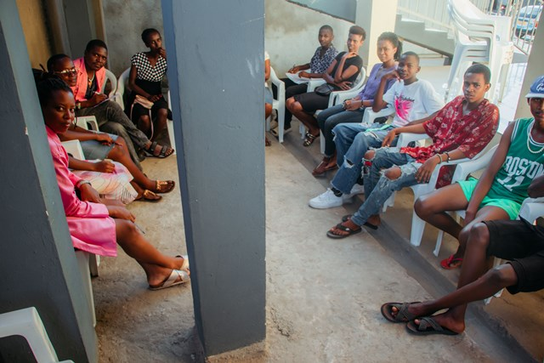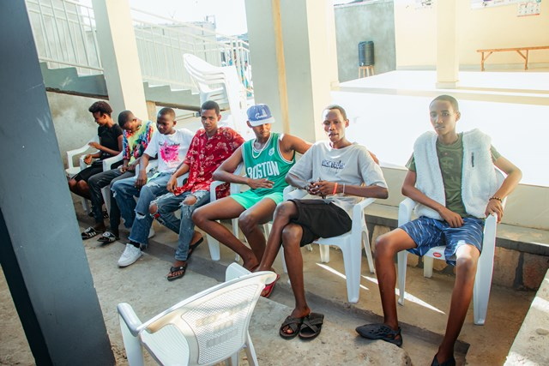

Recommendations
- Continue to support young girls' projects and start thinking about young boys’ projects as well
- Increase discussion groups on sexual and reproductive health for young people
- Ensure the coordination of mentors where the more experienced help the less
- Engage boys to be at the same level of understanding as girls on information related to sexual and reproductive health
- Organize events for young people and networking among themselves to help them to be independent financially. This helps them a lot.

Rape Survivors’ Support (RSS)
In the month of May, the Rape Survivors Support program had different activities: the supervision of Self-Help Groups (SHGs) and two trauma healing workshops at Randa in Bubanza province. At the end of May 2023, we had a total of 159 SHGs in Kamenge, Bujumbura Mairie province for a total of 3763 women and 43 SHGs for 1063 women in Nyabiraba commune, Bujumbura province.
- SHGS
TOTAL SHGs
No | Name of SHG | Month of creation | Member Number | Created by

SHG Total Number: | 159+43=202
Evaluation
As the table shows, in the month May 2023, two SHGs made a sharing and the result are as follows;
No | About sharing | Number of SHG | Total
1 | Total money saved | 2 | 5,705,700
2 | Total Credit granted | 2 | 3,450,000
3 | Total interest | 2 | 5,262,000
4 | People who didn’t paid | 2 | 2
5 | Total money not refunded | 2 | 247,500

Classification of SHG
After evaluation it was found that;
Active | Less Active | Sick | Total
2 | 0 | 0 | 2

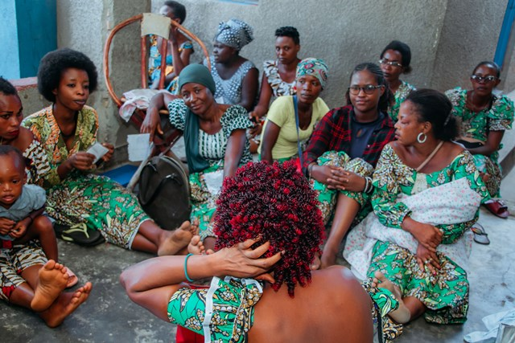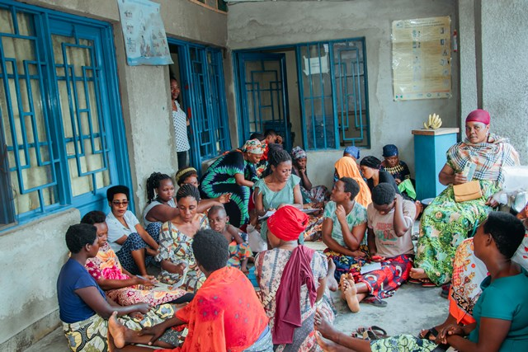
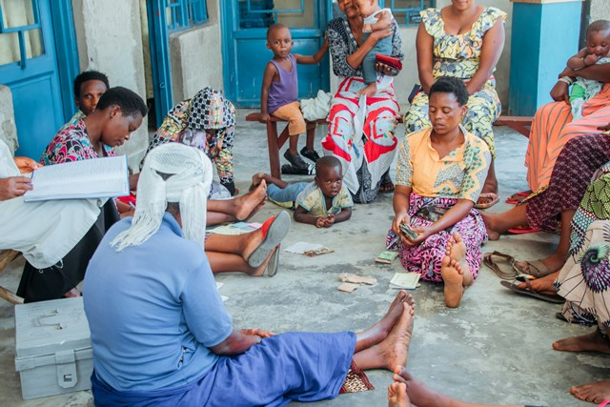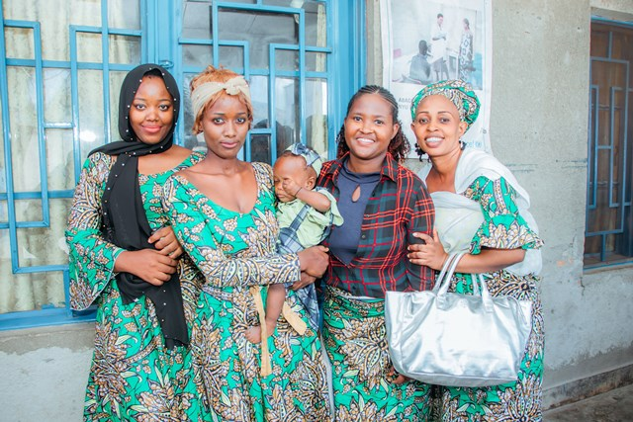

- HROC Workshops ( May23- 24 and May 25-26)

In the month of May, two training workshops were held in Randa in Bubanza province in the execution of the RSS project

Testimony 1
“I was born into a family of an irresponsible father who sold all our fields for no reason. When one of her children was sick, instead of paying for medical expenses, he used to say: “the pit to bury him is already available”
My mother was dead; He had another wife and continued to give birth while he sold all the land to cultivate.
I grew up full of bitterness I remember I wanted to go to military service with the motivation of destroying my family.
I married the first husband who abandoned me and I married the second who also rejected me.
My life is a nightmare; my 4 year old daughter was raped and I called for justice who imprisoned the author of the crime but my community turned against me and accused me to be a bad woman to mean that I could not put this man in prison. Accusations were too much for me and I was depressed; I took the road without knowing where I was going. People picked me up and brought me home.
Normally, at night I didn't sleep I had bad thoughts; sometimes I think how I can find what can kill my family or I feel I can burn my community to have peace in my heart. I can't go to church I work even on Sunday because if I don't work I can't have what to eat with my children.
I was amazed that I was able to sleep after the first day of this training and I feel my burden has become less heavy. Thank you for inviting me”.
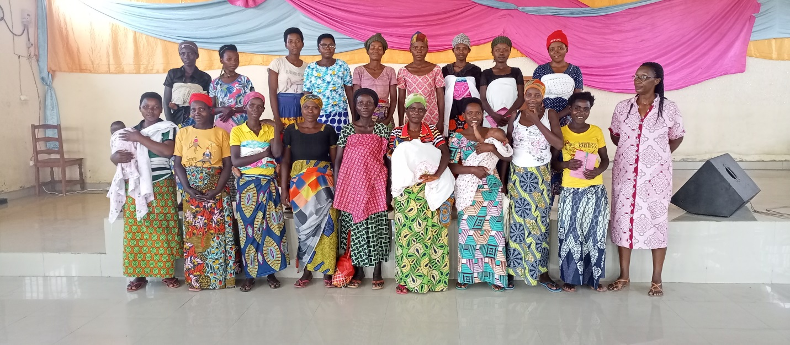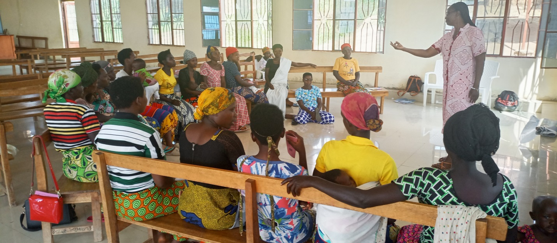
Testimony 2
“I had a husband who doesn't love me. If I fell ill He didn’t care but I was surprised to hear him say; “give me what I eat “, when He has left nothing to eat. I had always to work to feed him.
In my marriage I spent 10 months without being pregnant and when I got pregnant my husband accused me that this pregnancy is from another man. He can't find what I can eat and I got the malnutrition disease. I decided to go back to my mother; seeing me she cried because I was very thin and my body was swollen.
My mother took care of me and I was able to have strength and health back. My husband came looking for me saying that He changed; my mother told me that I must go to try again. But He didn't change.
I remember that one day I had just given birth and I was very hungry, so I was looking for local leaders to give advice to my husband so that he can find for me something to eat but I fell down because of hunger.
After 2 years, my husband abandoned me accusing me of giving birth to a boy; He told me that in their families they only give birth to girls.
That day he left me, we were in local court in the morning because I was at 8 month of pregnancy and I couldn't work. To punish me he left me and never returns. I don't know where he is now.
It was so hard for me because I went back to work in the rice fields two weeks after giving birth; my back was still weak but I was obliged to work in order to survive.
Thank you for thinking of us. I feel encouraged because I heard that there are those who live a worse life than me. This training gave me the courage to continue alone and raise my children”.
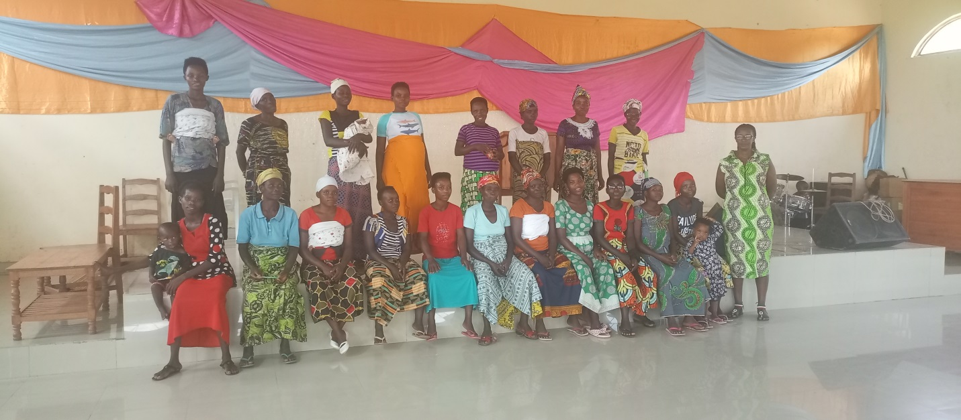
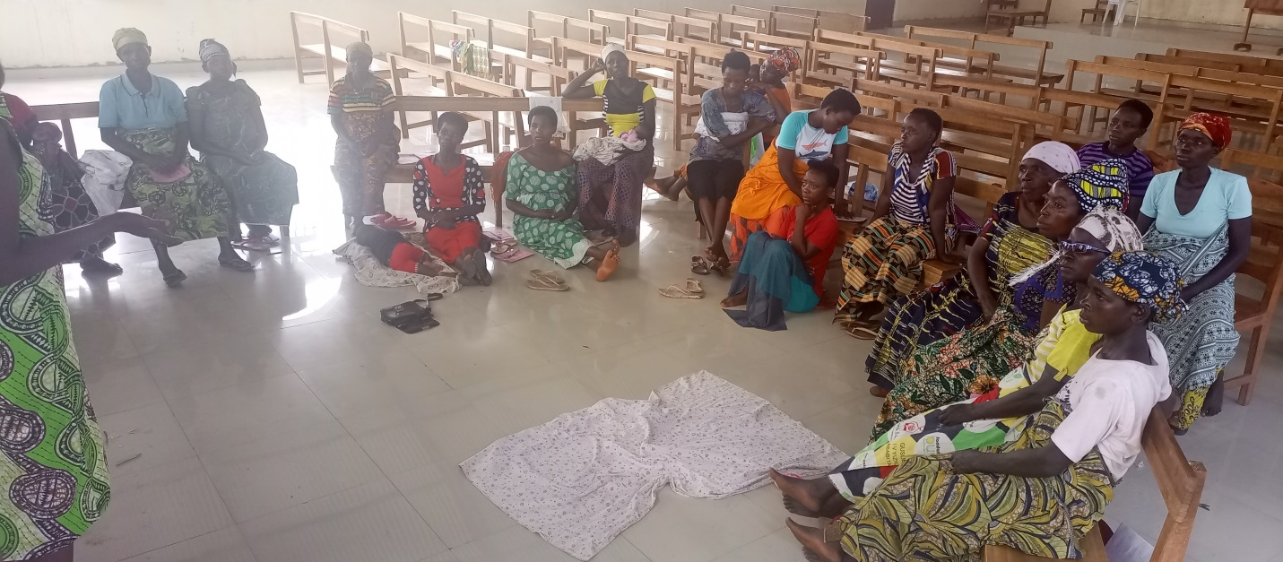
ACTION ON GENDER-BASED VIOLENCE (AGBV)
In the month of May 2023, in the context of the project "Connecting the Global to the Local: Strengthening Women's Leadership for the Localization of the United Nations Security Council Resolution 1325 (2000) on "Women, Peace and Security", seven psychologists and 132 psychologists’ assistants have been receiving gender-based violence survivors for both listening and counselling. Field visits were organized to identify the Incom eGenerating activities (Initiated by women) which the project will support.

MEDICAL TEAM

CONSULTATIONS
Our medical doctors consulted with 150 cases, including 54 adults (21 men and 33 women), 17 children (10 boys and 7 girls), 23 HIV positive people and 56 pregnant women for ultrasound. The nurse received 352 patients including 248 adults and 104 children.

LABORATORY
In the month of May, apart from HIV voluntary testing, there were a total of 416 tests.

Test | Test completed | Positive | Negative
G.E.  Malaria test | 108 | 30 | 78
Quick malaria test | 75 | 28 | 47
ECBU  Urine test | 12 | 10 | 2
Selles  Stool test | 18 | 14 | 4
Pregnancy | 49 | 16 | 33
Sero-widal  Typhoïd fever | 88 | 44 | 44
Glycémie  Diabetes | 14 | 7 | 7
RPR VDRL  (Syphilis) | 29 | 0 | 29
Complete Blood Count | 19 | 5 | 14
Hepatitis B | 2 | 0 | 2
Hepatitis C | 2 | 0 | 2
Viral Load | 0 | 0 | 0
Total Tests: 416

FAMILY PLANNING
550 people received contraceptives from FWA’s nurse, including 299 old cases and 251 new ones. 443 received the contraceptive injection, 40 were given contraceptive pills, 40 received male condoms, 4 received UID and 23 received implants.

PRENATAL CONSULTATION (PNC)
In May, 74 women came for prenatal consultation (PNC), including 29 who came for PNC 1, 29 for PNC 2, 8 for PNC 3 and 8 for PNC 4.
56 pregnant women came for the ultrasound test.

ANTI-RETROVIRAL SITE
At the end of May, we had 330 patients under retro drugs followed at NTASEKA clinic, including 267 women and 63 men.

PHARMACY
Regarding medications, FWA was able to purchase the minimum needed medicine.

PSYCHOSOCIAL TEAM
In the month of May, 71 people were tested for HIV and received pre and post HIV test counselling. Out of them, one woman was detected HIV positive with 1% of seropositivity.

Total Number of People Tested: | 71
Total Number of Women Tested: | 65
% of People Tested Who Are Women: | 92%
Average Age: | 27
Median Age: | 27
Total HIV+ : | 1
Total HIV- : | 70
Number of Women HIV+ : | 1
Total % Seropositivity: | 1%
% of Women Tested Who Are HIV+: | 2%

