Friends Women’s Association

MAY 2021 Report

Table of Contents
Friends Women’s Association MAY 2021 Report 1
COVID-19 AND NTASEKA CLINIC 2
ACTIVITIES 2
Caring for HIV Positive People (CHIVPP) 3
Improving Women’s Reproductive Health (IWRH) 4
RAPE SURVIVORS’ SUPPORT (RSS) 4
MEDICAL TEAM 8
CONSULTATIONS 8
LABORATORY 8
FAMILY PLANNING 9
PRENATAL CONSULTATION (PNC) 9
ANTI-RETROVIRAL SITE 9
PHARMACY 10
PSYCHOSOCIAL TEAM 10

COVID-19 AND NTASEKA CLINIC
In the month May 2021, Friends Women’s Association has continued to apply Covid-19 restrictions at Ntaseka Clinic for both the staff and the beneficiaries’ protection. John Gould Family Foundation has again supported Ntaseka clinic with 500 disposable gloves, 500 surgical masks, KN 95 masks and 15 face shields. They were given through Life Net International

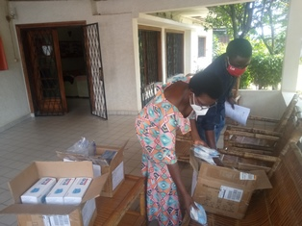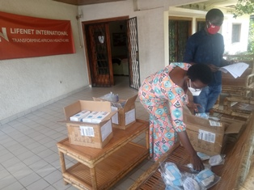

ACTIVITIES

Caring for HIV Positive People (CHIVPP)
In the month of May 2021, medical follow up and home visits were done for our HIV positive people.
Maternity Ward Building
In the month of May 2021, with the support from the Canadian Friends Service Committee (CFSC), we have completed putting broth on the walls of Ntaseka clinic extension plus the control work. Under the support of the Global Giving, we have started painting our maternity ward. Tiles for the first floor are already bought under the support of the African Great Lakes Initiative (AGLI). The first floor of the building will be tiled in the month of June 2021
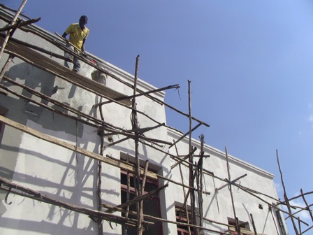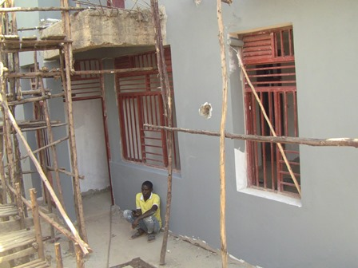
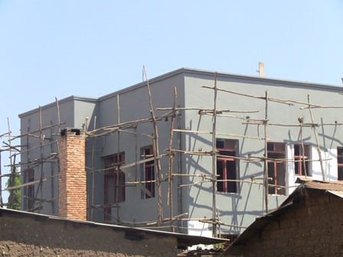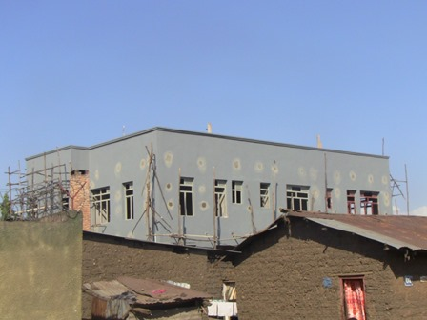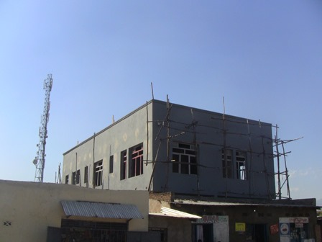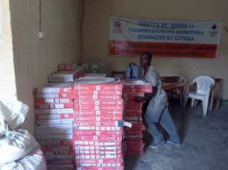

Improving Women’s Reproductive Health (IWRH)
FWA community health workers and FWA staff have continued to educate men, women and young people on the importance of family planning.
Two discussion groups for the SHGs leaders were done: on May 20&30, 2021. A total of 45 SHGs leaders were touched. The objective was to invite SHGs members to discuss about sexual and reproductive health every time they meet. The Community Health workers will be there to mentor them so that they can be facilitators in the future.
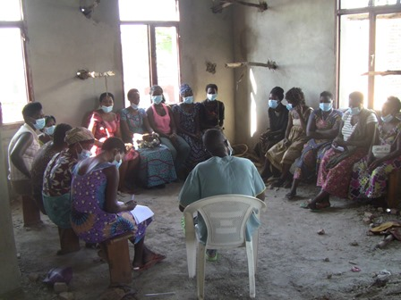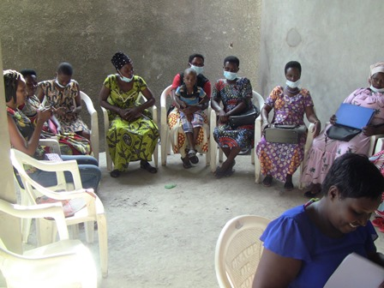
“My name is Jacqueline. I have three daughters. They are 17, 15 and 13 years old. When I heard that we have sessions on sexual and reproductive health (SRH), I invited all of them to be part of the SHGs so that they can benefit from the training sessions. Indeed, we mothers are often afraid to discuss with our daughters about SRH. I brought them so that they cannot have unwanted pregnancies. I would invite other mothers to encourage their daughters at Ntaseka clinic.”

Rape Survivors’ Support (RSS)
In the month of May 2021, Self-Help Groups (SHGs) have continued to meet once a week in Kamenge and 10 SHGs were created in Nyabiraba. At the end of May 2021, we had a total of 135 SHGs in Kamenge, Bujumbura Mairie province for a total of 3188 women and 25 SHGs for 613 women in Nyabiraba commune, Bujumbura province.
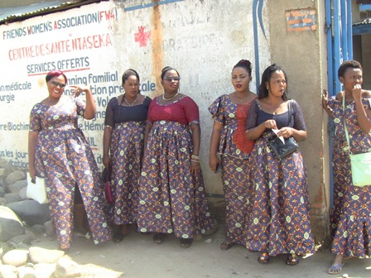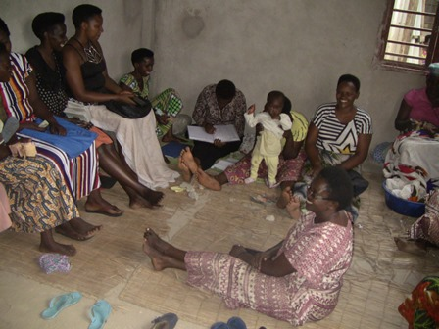
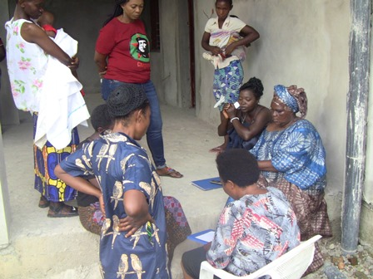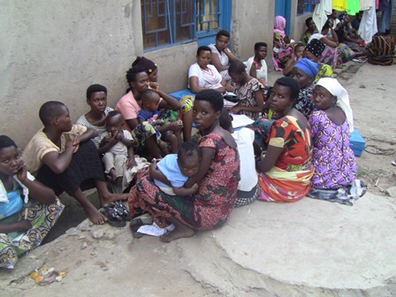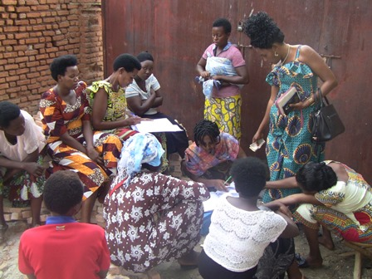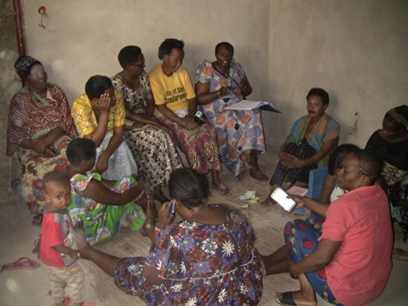
“My name is Aline. I was living a very difficult life. I was always asking for money from my husband in order to feed my children. He often gave me his money with insults telling me that I’m nothing. The, I decided to ask for a small loan of BIF120, 000 from our SHG. When they gave me the money, I started as mall restaurant. There I prepare rice, cassava leaves, meat beans and other. My daily benefit is between BIF12, 000 and BIF20,000. Every week, I’m able to pay back a small part of the loan I received. Our SHG has done very good things to me. I will never leave them”.
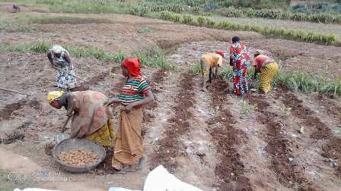
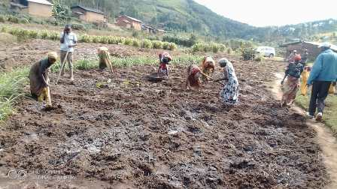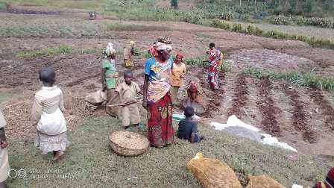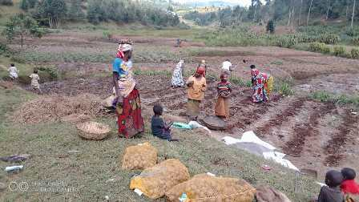
This is one SHG whose members are indigenous people. They have now planted potatoes
One trauma healing workshop was done on May 24-26, 2021.
“My mother was a sex worker. We were 6 children from different fathers. My father refused that I am his child and my mother threw us where she wants. She got married and took me with her because I was the smallest child. In their married life, there was no peace it was always quarrel. One day they threw hot coals on me. I wished to be dead.
One day I decide to leave mom because I have seen enough. I took refuge in Bujumbura to look for a job. I worked as a housekeeper; I became beautiful and the boys started flirting with me. This is how I had a child and his father refused to know him as his son because I and the man were from two different ethnic groups.
After this rejection then my life was to go from one house to another. One day I found a house that is under construction and I lived there. I got to know a man who married me but he had another wife. I suffered all kinds of violence; He was beating me for no reason. When he got home he was using his fingers in my sex to check that I had sex with another man. When he found it was very wet, he hit me. He put me under the chair, to beat me. It was so hard. He always told me that he will kill me. To this, it was added my sterility problem. I could not have a child with him; he always insults me because of that. After 6 years this man left me and I started my own life from zero. Now, live in peace although I still have financial issues”

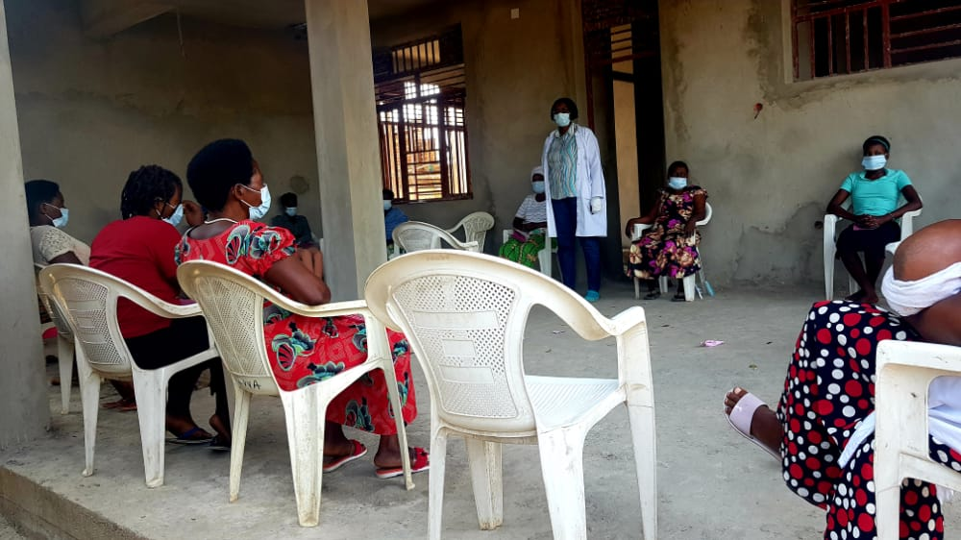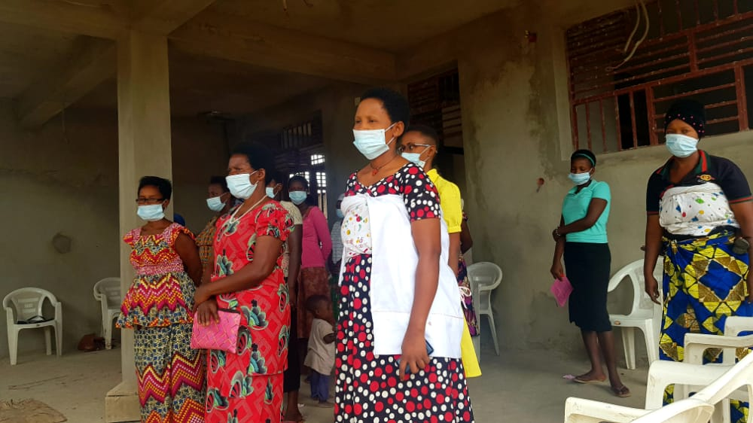

The growing rice project has continued. A total of 877kg from the first harvest in the month of February 2021 was now sold.
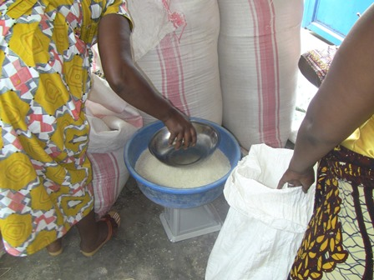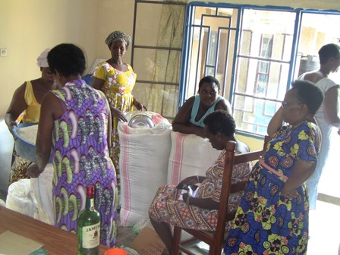

STREET BUSINESS SCHOOL (SBS)
On May 28, 2021 the third SBS cohort started. This year the SBS group is composed by 2 SHG. (JIMBERE and DUFATANEMUNDA B) In total of 42 members of the two SHG invited 39 women were presented in module I.
Module I is entitled “Getting out of your comfort zone” which prompts participants to Try something that is new and may be uncomfortable and scary.
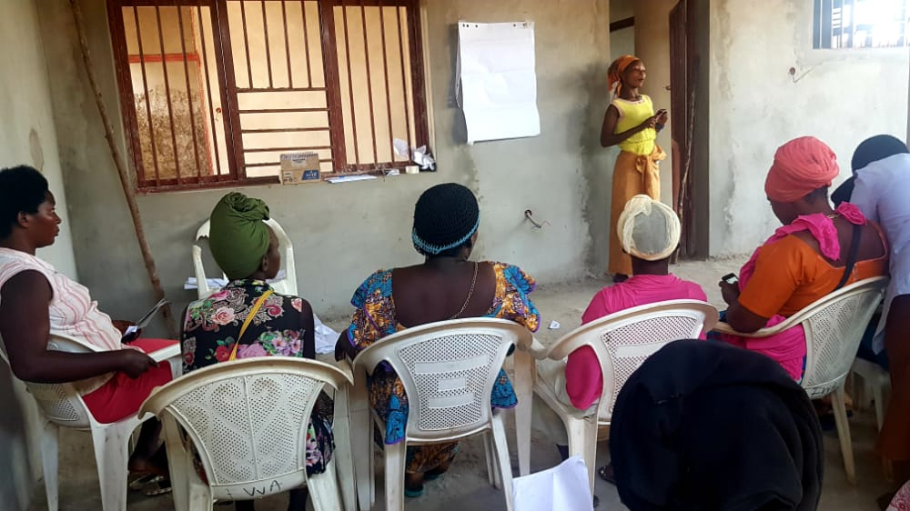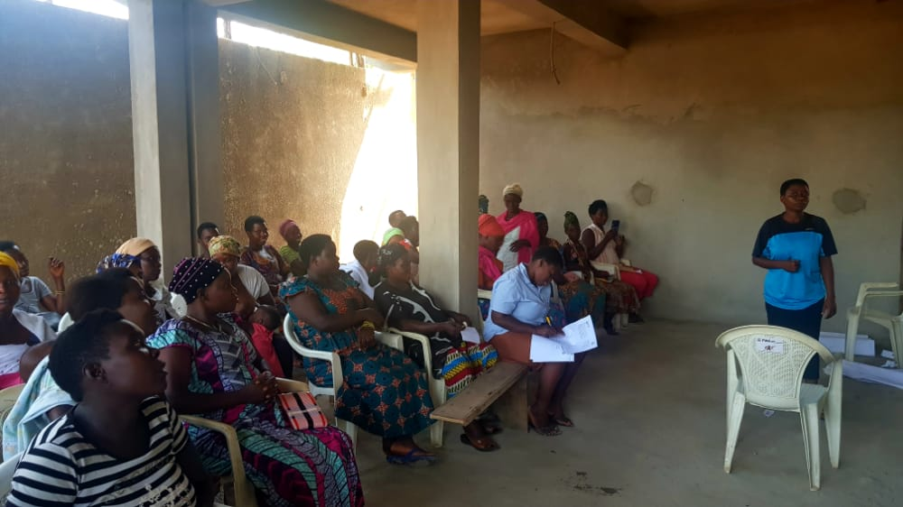
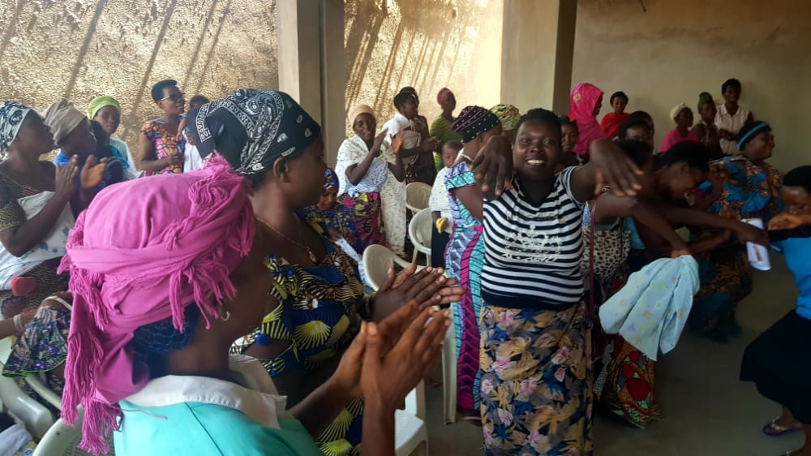

ACTION ON GENDER-BASED VIOLENCE (AGBV)
In the month of May 2021, there was contact of the local administration and identification of 20 GBV accompanists who will attend a three day retreat scheduled in the month of June 2021.

MEDICAL TEAM

CONSULTATIONS
Our medical doctors consulted with 115 cases, including 60 adults (25 men and 35 women), 22 children (15 boys and 7 girls), 22 HIV positive people and 11 pregnant women for ultrasound. The nurse received 207 patients including 144 adults and 63 children.

LABORATORY
In May 2021, apart from HIV voluntary testing, there were a total of 189 tests.

Test | Test completed | Positive | Negative
G.E.  Malaria test | 49 | 13 | 36
Quick malaria test | 32 | 10 | 22
ECBU  Urine test | 7 | 7 | 0
Selles  Stool test | 9 | 8 | 1
Pregnancy | 30 | 10 | 20
Sero-widal  Typhoïd fever | 30 | 12 | 18
Glycémie  Diabetes | 18 | 8 | 10
RPR VDRL  (Syphillis) | 1 | 0 | 1
Complete Blood Count | 3 | 1 | 2
Hepatite B | 2 | 0 | 2
Hepatite C | 0 | 0 | 0
Viral Load | 8 | 0 | 8
Total Tests: 189

FAMILY PLANNING
412 people received contraceptives from FWA’s nurse, including 240 old cases and 172 new ones. 286 received the contraceptive injection, 40 were given pills, 72 received male condoms, 1 received collar and 13 received implants

PRENATAL CONSULTATION (PNC)
In the month of May 2021, 45 women came for prenatal consultation (PNC), including 10 who came for PNC 1, 13 for PNC 2 and 13 for PNC 3 and 9 for PNC 4.
11 pregnant women came for the ultrasound test.

ANTI-RETROVIRAL SITE
At the end of May 2021, we had 330 patients under retro drugs followed at NTASEKA clinic, including 267 women and 63 men.

PHARMACY
Regarding medications, FWA was able to purchase the minimum needed medicine.

PSYCHOSOCIAL TEAM
In the month of May 2021, a total of 63 people received pre and post HIV test counselling and were tested for HIV. Out of the total number, 68% were women and 1 woman out of the 2 people detected HIV positive with 3% of seropositivity.
Total Number of People Tested: | 63
Total Number of Women Tested: | 43
% of People Tested Who Are Women: | 68%
Average Age: | 29
Median Age: | 28
Total HIV+ : | 2
Total HIV- : | 61
Number of Women HIV+ : | 1
Total % Seropositivity: | 3%
% of Women Tested Who Are HIV+: | 2%

