Friends Women’s Association

MARCH 2024 Report

Table of Content
Friends Women’s Association 1
MARCH 2024 Report 1
ACTIVITIES 6
Caring for HIV Positive People (CHIVPP) 6
Improving Women’s Reproductive Health (IWRH) 9
Rape Survivors’ Support (RSS) 9
MEDICAL TEAM 12
CONSULTATIONS 15
LABORATORY 15
FAMILY PLANNING 16
PRENATAL CONSULTATION (PNC) 16
ANTI-RETROVIRAL SITE 16
PHARMACY 16
PSYCHOSOCIAL TEAM 17

INTERNATIONAL MEETINGS
Marie Claire Kamugisha, the Ntaseka clinic chief nurse came back from the HROC global training in Gisanze/Rwanda on March 12, 2024. She is now a new HROC facilitator.
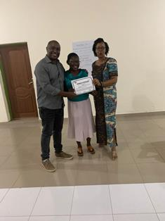
Graduation day: From left to right: Peter Serete, Marie Claire Kamugisha, Solange Maniraguha
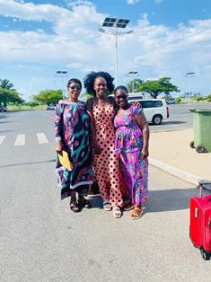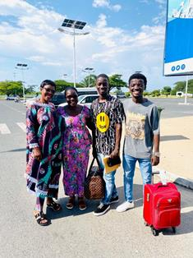
Marie Claire Kamugisha together with two from FWA staff and his two sons at Ndadaye Melchior international airport

The FWA coordinator attended the Friends World Committee for Consultation Africa Section (FWCC-AS) executive committee meeting at Saint Augustine Center in Kampala/Uganda on 23&24/03/2024
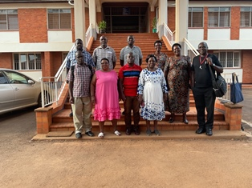
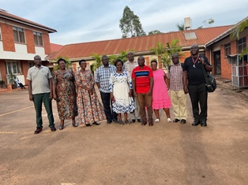
She then attended a three-day retreat to develop the Quaker Peace Network Africa five-year strategic plan in one of the Kibimba hospital Guests’ houses in Gitega province in Burundi. This retreat was supported by both Quaker Service Norway the Friends World Committee for Consultation Africa Section (FWCC-AS) and FWCC World Office.
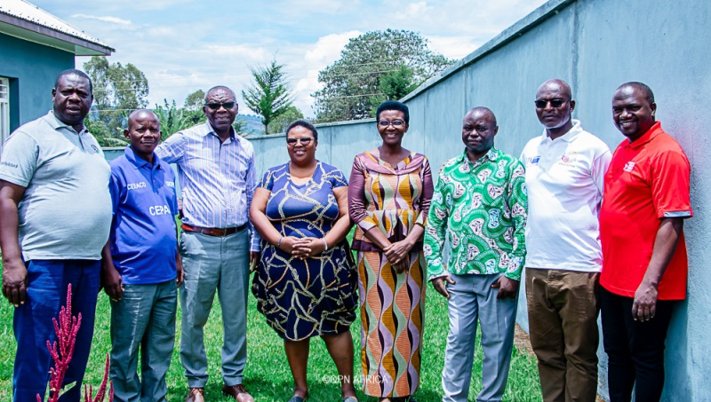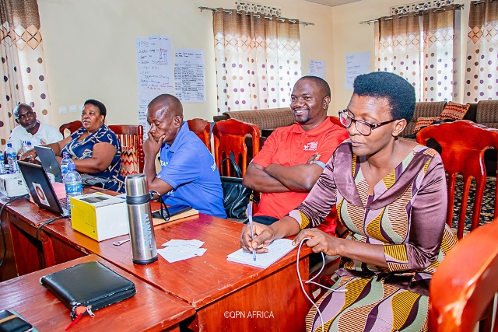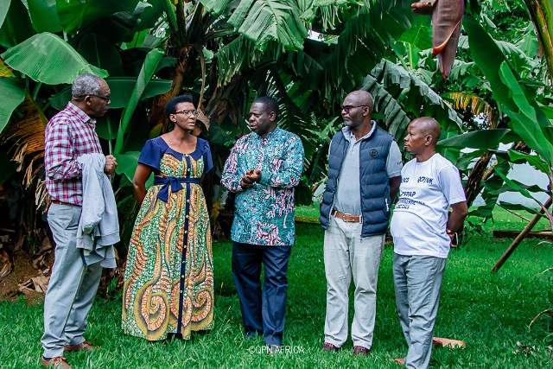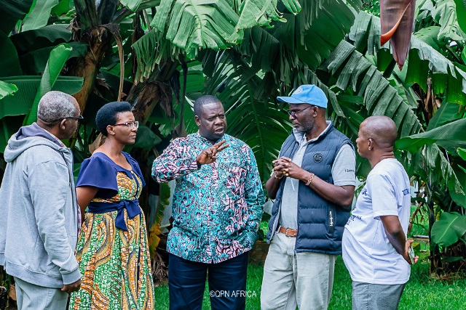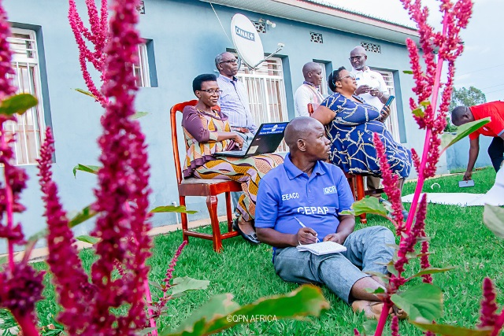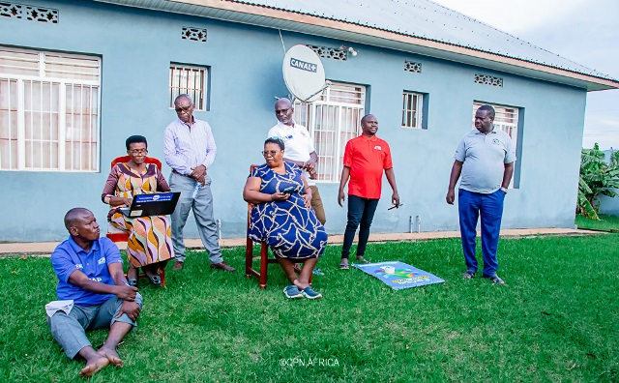

THE WOMEN’S INTERNATIONAL DAY
The FWA was represented at the national celebration of the women’s International day on March 8, 2024 in Gitega province
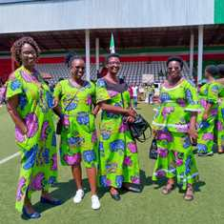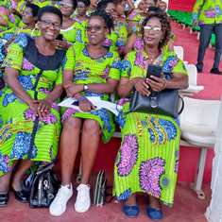
Then the FWA celebrated the Women’s International day on March 22, 2024. We shared food at Ntaseka clinic and then went together to relax at one of the Tanganyika Lake Beachs
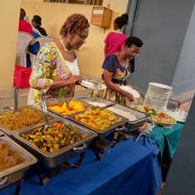
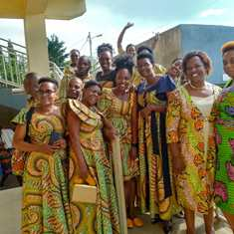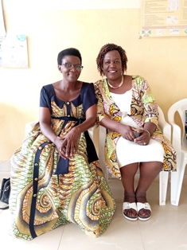

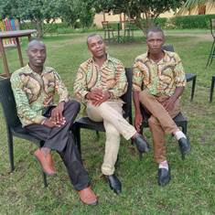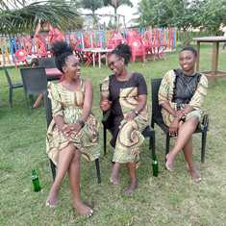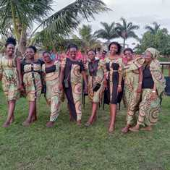
On March 29, 2024, the FWA joined Bujumbura province in Nyabiraba commune where they celebrated the Women’s International Day
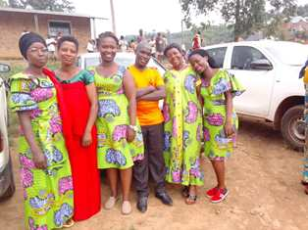
ACTIVITIES

Caring for HIV Positive People (CHIVPP)
In the month of March, medical follow-up and home visits were done for our HIV positive people.
Rice and beans were given to our HIV positive beneficiaries as nutritional support
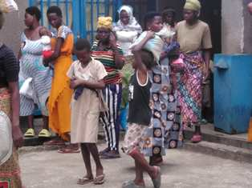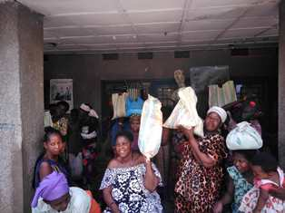
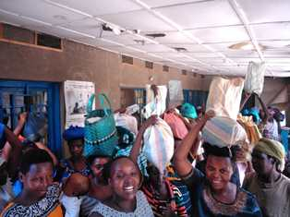
Maternity Ward Building
Although Ntaseka maternity ward still needs some medical equipment; both the delivery and the hospitalization services are currently functional.
In the month of March, there was a workshop on prenatal examinations and risk factors for pregnancy.
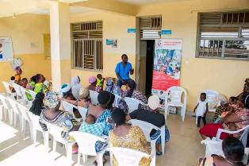
The Society for Women Against AIDS in Africa (SWAA) Burundi organized a post-training follow up at Ntaseka clinic on March 25, 2024. Participants were medical staff. These included those who are doing pre and post counselling for those who come to get tested to know their HIV status, those working for the prevention of HIV transmission from mother to child, the prenatal consultation service, the maternity service and the family planning services. They received coaching on the provision of first-line support and minimum care post-violence.
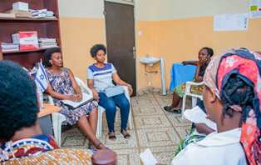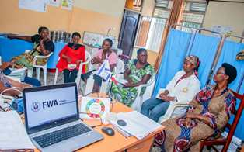
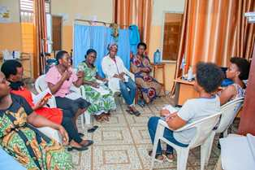

Improving Women’s Reproductive Health (IWRH)
FWA community health workers and FWA staff have continued to educate men, women and young people on the importance of birth control​

Rape Survivors’ Support (RSS)
In the month of March, the Rape Survivors Support program had different activities: the supervision of Self-Help Groups (SHGs) evaluation, the Street Business School and a three-day HROC workshop.
- Evaluation of SHGS
As the table shows, in the month March 5 SHGs made a sharing and the result are as follows;
No | About sharing | Number of SHG | Total
1 | Total money saved | 5 | 8,675,500
2 | Total Credit granted | 5 | 9,530,000
3 | Total interest | 5 | 5,100,000
4 | People who didn’t paid | 5 | 2
5 | Total money not refunded | 5 | 153,400

Classification of SHG
After evaluation it was found that;
Active | Less Active | Sick | Total
5 | 0 | 0 | 5

- SBS
In the mouth of Mach 4modules were developed (Module 5, 6, 7, and 8):
- Market Research witch is the process of gathering and analyzing information about a market in which products and/or services will be offered for sale. Participants were able to understand what we consider when doing market research and reasons why it is important to conduct market research for a business.

- Business Planning which defined as a thoughtfully considered outline regarding how a business is going to be established and operated. This module is designed to learn reasons to develop a business plan and components of a business plan.

- Growing Your Customer Base which is materials or outreach created to draw buyers ‘attention to goods and services. Participants understood ways to grow customer base through promotions, examples of good customer care and benefits of good customer service.
- Money Management: we lean concepts of money management, approaches to saving, reasons you should plan and budget, solutions for unexpected costs that may arise for a business.

- HROC Workshop ( March, 4-6 and 7-9)

In the month of March two workshops on trauma healing were organized at EEA Ruvumvu in Bubanza province for Victims of GBV

Stories

“My name is Cecile; I grew up in my uncle family because I am an orphan. I used to work very hard on vacation to pay my school fees because I like to study more than anything. One day, the wife of my uncle sent me to another family to help them with housework.
The father of this family began to sympathize with me. When I went back to school (I studied at a boarding school), this man bought me everything I needed for school. I thought it is a reward for working in their house but he was looking for sex. This man continued to visit me at the boarding school. He brought me money and other things that a girl needs.
When I came back home from school, he used to tell me that he was waiting for me in Bujumbura. (I was studying in Kivoga) and took the hotel where we spent a night with him. He is the one who took my virginity. I kept all this in my heart and it pained me very much. I had no one to advise me I did it so I could study. He made sure I didn't get pregnant.
When I was in my final year, he got me pregnant and he did it so that I wouldn't finish my studies. He rented a house for me in Bujumbura in Kinama. I had the pain of not finishing my studies but also regretting having taken the man of another woman. I had the feeling of shame and of hating myself .I used to stay in the house so that no one who knew me would see me. He was trying everything to make me happy in vain.
When I gave birth, he told me that he is not the Father because I gave birth a week before the date the nurse said. Because of this, He abandoned me and turned off his phone. I went through a lot of sufferings. I remember I passed two days without eating even though I had just given birth.
From that day, he came whenever he wanted; if he wanted he would give me money. One day I made the decision to no longer depend on him. I took everything that was in the house and sold it to have a small capital for a business. Until now 5 years ago, I no longer want to see him I live with my child I no longer want a man.
I thank you for inviting me, it’s difficult and it takes courage to say such things in front of other women who suffer of polygamy; I am one of the women who caused violence to another woman. I am feeling good because my burden goes away by telling my story”.

“I married a soldier. After one year, he went on a mission abroad. When he returned, I learned that he had another wife in Bujumbura. One day he told me that he was coming to the house with a visitor. I got ready to welcome them but I was disappointed to find that e was coming with his second wife. I calmed down, I gave them something to eat and we slept on the same bed. I was like I am watching a movie. I couldn't understand what happened to me. Then they returned to Bujumbura.
Life forced them to come and live in Bubanza. They rented a house but they didn't have enough to eat, so they came to harvest what they didn’t sown. When I saw this I harvested everything that was left in my field.
He refused to give me the money and I complained to his boss. This is how his boss divided his salary in two so that I can receive half of his salary. After this, He wanted to kill me. He threw a machete at me but it couldn't reach me. He beat me until the authorities came and he told the administrator that he will cut me into pieces. And the administrator advised me to flee the house. When I left the house they came to live in. It was the police who intervened so that they can leave the house. But I couldn't find peace; I had endless headaches because I couldn't sleep because of the fear. I spent the night changing room to room because I feared of being killed by my husband.
This is how we were divorced. Today I live with my children in my house and we benefit a part of his salary. I am traumatized by what my husband did to me; I often have nightmares at night, I often find myself talking to myself and other signs of the trauma that have been cited here”.

ACTION ON GENDER-BASED VIOLENCE (AGBV)
In the month of March, in the context of the project "Connecting the Global to the Local: Strengthening Women's Leadership for the Localization of the United Nations Security Council Resolution 1325 (2000) on "Women, Peace and Security", seven psychologists and 132 psychologists’ assistants have been receiving gender-based violence survivors for both listening and counselling. There was support of 12 small projects in Cibitoke, bubanza and Makamba provinces. The projects have been initiated by women’s groups whose members are GBV survivors.
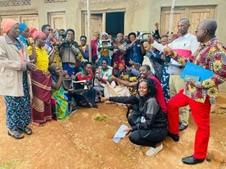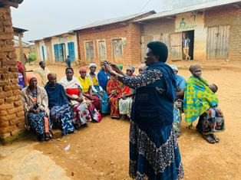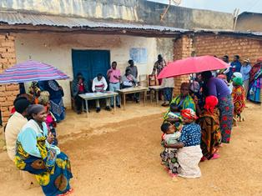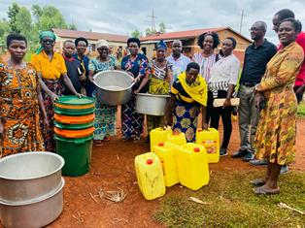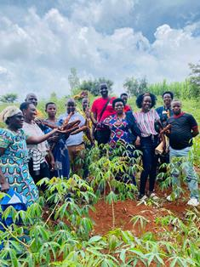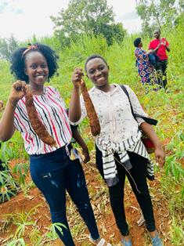
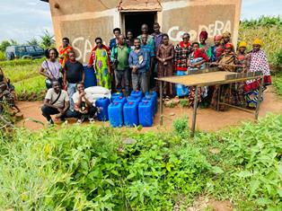

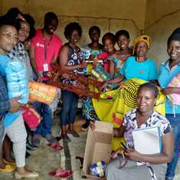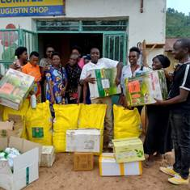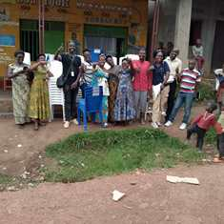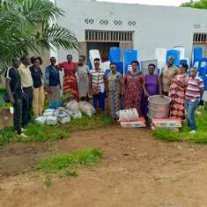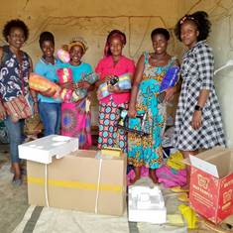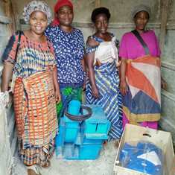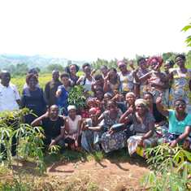
Purchase of a plot of land where COFACOF, a women’s group from Rugombo in Cibitoke province will grow mangoes. The project is about the production and selling of fruits.

MEDICAL TEAM

CONSULTATIONS
Our medical doctors consulted with 151 cases, including 51 adults (19 men and 32 women), 11 children (2 boys and 9 girls), 36 HIV positive people and 53 pregnant women for ultrasound. The nurse received 207 patients including 147 adults and 60 children.

LABORATORY
In the month of March, apart from HIV voluntary testing, there were a total of 323 tests.

Test | Test completed | Positive | Negative
G.E.  Malaria test | 55 | 20 | 35
Quick malaria test | 28 | 13 | 15
ECBU  Urine test | 29 | 21 | 8
Selles  Stool test | 12 | 12 | 0
Pregnancy | 46 | 4 | 42
Sero-widal  Typhoïd fever | 60 | 25 | 35
Glycémie  Diabetes | 13 | 6 | 7
RPR VDRL  (Syphilis) | 22 | 1 | 21
Complete Blood Count | 34 | 12 | 22
Hepatitis B | 13 | 1 | 12
Hepatitis C | 11 | 1 | 10
Viral Load | 0 | 0 | 0
Total Tests: 323

FAMILY PLANNING
443 people received contraceptives from FWA’s nurse, including 315 old cases and 128 new ones. 372 received the contraceptive injection, 39 were given contraceptive pills, 10 received male condoms at Ntaseka clinic, 2 received UID and 20 received implants

PRENATAL CONSULTATION (PNC)
In March, 65 women came for prenatal consultation (PNC), including 20 who came for PNC 1, 19 for PNC 2, 17 for PNC 3 and 9 for PNC 4.
53 pregnant women came for the ultrasound test.

ANTI-RETROVIRAL SITE
At the end of March, we had 330 patients under retro drugs followed at NTASEKA clinic, including 267 women and 63 men.

PHARMACY
Regarding medications, FWA was able to purchase the minimum needed medicine.

PSYCHOSOCIAL TEAM
In the month of March, 66 people were tested for HIV and received pre and post HIV test counselling. All the three people detected HIV positive were women with 5% of seropositivity.
Total Number of People Tested: | 66
Total Number of Women Tested: | 59
% of People Tested Who Are Women: | 89%
Average Age: | 26
Median Age: | 26
Total HIV+ : | 3
Total HIV- : | 63
Number of Women HIV+ : | 3
Total % Seropositivity: | 5%
% of Women Tested Who Are HIV+: | 5%

