Friends Women’s Association

MARCH 2022 Report

Table of Contents
Friends Women’s Association 1
MARCH 2022 Report 1
ACTIVITIES 2
Caring for HIV Positive People (CHIVPP) 2
Improving Women’s Reproductive Health (IWRH) 3
Rape Survivors’ Support (RSS) 4
MEDICAL TEAM 9
CONSULTATIONS 9
LABORATORY 9
FAMILY PLANNING 10
PRENATAL CONSULTATION (PNC) 10
ANTI-RETROVIRAL SITE 10
PHARMACY 10
PSYCHOSOCIAL TEAM 10

COVID-19 AND NTASEKA CLINIC
In the month of March, Friends Women’s Association has continued to apply covid restrictions restrictions at Ntaseka Clinic for both the staff and the beneficiaries’ protection.
On March 8, 2022 FWA staff joined the world to celebrate the Women’s International Day.
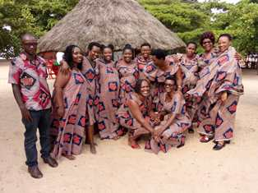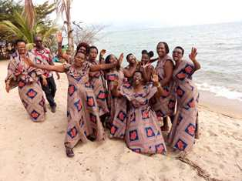
FWA staff together with the FWA legal representative at Spot 257 Beach, Tanganyika Lake

ACTIVITIES

Caring for HIV Positive People (CHIVPP)
In the month of March, medical follow-up and home visits were done for our HIV positive people.
Maternity Ward Building
In the month of March, under the support of the Global Giving Foundation, More work was done for the maternity ward completion. Windows’ glasses were put on the second floor under the support of the African Great Lakes Initiative (AGLI) of the Friends Peace Teams (FPT)
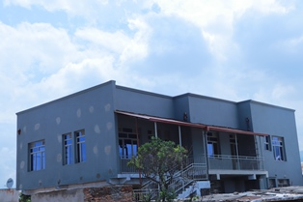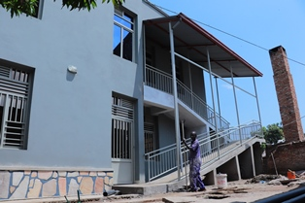

Improving Women’s Reproductive Health (IWRH)n
FWA community health workers and FWA staff have continued to educate men, women on the importance of birth control. One discussion groups was done for breastfeeding women under one year.

As of March 30, 2022, a discussion group of 20 other women who are breastfeeding children under one year old was organized to discuss sexual and reproductive health in general and family planning in particular for the follow-up of women/nursing mothers in family planning because postpartum is at the bottom with regard to birth control in Burundi

The Ntaseka clinic midwife Augustin HARUSHIMANA was the facilitator!

The discussion group began with a survey of participants regarding their lifestyle as women breastfeeding a child under one year old and the results were:

- All 20 participants are in FWA Self Help Groups

- 03/20 are legally married

- 17/20 are illegally married with many partners

- 8/20 do not know where their husbands are

- 20/20 are less than 27 years old

- 18/20 do not know their menstrual cycle

- 9/20 present have accepted and received the contraceptive methods of their choice

- 3/20 will speak with their husband to join family planning

- 19/20 were waiting for the diapers to return to ask for information on family planning

- 1/20 is already on PF

- 13/20 had sex with another man (not the author of the pregnancy) to earn enough to feed the baby in two weeks following delivery without protection or family planning, the earliest possible was a week and the later was 3 months after giving birth

We discussed sexual and reproductive health after childbirth and the sexual life of the couple after childbirth, and information related to free care and some necessary information on the Ntaseka Clinic services.

Testimony:

My name is Jeanne. I am 17 years old. I have a 7 month old child. His father disowned him. During the pregnancy, I lived with my family who kicked me out at 5 months of pregnancy. One of my best friends who is a boy asked my family to put me up. This was a way for my friend to often have sex with me until the delivery. After two weeks of giving birth, my friend lost his job and kicked me out because there was no way to continue taking care of me. When I returned to my parents, my mother decided to give me some capital for a small business. During the trade, I heard about the self-help groups (SHGs) at Ntaseka clinic. I joined one of the SHGs. Today my child is 7 months old. I left my parents to be independent with my child and it's been 5 months. My basic needs are somewhat satisfied. To stay safe because accidents can happen and get pregnant again without a husband, I decided to adhere to the long-acting contraceptive method Jadelle (Implant).

Rape Survivors’ Support (RSS)
In the month of March, the Rape Survivors Support program had different activities: one trauma healing workshop for GBV survivors on March 29-31 (Faciliatators were Grace Horanimana and Gisele Misago), the evaluation of Self-Help Groups (SHGs) and field visits for both the Growing Rice Project and the Growing Corns Project.
“I married a man and we were happy with our 2 boys. One day a friend of mine told me that my husband has another wife in the countryside. I was shocked by this bad news. I spent days in my room crying. I made research and I found that it was the reality. My husband whom I loved had another wife. When I asked him why he did that to me, he became naughty and he traumatized me with these words: "You were lucky to have me and you ask me that I have another wife; you are stupid like all women". Then he took my children and until now 17 years have passed I am not allowed to see my children.
I have an inexplicable sorrow I feel like I am a bad mother, I feel guilty and I spend sleepless nights thinking about my children. I don't know if they will accept me as their mother one day. I got remarried to another man but I couldn’t have child. I am a woman who does not know what joy is. Thank you for inviting me to this workshop, I feel relieved because of the subject discussed and advice.”
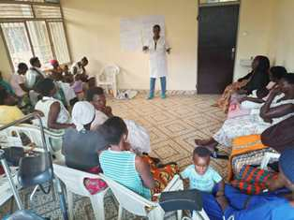

Evaluation of SHGs
No | Description | Number of SHG | Total
1 | Total money saved | 7 | 18,639,050
2 | Total Credit granted | 7 | 24,717,200
3 | Total interest | 7 | 12,992,400
4 | People who didn’t paid | 7 | 25
5 | Total money not refunded | 7 | 2,147,200
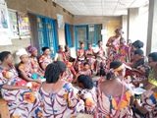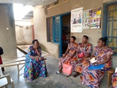
Time for one SHG evaluation
As the table above shows, in the month of March 7 SHGs made a sharing and the results are as follows;
- Savings made by the 4 SHGs were: 18,639,050 BIF
- Credits granted by the 4 SHGs were: 24,717,200 BIF
- Interest generated by 4 SHGs credits : 12,992,400 BIF
- People who have not paid back : 25
- Total money not refunded : 2,147,200 BIF

Classification of SHG
Active | Less Active | Sick | Total
5 | 1 | 1 | 7
After evaluation it was found that 5 SHGs are active, 1 SHG is less active and 1SHG is sick.
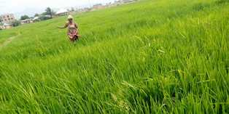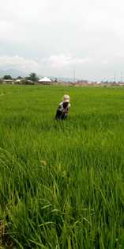
The Growing Rice Project in Bujumbura Mairie province

ACTION ON GENDER-BASED VIOLENCE (AGBV)
On March 25, 2022, the FWA took advantage of the Women’s International day to hand over officially the 19 houses (covered by iron sheets in the month of December 2021 under the support of national solidarity, social affairs, human rights and gender) to 19 indigenous families.

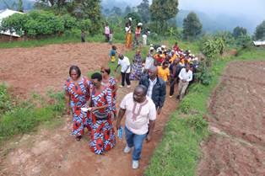
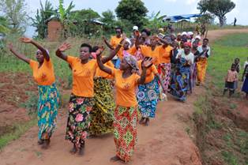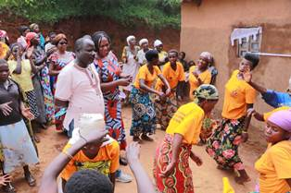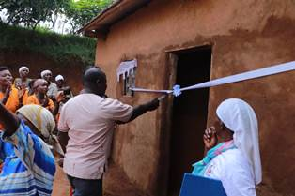
The General Director in the Ministry of National Solidarity cutting the ribbon to hand over the 19 houses to 19 indigenous families
In the month of March, FWA has continued to implement the project sponsored by the United Nations Peace Building Fund "Connecting the Global to the Local: Strengthening Women's Leadership for the Localization of the United Nations Security Council Resolution 1325 (2000) on "Women, Peace and Security". During the month of March we carried out field visits in the provinces of Bubanza, Bujumbura, Cibitoke and Makamba. The objective was to identify IGRs that we can support. A questionnaire was elaborated on a total of 60 points. Then, we organized field visits to visit the first two IGRs per commne in order to support at least one IGR per commune.
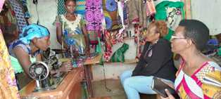
Visite d’une IGR a Kayogoro, commune Mabanda
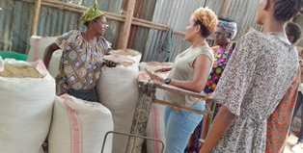
IGR TURI BAMWE BAKENYEZI in Gihanga, Bubanza Province

MEDICAL TEAM

CONSULTATIONS
Our medical doctor consulted with 79 cases, including 20 adults (9 men and 11women), 7 children (5 boys and 2 girls), 21 HIV positive people and 31 pregnant women for ultrasound. The nurse received 267 patients including 194 adults and 73 children.

LABORATORY
In the month of March, apart from HIV voluntary testing, there were a total of 299 tests.
Test | Test completed | Positive | Negative
G.E.  Malaria test | 74 | 43 | 31
Quick malaria test | 77 | 28 | 49
ECBU  Urine test | 13 | 7 | 6
Selles  Stool test | 14 | 3 | 11
Pregnancy | 47 | 14 | 33
Sero-widal  Typhoïd fever | 25 | 10 | 15
Glycémie  Diabetes | 5 | 3 | 2
RPR VDRL  (Syphilis) | 24 | 0 | 24
Complete Blood Count | 14 | 6 | 8
Hepatitis B | 2 | 0 | 2
Hepatitis C | 1 | 0 | 1
Viral Load | 3 | 0 | 3
Total Tests: 299

FAMILY PLANNING
570 people received contraceptives from FWA’s nurse, including 201 old cases and 369 new ones. 306 received the contraceptive injection, 124 were given contraceptive pills, 127 received male condoms, and 13 received implants.

PRENATAL CONSULTATION (PNC)
In March, 60 women came for prenatal consultation (PNC), including 24 who came for PNC 1, 15 for PNC 2, 15 for PNC 3 and 6 for PNC 4.
31 pregnant women came for the ultrasound test.

ANTI-RETROVIRAL SITE
At the end of March, we had 330 patients under retro drugs followed at NTASEKA clinic, including 267 women and 63 men.

PHARMACY
Regarding medications, FWA was able to purchase the minimum needed medicine.

PSYCHOSOCIAL TEAM
In the month of March, 82 people were tested for HIV and received pre and post HIV test counselling. Out of the four people detected HIV positive, three were women with 5% of seropositivity.
Total Number of People Tested: | 82
Total Number of Women Tested: | 71
% of People Tested Who Are Women: | 87%
Average Age: | 29
Median Age: | 27.5
Total HIV+ : | 4
Total HIV- : | 78
Number of Women HIV+ : | 3
Total % Seropositivity: | 5%
% of Women Tested Who Are HIV+: | 4%

