Friends Women’s Association

JULY 2023 Report

Table of Contents
Friends Women’s Association 1
JULy 2023 Report 1
ACTIVITIES 2
Caring for HIV Positive People (CHIVPP) 2
Improving Women’s Reproductive Health (IWRH) 2
Rape Survivors’ Support (RSS) 2
MEDICAL TEAM 7
CONSULTATIONS 9
LABORATORY 9
FAMILY PLANNING 9
PRENATAL CONSULTATION (PNC) 9
ANTI-RETROVIRAL SITE 10
PHARMACY 10
PSYCHOSOCIAL TEAM 10

COVID-19 AND NTASEKA CLINIC
In the month of July 2023, Friends Women’s Association has continued to apply covid restrictions at Ntaseka Clinic for both the staff and the beneficiaries’ protection.

ACTIVITIES

Caring for HIV Positive People (CHIVPP)
In the month of July, medical follow-up and home visits were done for our HIV positive people.
Nutritional support was given to Ntaseka clinic HIV positive beneficiaries.
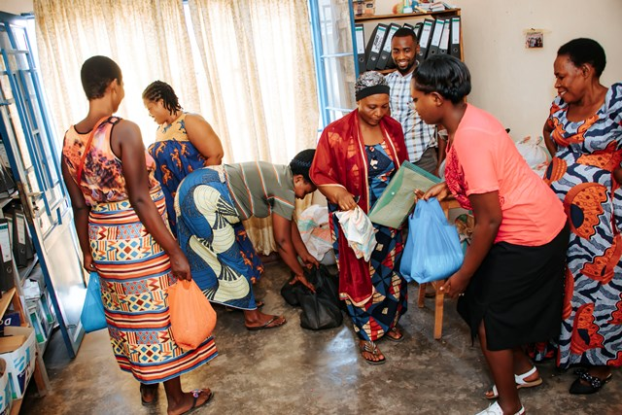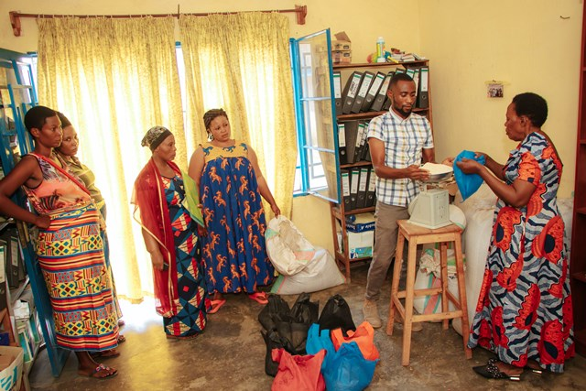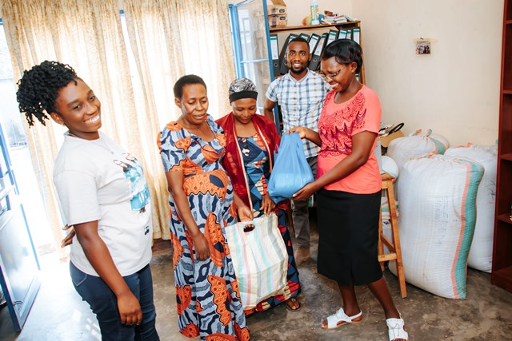
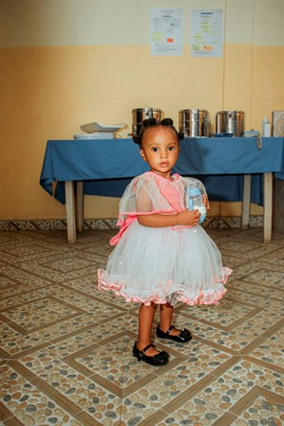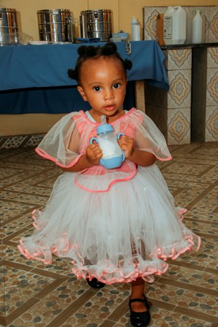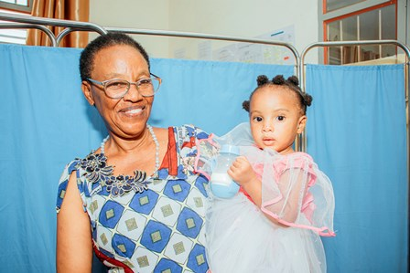
Ciella was born from an HIV positive mother, she was suffering from malnutrition. Under the support of Red Cross Burundi, FWA was able to give milk to her. Esperance, one of the FWA health mediators, took the initiative to raise her from her own home

Maternity Ward Building
Although Ntaseka maternity ward still needs some medical equipment; both the delivery and the hospitalization services are currently functional.

Improving Women’s Reproductive Health (IWRH)
FWA community health workers and FWA staff have continued to educate men, women and young people on the importance of birth control.
As of July 31, 2023, a discussion group of 20 women of childbearing age, members of the FWA SHGs,, was organized to discuss sexual and reproductive health in general and postpartum family planning in particular in improving family health and sexual health dialogues in the community
The NTASEKA clinic Midwife Augustin HARUSHIMANA and Doctor Marie Salomé CISHAHAYO were Facilitators.
The discussion group started with a survey of the participants regarding their lifestyle as women of childbearing age and the results were:
- All 20 participants are women members of FWA Self Help Groups
- 5/20 are legally married women
- 8/20 have children under one year old
- 12/20 do not know where their husbands are now
- 20/20 are between 17 and 38 years old
- 13/20 never discuss sexual health in the community
- 3/20 are illegally married
We discussed on sexual and reproductive health in the community which helped us to know how a woman who has given birth resumes her sexual life. This opened up the debate on postpartum planning. All said they were ashamed when they or their friends got pregnant before two years after giving birth.
Some necessary information on the services of Ntaseka Clinic for young people and the community in general has been shared by the facilitators
Testimonies :
My name is Diana. I'm 18 years old. I got pregnant from a biker who disappeared after finding out I was pregnant. After giving birth I waited to see my period. A man took care of me during this time and encouraged me to do the planning but I refused. We went eight months without sex. One day during conversations about postpartum sexuality with my neighborhood friends, they made fun of me saying that I don't know how to thank someone who supported me during my misery. I came here at Ntaseka clinic for counselling. The provider who welcomed me explained to me that it is not necessary to wait for menstruation after childbirth and I had the injection. Now I feel safe. I thank my friends and the Ntaseka providers who helped me to do family planning.
Dear women who are here, when you come to save your money in the self-help groups (SHGs), go to the offices of the providers to ask for all the advice on your health. It can save your life.

My name is Edith. I am 33 years old.
I have my friend who gave birth to eight children. She died after giving birth to her 8th baby. I was her companion and we were at Rugombo Hospital. It was a blow for me because since the 3rd child, I encouraged her to go to the family planning service as soon as possible after giving birth but she was lying me that she went there but fell pregnant before two years. In our conversations with others about sexuality, she shared that her beliefs and her husband did not allow her to use modern contraceptive methods. And the result was that she died on the delivery table because of blood pressure. Her blood pressure was caused by her husband because during the pregnancy, this same man impregnated 3 other girls and his wife lost her mind. Hence the hypertension on the 7 month pregnancy. We really suffered during these 2 months until we even came to Bujumbura for consultations with the Gynecologist but she ended up dying. I made the decision to inform all the girls and women I knew that every childbirth requires family planning and here at Ntaseka, they organize a lot of sessions on family planning. I want to participate in all these sessions to have a lot of information to pass on to others. I have 3 children and I support them alone because my husband did not say goodbye to me. After he left, as a member of one self-help group, I started working hard to support my children. I haven't forgotten the long-acting contraceptive method, here in Kamenge no one knows where a man can come from who can even get you pregnant and leave without saying goodbye like it happened to me. Please consult medical personnel in time. It saves women's lives. Then, you fight with the other challenges with a peaceful heart
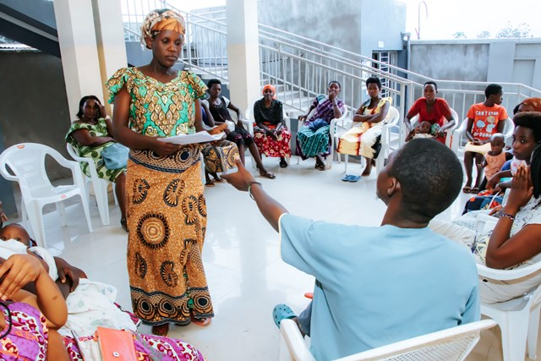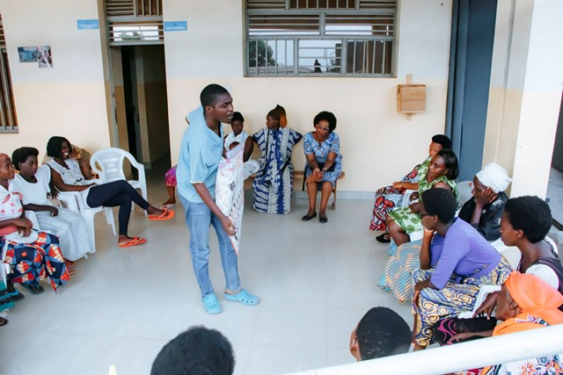
Recommendations
- Continue Conversation Sessions on Social Life and Sexual and Reproductive Health
- Focus on self-help groups
- Organize more than two discussion groups for young people and women per month to reach all the women members of the self-help groups
​

Rape Survivors’ Support (RSS)
In the month of July, the Rape Survivors Support program had different activities: the supervision of Self-Help Groups (SHGs) and one trauma healing workshop at Randa in Bubanza province. At the end of July 2023, we had a total of 159 SHGs in Kamenge, Bujumbura Mairie province for a total of 3763 women and 43 SHGs for 1063 women in Nyabiraba commune, Bujumbura province.
- SHGS
TOTAL SHGs
No | Name of SHG | Month of creation | Member Number | Created by

SHG Total Number: | 159+43=202
Evaluation
As the table shows, in the month July 1 SHG made a sharing and the result are as follows;
No | About sharing | Number of SHG | Total
1 | Total money saved | 1 | 6,270,700
2 | Total Credit granted | 1 | 6,626,500
3 | Total interest | 1 | 3,135,100
4 | People who didn’t paid | 1 | 2
5 | Total money not refunded | 1 | 109.000

Classification of SHG
After evaluation it was found that;
Active | Less Active | Sick | Total
1 | 0 | 0 | 1

- SBS
One training session on SBS was held where we discussed about Module 3; “Finding Capital and Starting Small “ Participant were able to understood ;What is capital, What 4 resources make up capital, What is good way to raise revenue for your business and What does “starting small” mean.
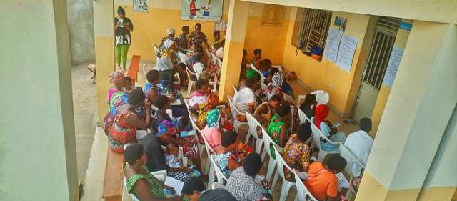
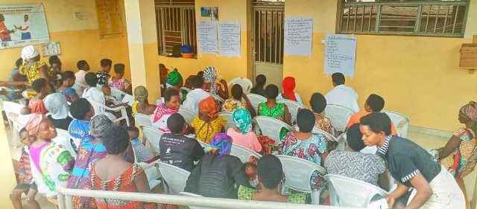

- HROC Workshop ( July 31- August 1)

In the month of July, one workshop was held in Randa Friends church in Bubanza province in the execution of the RSS project.
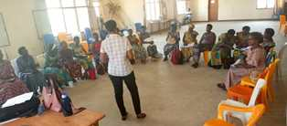
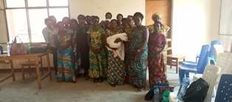

Testimony
I have suffered since my adolescence when my father wanted to rape me; that night my mother was not in the house because of conflicts between her and my father. My father came where I slept wanting to rape me and I fled outside. What traumatized me too much in this incident was seeing my father naked; He came out naked and beat me and my little sister. This affected me so much I could not tell this story to anyone.
When I got married, my husband told me clearly that He will going to have 3 children with me and that the 4th child will be from another woman. I mean, at the beginning of my marriage I already knew that He will have another wife.
After the 3rd child, I did family planning but it was too late because I was already pregnant. I have seen the worst with this pregnancy; if I told him that I felt bad, He used beat me legs up and head down. He didn't give me anything to eat. When I wanted to give birth I was afraid to tell him about it. By the grace of God I gave birth to a child with good health.
He hated my child. He never bought him clothes. When I told him to give me the money to take care of my children, He told me that He wished my children were dead.
He left me with nothing 2 years ago; He gave my plot to his second wife. Some of my children have dropped out of school because I am unable to pay for their education.
Thank you for giving us the opportunity to talk about what is cause us pain, for me this is the first time that I talk about what happened between me and my father I think my Dad is the source of my pain.
ACTION ON GENDER-BASED VIOLENCE (AGBV)
In the month of July 2023, in the context of the project "Connecting the Global to the Local: Strengthening Women's Leadership for the Localization of the United Nations Security Council Resolution 1325 (2000) on "Women, Peace and Security", seven psychologists and 132 psychologists’ assistants have been receiving gender-based violence survivors for both listening and counselling.
Seven refresher workshops on trauma healing were organized for 137 psychosocial assistants. One workshp was done per province. The seven provinces were Bubanza, Bujumbura, Bujumbura Mairie, Cibitoke, Gitega, Makamba and Rumonge. It was a good time to remember together what is trauma, its causes, its symptoms, its consequences and how we can recover from trauma. Psychosocial assistants had also a good opportunity to share the work they have been doing including success stories and challenges.
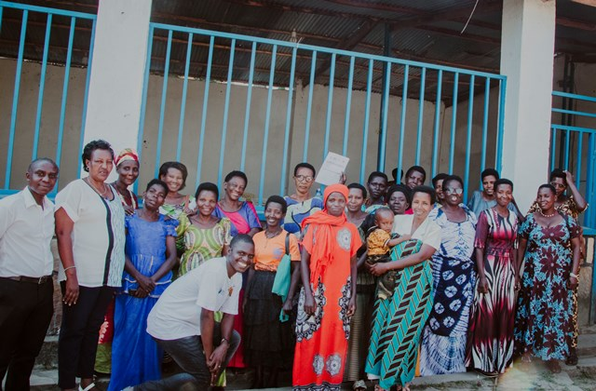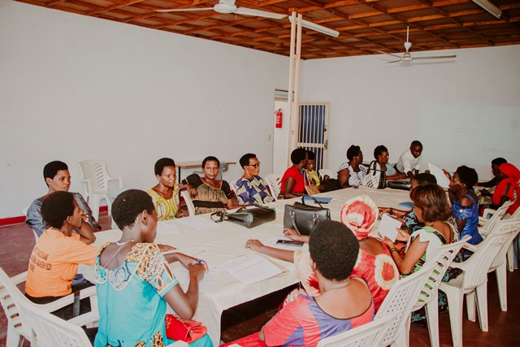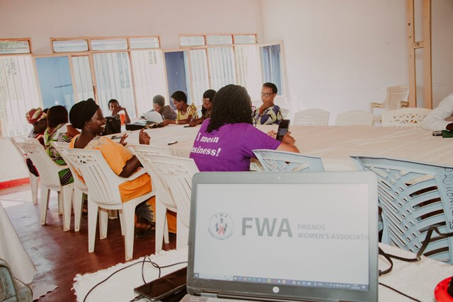
Refresher workshop in Rumonge province
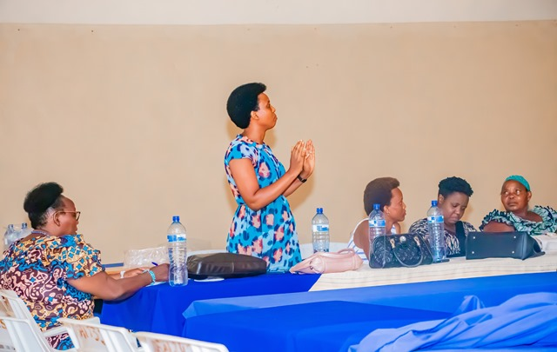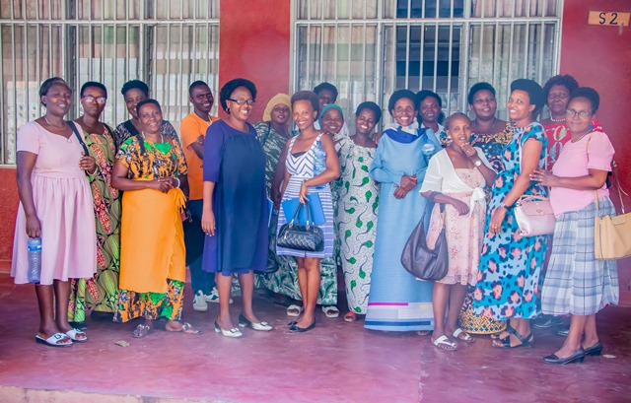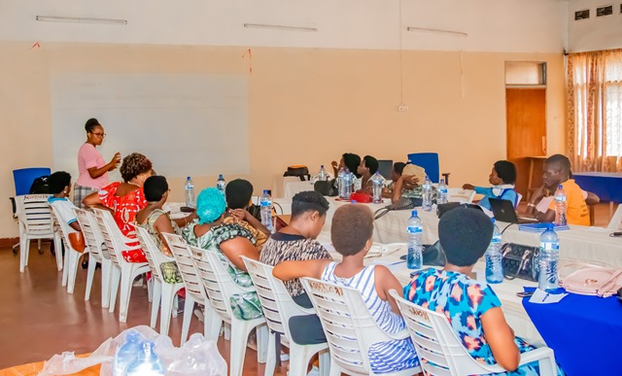
Refresher workshop in Bujumbura Mairie
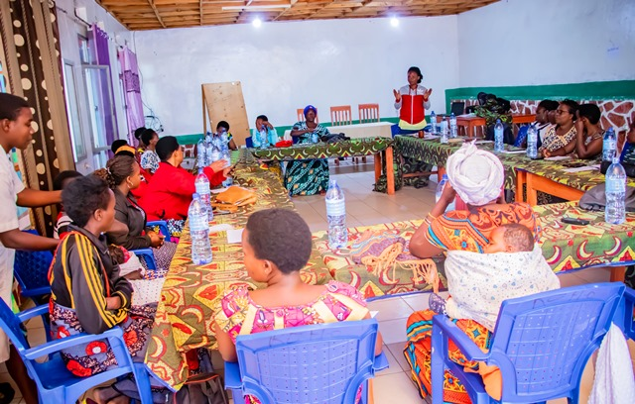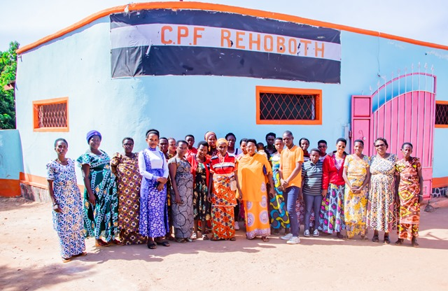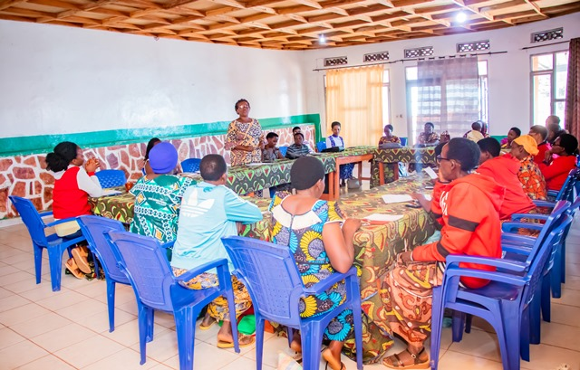
Refresher workshop in Gitega province
I have helped a family whose husband, who is the director of a secondary school. This director has impregnated some of his students and has been looking for young boys in the community to pretend they are the authors of the pregnancies. Each one was paid BIF5,000,000. We almost put in prison one young boy who claimed to have impregnated a young girl. He ended up telling the truth. The director's wife lived in the total mood of marriage and was unaware of her husband's deeds. She defended her husband without knowing the truth because she was well treated and respected as a wife in the home. When she discovered that all the family property had been granted in this way: the plots and their dwelling house, and that the husband had signed memorandums of understanding with the false authors of the pregnancies, the wife was traumatized. When the truth was revealed, the husband left home. For the moment, we have managed to help this woman by reminding them of the law which says that the property of the family must be sold after consent between both the husband and the wife.

MEDICAL TEAM

CONSULTATIONS
Our medical doctors consulted with 124 cases, including 44 adults (16 men and 28 women), 14 children (7 boys and 7 girls), 22 HIV positive people and 44 pregnant women for ultrasound. The nurse received 206 patients including 151 adults and 55 children.

LABORATORY
In the month of July, apart from HIV voluntary testing, there were a total of 246 tests.

Test | Test completed | Positive | Negative
G.E.  Malaria test | 40 | 16 | 24
Quick malaria test | 29 | 8 | 21
ECBU  Urine test | 17 | 15 | 2
Selles  Stool test | 18 | 15 | 3
Pregnancy | 33 | 7 | 26
Sero-widal  Typhoïd fever | 29 | 12 | 17
Glycémie  Diabetes | 15 | 6 | 9
RPR VDRL  (Syphilis) | 17 | 0 | 17
Complete Blood Count | 26 | 9 | 17
Hepatitis B | 3 | 0 | 3
Hepatitis C | 3 | 0 | 3
Viral Load | 16 | 2 | 14
Total Tests: 246

FAMILY PLANNING
487 people received contraceptives from FWA’s nurse, including 325 old cases and 162 new ones. 277 received the contraceptive injection, 114 were given contraceptive pills, 76 received male condoms, 3 received UID and 17 received implants.

PRENATAL CONSULTATION (PNC)
In July, 62 women came for prenatal consultation (PNC), including 18 who came for PNC 1, 23 for PNC 2, 10 for PNC 3 and 11 for PNC 4.
44 pregnant women came for the ultrasound test.

ANTI-RETROVIRAL SITE
At the end of July, we had 330 patients under retro drugs followed at NTASEKA clinic, including 267 women and 63 men.

PHARMACY
Regarding medications, FWA was able to purchase the minimum needed medicine.

PSYCHOSOCIAL TEAM
In the month of July, 85 people were tested for HIV and received pre and post HIV test counselling. Out of them, one woman was detected HIV positive with 1% of seropositivity.

Total Number of People Tested: | 85
Total Number of Women Tested: | 69
% of People Tested Who Are Women: | 81%
Average Age: | 28
Median Age: | 27
Total HIV+ : | 1
Total HIV- : | 84
Number of Women HIV+ : | 1
Total % Seropositivity: | 1%
% of Women Tested Who Are HIV+: | 1%

