Friends Women’s Association

JANUARY 2024 Report

Table of Content
Friends Women’s Association 1
JANUARY 2024 Report 1
ACTIVITIES 2
Caring for HIV Positive People (CHIVPP) 2
Improving Women’s Reproductive Health (IWRH) 2
Rape Survivors’ Support (RSS) 2
MEDICAL TEAM 5
CONSULTATIONS 11
LABORATORY 11
FAMILY PLANNING 11
PRENATAL CONSULTATION (PNC) 11
ANTI-RETROVIRAL SITE 12
PHARMACY 12
PSYCHOSOCIAL TEAM 12

ACTIVITIES

Caring for HIV Positive People (CHIVPP)
In the month of January, medical follow-up and home visits were done for our HIV positive people.
Maternity Ward Building
Although Ntaseka maternity ward still needs some medical equipment; both the delivery and the hospitalization services are currently functional.
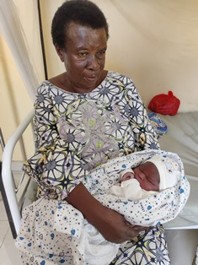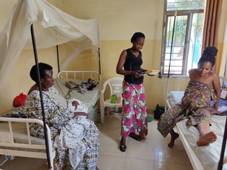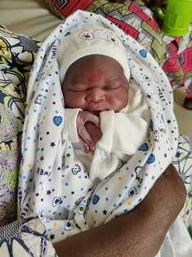

Improving Women’s Reproductive Health (IWRH)
FWA community health workers and FWA staff have continued to educate men, women and young people on the importance of birth control. ​

Rape Survivors’ Support (RSS)
In the month of January, the Rape Survivors Support program had different activities: the supervision of Self-Help Groups (SHGs). At the end of January, we had a total of 159 SHGs in Kamenge, Bujumbura Mairie province for a total of 3763 women and 43 SHGs for 1063 women in Nyabiraba commune, Bujumbura province. Unfortunately, these groups are progressively stopping to meet one a week because of the new law of the central Bank of Burundi.
- SHGS
TOTAL SHGs
No | Name of SHG | Month of creation | Member Number | Created by

SHG Total Number: | 159+43=202
Evaluation
As the table shows, in the month January 15 SHGs made a sharing and the result are as follows;
No | About sharing | Number of SHG | Total
1 | Total money saved | 15 | 20,663,400
2 | Total Credit granted | 15 | 15,730,900
3 | Total interest | 15 | 6,981,400
4 | People who didn’t paid | 15 | 3
5 | Total money not refunded | 15 | 231,400

Classification of SHG
After evaluation it was found that;
Active | Less Active | Sick | Total
12 | 1 | 2 | 15

Meeting with SHG leaders
Considering that more than 4/5 of the FWA SHGs no longer function because of the new law from the Central Bank of Burundi. Therefore, a meeting was organized by the FWA for the SHGs’ leaders with the aim of providing information on the requirements of the Bank of the Republic of Burundi.
After presenting the requirements of the Central Bank of Burundi, the SHGs leaders agreed to adhere to the new system and asked FWA to continue the process in order to restart activities as soon as possible.
- HROC Workshops ( January, 15-17 and 21-23)

In the month of January two workshops on trauma healing were organized at Ruvumvu in Bubanza province for Victims of GBV.

Stories

“My name is Pascasie. I spent 4 years without children in my marriage. I was living in hell because my husband and my in-laws mistreated me with hurtful words and my husband used to beat me whenever he wanted. I too was in pain because I didn't have a child like others. I blamed myself and I hated myself.
God gave me grace. I gave birth to twin girls. I thought my husband would be happy but the first word that came out of his mouth was the following; “this is worst” He said that because they are girls. He continued to beat me day and night.
I gave birth to the third daughter living in this situation. During the fourth pregnancy, I wanted to go to the hospital because I felt that the time of delivery was close. He told me:” This pregnancy is not mine because when I make a woman pregnant I know it and I feel it.” Then he beat me and I finally went to the hospital alone.
Until now I am traumatized; everything you said as signs of trauma touched me and I see myself with those signs. This training allowed me to discover myself as you said before you get better after knowing that you are sick”.

“I was in the 9th year of high school when my boyfriend impregnated me, and my family rejected me from their house. My boyfriend wanted to rent a house for me and give me capital for a small business but his mother suggested that I could go and live with her.
At my mother-in-law's house I saw the worst because she mistreated me; she gave me too much work, and she refused the people who lived in that house to work. I was the one person to do everything. She accused me of lies which made my husband no longer believe me; she made me sleep on the floor.
When I gave birth, we decided to live with my husband. I had the second child but my husband left me. He told me that he was going to Kenya but until now he hasn't sent me anything and it's really difficult to live for me and my two children. This pushes me to do actions that are not in my beliefs in order to survive. I sometimes have sex because a man gives me something to eat. I do it for my children but inside I feel guilty.
Thank you for organizing this workshop. I was able to talk about the things that I was hiding and that hurt me in my heart. I was encouraged by the testimonies of other women who were able to overcome the life of rejection and they choose to live. I come back full of hope believing that it will be well.”

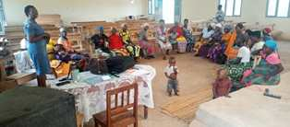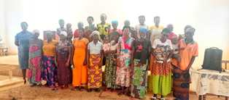
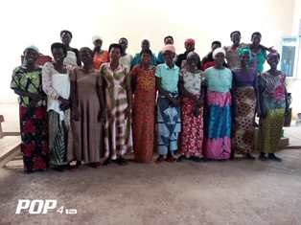
ACTION ON GENDER-BASED VIOLENCE (AGBV)
In the month of January, in the context of the project "Connecting the Global to the Local: Strengthening Women's Leadership for the Localization of the United Nations Security Council Resolution 1325 (2000) on "Women, Peace and Security", seven psychologists and 132 psychologists’ assistants have been receiving gender-based violence survivors for both listening and counselling. There were also field visits to introduce psychologists to the local authorities
Again in the month of January 2024, two groups of GBV survivors were supported to promote their economic autonomy. The first group from Gitega commune was given six goats. Two will share one goat. When it multiplies, each one of them will have one goat and the third one will be given to the FWA for the sustainability of this project. Sharing one goat as two GBV survivors is a way to keep in touch, sharing their stories and encouraging each other. This is the psycho-social aspect. On the other hand, it is a way to be economically independent as GBV survivors.
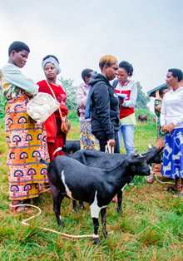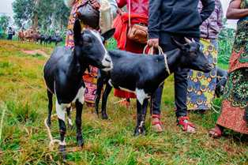
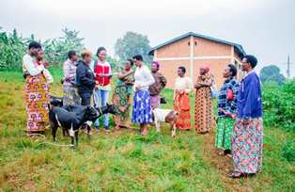
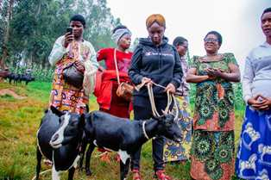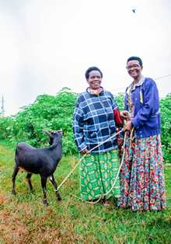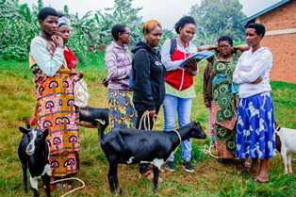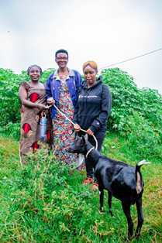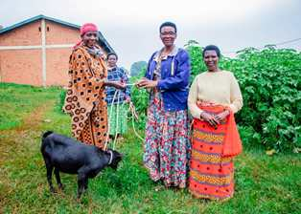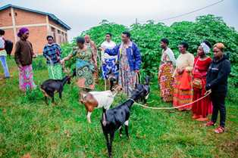
The second group from Kibimba was supported with three sewing machines, sewing threads, loincloths so that they can produce handmade warm clothes, tablecloths, loincloths bags. This will be a way to make money as a group of women. The main recommendation was that FWA supports them to do marketing of their products.
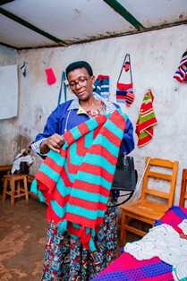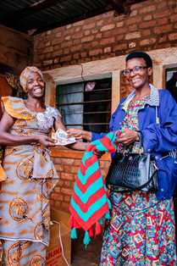
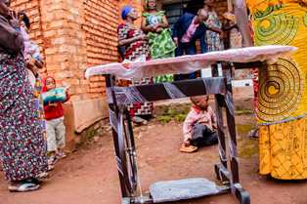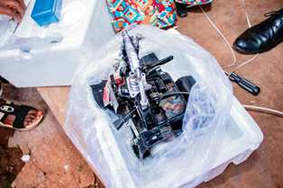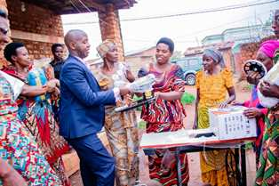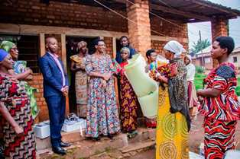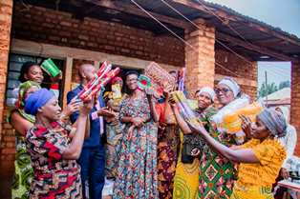
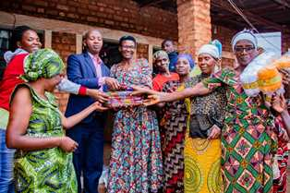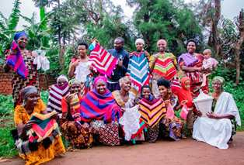

MEDICAL TEAM

CONSULTATIONS
Our medical doctors consulted with 141 cases, including 47 adults (17 men and 30 women), 12 children (4 boys and 8 girls), 28 HIV positive people and 54 pregnant women for ultrasound. The nurse received 241 patients including 165 adults and 76 children.

LABORATORY
In the month of January, apart from HIV voluntary testing, there were a total of 337 tests.

Test | Test completed | Positive | Negative
G.E.  Malaria test | 63 | 17 | 46
Quick malaria test | 50 | 26 | 24
ECBU  Urine test | 19 | 16 | 3
Selles  Stool test | 20 | 20 | 0
Pregnancy | 40 | 11 | 29
Sero-widal  Typhoïd fever | 48 | 20 | 28
Glycémie  Diabetes | 11 | 8 | 3
RPR VDRL  (Syphilis) | 37 | 0 | 37
Complete Blood Count | 40 | 14 | 26
Hepatitis B | 6 | 0 | 6
Hepatitis C | 3 | 0 | 3
Viral Load | 0 | 0 | 0
Total Tests: 337

FAMILY PLANNING
371 people received contraceptives from FWA’s nurse, including 240 old cases and 131 new ones. 280 received the contraceptive injection, 3 were given contraceptive pills, 65 received male condoms at Ntaseka clinic, 3 received UID and 20 received implants

PRENATAL CONSULTATION (PNC)
In January, 61 women came for prenatal consultation (PNC), including 31 who came for PNC 1, 15 for PNC 2, 6 for PNC 3 and 9 for PNC 4.
89 pregnant women came for the ultrasound test.

ANTI-RETROVIRAL SITE
At the end of January, we had 330 patients under retro drugs followed at NTASEKA clinic, including 267 women and 63 men.

PHARMACY
Regarding medications, FWA was able to purchase the minimum needed medicine.

PSYCHOSOCIAL TEAM
In the month of January, 95 people were tested for HIV and received pre and post HIV test counselling. Out of eight people who were detected HIV positive, six women were women with 8% of seropositivity.
Total Number of People Tested: | 95
Total Number of Women Tested: | 65
% of People Tested Who Are Women: | 68%
Average Age: | 29
Median Age: | 27
Total HIV+ : | 8
Total HIV- : | 87
Number of Women HIV+ : | 6
Total % Seropositivity: | 8%
% of Women Tested Who Are HIV+: | 9%

