Friends Women’s Association

JUNE 2022 Report

Table of Contents
Friends Women’s Association 1
JUNE 2022 Report 1
ACTIVITIES 2
Caring for HIV Positive People (CHIVPP) 2
Improving Women’s Reproductive Health (IWRH) 2
Rape Survivors’ Support (RSS) 2
MEDICAL TEAM 7
CONSULTATIONS 7
LABORATORY 7
FAMILY PLANNING 8
PRENATAL CONSULTATION (PNC) 8
ANTI-RETROVIRAL SITE 8
PHARMACY 8
PSYCHOSOCIAL TEAM 8

COVID-19 AND NTASEKA CLINIC
In the month of June, Friends Women’s Association has continued to apply covid restrictions restrictions at Ntaseka Clinic for both the staff and the beneficiaries’ protection.

ACTIVITIES

Caring for HIV Positive People (CHIVPP)
In the month of June, medical follow-up and home visits were done for our HIV positive people.

Improving Women’s Reproductive Health (IWRH)
FWA community health workers and FWA staff have continued to educate men, women and young people on the importance of birth control.
On June 26, 2022, a discussion group of 20 Young Women who are in the two committees of two young girls' self-help groups (SHGs) was organized. The theme was the choice of a spouse and career orientation. NTASEKA clinic Midwife Augustin HARUSHIMANA, and Doctor NIBONA Alexia were facilitators! The presentation of everyone focused on his career and his ambitions in life.
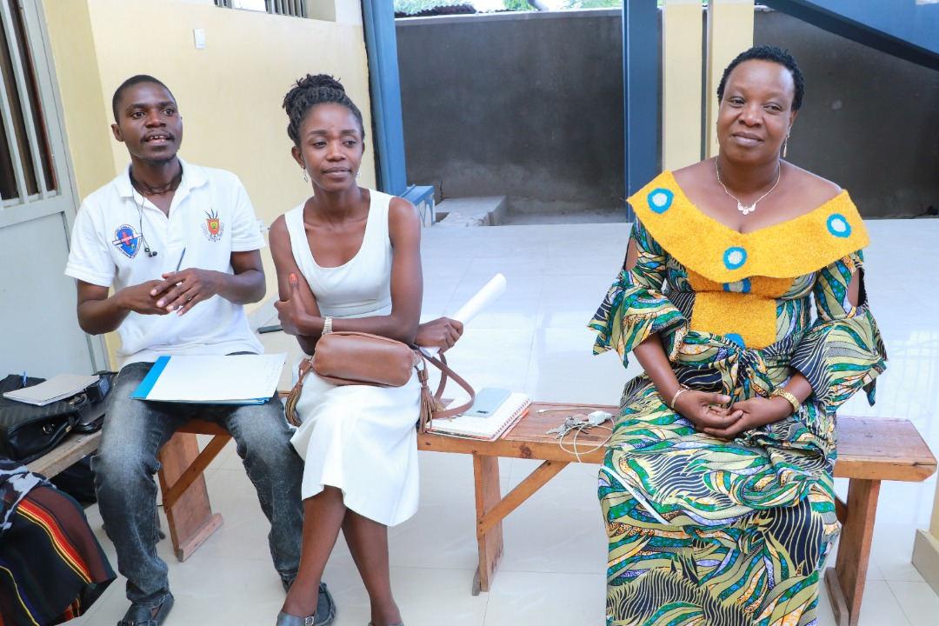
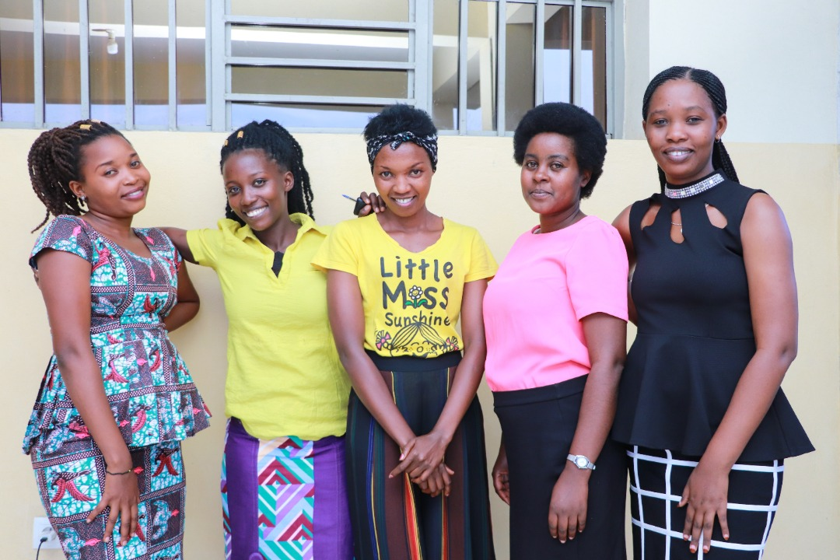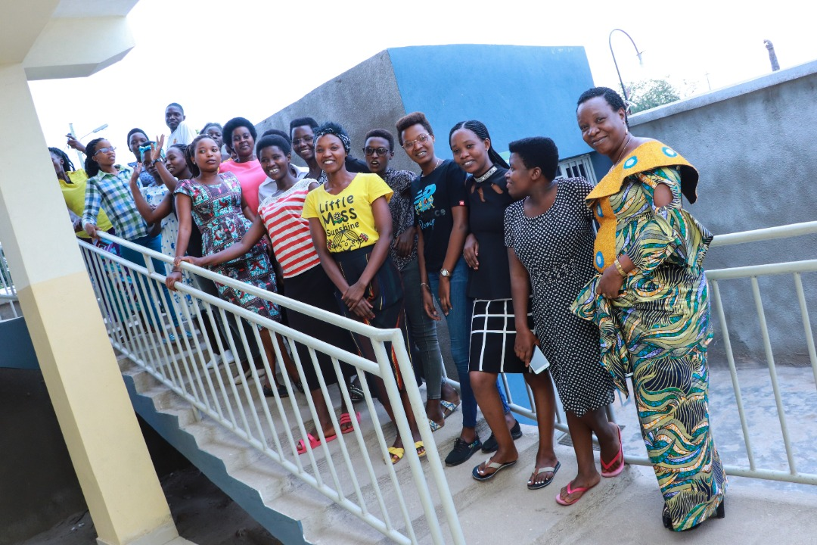

Augustin Harushimana shared his point of view on the choice of career. He insisted on our Burundian culture which does not facilitate the choice of career because there are careers which are more brilliant than others. He added that next to the academic career there must development of our own talents and personalities. Among the young girls who were present, more than 50% attend the sections or the faculties at different Universities that they did not choose. They have now tried to like what they study. As for Doctor Alexia, she shared her experience in her career. She then continued with the choice of a spouse. The theme took much time because the participants had lots of questions after Dr Alexia shared her testimony about how she met her spouse. At the end, she concluded by saying that the choice is personal, and that love matters for a successful marriage. She advised never tell yourself that a guy is in love with you while he never told you that. Actually, when you feel you are loved by someone, you will be disappointed when you will find out that you were wrong. In addition, Dr. Alexia insisted on the economic autonomy of a girl. She strongly appreciated and encouraged them for being part of the SHGs. Indeed, when a girl has money, she is independent and can decide what she can or cannot do.

The theme was not concluded. The recommendation was to start by the same theme in the month of July 2022.

Rape Survivors’ Support (RSS)
In the month of June, the Rape Survivors Support program had different activities: the supervision of Self-Help Groups (SHGs), one trauma healing workshop, and the Street Business School (SBS) fourth promotion first session. At the end of June 2022, we had a total of 152 SHGs in Kamenge, Bujumbura Mairie province for a total of 3588 women and 30 SHGs for 738 women in Nyabiraba commune, Bujumbura province.
On June 22-24 2022, there was a three-day trauma healing workshop for 20 GBV survivors.
My husband was hospitalized and we were given an invoice for the amount of 300 000BIF. This amount was very heavy for us, we were not able to pay it and hospital administration imprisoned my husband. The only solution I had was to apply for credit from the FWA’s saving group. They gave me a loan, and I was able to pay the bill with the agreement that my husband will help me pay this debt.
After that, my husband returned to his work but he did not pay this credit. I begged him but he refused. One day I came home and found the house empty; my husband left us with everything which has a value in our house and until now, 5 months ago I don't know where he is.
So I fell into depression: I used to cry every moment, I didn't know where to go. When I thought about this credit, I felt very bad. I wanted death. He left me with our three children “how can I start from zero, whereas I only have a capital of 50,000BIF”.
I thank FWA; this center has a really meaning on empowering and healing women. It’s like women’s refuge; my saving group understood my problem and gave me another deadline to pay this debt. This training helped me calm down I understood that I am not alone in this fight about gender based violence.

Photos
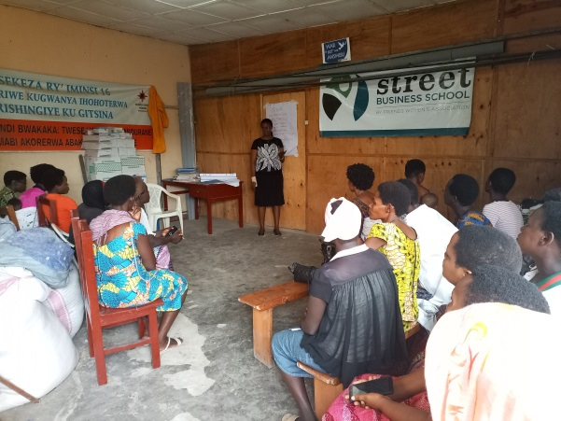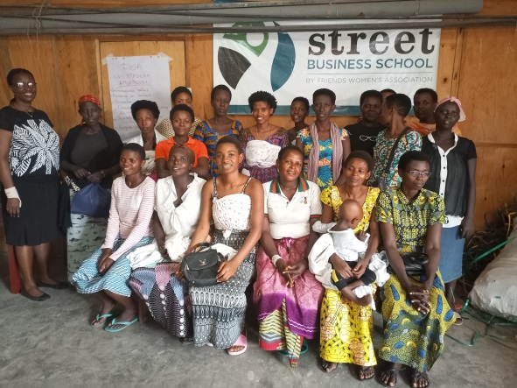
Street business School (SBS)
In the month of June the training on entrepreneurship (SBS) has been started for the 40 women from the SHGs of FWA.
The identification, SBS introduction and basic survey of participants, were activities that characterized the month of June.

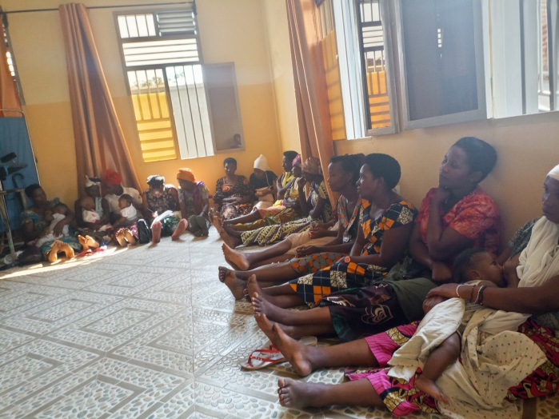

ACTION ON GENDER-BASED VIOLENCE (AGBV)
In the month of June 28-30, 2022 under the support of Quaker Service Norway (QSN) there was a three-day retreat for 20 GBV survivors’accompanists at centre MUGATUTU in Gitega province.

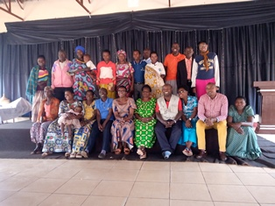
n the same month of June, FWA has continued to implement the project sponsored by the United Nations Peace Building Fund "Connecting the Global to the Local: Strengthening Women's Leadership for the Localization of the United Nations Security Council Resolution 1325 (2000) on "Women, Peace and Security". Kits were distributed to support income generating activities initiated by women mediators in four provinces (Bubanza, Bujumbura, Cibitoke and Makamba)
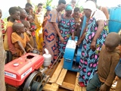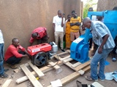
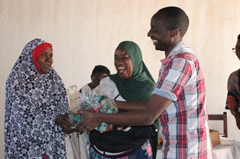

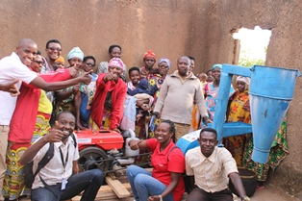

MEDICAL TEAM

CONSULTATIONS
Our medical doctors consulted with 91 cases, including 8 adults (4 men and 4 women), 3 children (all of them were girls), 10 HIV positive people and 70 pregnant women for ultrasound. The nurse received 217 patients including 153 adults and 64 children.

LABORATORY
In the month of June, apart from HIV voluntary testing, there were a total of 299 tests.
Test | Test completed | Positive | Negative
G.E.  Malaria test | 56 | 38 | 18
Quick malaria test | 47 | 20 | 27
ECBU  Urine test | 10 | 5 | 5
Selles  Stool test | 21 | 15 | 6
Pregnancy | 32 | 9 | 23
Sero-widal  Typhoïd fever | 43 | 16 | 27
Glycémie  Diabetes | 16 | 11 | 5
RPR VDRL  (Syphilis) | 32 | 0 | 32
Complete Blood Count | 18 | 9 | 9
Hepatitis B | 6 | 0 | 6
Hepatitis C | 3 | 1 | 2
Viral Load | 15 | 1 | 14
Total Tests: 299

FAMILY PLANNING
539 people received contraceptives from FWA’s nurse, including 322 old cases and 217 new ones. 413 received the contraceptive injection, 86 were given contraceptive pills, 18 received male condoms, 2 received UID and 20 received implants.

PRENATAL CONSULTATION (PNC)
In June, 58 women came for prenatal consultation (PNC), including 28 who came for PNC 1, 19 for PNC 2, 8 for PNC 3 and 3 for PNC 4.
70 pregnant women came for the ultrasound test.

ANTI-RETROVIRAL SITE
At the end of June, we had 330 patients under retro drugs followed at NTASEKA clinic, including 267 women and 63 men.

PHARMACY
Regarding medications, FWA was able to purchase the minimum needed medicine.

PSYCHOSOCIAL TEAM
In the month of June, 76 people were tested for HIV and received pre and post HIV test counselling. Out of the three people detected HIV positive, two were women with 4% of seropositivity.
Total Number of People Tested: | 76
Total Number of Women Tested: | 63
% of People Tested Who Are Women: | 83%
Average Age: | 29
Median Age: | 27
Total HIV+ : | 3
Total HIV- : | 73
Number of Women HIV+ : | 2
Total % Seropositivity: | 4%
% of Women Tested Who Are HIV+: | 3%

